JOHN 1
PURPOSE:
Joh 20:30 Now Jesus did many other signs in the presence of the disciples, which are not written in this book;
Joh 20:31 but these are written so that you may believe that Jesus is the Christ, the Son of God, and that by believing you may have life in his name.

Joh 1:1 In the beginning was the Word, and the Word was with God, and the Word was God.
Joh 1:2 He was in the beginning with God.
Joh 1:3 All things were made through him, and without him was not any thing made that was made.
- The first thing you’ll notice as we work through John 1, is that it begins in significantly different fashion than Matthew, Mark, and Luke.
- Here we are introduced to the “Word.”
  - Notice the word “Word” is capitalized.
  - This “Word” is a reference to Jesus (this will become clear as we progress).
- John tells us a few things about the “Word”:
  - He was present in the “beginning.”
  - He was with God.
  - He was God.
- We are given a time, place, and a statement about the Word’s nature.
  - Time.
    - The “beginning” seems to reference the creation of the world (the beginning of time as humans know it).
      - If you are familiar with Genesis chapter 1, you will recognize the similarities between the way John opens his book and the way Moses begins the Bible.
      - “In the beginning…”
    - Before anything was created, Jesus was there.
  - Place.
    - Where was Jesus before the creation?
    - He was with God.
  - Nature.
    - How was He with God before the creation?
    - He is God.
    - He shared the divine, timeless, eternal, nature with the other “God beings.”
    - The fact that more than one “God person” existed is evident from verses like Genesis 1:27.
    - Gen 1:26 Then God said, “Let us make man in our image, after our likeness. And let them have dominion over the fish of the sea and over the birds of the heavens and over the livestock and over all the earth and over every creeping thing that creeps on the earth.”
- John informs us that God created the world through Jesus.

Joh 1:4 In him was life, and the life was the light of men.

- In Jesus was life and light.
  - God was/is the giver of life.
    - Without God there is no life for plants, animals, or humans.
    - “Secure, is life from mortal mind, God holds the germ within His hand, Though men may search, they cannot find, for God alone does understand.”
    - Gen 2:7 then the LORD God formed the man of dust from the ground and breathed into his nostrils the breath of life, and the man became a living creature.
  - God was/is the giver of light.
    - Everything was covered in darkness before God’s creative work was complete.
    - Gen 1:2 The earth was without form and void, and darkness was over the face of the deep.
    - The first specific recorded act of God was the creation of light.
    - Gen 1:3 And God said, “Let there be light,” and there was light.
- What connection is John trying to make between the creation of the world and the appearance of the Word (Jesus) on earth?
  - In Genesis, the “word” of God created the heavens and the earth, gave physical life to all things, and brought physical light into the darkness.
  - But when mankind sinned, the world fell back into a state of spiritual death and darkness.
  - In John 1, God spoke again through His “Word” (Jesus), bringing spiritual life and spiritual light back into the world.
  - An act of creation.
  - To bring the dead to life and light into the darkness.
  - 2 Corinthians 5:17 Therefore, if anyone is in Christ, he is a new creation.
  - Just as the physical creation was accomplished by God through Jesus, this new spiritual creation was accomplished by God through Jesus.
- Jesus as “life” will be a theme throughout John’s writing:
  - Joh 5:26 For as the Father has life in himself, so he has granted the Son also to have life in himself.
  - Joh 6:33 For the bread of God is he who comes down from heaven and gives life to the world.”
  - Joh 11:25 Jesus said to her, “I am the resurrection and the life. Whoever believes in me, though he die, yet shall he live,
  - Joh 5:21 For as the Father raises the dead and gives them life, so also the Son gives life to whom he will.
  - 1Jn 1:1 That which was from the beginning, which we have heard, which we have seen with our eyes, which we looked upon and have touched with our hands, concerning the word of life—
  - 1Jn 1:2 the life was made manifest, and we have seen it, and testify to it and proclaim to you the eternal life, which was with the Father and was made manifest to us—
  - 1Jn 5:11 And this is the testimony, that God gave us eternal life, and this life is in his Son.
  - 1Jn 5:12 Whoever has the Son has life; whoever does not have the Son of God does not have life.

Joh 1:5 The light shines in the darkness, and the darkness has not overcome it.

- As at the creation, light was created in the darkness.
- The darkness was not powerful enough to shut it out.
- Satan would have loved to stop Jesus bringing salvation to the sinners in darkness but he was not powerful enough to stop the Word of God.
- Satan does his best to shut out the light, but it can always be found by those who search for it.
- Zechariah, the father of John the Baptist (who we will meet in a minute) spoke of Jesus as a sunrise to people sitting in darkness and death.
- Luke 1:78-79 because of the tender mercy of our God, whereby the sunrise shall visit us from on high to give light to those who sit in darkness and in the shadow of death, to guide our feet into the way of peace.”

Joh 1:6 There was a man sent from God, whose name was John.
Joh 1:7 He came as a witness, to bear witness about the light, that all might believe through him.
Joh 1:8 He was not the light, but came to bear witness about the light.

- John now introduces us to the second character of his gospel.
  - John the baptizer.
  - One point of clarification, John the baptizer and the author of this gospel are different Johns.
- This man, John, often referred to as John the Baptist, was specifically chosen by God for the role of introducing the Word (Jesus).
- Although he was a messenger of God, he was not the savior, the one who could bring light to the dark world.
- His job was to “bear witness” of the Savior and the light He would bring.
  - What does it mean to bear witness?
  - Bear witness – to show that something exists or is true.
  - How can you bear witness about something that hasn’t happened yet?
  - He was given divine insight into the Savior’s arrival.
- John pointed the attention of his listeners to the coming Savior so that when He finally arrived, they would believe in Him.
- APPLICATION:
  - None of us are the light.
  - We bear witness to the one who brought light into the world.
  - We try to tell people why we believe Jesus existed and why truth is found in Him.
  - Christians are kind of like the moon.
  - They don’t have any light of their own, they reflect the light of Jesus.
  - It would be pretty dumb for the moon to go around bragging about how bright it is to draw attention to itself.
  - Without the sun, it would be floating in darkness.
  - Without the Son, we would be walking around in darkness.

Joh 1:9 The true light, which gives light to everyone, was coming into the world.
Joh 1:10 He was in the world, and the world was made through him, yet the world did not know him.
Joh 1:11 He came to his own, and his own people did not receive him.
Joh 1:12 But to all who did receive him, who believed in his name, he gave the right to become children of God,
Joh 1:13 who were born, not of blood nor of the will of the flesh nor of the will of man, but of God.

- John gives us a bit of a preview of Jesus’ life which will play out in detail throughout the book.
  - You might think a man who had come to bring life and light would be well received by those stuck in darkness but that was not the case.
  - Jesus was largely rejected by those He came to save.
- I find verse 10 intriguing.
  - Jesus was the Creator of everything/every one.
  - But when He entered His creation, most of His creation didn’t recognize Him.
  - They refused to listen to Him.
- But verse 12 reveals there were some who received Him.
  - They believed Him.
  - And He gave them the right to become “children of God.”
- There were some people who looked their Creator in the eye and said, “You don’t know what you are talking about!”
- There were other people who believed Jesus was who He said He was and realized He knew what He was talking about!
- It is Satan’s greatest endeavor to get you in the first group.
  - How does He do that?
  - By attempting to distort your identity.
  - Confuse you about who you are.
  - Lying to you every day.
    - Get you to believe you’ll find your satisfaction outside of God.
    - Get you to believe your greatest joys are found outside of God.
    - Get you to believe God isn’t seeking your best interest.
    - Get you to believe lies about God’s identity.
    - Get you addicted to stuff to the point it consumes your mind (sex, recognition, chemical substances, achievement, accumulation, etc).
  - He wants us to swallow those lies until we are so confused about who we really are, we can’t even recognize where we came from.
  - He doesn’t want you to recognize your Creator, even if He stands in front of your face.
- Jesus came with a message much different than the devils.
  - He told us we weren’t meant to waste away here on earth pursuing petty pleasures.
  - He told us we are meant to be “sons of God.”
  - Those who had bought into the Devil’s lies thought that was ridiculous, but some recognized Jesus held the truth that the Devil tried so hard to keep hidden (the light in the darkness).
- Those who believed Jesus were “born” again (verse 13).
  - “not of blood” – Not a physical birth or inherited through a bloodline.
  - “nor of the will of the flesh nor of the will of man” – Mankind did not have the power to achieve this new life for themselves.
  - “but of God.” – our new birth/life is accomplished by the power of God through Jesus (the new creation). Only God can grant the privilege of becoming one of His sons.
  - (We will discuss this birth more in John 3).

Joh 1:14 And the Word became flesh and dwelt among us, and we have seen his glory, glory as of the only Son from the Father, full of grace and truth.

- The Word (Jesus) came down from heaven and took on a human identity to live among us.
- John, the Apostles, and many others were privileged to see Jesus with their own eyes and could personally attest to his “glory.”
  - Synonyms for glory include:
  - Praiseworthiness.
  - Renown.
  - Magnificence.
- Jesus’ glory was unlike any man’s.
  - John may have been thinking about events like the Transfiguration and ascension when he wrote verse 14.
  - It belonged uniquely to the “only Son from the Father.”
- You’ll notice, Jesus is referred to as the “Son of God” and we are told we are given the right to become “sons of God.”
  - As we work through the Bible it will become clear these terms aren’t equivalent.
  - The text isn’t saying we can become God (like Jesus).
  - But we can be recipients of a measure of His glory.
- Jesus was full of “grace and truth.”
  - Jesus embodied grace in his treatment of the poor, sick, and sinful.
  - He spoke truth into a world darkened by lies.

Joh 1:15 (John bore witness about him, and cried out, “This was he of whom I said, ‘He who comes after me ranks before me, because he was before me.’”)

- When Jesus arrived, John confirmed He was the Savior he had foretold.
- A voice from heaven also confirmed Jesus identity.
- Several witnesses were present and could attest to both events.

Joh 1:16 For from his fullness we have all received, grace upon grace.

- We’ve all received grace from the overflow of Jesus’ abundance.
- He is so full of grace there is enough for all.
- APPLICATION:
  - Your past cannot be so full of sin that Christ’s fullness of grace cannot save you.
  - So long as you “receive Him” (verse 12).

Joh 1:17 For the law was given through Moses; grace and truth came through Jesus Christ.

- The law being talked about here is the Old Testament Law (Law of Moses or Old Covenant).
- The Law clarified sin.
  - It made it very plain what was right and wrong.
  - It also condemned those who broke it.
  - The Bible tells us no one was able to keep the Old Testament Law perfectly.
  - So everyone was condemned under the Old Law because everyone broke the Law.
- The Law was first given by God to men during the time of Moses ~1500 B.C..
- The grace and truth necessary to save the world didn’t arrive until 1500 years later (30-33 A.D.)

Joh 1:18 No one has ever seen God; the only God, who is at the Father's side, he has made him known.

- FACT: Nobody has ever seen God in His fullness.
- But Jesus, who is here called “God,” reveals God to the world.
- If you want to know what God is like, learn about Jesus.
- Later in the book, Jesus says, “…Whoever has seen me has seen the Father…” (John 14:9).

Joh 1:19 And this is the testimony of John, when the Jews sent priests and Levites from Jerusalem to ask him, “Who are you?”
Joh 1:20 He confessed, and did not deny, but confessed, “I am not the Christ.”
Joh 1:21 And they asked him, “What then? Are you Elijah?” He said, “I am not.” “Are you the Prophet?” And he answered, “No.”

- You can think of verses 1-18 as John’s opening statement to the book.
- He now moves to tell us about the ministry of John the Baptist.

*If you want some additional details on the background and ministry of John the Baptist, check out the Matthew 3 notes at 2BeLikeChrist.com.

- The Jews sent a number of their officials to question John.
  - They wanted to know who he was and why he believed he had authority to preach and baptize the way he did.
  - As we read, we will find out these Jewish officials are going to be hostile to, not only to John, but also to Jesus.
- John told them, “I am not the Christ.” (Christ means “anointed”)
  - John wasn’t the world’s Savior.
  - As we saw in verse 15, John was preaching in advance of the Savior.
  - The Savior was superior to him.
- John wasn’t the Christ but that still didn’t clarify his identity. The Jewish officials asked him:
  - “Are you Elijah?”
    - John responded, “No.”
  - “Are you the Prophet?”
    - John responded “No.”
- Why did they ask if He was Elijah?
  - A popular opinion among the Jews during this time was that Elijah was going to make a reappearance on earth before Jesus (the Messiah) showed up.
  - Elijah was a Jewish prophet who lived ~800 years before Jesus.
  - They likely based this off of a few prophecies in the book of Malachi:
    - Mal 3:1 “Behold, I send my messenger, and he will prepare the way before me. And the Lord whom you seek will suddenly come to his temple; and the messenger of the covenant in whom you delight, behold, he is coming, says the LORD of hosts.
    - Mal 4:5 “Behold, I will send you Elijah the prophet before the great and awesome day of the LORD comes.
  - Based on those prophecies, I feel like their expectation had some merit.
  - But Jesus helped them understand that the coming “Elijah” wasn’t the old dead prophet, it spoke of a man who would preach with the “spirit and power of Elijah” (Luke 1:17).
  - Understanding their misunderstanding helps us understand why they asked the question.
    - Taking the time to connect a few passages and gather some background information gives us some clarity into their perspective.
    - SIDE NOTE: If we don't take the time to understand the reason behind people's misunderstandings, we shouldn't expect to convince many people they've misunderstood.
- Who was “the Prophet” (Notice how it is capitalized).
  - They don’t ask him if he is “a prophet.”
  - If that had been the question, John would have responded affirmatively. A prophet was anyone who carried a message from God to a designated audience.
  - But they wanted to know if he was “the Prophet.”
  - “The Prophet” is probably a refence to the prophet foretold by Moses in the book of Deuteronomy.
    - Moses foretold of a prophet like himself who God would send to the Jews.
    - Deu 18:15 “The LORD your God will raise up for you a prophet like me from among you, from your brothers—it is to him you shall listen—

Joh 1:22 So they said to him, “Who are you? We need to give an answer to those who sent us. What do you say about yourself?”
Joh 1:23 He said, “I am the voice of one crying out in the wilderness, ‘Make straight the way of the Lord,’ as the prophet Isaiah said.”

- John the Baptist wasn’t Christ, wasn’t Elijah, and wasn’t “the prophet.”
- After these three attempts the Jewish leaders ran out of guesses, got frustrated, and decided to ask John straight-up, “Who are you?”
- John quotes Isa 40.
  - Isa 40:3-4 A voice cries: “In the wilderness prepare the way of the LORD; make straight in the desert a highway for our God. Every valley shall be lifted up, and every mountain and hill be made low; the uneven ground shall become level, and the rough places a plain.
  - When a king or official went on a trip, it was common for them to send servants and announcements ahead of them.
  - The servants would announce the imminent arrival of the king to the townsfolk, prompting them to make ready (get things cleaned up).
  - The king’s subjects were responsible for preparing the road on which the king would be travelling.
  - They would ride ahead and patch potholes, add fill in areas where valleys had formed, level off elevated/uneven ground, and, where possible, redirect crooked roads and make them straight.
- Do you see the parallel?
  - John quotes this passage because that was his role to prepare the way for the coming of Jesus.
  - Not that John was a physical laborer repairing the Galilean roads so Jesus didn’t sprain His ankle, but He was a spiritual laborer preparing people’s hearts and minds for their spiritual King (Jesus).

Joh 1:24 (Now they had been sent from the Pharisees.)
Joh 1:25 They asked him, “Then why are you baptizing, if you are neither the Christ, nor Elijah, nor the Prophet?”
Joh 1:26 John answered them, “I baptize with water, but among you stands one you do not know,
Joh 1:27 even he who comes after me, the strap of whose sandal I am not worthy to untie.”

- These questioners had been sent by the Pharisees.
- Who were the Pharisees and Sadducees?
  - Who are the Pharisees?
    - Generally made up of wealthy men who turned their attention to religion.
    - They had significant influence among the common Jewish citizens.
    - Promoted strict adherence to the Old Testament Laws and oral traditions
    - Promoted Jewish culture rather than Hellenization
    - Believed in the supernatural.
    - Believed in an afterlife
  - Who are the Sadducees?
    - Upper economic class among the Jews (contrast with Jesus followers). They had significant influence with the governing Roman authorities.
    - Rejected the Pharisees’ binding of tradition. Viewed the written Torah (first 5 books of the Old Testament) as the only binding law.
    - More friendly to Hellenization
    - Limited belief in the supernatural
    - Rejected the resurrection of the body, the afterlife, and angels.
    - Responsible for the Temple in Jerusalem.
- As we continue through Matthew’s book, we will see the Pharisees and Sadducees at continual odds with Jesus. Having read the descriptions above, it is not hard to see why…
  - The Pharisees didn’t like Jesus because He repeatedly condemned them for creating unauthorized laws and rules that they bound on their fellow Jews. In addition, Jesus condemned them for their hypocrisy, because they didn’t even keep the laws they bound on others.
  - The Sadducees didn’t like Jesus because He was always talking about the afterlife, and resurrection, and angels, and was just generally WAY to supernatural for their liking. They also disliked Him because He threatened their lucrative money-making operation at the Temple.
- They wanted to know why John was preaching and baptizing the way he was if he wasn’t Elijah, the Prophet, or Christ.
  - This question was probably motivated by malice, much like the questions asked to Jesus about His source of authority.
  - Mar 11:28 and they said to him, “By what authority are you doing these things, or who gave you this authority to do them?”
- John doesn’t answer them directly but tells them the Christ, who they were anticipating and for who he was preparing the way, was standing among them.
  - Jesus would have been about 30 years old at this time but had not yet revealed Himself as the Messiah.
  - The Jewish leaders would shortly find out from where John received authority to preach and baptize.
  - And they would not have to wait long to get their answer.
  - Jesus would confirm John’s work as being the work of God.
- It probably would have been pretty shocking to the Jewish leaders to hear the Messiah was standing among them and they were unable to recognize Him.
- As scholars of the Jewish law, they probably thought they would be the first people to know.

Joh 1:28 These things took place in Bethany across the Jordan, where John was baptizing.

- Verse 28 tells us these events happened in Bethany across the Jordan (Some versions read “Bethabara”).
  - There has been a lot of discussion as to the exact location of this Bethany.
  - We know there was a Bethany just east of Jerusalem on the west side of Jordan, but archeology has yet to reveal the precise spot of the Bethany to the east of Jordan.
  - The map below suggests a location.
  - 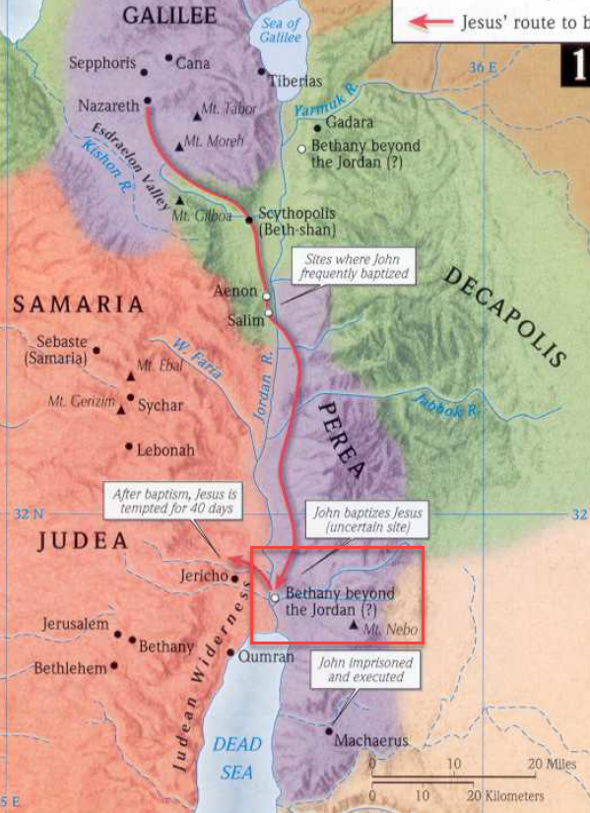

Joh 1:29 The next day he saw Jesus coming toward him, and said, “Behold, the Lamb of God, who takes away the sin of the world!
Joh 1:30 This is he of whom I said, ‘After me comes a man who ranks before me, because he was before me.’
Joh 1:31 I myself did not know him, but for this purpose I came baptizing with water, that he might be revealed to Israel.”
Joh 1:32 And John bore witness: “I saw the Spirit descend from heaven like a dove, and it remained on him.
Joh 1:33 I myself did not know him, but he who sent me to baptize with water said to me, ‘He on whom you see the Spirit descend and remain, this is he who baptizes with the Holy Spirit.’
Joh 1:34 And I have seen and have borne witness that this is the Son of God.”

- The next day, Jesus came to John the Baptist.
  - This text gave me some difficulty when attempting to harmonize it with the other gospel accounts.
  - Mark’s gospel says, the Spirit of God “drove” Jesus out into the wilderness for 40 days “immediately” after His baptism.
  - It is difficult to fit Jesus’ baptism anywhere within the next few verses.
    - Joh 1:29 The next day.
    - Joh 1:35 The next day.
    - Joh 1:43 The next day.
  - Jesus meets some of the Apostles in the next few verses and the timestamps don’t allow us to fit a 40 day temptation anywhere in between.
  - It is my understanding that at this point (verse 29), Jesus has already been baptized and has recently returned from the 40 day temptation in the wilderness.
  - He meets John again and John testifies to His identity as the Son of God.
- John calls Him the “Lamb of God.”
  - If you aren’t super familiar with the Bible, that may seem like an odd name.
  - Why call Jesus a lamb?
    - In the Old Testament, the Jews had to offer sacrifices for their sins.
    - They offered cows, and doves, sheep, etc…
    - But the animal sacrifices weren’t sufficient to cleanse their sins.
    - So Jesus came to earth to sacrifice Himself to pay the price for our sins.
    - Like an innocent lamb that is sacrificed for someone’s wrongs, Jesus is the innocent (sinless) Lamb of God, sacrificed for the wrongs of all mankind.
    - We will discuss this more as we go through John’s gospel but there are additional details on this available in the Mark 14 notes.
  - Jesus is the Lamb of God because He is the world’s sacrifice.
- John, acknowledges Jesus as the one who is greater than he.
- This was the man for which John has been preparing the way and he announces it to the people.
- How does he know? How does he know Jesus is the right guy?
  - Because God told him, “He on whom you see the Spirit descend and remain, this is he who baptizes with the Holy Spirit.”
  - When had John seen that happen?
  - Answer: At Jesus’ baptism.
  - Joh 1:32 And John bore witness: “I saw the Spirit descend from heaven like a dove, and it remained on him.
- John had seen the evidence and was now bearing witness to the identity of Jesus.
- John was told to baptize (immerse) people in water, but Jesus was coming to baptize with the Holy Spirit.
  - Following His death and resurrection, Jesus’ followers received miraculous power and knowledge from the Holy Spirit (God).
  - This power enabled them to carry out their mission of spreading the good news about Jesus.
  - We will discuss the Holy Spirit more as we study through the book.
- So, in verse 34, John’s testimony is… This man Jesus is the Messiah, the Christ, the Son of God, the Savior we’ve all been anticipating.

Joh 1:35 The next day again John was standing with two of his disciples,
Joh 1:36 and he looked at Jesus as he walked by and said, “Behold, the Lamb of God!”
Joh 1:37 The two disciples heard him say this, and they followed Jesus.
Joh 1:38 Jesus turned and saw them following and said to them, “What are you seeking?” And they said to him, “Rabbi” (which means Teacher), “where are you staying?”
Joh 1:39 He said to them, “Come and you will see.” So they came and saw where he was staying, and they stayed with him that day, for it was about the tenth hour.
Joh 1:40 One of the two who heard John speak and followed Jesus was Andrew, Simon Peter's brother.
Joh 1:41 He first found his own brother Simon and said to him, “We have found the Messiah” (which means Christ).
Joh 1:42 He brought him to Jesus. Jesus looked at him and said, “You are Simon the son of John. You shall be called Cephas” (which means Peter).

- The following day, John was standing with two of his disciples when Jesus walked by.
- John called attention to Jesus announcing Him once again as the “Lamb of God.”
- The two men immediately followed Jesus.
- The two men went with Jesus to where He was staying and spent the day with Him.
- The text then tells us one of the men was Andrew, Simon Peter’s brother.
  - Now, if you remember Matthew and Mark’s gospels, Jesus called Simon Peter and Andrew beside the sea of Galilee.
  - But the story seems different here.
  - Why?
  - That is a good question and one people have had difficulty with for a long time, including myself.
  - But when you take the time to study the text, there is no contradiction here.
  - Let me try to explain:
    - This account in John 1 and the call of Simon and Andrew in Matthew are not the same.
    - Here, John is recording the first encounter of Jesus with Simon and Andrew.
    - But you will notice, Jesus doesn’t ask these two men to follow Him.
    - That may not be super significant to us in our culture but it was very significant in the Jewish culture.
      - In those days, it was a high honor to be a disciple of a rabbi.
      - But not everyone had the privilege of following rabbi and learning from him.
      - In order to become the student of a rabbi, you had to be called/invited.
    - John 1 records Simon and Andrew’s first encounter with Jesus but we don’t see Jesus inviting them to follow Him and be His disciples until a bit later when He is with them at the Sea of Galilee (Matthew 4:18ff).
- Some point after leaving John the Baptist to follow Jesus, Andrew ran and found his brother, Simon, and introduced him to Jesus.
- Jesus gave Simon the name “Cephas” (which means Peter; John 1:42).
- Many suspect John (the author of this gospel) may have been the other man with Andrew.

Joh 1:43 The next day Jesus decided to go to Galilee. He found Philip and said to him, “Follow me.”
Joh 1:44 Now Philip was from Bethsaida, the city of Andrew and Peter.

- The following day Jesus decided to go to Galilee.
- 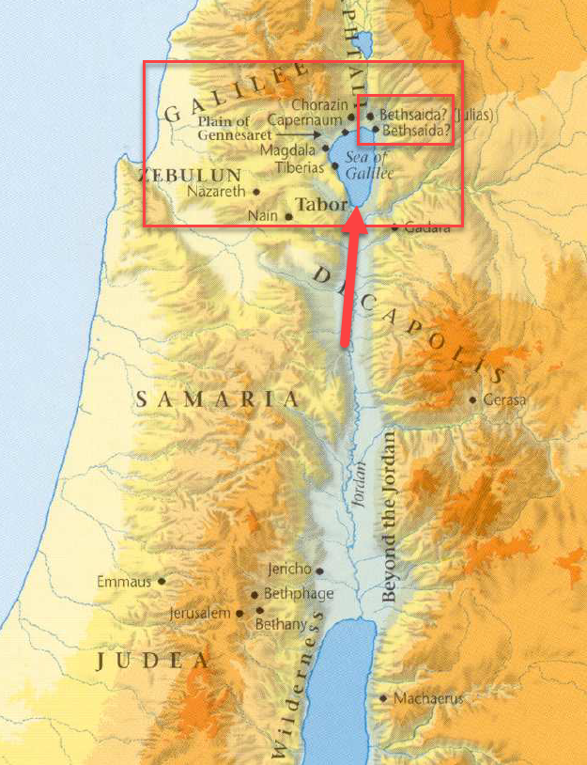
- There he called a man named Philip to follow Him.
- Philip was from Bethsaida (see map above).
- Bethsaida was the “city of Andrew and Peter (Simon).
  - This may be a reference to the city of their birth rather than their current residence.
  - Other passages seem to suggest they lived in Capernaum.
  - See Luke 4:38.

Joh 1:45 Philip found Nathanael and said to him, “We have found him of whom Moses in the Law and also the prophets wrote, Jesus of Nazareth, the son of Joseph.”
Joh 1:46 Nathanael said to him, “Can anything good come out of Nazareth?” Philip said to him, “Come and see.”

- Philip then went and found a man named Nathanial and told Him he had found the Messiah, Jesus of Nazareth.
- Upon hearing of Nazareth, Nathaniel replied, “Can anything good come out of Nazareth?”
  - Many have speculated as to the intention of Nathaniel in this statement.
  - Nazareth may not have had a very good reputation.
  - I did a quick search into the historical information about Nazareth, but was unable to establish a concrete reason as to why Nazareth may have had a tarnished reputation.
  - It could have been that Nazareth was so small, Nathaniel didn’t think it had any potential to be the origin of someone/something as great as the Messiah.
- Philip told Nathaniel to “come and see” whether or not anything good could come out of Nazareth.
- APPLICATION:
  - We see a trend developing here.
  - Those who learn about Jesus are quick to go find their friends and tell them.
  - If we could instill the same attitude in new/old Christians alike, the church wouldn’t have a growth problem.
  - If you had a congregation of 10 people and you could get each of those 10 people to make 1 disciple per year and then to do the same the next year… how long would it take to convert the world?
  - Answer: 31 years = 10,737,418,240 people. (~1.5X earth’s population).

Joh 1:47 Jesus saw Nathanael coming toward him and said of him, “Behold, an Israelite indeed, in whom there is no deceit!”
Joh 1:48 Nathanael said to him, “How do you know me?” Jesus answered him, “Before Philip called you, when you were under the fig tree, I saw you.”
Joh 1:49 Nathanael answered him, “Rabbi, you are the Son of God! You are the King of Israel!”
Joh 1:50 Jesus answered him, “Because I said to you, ‘I saw you under the fig tree,’ do you believe? You will see greater things than these.”

- Jesus saw Nathanael coming and paid him a high compliment.
- Deceit:
  - Definition - The action or practice of deceiving someone by concealing or misrepresenting the truth.
  - Synonyms – Deception, dishonesty, trickery, treachery, etc.
- Having never met Jesus, Nathanael is surprised Jesus knows Him and speaks of his character.
- Jesus tells him He saw him under the fig tree before Philip ever called him.
- At hearing this, Nathanael immediately concludes Jesus must be the Son of God and the Messiah.
  - Jesus’ statement and Nathanael’s response make it obvious that Jesus’ ability to see Nathanael was miraculous.
  - Wherever this fig tree was, it must have been in a location Nathanael knew Jesus could not have physically seen him (otherwise his response wouldn’t make any sense).
- Jesus tells Nathanael he will have the privilege of witnessing much greater miracles.

Joh 1:51 And he said to him, “Truly, truly, I say to you, you will see heaven opened, and the angels of God ascending and descending on the Son of Man.”

- This is a difficult saying.
- Some people think Jesus is referring the mind of Nathanial back to Genesis 28:12-22 when Jacob saw a ladder leading to heaven with angels ascending and descending.
  - Jesus may be telling Nathaniel that he would witness the fulfillment of the promise made to Jacob on that occurrence.
  - Gen 28:14 Your offspring shall be like the dust of the earth, and you shall spread abroad to the west and to the east and to the north and to the south, and in you and your offspring shall all the families of the earth be blessed.
- Or, Jesus may have been telling Nathanael that the divine power he was going to witness on earth would be so abundant and potent, it would be as if the angels brought him a continuous supply. As if the storehouses of heaven’s power were being opened and the angels were continuously bringing it down to Jesus.
- Or, the angels going from heaven to earth may be a picture of the continuous work of God being done on earth during Jesus ministry (some being accomplished through miraculous works that Nathanael would get to witness).

https://en.wikipedia.org/wiki/Glory_(honor)
http://www.rationalchristianity.net/jesus_early.html
https://hermeneutics.stackexchange.com/questions/819/reconciling-the-accounts-of-the-calling-of-simon-peter
https://carm.org/bible-difficulties/matthew-mark/where-did-jesus-first-meet-simon-peter-and-andrew
https://www.blueletterbible.org/study/intros/john.cfm
Oxford Dictionary

