JOHN 11

Joh 11:1 Now a certain man was ill, Lazarus of Bethany, the village of Mary and her sister Martha.
Joh 11:2 It was Mary who anointed the Lord with ointment and wiped his feet with her hair, whose brother Lazarus was ill.
Joh 11:3 So the sisters sent to him, saying, “Lord, he whom you love is ill.”

- 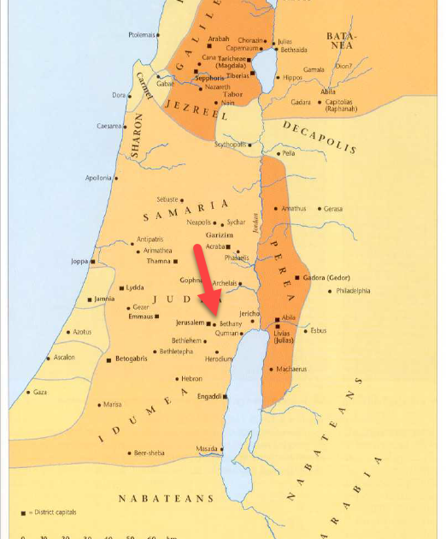
- We are here introduced to a family who Jesus knew and loved, Mary, Martha, and Lazarus.
  - Mary and Martha were Lazarus’ sisters.
  - They lived in Bethany, which was only 1-2 miles east of Jerusalem.
- Verse 2 tells us this was the same Mary who anointed Jesus with ointment and wiped His feet with her hair (more about this in chapter 12).
- We aren’t told the exact nature of the relationship between this family and Jesus but the wording of the text suggests Jesus had a personal friendship with them.
- One day, Lazarus got very sick and Mary and Martha sent a message to Jesus to inform Him.
  - More than just to inform Jesus, they probably were requesting Him to come heal Lazarus.
  - Jesus probably wasn’t very far away.
  - Chapter 10 ended with Jesus in the Jordan River region.
  - John 11:8 suggests not much time had past since the events of chapter 10 and He was probably still there when He received Mary and Martha’s message.
  - 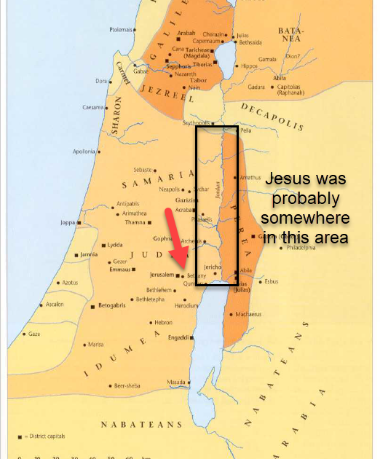

Joh 11:4 But when Jesus heard it he said, “This illness does not lead to death. It is for the glory of God, so that the Son of God may be glorified through it.”

- Do you remember the last time Jesus said a person was sick so that God could be glorified?
  - The blind man in John 9.
  - Joh 9:3 Jesus answered, “It was not that this man sinned, or his parents, but that the works of God might be displayed in him.
- The origins of sickness date back to the first sin in the Garden of Eden.
  - God is glorified in healing sick people and raising dead people because it shows He has the power over the consequences of sin.
  - These healing show God’s ability to remove corrupting influence and make something healthy again.
  - And that is important when we think about heaven and eternal life with Him.
  - He has the ability to make all things new.
    - Sin has a decaying power.
    - Death is a consequence of sin’s influence in the world.
    - Jesus came to the world to rid us of that corruption.
  - These healings are small pictures of His ultimate sin healing work.
  - APPLICATION:
    - Jesus isn’t around to heal sick people anymore.
    - Those who Jesus did healed still eventually died because they still had to live in a world full of sin.
    - God promises His faithful followers He will give them a new body when they die and they will live in a new world with no sin and therefore no death.
    - God tells us if we fall in love with this world and live for this world and indulge in the decaying corruption of this world, we will be destroyed (hell), because God hates the corruption of sin.
    - But if we turn our back on sin and live for God and love the things God loves and help others understand why they should make the same decision, God promises to save us from the corruption in the end and to bring us home to live with Him in a sinless place.
    - In order for Him to save us He needs a way to wash us clean of the corruption we’ve participated in, because that stuff can’t come into His presence.
    - This is why Jesus came into the world.
    - His blood is going to act as the cleaning agent.

Joh 11:5 Now Jesus loved Martha and her sister and Lazarus.
Joh 11:6 So, when he heard that Lazarus was ill, he stayed two days longer in the place where he was.
Joh 11:7 Then after this he said to the disciples, “Let us go to Judea again.”
Joh 11:8 The disciples said to him, “Rabbi, the Jews were just now seeking to stone you, and are you going there again?”

- You would think verse 6 would read differently after reading verse 5.
  - You would think Jesus would get on the road to Bethany immediately if He really loved Mary, Marth, and Lazarus.
  - Instead He stayed where He was for 2 additional days.
  - Mary and Martha were probably wanting Him to come immediately.
  - But Jesus knew if He waited 2 days, the miracle He would perform to help Lazarus would have a greater impact on Mary, Martha, and all of its observers.
  - APPLICATION:
    - Sometimes we think we know best how we want God to solve our problems.
    - Sometimes He doesn’t solve our problems the way we want because He has a better plan.
- When 2 days had past, Jesus told His Apostles it was time to go to Judea and visit Lazarus.
- The Apostles were surprised He was ready to go back in the direction of Jerusalem because the Jews there had just tried to kill Him (see chapter 10).

Joh 11:9 Jesus answered, “Are there not twelve hours in the day? If anyone walks in the day, he does not stumble, because he sees the light of this world.
Joh 11:10 But if anyone walks in the night, he stumbles, because the light is not in him.”

- Jesus’ response to the Apostles is a bit tricky to understand.
- He tells them people who walk during daylight hours don’t trip, but those who walk around at night trip due to the lack of light.
- The picture is of a traveler who knows He has a designated period of safety every day while the sun illuminates the road in front of Him.
- What did Jesus intend to communicate by this?
  - I think these words are similar to words spoken to the Apostles in John 9.
    - Joh 9:4 We must work the works of him who sent me while it is day; night is coming, when no one can work. As long as I am in the world, I am the light of the world.”
  - Jesus was in the world for a very precise and limited amount of time.
  - During that period, no harm could come to Him until the appointed time of His death.
  - He had work to do and nothing could hinder Him or cause Him to stumble before achieving His purpose.
- Jesus’ two escapes from the Temple were evidence that while the Light of the World was in the world nothing could harm Him against His will.
- Jesus wasn’t afraid to go back to Judea because human threats were powerless to affect the timing of God.

Joh 11:11 After saying these things, he said to them, “Our friend Lazarus has fallen asleep, but I go to awaken him.”
Joh 11:12 The disciples said to him, “Lord, if he has fallen asleep, he will recover.”
Joh 11:13 Now Jesus had spoken of his death, but they thought that he meant taking rest in sleep.
Joh 11:14 Then Jesus told them plainly, “Lazarus has died,
Joh 11:15 and for your sake I am glad that I was not there, so that you may believe. But let us go to him.”
Joh 11:16 So Thomas, called the Twin, said to his fellow disciples, “Let us also go, that we may die with him.”

- These verses aren’t too hard to understand.
- Jesus tells the Apostles Lazarus is asleep and He needs to go wake him up.
- Sick people need rest, so the Apostles thought Lazarus would be just fine if Jesus left him asleep.
- But Jesus didn’t mean Lazarus was asleep in the literal sense, He meant he had died (falling asleep is a common way of referring to death in the Bible).
- Jesus tells the Apostles He is glad He wasn’t there when Lazarus died because the miracle He is about to perform will be a benefit to their faith.
- They then leave the region around Jordan and begin their trip to Bethany.
- The Apostles must not have understood the meaning of Jesus’ words in verses 9-10 because they still believed Jesus was in danger.
  - Thomas said, “Let us also go, that we may die with him.”
  - Although Thomas didn’t understand Jesus wasn’t in danger, it is admirable He was willing to follow Jesus into what he perceived was a dangerous situation.

Joh 11:17 Now when Jesus came, he found that Lazarus had already been in the tomb four days.
Joh 11:18 Bethany was near Jerusalem, about two miles off,
Joh 11:19 and many of the Jews had come to Martha and Mary to console them concerning their brother.

- We don’t know how long it took Jesus to make the trip from His previous location to Bethany, but it seems likely Lazarus died not long after Mary and Martha sent Jesus news of his sickness.
- When Jesus arrived, Lazarus had been in a tomb for 4 days.
- Many people from Jerusalem had come to Bethany to console the two sisters.

Joh 11:20 So when Martha heard that Jesus was coming, she went and met him, but Mary remained seated in the house.
Joh 11:21 Martha said to Jesus, “Lord, if you had been here, my brother would not have died.
Joh 11:22 But even now I know that whatever you ask from God, God will give you.”

- APPLICATION:
  - Be careful about speculation!
  - I think verse 20 is a tempting verse to speculate about.
  - Why did Mary stay at the table while Martha ran to see the Lord?
  - Maybe she was angry at Jesus for delaying His arrival.
  - Maybe she didn’t think Jesus could raise her brother from the dead.
  - Maybe her sister had greater faith than her.
  - There is nothing wrong with speculation, but we need to be careful we aren’t making points the text isn’t making.
- When Martha heard Jesus had arrived, she ran out of the house to meet Him.
- She told Jesus something He already knew, “…if you had been here, my brother would not have died.”
  - She knew Jesus could have healed her brother.
  - She may have wondered what took Him so long to arrive.
  - Nonetheless, the next verse reveals she didn’t say this as a rebuke.
- Martha knew Jesus could have healed Lazarus while he was alive, but she also knew her brothers death didn’t render Jesus incapable of fixing the situation, which shows incredible faith on her part.
  - There has been some debate as to whether Martha was actually implying Jesus had the power to raise the dead when she spoke the words of verse 22.
  - From my personal reading and based on the other interpretations I’ve read, I believe Martha was suggesting Jesus had the power to raise her brother.

Joh 11:23 Jesus said to her, “Your brother will rise again.”
Joh 11:24 Martha said to him, “I know that he will rise again in the resurrection on the last day.”
Joh 11:25 Jesus said to her, “I am the resurrection and the life. Whoever believes in me, though he die, yet shall he live,
Joh 11:26 and everyone who lives and believes in me shall never die. Do you believe this?”
Joh 11:27 She said to him, “Yes, Lord; I believe that you are the Christ, the Son of God, who is coming into the world.”

- After saying what she just said to Jesus, I imagine Martha was expecting a response as to whether or not He was going to raise Lazarus from the dead.
- Instead, Jesus gives her a more general answer, but one of greater importance in the grand scheme of His overall mission.
  - He told her, “Your brother will rise again.”
  - This answer wasn’t as precise as Martha may have wanted.
  - She tells Jesus she knows he will spiritually rise again in the resurrection at the end of time, but…
    - Have you ever tried to ask someone a question without stating the question.
    - I think that is what is happening here.
  - Jesus then responds again without speaking directly to her question.
    - He tells her He is the resurrection and the life and anyone who believes in Him will not die.
    - When asked if she believed these things, Martha responded, “Yes, Lord; I believe that you are the Christ, the Son of God, who is coming into the world.”
      - These themes wouldn’t have been new to Martha as a disciple of Christ.
      - He taught regularly about the eternal life He was making available.

Joh 11:28 When she had said this, she went and called her sister Mary, saying in private, “The Teacher is here and is calling for you.”
Joh 11:29 And when she heard it, she rose quickly and went to him.
Joh 11:30 Now Jesus had not yet come into the village, but was still in the place where Martha had met him.
Joh 11:31 When the Jews who were with her in the house, consoling her, saw Mary rise quickly and go out, they followed her, supposing that she was going to the tomb to weep there.
Joh 11:32 Now when Mary came to where Jesus was and saw him, she fell at his feet, saying to him, “Lord, if you had been here, my brother would not have died.”

- Martha went to the house, found her sister Mary, and told her privately that Jesus had arrived and was looking for her.
- She got up and left the house quickly.
- The Jews who came to comfort her thought she was going to her brother’s tomb to weep so they followed her.
- When Mary found Jesus she fell down at His feet and, interestingly, made the same statement as her sister.
  - “Lord, if you had been here, my brother would not have died.”
  - Curiously, she didn’t include the last part of her sister’s statement.

Joh 11:33 When Jesus saw her weeping, and the Jews who had come with her also weeping, he was deeply moved in his spirit and greatly troubled.
Joh 11:34 And he said, “Where have you laid him?” They said to him, “Lord, come and see.”
Joh 11:35 Jesus wept.
Joh 11:36 So the Jews said, “See how he loved him!”
Joh 11:37 But some of them said, “Could not he who opened the eyes of the blind man also have kept this man from dying?”

- SPOILER ALERT: By the end of this chapter, Jesus is going to raise Lazarus from the dead. The reason I make you aware of this now is because it is important when discussing the verses we just read.
- Mary was crying when she fell down at Jesus’ feet.
- And Jesus’ didn’t just stand there like a stoic brick wall.
- The text says, He was deeply moved, greatly troubled, and He also wept with the mourners.
  - Why?
  - Why is He sad if He knows He is going to raise Lazarus from the dead in a few minutes?
  - There has been a lot of debate over this question and for the sake of time I won’t go through all of the possible answers, I will just suggest one.
  - Jesus isn’t removed from our suffering.
  - He isn’t numb to our sorrows and pains.
  - How do we know?
    - Because sin brought pain, sorrow, and death into the world.
    - Jesus came to the world to deal with the consequences of sin.
    - If Jesus didn’t care He wouldn’t have come.
  - Jesus was going to raise Lazarus from the dead but His family didn’t know it.
  - They wept because they thought their future on earth was going to be one their brother wasn’t in.
  - And Jesus knew what that sorrow was like and how real it was to people who had to live in a world where sin made it a reality.
  - Yes, Jesus was going to raise Lazarus and the family would rejoice, but Jesus also knew there were thousands, if not millions, of families around the world that same day who wouldn’t have their loved ones raised.
  - The genuine sorrow He observed in this scene had been and would be shared by almost every human being on earth when they lose a loved one to death.
  - He was sad the world was in that state, but He came to do something about it!
    - To take away our sorrows.
    - To give us a home where that wouldn’t happen anymore.
  - We talk a lot about Jesus paying the price for our sins, but the Bible also talks about Him bearing our sorrows.
    - Isa 53:4 Surely he has borne our griefs and carried our sorrows;
    - Jesus came to take away our sin guilt.
    - He also came to take away the grief and sorrows of a world saturated by sin.
  - It will be a great day when we get to live in a place where death can’t take people we love.
  - When we get to heaven we can thank Jesus for killing the sin that killed us and those we loved.
  - John 11:35 is the shortest verse in the Bible but the idea of the Son of God in tears over the death of a human friend is deeper and more beautiful than 1,000,000 words can explain.
- The Jews standing around observed Jesus’ love for this family.
- But some questioned and perhaps mocked Jesus for not healing Lazarus and saving Him from death.

Joh 11:38 Then Jesus, deeply moved again, came to the tomb. It was a cave, and a stone lay against it.
Joh 11:39 Jesus said, “Take away the stone.” Martha, the sister of the dead man, said to him, “Lord, by this time there will be an odor, for he has been dead four days.”

- Jesus then went to Lazarus’ tomb and asked for the stone to be taken away from the entrance to the cave.
  - Although most people today are buried under 6 ft of dirt in a graveyard, families in ancient Judea were commonly buried in tombs cut out of a hillside or in a small structure made of stone.
  - 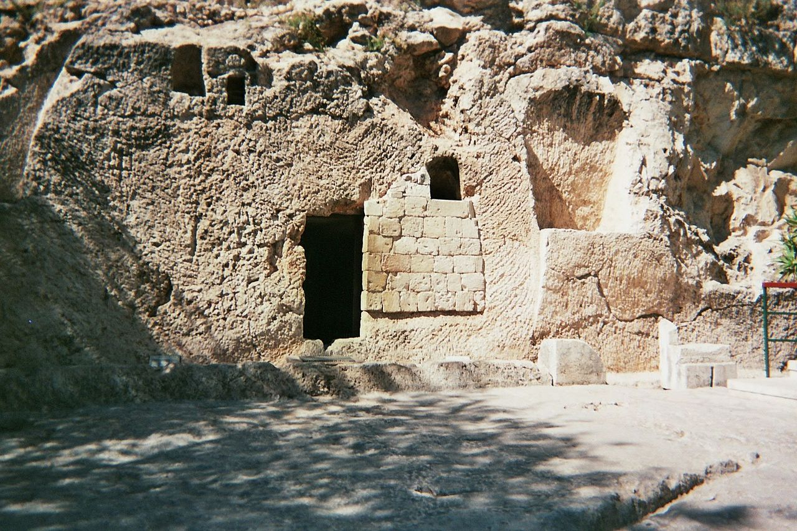
  - A large stone would be rolled in front of the tomb to keep animals and robbers out.
- Martha wasn’t sure opening the tomb was a good idea. A body dead 4 days would already have begun to decay and smell.

Joh 11:40 Jesus said to her, “Did I not tell you that if you believed you would see the glory of God?”

- When did Jesus say this to Martha?
- These exact words aren’t recorded in this chapter.
- Its possible this was implied in His statement to Martha in verses 23-25.
- It is also possible there were additional words spoken between them that John doesn’t record.
  - In fact, we know there were some unrecorded words in their dialog.
  - In verse 28, Martha tells Mary Jesus had called her, but we have no record of Jesus asking Martha to call Mary to Him.

Joh 11:41 So they took away the stone. And Jesus lifted up his eyes and said, “Father, I thank you that you have heard me.
Joh 11:42 I knew that you always hear me, but I said this on account of the people standing around, that they may believe that you sent me.”
Joh 11:43 When he had said these things, he cried out with a loud voice, “Lazarus, come out.”
Joh 11:44 The man who had died came out, his hands and feet bound with linen strips, and his face wrapped with a cloth. Jesus said to them, “Unbind him, and let him go.”

- The stone of the tomb was rolled away and Jesus looked up into heaven and began to pray.
- He thanked God for hearing Him.
  - He thanks God before the miracles is actually performed, why?
  - He did it, not for His own benefit, but for the benefit of those observing the scene.
  - He attributes His miraculous power to God so those who witness what He is about to do will know He came from God.
- The Jewish religious leaders have been suggesting Jesus’ power isn’t from God.
- They’ve accused Jesus of blaspheming and accused Him of getting His power from the Devil.
- But here, Jesus calls out to God before performing the miracle.
  - If there was ever a time for God to shut Jesus down this was it!
  - If there was ever a time for God to show His disapproval of Jesus this was it!
- Jesus called God as His witness!
- Would God confirm His words?
- Jesus cried with a loud voice, “Lazarus, come out.”
  - And Lazarus came out.
  - With burial cloth wrapped around his hands, feet, and face.
  - Jesus told the onlookers to “Unbind him, and let him go.”
- This undeniable miracle was and undeniable confirmation of Jesus’ words.
- God had indeed sent Jesus into the world!
- SIDE NOTE:
  - To a human reader, this story ends in the most unsatisfying way.
  - It tells us exactly what we need to know, Jesus proved He had been sent by God by resurrecting a dead man.
  - But it doesn’t satisfy all of our curiosities.
    - If I were John, I would have included a few chapters about all the questions He probably asked Lazarus when they got an opportunity to talk.
    - What does it feel like to be dead?
    - Did you see anything?
    - Could you see your soul leave your body?
    - Did you actually go anywhere or were you just stuck in your body for 4 days?
    - How did you feel when you came back to life?
  - We don’t get the answers to any of these questions .
  - And it’s a reminder to us that the Bible’s goal is to inform us of God’s plan to redeem man through His Son.
  - It is not a book meant to answer all of our curious questions about things unimportant to our salvation.
- SIDE NOTE:
  - Why is Lazarus’ resurrection so important?
    - Was it a gift to Mary and Martha? Yes.
    - Was it evidence God sent Jesus? Yes.
  - It is also important because it was proof Jesus commanded death.
  - That fact is extremely important when assessing Jesus’ ability to keep His words in John 11:23-26.
    - Jesus promises those who believe an escape from death (spiritual death).
    - Someone might say, “Prove it! Anyone can make claims about future spiritual realities.
    - Lazarus was the proof.

Joh 11:45 Many of the Jews therefore, who had come with Mary and had seen what he did, believed in him,
Joh 11:46 but some of them went to the Pharisees and told them what Jesus had done.
Joh 11:47 So the chief priests and the Pharisees gathered the council and said, “What are we to do? For this man performs many signs.
Joh 11:48 If we let him go on like this, everyone will believe in him, and the Romans will come and take away both our place and our nation.”

- There were at least two types of people who observed the resurrection of Lazarus.
  - Those who accepted the evidence and believed in Jesus.
  - Those who were loyal to the evidence rejecting Pharisees who went back to Jerusalem and snitched on Jesus.
- Upon hearing about the miracles, the chief priests and Pharisees gathered and began discussing their next course of action.
- As we’ve observed before, there doesn’t appear to be any attempt to discredit the miracle.
  - At this point, Jesus had performed miracles on all types of people in all types of places.
  - They had almost all been done in the presence of many witnesses.
  - Convincing the people Jesus was a trickster and just talented at slight-of-hand wasn’t really an option.
- The Jewish authorities were worried about Jesus’ popularity because it threatened their institutions.
  - If Jesus became to popular and caused too much noise, Rome wouldn’t be pleased.
  - The Jewish authorities were dependent on Rome to allow them to keep their roles.
  - If Rome was displeased with them, they could remove them or strip them of their power.
- So, there is this undeniable truth in front of them, but they know that truth threatens their way of life.
  - They can either squash the truth and keep their lives comfortably the same.
  - Or they can accept the truth and have their lives overturned.
- The Bible gives us a great contrast of what it looks like to take each of those routes.
  - We are going to see the Pharisees in John’s gospel kill Jesus to remain in the life they know and love.
  - In the book of Acts we will be introduced to another Pharisee, Paul, who realized He was on the wrong side and pursued the truth.
    - He didn’t get to stay in his old comfortable life.
    - His entire life was turned upside down because he followed the evidence to belief in Jesus.
- APPLICATION:
  - Jesus doesn’t promise us following Him will permit us to stay in the comfortable lives we were in when we found Him.
  - I think every Christian, on some level, has to make the decision between staying where they are and staying comfortable vs. moving closer to Jesus.

Joh 11:49 But one of them, Caiaphas, who was high priest that year, said to them, “You know nothing at all.
Joh 11:50 Nor do you understand that it is better for you that one man should die for the people, not that the whole nation should perish.”
Joh 11:51 He did not say this of his own accord, but being high priest that year he prophesied that Jesus would die for the nation,
Joh 11:52 and not for the nation only, but also to gather into one the children of God who are scattered abroad.

- Who was Caiaphas?
  - Joseph Caiaphas was appointed high priest by the Roman governor Valarius Gratus (governor before Pontus Pilate).
  - Annas (Luke 3:1-2) had been high priest before Caiaphas but was removed by the Romans in 15 A.D.
  - Although Annas had been removed, it is thought he still pulled many of the strings in the background.
  - Caiaphas was Annas’ son-in-law.
  - 5 of Annas’ sons would later succeed as high priests.
  - Caiaphas was removed by the Romans in 37 A.D.
- This has to be one of the most interesting prophecies in the entire Bible because it has a double meaning.
- It reveals God’s ability to work through the actions of sinful men.
- Caiaphas’ meaning:
  - When Caiaphas said, “…it is better for you that one man should die for the people, not that the whole nation should perish” he was telling the Jewish authorities the solution to their problem was clear.
  - They needed to kill Jesus!
  - Why?
  - Because killing this one man would spare the entire nation the wrath of their Roman rulers.
  - For the sake of the public peace and the public’s overall good, Jesus needed to be taken out of the picture.
  - In other words, the ends justifies the means.
- But John tells his readers in verses 51-52, “He did not say this of his own accord, but being high priest that year he prophesied that Jesus would die for the nation, and not for the nation only, but also to gather into one the children of God who are scattered abroad.”
- God’s meaning:
  - God used Caiaphas’ mouth, even as it was speaking evil, to communicate a greater truth God was accomplishing through his wickedness.
  - God and Jesus had determined it was better for one man (Jesus) to die than for the entire race of humanity to perish.
  - Jesus had determined to go to the cross and die so the world wouldn’t perish in their sins.
  - Caiaphas wanted to spare the nation from the wrath of the Romans.
  - Jesus wanted to spare the nations from the wrath of God.
- While Caiaphas was attempting to thwart God’s work through Jesus, God was accomplishing Jesus’ work through Caiaphas… Can’t fight God!

Joh 11:53 So from that day on they made plans to put him to death.
Joh 11:54 Jesus therefore no longer walked openly among the Jews, but went from there to the region near the wilderness, to a town called Ephraim, and there he stayed with the disciples.

- Following the resurrection of Lazarus, the Jews began scheming up a way to murder Jesus.
- Knowing the intention of their hearts, Jesus avoided Jerusalem and stayed near the wilderness in the town of Ephraim.
- 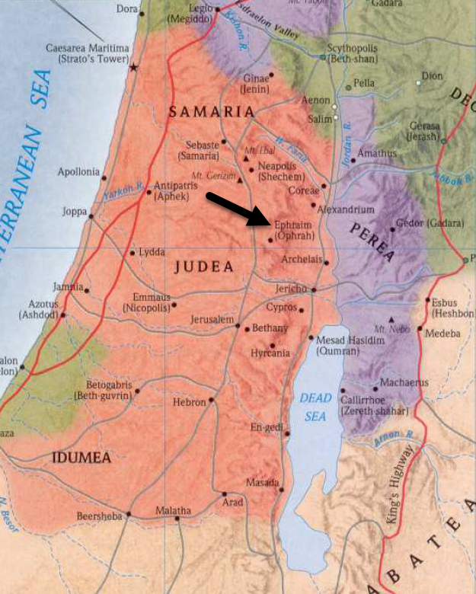

Joh 11:55 Now the Passover of the Jews was at hand, and many went up from the country to Jerusalem before the Passover to purify themselves.
Joh 11:56 They were looking for Jesus and saying to one another as they stood in the temple, “What do you think? That he will not come to the feast at all?”
Joh 11:57 Now the chief priests and the Pharisees had given orders that if anyone knew where he was, he should let them know, so that they might arrest him.
- In the springtime, the Passover was approaching and many Jews were traveling to Jerusalem to celebrate the feast.
- While the Jews were making sure they were ritually “clean” in order to participate in the Passover, they wondered whether Jesus would make an appearance at the feast.
- The Jewish authorities told the feast goers if anyone saw Jesus they were to report His whereabouts to them.

