JOHN 15

Joh 14:31 but I do as the Father has commanded me, so that the world may know that I love the Father. Rise, let us go from here.
Joh 15:1 “I am the true vine, and my Father is the vinedresser.
Joh 15:2 Every branch in me that does not bear fruit he takes away, and every branch that does bear fruit he prunes, that it may bear more fruit.

- At the end of chapter 14, Jesus tells His Apostles it is time to leave the upper room.
  - There is some debate about when the words of the upcoming chapters were spoken.
  - It may be Jesus spoke these words to the Apostles as they were walking to the Garden of Gethsemane where Jesus would be arrested.
- Jesus presents a new image/parable to the Apostles, God as a vine dresser, Himself as a vine, and His disciples as branches.
- If you have 5 minutes, I highly recommend the following YouTube video to you: https://www.youtube.com/watch?v=E-ltkKSxEy8
- I never realized how complex pruning could be.
  - Pruning involves cutting back up to 95% of the grape vines growth from the previous year.
  - Pruning allows the vinedresser to shape the branches (canes) of the vine as he/she likes.
  - The branches grow off of the vines trunk, which is the permanent part of the vine that grows down into the soil.
  - The vinedresser methodically cuts the branches from last year based on:
    - The shape the vinedresser wants the plant to take.
    - Which branches produced ideal grape yields.
    - Type of vintage desired.
    - Amount of leaf coverage/sun desired to ripen the grapes without burning them.
    - Whether or not the branch is strong enough to support the expected grape clusters.
    - How the cuts will impact the plant over the next few years.
  - 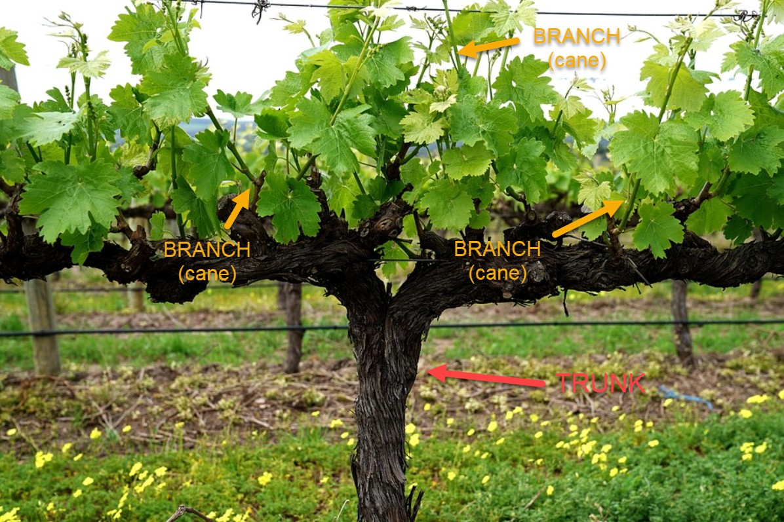
- The picture Jesus presents is God as the vinedresser, Him as the vine (trunk), and His disciples as the branches (canes).
  - When you understand a little bit about pruning, the meaning of the picture becomes clear.
  - If you own a vineyard or you are a vinedresser in charge of managing the vineyard’s crop, when pruning season comes around you aren’t going to leave branches on the vine which have proven unproductive. You are going to cut them off in their entirety.
  - The branches you are going to choose to keep are those which produced a good crop last year. You don’t keep the whole branch, you prune it back, and allow the new year’s growth to spring from those pruned branches.
  - The goal is to get a better and better crop every year.
  - *There are several different approaches to pruning and the specifics of the process vary slightly depending on the approach.*
- God and Jesus wanted productive, fruit bearing followers.
  - Fruitful in what way?
  - I think the idea is one of producing godly works.
  - Being a productive servant of God.
  - Growing (like a plant) into what God desires one to be.
  - In contrast to someone who isn’t growing, isn’t working, isn’t producing.

Joh 15:3 Already you are clean because of the word that I have spoken to you.

- A clean vine is one that has been pruned and any unproductive growth cut off.
- The Apostles had been undergoing this pruning process of Jesus shaping them through His teaching.
  - God had been pruning away their misconceptions about the Messiah.
  - He had been pruning away their misconceptions of what it looked like to please God. The Jewish religious leaders had come up with their own way of serving God and they had been promoting that way to the Jewish people but Jesus had been sent from God to reveal their unfruitfulness.
  - God had been pruning away their misconceptions of what it meant to be great in the Kingdom of Heaven (Jesus washing the Apostle’s feet, John 13).
- This picture of God’s people being part of a vine should not have been entirely new to the Apostles.
  - This imagery appears in the Old Testament.
  - The Jewish nation is described as a vine planted by God.
    - Isaiah 5:1-5
    - Psalm 80:8-16
    - The picture is one of a vine that initially flourished but then fell on hard times.
    - That picture paralleled the initial flourishing of the nation of Israel. For a time, they were faithful to God and God blessed them.
    - But before long, the nation turned its back on God and fell into ruin.
    - Jer 2:21 Yet I planted you a choice vine, wholly of pure seed. How then have you turned degenerate and become a wild vine?
- From a Jewish perspective, Jesus making Himself the vine, would have been a powerful lesson.
  - The Jewish nation wasn’t the source of spiritual life. Just being a child of Abraham wasn’t enough.
  - The Law of the Jews wasn’t the source of life (as the authorities suggested).
  - Jesus was the source of spiritual life.
  - This is a really important lesson which is going to be emphasized again and again throughout the New Testament.

Joh 15:4 Abide in me, and I in you. As the branch cannot bear fruit by itself, unless it abides in the vine, neither can you, unless you abide in me.
Joh 15:5 I am the vine; you are the branches. Whoever abides in me and I in him, he it is that bears much fruit, for apart from me you can do nothing.
Joh 15:6 If anyone does not abide in me he is thrown away like a branch and withers; and the branches are gathered, thrown into the fire, and burned.

- The branch must stay attached to the vine if it wants to produce a cluster of grapes.
  - If it is broken off from the vine by a windstorm, an animal, or some other force it isn’t going to have the nutrients it needs to bear fruit and it will be unproductive.
    - This is almost universal in the plant kingdom.
    - If you cut a branch off an oak tree it won’t be able to produce acorns.
    - If you cut a branch off an orange tree it won’t produce oranges.
    - The branch will die when separated from the tree/vine/bush.
  - If you are a vinedresser, you will gather up all of the unproductive branches, take them outside of the vineyard and burn them.
- You may already have made the spiritual application.
  - Those who want to serve God, grow in His Kingdom, and produce fruit must stay attached Jesus.
  - Jesus is the only source of life.
  - Only His words lead to eternal life.
  - There wasn’t any other spiritual source through which the Apostles could develop into who God wanted them to be.
  - If you think about it in a wider perspective:
    - Everything in the world is decaying and dying because of sin.
    - The world is passing away and will eventually be burned up (more on this later in the NT).
    - There is only one thing in this world that has life and is growing and won’t be burned up.
    - What is that thing?
    - Answer: The Kingdom of God, which is given life through Jesus.
  - Apart from Jesus, human beings “can do nothing” (verse 5).
    - Nothing lasting can be accomplished except through Jesus.
    - Anything done outside of the vine will not make it through the burning.
    - APPLICATION:
      - Think about how you can use your talents and hobbies in a more lasting way.
      - Instead of doing those things for personal benefit or personal pleasure, ask how Jesus can use them.
      - How you can use them to bear fruit and contribute to the Kingdom of God.
  - Anyone who doesn’t abide in Jesus, who attempts to make a life outside the vine, what will happen to them?
    - Same thing that happens to a branch cut off a tree.
    - The person will die outside of the source of eternal life.
    - They will be gathered up and burned (Hell, eternal separation from Jesus).
- Jesus is telling His Apostles where they can find life and warning them not to seek it somewhere else.
- They don’t want to be like their colleague Judas Iscariot who had just decided He wanted to try to find life outside the vine.

Joh 15:7 If you abide in me, and my words abide in you, ask whatever you wish, and it will be done for you.

- If the Apostles continued to abide in Jesus, God would grant “whatever” they asked.
- I think it is implied that Jesus would give them whatever they wished so long as it was within the will of God.
- The “whatever” here wasn’t meant as a blank check of infinite power.
- Jesus wasn’t a genie handing out wishes.

Joh 15:8 By this my Father is glorified, that you bear much fruit and so prove to be my disciples.

- God is glorified in the growth and multiplication of His children.
- When His children choose Jesus over all the offerings of the world it is a glory to God,
- Those children’s lives speak to the infinite worth of God when they turn their backs on a dying world and in their work to show others the supremacy of Jesus.

Joh 15:9 As the Father has loved me, so have I loved you. Abide in my love.
Joh 15:10 If you keep my commandments, you will abide in my love, just as I have kept my Father's commandments and abide in his love.

- There wasn’t/isn’t a deeper love than the love the Father had for Jesus.
- Jesus told the Apostles He loved them with the same love.
- Jesus communicated His love for His Father by keeping His commandments.
  - Remember what Jesus said at the end of chapter 14?
  - The devil had no claim on Jesus because Jesus had no love for the things of the devil.
  - But He intended to keep His Fathers commands so the world would know He loved the Father.
- Jesus instructs the Apostles to keep His commandments.
- By keeping Jesus’ instructions, they would abide in His love.

Joh 15:11 These things I have spoken to you, that my joy may be in you, and that your joy may be full.

- They needed to know about abiding in the love of Jesus the vine so their joy could be full.
- How incredible is it that Jesus is concerning Himself with the Apostles’ joy just hours before His death.
- He really did love them “to the end” (13:1)
- The Apostles could be full of joy even though Jesus was leaving them (at His ascension) because they knew how to abide in His love.
  - They weren’t going to be cut off from their friend when He physically left them.
  - This was unquestionably a concern for the Apostles, as will become obvious as we observe how they react following the crucifixion of Jesus.
- Jesus told them He had said these things to them so He could find His joy in them.
- God’s design had never been to spread the Kingdom by Jesus continuing His ministry on earth.
- He was leaving and entrusting the Kingdom to His Apostles.
  - Watching them successfully transition into that role while abiding in His love would be a source of joy for Jesus.
  - It was/is a pleasure for Jesus to watch His “little children” grow up to be the people He created them to be.

Joh 15:12 “This is my commandment, that you love one another as I have loved you.
Joh 15:13 Greater love has no one than this, that someone lay down his life for his friends.
Joh 15:14 You are my friends if you do what I command you.

- Jesus just told the Apostles to abide in His love by keeping His commandments, here He gives one of those commandments.
- “…love one another as I have loved you.”
- Certainly, if God can love human beings, as imperfect as we are, we can find it in our hearts to love one another.
- Jesus taught the Apostles to love one another by washing their feet in chapter 13, but He was about to teach an even more powerful lesson.
  - The greatest way a man can love another is by laying down His life for His friend.
  - Sacrificing ones life for the good of another.
- Why does Jesus bring this up here?
  - Because He is about to do this very thing for them.
  - The Apostles are His friends (wow) and He is going to die to save them.
  - SIDE NOTE: It would be pretty amazing to be walking beside the guy who created the Milky Way Galaxy and know He would call you His friend.
  - SIDE NOTE: Again, we will see Jesus practice what He was preaching. Other religions don’t have a god like Jesus.

Joh 15:15 No longer do I call you servants, for the servant does not know what his master is doing; but I have called you friends, for all that I have heard from my Father I have made known to you.

- Jesus calling the Apostles His friends was significant.
- A servant isn’t privy to everything going on in His master’s mind.
- A servant must follow his masters orders even if He doesn’t fully understand why he is being ordered to do a particular thing.
- But a friend is different.
  - The master will tell his friends his reasons for doing things.
  - They will know everything on the master’s mind.
  - Being a friend is a much more intimate relationship.
- The Apostles were now in the privileged position of being Jesus’ friends which meant He told them plainly of His work and God’s future plans.
- That wasn’t a privilege Jesus gave to everyone.
- The Apostles really were in a privileged group, even among Jesus’ followers.

Joh 15:16 You did not choose me, but I chose you and appointed you that you should go and bear fruit and that your fruit should abide, so that whatever you ask the Father in my name, he may give it to you.

- Jesus had selected these 11 men for the special role as an Apostle.
- They had a friend’s view into the work of God because they would be tasked with bearing fruit in God’s kingdom.
- The work they would accomplish would be lasting and permanent.
- Jesus permitted these men to “open the church” for lack of a better term.
- They, with the guidance of the Holy Spirit, would take the gospel to the world and preach the good news of Christ to the Jews and Gentiles.
- Jesus promises them empowerment for this work, first via the Holy Spirit, and second, by promising them God would incline His ear to hear their requests.

Joh 15:17 These things I command you, so that you will love one another.

- In light of all Jesus had just told them, they ought to love one another.
  - They were all connected to the same vine.
  - They drew life from the same source.
  - They were all united in friendship with Jesus.
  - They were all going to be redeemed by the death of Jesus.
  - They were all loved by God.
  - They would all receive the same Spirit.
  - They were all going to be employed in the same work.
  - They were all going to be pursing God’s glory by producing fruit.
  - They were going to be together following Jesus departure.
  - In light of all they shared… they were to love one another.
  - It wouldn’t make sense for them to do otherwise.
- APPLICATION:
  - Today, Christians are unified in all the same ways.
  - Does it make sense for Christians not to love each other?
  - It is unfortunate when Christians who share so much and ought to be a tight knit group of people, can’t find it in their hearts to love each other.
- APPLICATION:
  - It should be concerning when we find it easier to make friends outside the church than in the church.
  - Because Christians don’t share any of these things with people in the world.
  - What does it say about what our friendships are built on and what is important to us when our strongest friendships are void of all these things.
- APPLICATION:
  - What does it say about us when we don’t have any friends in the Church?
  - It may mean our congregation is more about meeting in a building once a week than it’s about bearing fruit.
  - Because if it were about bearing fruit, you would need your fellow Christians to get the work done.
  - You would love them and build relationships with them in order to get God’s work done.

Joh 15:18 “If the world hates you, know that it has hated me before it hated you.
Joh 15:19 If you were of the world, the world would love you as its own; but because you are not of the world, but I chose you out of the world, therefore the world hates you.
Joh 15:20 Remember the word that I said to you: ‘A servant is not greater than his master.’ If they persecuted me, they will also persecute you. If they kept my word, they will also keep yours.
Joh 15:21 But all these things they will do to you on account of my name, because they do not know him who sent me.

- These verses are pretty straight forward.
- Jesus had many enemies.
  - Not because He was a bad man.
  - But because He was the man the people needed.
- If many in the world hated Jesus who was perfect and sinless, the Apostles could be a certain the hatred of many would be directed at them as they worked in Jesus’ name.
- If the Apostles were more like the world, the world wouldn’t have a problem with them.
  - If you blend in, go along with the things the world supports, participate in the world’s sins, they will see you as one of their own.
  - Peter will fall for this temptation in the upcoming chapters.
  - He will deny knowing Jesus to blend in to the crowd and stay out of trouble.
  - He didn’t want anyone to recognize Him as a follower of Jesus.
  - APPLICATION:
    - The same temptation is present for modern Christians.
    - The temptation to drift more and more towards a resemblance to the world in order to avoid more and more difficulty from them.
- But Jesus hadn’t called the Apostles to blend in with the sinful world.
  - They were selected to boldly preach a message that would stir people up.
  - To tell people they were dead in their sins and needed Jesus to make them alive.
  - That wasn’t a message many wanted to hear.
  - The Apostles would be hated like Jesus because they would preach like Jesus.
  - If Jesus their perfect master wasn’t treated well, His imperfect servants couldn’t expect better.
- The reason they mistreated Jesus and were going to mistreat His disciples was because they didn’t know God.
  - The gospel’s enemies in the 1st Century opposed its preaching because they weren’t familiar with and didn’t love the God the Old Testament described to them.
  - The gospel’s enemies in the 21st Century oppose its preaching because they aren’t familiar with and don’t love the God the Old and New Testaments describe to them.
  - The gospel offends them because they don’t know their Creator and they don’t know their relationship to Him.
  - They don’t want to be told they are sinners in need of saving.

Joh 15:22 If I had not come and spoken to them, they would not have been guilty of sin, but now they have no excuse for their sin.
Joh 15:23 Whoever hates me hates my Father also.
Joh 15:24 If I had not done among them the works that no one else did, they would not be guilty of sin, but now they have seen and hated both me and my Father.
Joh 15:25 But the word that is written in their Law must be fulfilled: ‘They hated me without a cause.’

- These verses aren’t the easiest.
- What does Jesus mean, “If I had not come and spoken to them, they would not have been guilty of sin”?
  - Those who hated Jesus had certainly sinned before Jesus began His ministry.
  - Jesus even describes some of their past sins and condemns them for them.
- I think Jesus speaks here of a specific sin, namely the sin of rejecting the Christ, Him, the One sent from the Father.
  - This sin was comparatively greater than their others sins.
  - In part, because in rejecting Jesus they were rejecting the remedy to all other sins.
- The Jews are now inexcusable.
- They hated the One sent by the Father, which, in turn, meant they hated the Father who had sent Him.
- They had every reason to believe!
  - Jesus fulfilled all of the prerequisites of being the Messiah.
  - They had heard Jesus’ masterful command of the Law.
  - They had seen His miracles.
- Their rejection of this evidence was their condemnation.
- If Jesus hadn’t appeared to them and worked among them, their guilt would be less.
- But because they hated Jesus “without a cause” they condemned themselves.

Joh 15:26 “But when the Helper comes, whom I will send to you from the Father, the Spirit of truth, who proceeds from the Father, he will bear witness about me.
Joh 15:27 And you also will bear witness, because you have been with me from the beginning.

- The rejection of Jesus and God by so many Jews wasn’t going to hinder the divine plan.
- Jesus had all He needed in these 11 men and the Holy Spirit.
- The Holy Spirit would work alongside the Apostles to accomplish the spread of the gospel.
  - The Apostles would give their lives to the effort of bearing fruit for the glory of God.
  - The Spirit would assist them with knowledge, miraculous power, and spiritual guidance so the world would know they came in the name of Jesus.

