JOHN 18

Joh 18:1 When Jesus had spoken these words, he went out with his disciples across the brook Kidron, where there was a garden, which he and his disciples entered.
- The “brook Kidron” ran in the Kidron valley located between the high eastern wall of Jerusalem and the mount of olives.
- The images below show the location of the valley and the suggested location of Gethsemane.
- The second image was taken in the early 20th century and shows the topography of the area better than most modern photos because much of the land has been developed.
- 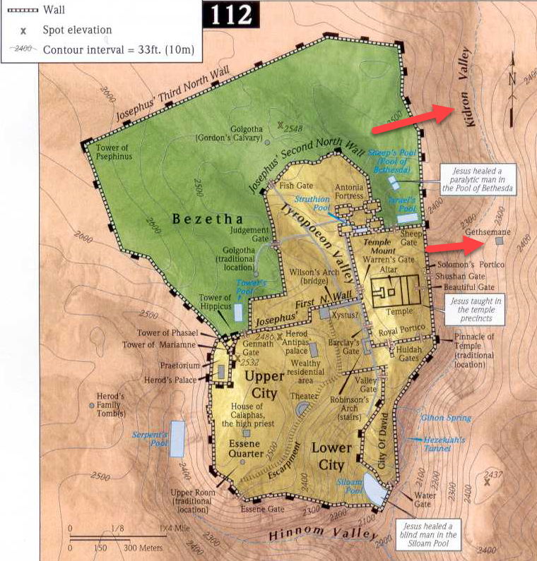
- 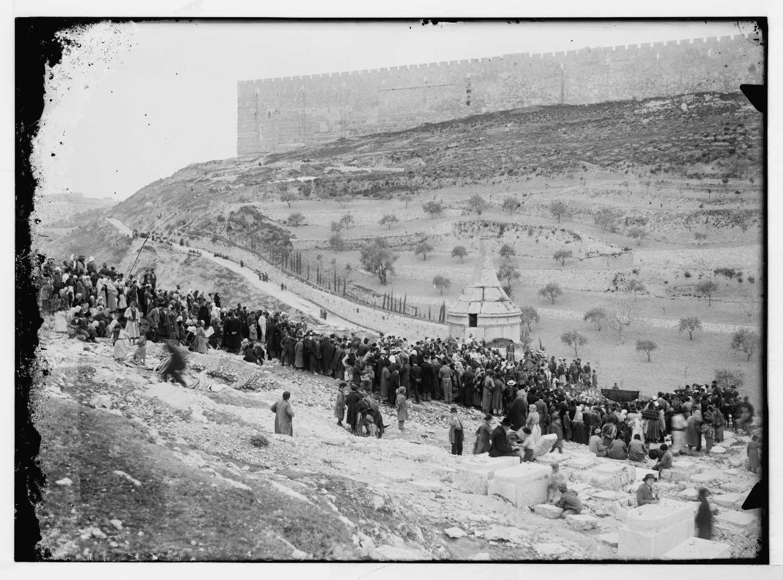
- Jesus would have descended out of Jerusalem and ascended back up the Mount of Olives.

Joh 18:2 Now Judas, who betrayed him, also knew the place, for Jesus often met there with his disciples.
Joh 18:3 So Judas, having procured a band of soldiers and some officers from the chief priests and the Pharisees, went there with lanterns and torches and weapons.

- It wasn’t uncommon for Jesus to take the disciples to the Garden of Gethsemane.
- Evidently, they had spent a lot of time there and Judas knew Jesus was planning to go there again following the Passover meal.
- While the 11 Apostles were with Jesus soaking up His teaching and hearing about their future work, Judas was discussing a work of his own with the people who hated Jesus’ teaching.
- Along with the chief priests, Judas gathered up some “soldiers and some officers” and went out in the night with lanterns, down into the valley and up the other side, to the place where Jesus was.
- Some people suggest a parallel between the Garden of Eden and the Garden of Gethsemane.
  - Adam and Eve were approached by Satan in the Garden of Eden and lost the spiritual trial.
  - Jesus (who the Bible calls the “second Adam”) is about to be challenged by Satan in the Garden of Gethsemane but He will win the spiritual confrontation.

Joh 18:4 Then Jesus, knowing all that would happen to him, came forward and said to them, “Whom do you seek?”
Joh 18:5 They answered him, “Jesus of Nazareth.” Jesus said to them, “I am he.” Judas, who betrayed him, was standing with them.

- Jesus, unsurprised by their arrival, went up to the soldiers and asked them who they were looking for.
  - They told Him, “Jesus of Nazareth.”
  - Jesus confirmed His identity to them.
- APPLICATION:
  - We don’t see Jesus running away or lying about who He was.
  - He patiently waited and prepared Himself through prayer to accomplish God’s work.
  - He could have run, spared Himself the discomfort and agony of the cross… but the world would never have hope of salvation.
  - Do you remember Jonah in the Old Testament who tried to run away from what God wanted him to do?
    - He didn’t want the Assyrians to be saved (they were evil).
    - So he attempted to run away from the mission God gave Him.
    - Jesus wanted all sinners to be saved.
    - His love kept Him from running away from the mission God gave Him.
    - Are we Jonah or are we Jesus?
      - Do we not really care if the world is saved?
      - Or do we really want to see everyone saved?
      - We can save ourselves some discomfort, maybe even some agony, if we don’t really care about people.
      - But if we really want to see the lost saved, we will have to face the discomfort of accomplishing the mission of God.
  - Christian avoidance of discomfort is detrimental to the Church’s growth and the spread of the Gospel.
  - For many Christians, their faith ends where comfort drops off.
  - They are willing to serve God up to the point they start to feel uncomfortable.
  - What if that was Jesus’ mentality?
  - We wouldn’t have a Savior!

Joh 18:6 When Jesus said to them, “I am he,” they drew back and fell to the ground.

- This detail is only recorded in the gospel of John.
- When Jesus told them “I am he” the soldiers fell to the ground.
  - Jesus’ words sent their small army to the ground.
  - I don’t know of another way to interpret this except as a miraculous force.
- The term Greek term translated “I am he” here is the same as the one translated “I am” in John 8:58 when Jesus claims the title of God. He may have spoken it with the same intention.
- This miracle was both a display of the power of God and the mercy of God.
  - Power:
    - No doubt a bit of fear filled the soldiers when this happened.
    - If Jesus could knock over a band of hearty soldiers with a word, it should have concerned them what other power He had.
  - Mercy:
    - Jesus made it clear He had power over them but He did not destroy them.
    - He hadn’t come to judge the world, destroy sinners, and send them straight to hell.
    - Instead, He surrendered to them to die for them.

Joh 18:7 So he asked them again, “Whom do you seek?” And they said, “Jesus of Nazareth.”
Joh 18:8 Jesus answered, “I told you that I am he. So, if you seek me, let these men go.”
Joh 18:9 This was to fulfill the word that he had spoken: “Of those whom you gave me I have lost not one.”

- I’m not sure verse 8 was as much a request as it was a statement of what was going to happen.
- Even with an army in front of Him, Jesus was the one calling the shots and His Apostles were not going to be arrested with Him.
- Jesus’ words, “let these men go” was specifically referring to the Apostles but are a shadow of His ultimate work.
- On the Day of Judgement at the end of time, when Christians stand before God, Jesus will tell Him “Let these men go! I died so they don’t have to.”
- Jesus’ words here affirm what He prayed in John 17:12, “Of those whom you gave me I have lost not one.”
  - Jesus had guarded and cared for the Apostles through His entire ministry.
  - Even in the last moments, He was still caring for them and protecting them.

Joh 18:10 Then Simon Peter, having a sword, drew it and struck the high priest's servant and cut off his right ear. (The servant's name was Malchus.)
Joh 18:11 So Jesus said to Peter, “Put your sword into its sheath; shall I not drink the cup that the Father has given me?”

- Jesus was protecting Peter from arrest when Peter decided to give them a reason to arrest Him.
- He drew out his sword (probably a short sword or a long dagger) and cut off the ear of the High Priest’s servant, whose name was Malchus.
  - Do you think Peter was aiming for Malchus’ ear?
  - He was probably aiming for his head and Malchus ducked.
- Peter’s actions show His very real convictions.
  - He was ready to die for his friend and for the Kingdom of God.
  - He may have had Jesus’ words in chapter 15 in mind when he reached for the hilt of his sword...
  - Joh 15:13 Greater love has no one than this, that someone lay down his life for his friends.
  - The problem was, he didn’t fully grasp how the Kingdom of God was going to be established and what Jesus was accomplishing by dying.
- Jesus told Him as much when He told him “Put your sword into its sheath; shall I not drink the cup that the Father has given me?”
  - The cup symbolized His death.
  - As if God had put this cup, this work, in front of Jesus and He had to drink from it even though it was bitter.
  - Similar to when we say something “is hard to swallow.”
    - Jesus uses the cup imagery in Luke’s gospel as well.
    - Luk 22:42 saying, “Father, if you are willing, remove this cup from me. Nevertheless, not my will, but yours, be done.”
  - Jesus didn’t want to go through the trial of death, but He would drink from the cup of pain and suffering if it was the only way to defeat Satan.
- SIDE NOTE: John’s gospel is the only gospel to reveal it was Peter who cut off the High Priest’s ear.
  - It is suspected the other gospel writers, who wrote before Peter’s death, excluded his name to protect him.
  - John’s gospel was probably written after Peter’s death so it was no longer necessary to keep him anonymous.

Joh 18:12 So the band of soldiers and their captain and the officers of the Jews arrested Jesus and bound him.
Joh 18:13 First they led him to Annas, for he was the father-in-law of Caiaphas, who was high priest that year.
Joh 18:14 It was Caiaphas who had advised the Jews that it would be expedient that one man should die for the people.

- Who were Annas and Caiaphas?
  - Joseph Caiaphas was appointed high priest by the Roman governor Valarius Gratus (governor before Pontus Pilate).
  - Before Caiaphas, Annas (Luke 3:1-2) was appointed High Priest of Judaea in 6 A.D. but was removed by the Romans in 15 A.D.
  - Although Annas had been removed, it is thought he still pulled many of the strings in the background (which explains why Jesus was taken to him).
  - Caiaphas was Annas’ son-in-law.
  - 5 of Annas’ sons would later succeed as high priests.
  - Caiaphas was removed by the Romans in 37 A.D.
- SIDE NOTE: The Law of God required the high priests to be descendant of the tribe of Levi.
  - In the 1st Century, this law was no longer being respected.
  - The Romans turned the position of High Priest into a position of political appointment for allies and those willing to pay the largest bribes.
  - It was time for a new High Priest.
  - The book of Hebrews is going to tell us how Jesus became the new High Priest.
- The fact that Jesus was brought to Annas first is a statement of how much power and influence he still had even though he “technically” had been removed from office.

Joh 18:15 Simon Peter followed Jesus, and so did another disciple. Since that disciple was known to the high priest, he entered with Jesus into the courtyard of the high priest,

- The other gospels tell us most of the Apostles fled when Jesus was arrested.
- Two disciples remained in the area.
  - Peter
  - An unnamed disciple who entered the courtyard of the High Priest.
    - Some suggest this was John.
    - Others suggest it couldn’t have been John because he was a Galilean and would have immediately been identified as a follower of Jesus.

Joh 18:16 but Peter stood outside at the door. So the other disciple, who was known to the high priest, went out and spoke to the servant girl who kept watch at the door, and brought Peter in.
Joh 18:17 The servant girl at the door said to Peter, “You also are not one of this man's disciples, are you?” He said, “I am not.”
Joh 18:18 Now the servants and officers had made a charcoal fire, because it was cold, and they were standing and warming themselves. Peter also was with them, standing and warming himself.

- Unlike the other disciple, Peter wasn’t known to the High Priest and stood outside the court.
- But the unnamed disciples had a word with the servant at the door and brought Peter into the courtyard.
- No doubt, it would have taken courage for Peter to draw his sword in the garden and additional courage for him to follow Jesus to the courtyard, but Peter’s courage was about to fall apart.
- The servant girl at the door asked Peter if he was one of Jesus’ disciples and Peter denied it.
  - This is the first of three denials which will fulfill Jesus’ prophecy in chapter 13 verse 38.
  - Joh 13:38 Jesus answered, “Will you lay down your life for me? Truly, truly, I say to you, the rooster will not crow till you have denied me three times.
  - You have to wonder if the other disciple heard Peter deny Jesus?
  - SIDE NOTE:
    - Set the scene:
      - Right before Jesus was taken for crucifixion He was in the Garden of Gethsemane with His Apostles.
      - Judas arrived and betrayed Jesus.
      - Peter worked up the courage to whip out His sword and was ready to go to battle with the band of soldiers who accompanied Judas.
      - Jesus told Peter to put the sword away because the sword wasn’t the way the Kingdom of God was going to be victorious.
      - No doubt, Peter was confused but put the sword back into its sheath.
      - Jesus is arrested and taken to the High Priest’s residence.
    - How did the Apostles respond?
      - They all fled out of fear.
      - With the exception of who?
      - Peter and “other disciple” mentioned in verse 15 (we don’t know if he was one of the 11 or another believer).
      - Mat 26:56 “…Then all the disciples left him and fled.”
      - Peter was confused, he didn’t know what is going on, but he worked up a little bit more courage and follows Jesus a little bit farther.
    - Peter followed Jesus to the courtyard of the High Priest and it was there He would commit a notorious sin of denying Jesus.
    - We often give Peter a really hard time for his sin.
    - But as I was thinking about the scene in John 18, I asked myself, “Who would I rather be and who would God rather me be?”
      - 1. The ones who ran away at the first sign of trouble.
      - 2. Or the one who was able to muster up a little bit more courage, have a little bit greater faith, follow a little bit longer…
        - And yes! He would fail spectacularly!
        - But he endured longer.
        - His faith carried him farther.
        - He displayed greater levels of courage.
    - Why is it that we are so hard on Peter?
      - The sins of the others aren’t highlighted nearly as much as Peter’s.
      - We don’t talk about their abandoning Jesus nearly as much as we talk about Peter’s denial.
      - Why does Peter get singled out here?
      - Why are we so quick to point our fingers at him as an example of someone who failed and yet hardly mention the others?
    - That is human nature, isn’t it?
      - If you quit with the majority, when you quit when everybody else says you should quit, when they are quitting because things are starting to get difficult, you aren’t going to be singled out.
      - You will just be one of the many who gave up with the rest.
      - But if you are one of the only ones to muster a bit more courage, to go on a little bit further, to step out a little bit more in faith, you’ll be out there on your own.
        - And people have a tendency to look at people like and point out their failures when they fall.
        - They love to look at those people and say, “I told you so!”
          - “Told you shouldn’t go out there.”
          - “I knew you shouldn’t have done that. Look what happened.”
          - “You should have stuck with the rest of us.”
        - Their sins are highlighted because they are alone.
    - Peter failed here, just like he did back in Matthew 14 when he tried to walk on the water, but his faith is admirable.
      - Why?
      - Because the others were back in the boat.
      - Here again, we see Peter having a little bit more faith and a little bit more courage than the others…
      - And yes, he failed just like the others in the end...
      - But who would you rather be?
      - Who would God rather you be?
    - Maybe, instead of viewing Peter as the giant failure of this situation, perhaps he is the one Jesus wants us to learn from.
      - He messed it up big time.
      - But at least he tried!
      - At least he pushed a little bit further.
      - God is able to work with those willing to try, but what is He going to do with people who give up at the first sign of trouble.
    - You can quit with the majority and not be singled out.
    - But I think I would rather fail with Peter than quit early with the others.
    - I may flop it and completely fail but we serve a God who is great at glorifying Himself even through our failures.
    - I can trust, if my faith is in Him, He can make everything alright in the end.
- Following Peter’s first denial, he entered the courtyard and gathered with the servants and officers around a fire to keep warm.
  - According to accuweather.com, average low temperatures at night in Jerusalem in April are around 48 degrees Fahrenheit.
  - Definitely cold enough to want to start a fire.

Joh 18:19 The high priest then questioned Jesus about his disciples and his teaching.
Joh 18:20 Jesus answered him, “I have spoken openly to the world. I have always taught in synagogues and in the temple, where all Jews come together. I have said nothing in secret.
Joh 18:21 Why do you ask me? Ask those who have heard me what I said to them; they know what I said.”

- Jesus is still with Annas as we turn our attention away from Peter and back to Jesus.
- Although not officially the High Priest, John gives him the title.
  - For all intents and purposes he was.
  - Although not recognized by Rome, the Jews may have continued to honor him with the title.
- Annas questioned Jesus about His disciples and His teaching.
  - He may have asked Him about His disciples picking grain on the Sabbath day.
  - Or why they didn’t wash their hands before they ate.
  - Etc…
- Whatever Annas asked Jesus, Jesus didn’t answer his questions directly.
  - In a way, He questioned why Annas was questioning Him.
  - Had He been secretive about His message?
  - Where His disciples told to sneak around at night to complete their clandestine assignments?
  - No!
  - Almost everything Jesus had done and taught had been done in a public way.
    - He taught in the streets and on hilltops and everyone was welcome to listen.
    - He even spoke directly to the Jewish officials on several occasions spanning back several years.
    - And Jesus knew the Jewish religious leaders had been fixated on Him for years. They knew exactly what He taught and had turned it over in their minds 100 times to try to find a way to trap Jesus in His words.
  - Jesus tells Annas as much.
    - “I have spoken openly to the world. I have always taught in synagogues and in the temple, where all the Jews come together.”
    - In Jewish life, the synagogues and the Temple were probably the most public places.
      - The synagogue the center of local Jewish community.
      - The Temple the center of global Jewish community.
    - Annas was questioning Jesus as if trying to extract secret information.
    - Jesus tells Him to go ask anyone who had heard Him teach.
    - There were thousands of people in Jerusalem that very day who had heard Jesus’ teaching.
  - Jesus was calling out Annas’ questioning out for what it was, a dishonest attempt to make it appears He was trying to ascertain the truth.

Joh 18:22 When he had said these things, one of the officers standing by struck Jesus with his hand, saying, “Is that how you answer the high priest?”
Joh 18:23 Jesus answered him, “If what I said is wrong, bear witness about the wrong; but if what I said is right, why do you strike me?”
Joh 18:24 Annas then sent him bound to Caiaphas the high priest.

- Jesus’ answer back to Annas was simple and true.
- But Annas and the Jewish elite weren’t interested in truth.
- One of the officers struck Jesus for what He perceived was a disrespect the High Priest.
- APPLICATION:
  - It isn’t wrong to offend someone with facts.
  - This officer responded in a ridiculous way when Jesus presented facts about the public nature of His message.
  - People will act in ridiculous ways when you present facts that they perceive as disrespecting someone or something they approve of.
  - This officer acts as if he is righteously offended.
  - And there will be people who act righteously offended when facts and truth are brought up to them.
  - And they will try to treat you like you’ve disrespected someone.
    - I think there are many Christians who have tender consciences who are affected when people tell them their presentation of truth was unloving.
    - They begin to question themselves as to whether they’ve done something wrong.
    - They will often back off of speaking truth in the future because some offended person told them they weren’t a very good Christian.
    - Jesus shows us here that truth takes a higher priority than offense.
      - Jesus knew He was going to get struck if He said what He said.
      - And He chose to prioritize truth over offense.
  - If you are going to eliminate offense from the world, you are going to have to live in a world without truth in it.
  - And no offense, but I’m not joining you in that world.
- The amount of self-restraint on Jesus’ part between verses 22 and 23 is incredible.
  - He could have struck the man back (or touched him) and killed him on the spot.
  - But He did come “…into the world to condemn the world, but in order that the world might be saved…” (John 3:17).
- Jesus’ response was very calm and measured.
  - “If what I said is wrong, bear witness about the wrong; but if what I said is right, why do you strike me?”
  - If He had said something factually wrong that deserved being struck He wanted to know.
  - But if not, He wanted to know why He had been hit.
  - Pretty fair question, right?
- But Jesus didn’t get the answer He requested.
  - They couldn’t tell Him what He had said wrong.
  - They didn’t have a real reason for hitting Him.
- Instead of answering, they sent Jesus away to Caiaphas.

Joh 18:25 Now Simon Peter was standing and warming himself. So they said to him, “You also are not one of his disciples, are you?” He denied it and said, “I am not.”
Joh 18:26 One of the servants of the high priest, a relative of the man whose ear Peter had cut off, asked, “Did I not see you in the garden with him?”
Joh 18:27 Peter again denied it, and at once a rooster crowed.

- The scene shifts back to Peter in verses 25-27.
- He was in the courtyard having already denied Jesus once when he was approached again about being Jesus’ disciple.
- He denied it again saying, “I am not.”
- A while later another person questioned Peter on the issue.
  - This questioner was a servant of the High Priest and a relative of Malchus, the temporarily earless man from the Garden of Gethsemane.
  - Evidently, he had been with Malchus in the garden and recognized Peter as his assailant.
- Peter denied it again and immediately the rooster crowd.
  - This fulfilled Jesus’ prophecy in John 13:38
  - Joh 13:38 Jesus answered, “Will you lay down your life for me? Truly, truly, I say to you, the rooster will not crow till you have denied me three times.

Joh 18:28 Then they led Jesus from the house of Caiaphas to the governor's headquarters. It was early morning. They themselves did not enter the governor's headquarters, so that they would not be defiled, but could eat the Passover.

- Scene goes back to Jesus.
- Jesus is taken from Caiaphas to Pilate (the Roman governor).
- Notice the time:
  - Jesus was arrested the night before.
  - The night has now past and it is “early morning.”
  - According to all the gospel accounts, Jesus made at least 3 appearances before Jewish officials that night.
    - Annas
    - Caiaphas
    - Herod
- The Jewish religious leaders did not enter Pilate’s headquarters because Jews normally did not enter the dwellings of Gentiles because of their traditions about ceremonial uncleanliness.
- A Jew who was unclean couldn’t eat the Passover.
  - But wait?!
  - Wasn’t the Passover already observed?
  - Remember, Jesus and His Apostles ate the Passover the night before.
  - So, why are the Jewish religious leaders concerned about being ceremonially clean to eat the Passover?
  - This is a tricky text and several theories have been proposed.
    - 1. Jesus ate the Passover with His Apostle’s a day early and then allowed Himself to be slain as the “Lamb of God” on the actual Passover day.
    - 2. The term “Passover” can refer to the specific day on which the lamb was eaten, but the term was also commonly used by the Jews when talking about the Passover day proper AND the 7 day feast immediately following the Passover, the Feast of Unleavened Bread (see Lev 23:5-6; Luke 22:1).
    - 3. The Jewish religious leaders delayed their Passover meal because they were organizing Jesus’ arrest and betrayal the night they were supposed to be remembering their deliverance from Egyptian slavery.
  - I personally like option 2 the best, followed by option 3, and I would rule out option 1 based on texts scattered throughout the gospels that suggest it is not a viable option.
- Can we take a moment and recognize the insanity of Jesus’ enemies.
  - They are so concerned with keeping the small details of the Old Testament Law and their traditions.
  - They stop before entering the governor’s headquarters in order that they may remain ceremonially clean to participate in Passover.
  - But they are, at the same time, lying about, abusing, slandering, and murdering an innocent man and their principles don’t stop them.

Joh 18:29 So Pilate went outside to them and said, “What accusation do you bring against this man?”
Joh 18:30 They answered him, “If this man were not doing evil, we would not have delivered him over to you.”
Joh 18:31 Pilate said to them, “Take him yourselves and judge him by your own law.” The Jews said to him, “It is not lawful for us to put anyone to death.”
Joh 18:32 This was to fulfill the word that Jesus had spoken to show by what kind of death he was going to die.

- Pilate came outside to them and asked them, as any reasonable judge would, “What accusation do you bring against this man?”
- They answered, “If He wasn’t guilty, would we have brought Him to you?”
  - If a prosecutor brought a man to court and told the judge, I want this man to be executed for his crimes, what would the judge ask?
  - “What did he do to deserve death and what evidence do you have?”
  - If the prosecutor responded, “I wouldn’t have brought him to you if he wasn’t guilty, just give him the death penalty,” the judge would probably throw the prosecutor out of his courtroom.
  - That is what the Jews were doing with Jesus.
- We know the Jews had their own court system and were able to pass their own judgements on religious matters.
  - Their council was known as the Sanhedrin.
  - Pilate confirmed their ability to do this when he said, “Take him yourselves and judge him by your own law.”
  - Although they were granted some judicial authority, they were evidently restricted from crucifying a convicted criminal without the conviction first being ratified by the governor.
  - This is why they brought Jesus to Pilate.
  - They wanted Him crucified, a particularly humiliating and painful death.
  - In doing having Him crucified they were fulfilling Jesus’ prophecies about His own death.
    - Mat 20:18-19 “See, we are going up to Jerusalem. And the Son of Man will be delivered over to the chief priests and scribes, and they will condemn him to death and deliver him over to the Gentiles to be mocked and flogged and crucified, and he will be raised on the third day.”
    - Joh 12:32 And I, when I am lifted up from the earth, will draw all people to myself.”
  - Pilate may have been in the habit of granting these requests without much thought, we don’t know, but we know Jesus’ conviction was of particular interest to him.
    - His wife had had a dream about Jesus and warned Pilate not to have anything to do with Him.
    - Pilate knew they had convicted Jesus because they were envious of Him (Mat 27:18).
  - He did not immediately grant the Jew’s request, instead he began questioning Jesus for himself.

Joh 18:33 So Pilate entered his headquarters again and called Jesus and said to him, “Are you the King of the Jews?”
Joh 18:34 Jesus answered, “Do you say this of your own accord, or did others say it to you about me?”

- Pilate took Jesus into the governor’s headquarters and asked Him what would have been an important question from his Roman perspective.
  - “Are you the King of the Jews?”
  - The Romans had already given power and governance to a man who claimed to be King of the Jews, Herod.
  - If Jesus claimed that title, the Romans might have a rebellion on their hands.
- Jesus doesn’t directly answer Pilate’s question.
  - He asks Pilate if he is asking because he had come to that conclusion or because others had told him about Jesus.
    - Had Pilate watched Jesus and concluded he was attempting sedition? (No)
    - Or was Pilate only asking because the Jews were screaming accusations outside? (Yes)
  - Jesus was asking him why he was asking.
    - Which I think was a round about way of reminding Pilate he didn’t have any evidence against Jesus.
    - He was only asking because of the screaming Jews outside His window.
    - And when Pilate previously asked them why they had brought Jesus, they responded, “We wouldn’t have brought Him unless He was guilty,” which is an accusation devoid of evidence.
    - Pilate had no evidence.
    - The Jews had no evidence.
  - SIDE NOTE:
    - Jesus didn’t give direct answers to a lot of people who questioned Him.
    - Some questions are phrased poorly.
    - Some questions are phrased to be a trap.
    - Some questions are false dilemmas.
    - Some questions have assumptions built into them.
    - Pilate wanted a yes or no answer from Jesus about whether He was King of the Jews, but Pilate was thinking about the “King of the Jews” in terms of a title of earthly authority.
      - If Jesus had said, “No,” He would have been lying because He was the King of the Jews in a spiritual sense.
      - If Jesus had said, “Yes,” Pilate could have interpreted Jesus’ answer as a threat to Roman rule.
    - Jesus didn’t answer Pilate’s question because it was constructed without a mature understanding of Jesus’ work.
    - Jesus was wise enough to answer the question with a question and get to the heart of the issue.
    - We should pray for similar wisdom to answer questions like Jesus (it isn’t an easy thing to do).

Joh 18:35 Pilate answered, “Am I a Jew? Your own nation and the chief priests have delivered you over to me. What have you done?”

- Pilate didn’t have any evidence against Jesus and when Jesus points that out to him, he deflects back to the Jews.
- “Am I a Jew?”
- “I don’t know why these people brought You to me. You tell me, what did You do to make them so angry?”

Joh 18:36 Jesus answered, “My kingdom is not of this world. If my kingdom were of this world, my servants would have been fighting, that I might not be delivered over to the Jews. But my kingdom is not from the world.”
Joh 18:37 Then Pilate said to him, “So you are a king?” Jesus answered, “You say that I am a king. For this purpose I was born and for this purpose I have come into the world—to bear witness to the truth. Everyone who is of the truth listens to my voice.”

- Pilate wanted to know if Jesus was a king and Jesus didn’t give him a yes/no answer.
- Now Jesus tells him He is a King but not in the sense Pilate had in mind.
- I think Jesus answered Pilate’s real question here.
  - Why did Pilate want to know if Jesus claimed to be a king?
  - Because how does one become a king?
  - A king has to gain power from somewhere.
  - If Jesus was going to gain power in Judaea He was going to have to take it away from the Roman empire.
  - And typically that happens through war.
  - Pilate wanted to know if Jesus was considering starting an uprising.
- Jesus relieved that worry by telling Pilate His kingdom wasn’t an earthly one.
- If it was, Jesus’ allies would have already turned to violence to deliver their leader from the hands of His Jewish accusers.
- Jesus confirmed to Pilate that He was a king.
- He was a king born into the world with the purpose of making truth known.
  - To overthrow the lying “ruler of this world.”
  - To set mankind free from slavery to sin.
  - To make the pathway to God clear.
  - Joh 8:32 and you will know the truth, and the truth will set you free.”
  - Joh 17:17 Sanctify them in the truth; your word is truth.
  - Joh 14:6 Jesus said to him, “I am the way, and the truth, and the life. No one comes to the Father except through me.

Joh 18:38 Pilate said to him, “What is truth?” After he had said this, he went back outside to the Jews and told them, “I find no guilt in him.
Joh 18:39 But you have a custom that I should release one man for you at the Passover. So do you want me to release to you the King of the Jews?”
Joh 18:40 They cried out again, “Not this man, but Barabbas!” Now Barabbas was a robber.

- It was to these words of Jesus that Pilate made his famous response, “What is truth?”
- It was that question that was on trial.
  - Pilate had the oppressive lies of Satan outside his quarter’s screaming for Jesus to be killed.
  - But then there was Jesus, claiming to be the world’s source of truth and with no evidence to against Him suggesting otherwise.
- APPLICATION:
  - If you know the end of this story, you’ll know it is easy to be hard on Pilate for making the wrong decision in the end.
  - But aren’t we all faced with this same decision at one or multiple times in our lives and don’t we often flop it like Pilate.
  - We have to choose to one side or the other.
    - Is truth really found in Jesus?
    - Or should I buy into the lies of Satan?
      - Pilate didn’t have any evidence to side with the Jews.
      - Do we have any good reason to buy into Satan’s lies, any evidence to suggest his way is the best way?
      - No!
      - But we still do it sometimes don’t we?
  - We are faced with Pilate’s decision all the time when temptation forces us to ask what is true and what isn’t.
- After asking his famous question, Pilate went out to the Jews and told them He couldn’t find any fault with Jesus.
  - At that point, He should have had Jesus released and chastised the Jews.
  - But he couldn’t commit to his conviction
  - APPLICATION:
    - There is a difference between being convicted and committing to your convictions.
  - He wanted to get out of the situation without having to side completely with one side or the other.
  - The Jews and Romans had a tradition to pardon one prisoner on Passover.
  - Pilate figured he could use this to his advantage.
    - He asked the Jews if they would rather pardon Jesus or Barabbas.
      - Matthew’s gospel calls Barabbas a “notorious prisoner.”
      - Marks gospel calls him a rebel and a murderer.
      - John calls him a robber.
    - By offering the Jews only the option between Jesus and a notorious criminal, Pilate likely thought there was no chance they would pick the notorious criminal.
    - But he was wrong.
    - His plan didn’t work.
    - He was going to have to take one side or the other.
    - APPLICATION:
      - We will all have to choose between God (truth) and Satan (lies).
      - There isn’t a third option.
      - You can’t ride the fence.
      - You must decide between one camp and the other and your choice will determine your fate.

https://en.wikipedia.org/wiki/Kidron_Valley
https://en.wikipedia.org/wiki/Annas
https://en.wikipedia.org/wiki/Caiaphas
https://www.accuweather.com/en/il/jerusalem/213225/april-weather/213225

