John 19

Joh 19:1 Then Pilate took Jesus and flogged him.
Joh 19:2 And the soldiers twisted together a crown of thorns and put it on his head and arrayed him in a purple robe.
Joh 19:3 They came up to him, saying, “Hail, King of the Jews!” and struck him with their hands.

- Dying by crucifixion was a terrible way to die, but most modern readers probably don’t realize most crucified criminals were half-dead by the time they reached the cross.
- In ancient Rome crucifixion was almost always preceded by the "flagrum" (flogging) and thus it made the vision of the crucified criminal all the more dreadful. Cicero called crucifixion the "extreme and ultimate punishment of slaves" (servitutis extremum summumque supplicium, Against Verres 2.5.169), and the "cruelest and most disgusting penalty." (crudelissimum taeterrimumque supplicium, ibid. 2.5. 165.) and Josephus called it "the most pitiable of deaths." (Jewish War 7:203.) (bible-history.com).
- The Roman scourge, also known as the “flagrum,” was a short instrument with a handle and 2 or 3 leather whips on the end.
  - On each whip were tied metal balls or animal bones
  - While the leather ripped the skin the metal balls created deep bruises.
  - The end of each whipped would sometimes include a hook, known as a “scorpion,” to hook and rip the flesh more violently (see the movie The Passion of the Christ).
  - 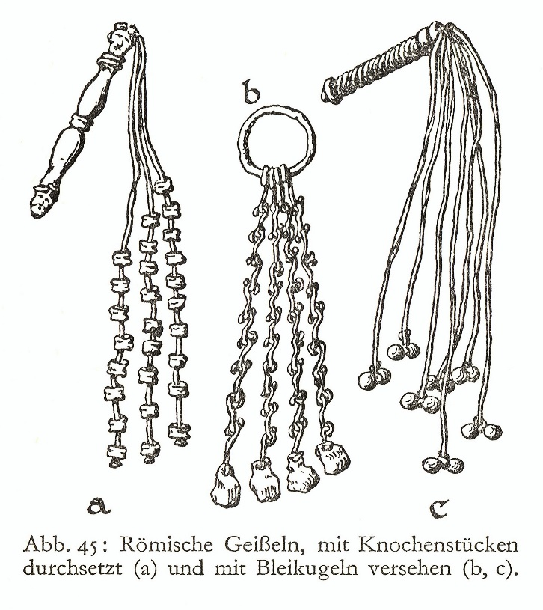
- The criminal was usually naked with his/her hands tied above their head.
- It wasn’t uncommon for people to die while being flogged.
- Pilate allowed his soldiers to dress Jesus up like a king and mock Him.
- They put a crown of thorns on Jesus’ head.
  - We don’t know for sure but many people believe the thorns came from the Euphorbia Milii.
  - Matthew 27 tells us they gave Jesus a reed as a mock scepter and used it to hit Him on the head which would have driven the thorns into His scalp.
- Just like the Jews, the Romans scoffed at the idea Jesus was a king.

Joh 19:4 Pilate went out again and said to them, “See, I am bringing him out to you that you may know that I find no guilt in him.”
Joh 19:5 So Jesus came out, wearing the crown of thorns and the purple robe. Pilate said to them, “Behold the man!”

- After having Jesus beaten, Pilate appeared before the Jews and told them he hadn’t found any reason to punish Jesus.
- He then brought Jesus out and showed them he had punished Him anyway.
- Why?
  - Why did Pilate have Jesus flogged?
  - It wasn’t because Jesus was guilty of anything but because Pilate was trying to escape the situation without committing to one side or the other.
  - Just like when he proposed the release of Barabbas, he thought he had found a third option that didn’t require releasing Jesus and infuriating the Jews or killing Jesus even though he knew He was innocent.
  - He thought if he declared Jesus innocence and then showed the Jews he had beat Him anyways, it would be enough to satiate the mob.
  - APPLICATION:
    - Pilate knew better than to flog Jesus, but he did it anyway to try to satisfy the people who were so vocally critical of him and Jesus.
    - He thought, if he did it, it would be enough to make them happy.
    - I think a lot of Christians and a lot of churches are tempted to give up a little ground to appease those who are vocally critical of them and Jesus.
    - They think if they just back off of a position or a doctrine a little bit it will be enough to satisfy their critics.
    - Was it in Pilate’s case?
    - We will find out in a few verses that it wasn’t.
    - And it won’t be in our case.
    - You aren’t going to be able to satisfy Satan.
    - He’ll be back to take more and more and more until he destroys you.
    - We have to decide whose side we are going to take.
      - There is no middle ground.
      - Pilate is trying to take the middle ground and he is quickly losing his footing on the slippery slope and sliding into the exact place the devil wants Him.
      - We need to plant our feet on God’s side and not give an inch.
- Pilate was hoping humiliating Jesus would be enough for the Jews and they would go back to their homes and enjoy their annual Feast of Unleavened Bread.

Joh 19:6 When the chief priests and the officers saw him, they cried out, “Crucify him, crucify him!” Pilate said to them, “Take him yourselves and crucify him, for I find no guilt in him.”

- When people are bent on doing evil, justice no longer matters to them.
- When they saw the humiliated state of Jesus it spurred them on to call for greater injustice.
  - APPLICATION:
    - Sin isn’t going to lead you to a world you want to live in.
    - A lot of people think it will.
    - Selfish people don’t care about justice unless it benefits/protects them.
    - If you have a society that doesn’t care about justice, it isn’t going to last very long and while it does last its going to be a miserable place to live.
    - I think that is why when sin becomes prevalent and begins to permeate a culture, things start to fall apart.
    - When foundational values like justice get tossed out the window it is only a matter of time.
- The Jews wanted Jesus crucified but they needed Pilate’s consent to do it.
- Pilate’s words, “Take him yourselves and crucify him, for I find no guilt in him” shouldn’t be understood as Pilate giving the Jews consent.
  - The Jews didn’t take it that way.
  - It suspect Pilate’s words should be read with a bit of sarcasm, as if he is mocking them.
    - He isn’t going to give them his Roman approval.
    - So he tells them to go do it themselves, knowing full well they are prohibited from doing it and implying the threat that he will bring the authority of Roman law down on them if they attempt it.
  - He may also have said this in an aggravated way.
    - Have you ever been frustrated with someone trying to get you to do something and responded, “Go do it yourself!”
    - I’ve responded that way to people even when I know they can’t do it themselves, which is why they are asking me to help.
    - It’s just an expression of aggravation.

Joh 19:7 The Jews answered him, “We have a law, and according to that law he ought to die because he has made himself the Son of God.”

- We find out from Luke 23, the Jews originally brought Jesus to Pilate suggesting he was a threat to Rome.
  - They said He was misleading the nation.
  - Stopping people from paying taxes.
  - And claiming to be a king.
  - Luk 23:2 And they began to accuse him, saying, “We found this man misleading our nation and forbidding us to give tribute to Caesar, and saying that he himself is Christ, a king.”
- Pilate has now evaluated those accusations and come to the conclusion Jesus isn’t guilty of any of it.
- Realizing they aren’t making any headway, the Jews appear to switch tactics in verse 7.
  - They move from accusations of sedition against Rome and tell Pilate Jesus needs to be put to death because He had broken the Jewish law.
  - They wanted Jesus dead because He claimed to be the Son of God.
  - They considered Jesus’ claim a blasphemy which was punishable by death according to verses like Leviticus 24:16.
    - Lev 24:16 Whoever blasphemes the name of the LORD shall surely be put to death. All the congregation shall stone him. The sojourner as well as the native, when he blasphemes the Name, shall be put to death.
  - The truth is, the Jews didn’t care a lick about people who wanted to undermine the Roman Empire.
  - They were all waiting around for a Messiah to do just that!
  - They accused Jesus of sedition because they thought it was their best shot to get Pilate’s approval.
  - When it failed, they threw some more mud at the wall.

Joh 19:8 When Pilate heard this statement, he was even more afraid.
Joh 19:9 He entered his headquarters again and said to Jesus, “Where are you from?” But Jesus gave him no answer.
Joh 19:10 So Pilate said to him, “You will not speak to me? Do you not know that I have authority to release you and authority to crucify you?”
Joh 19:11 Jesus answered him, “You would have no authority over me at all unless it had been given you from above. Therefore he who delivered me over to you has the greater sin.”

- I initially thought Pilate was afraid because “Son of God” was a title claimed by the Roman emperors.
  - Augustus claimed to be the son of God.
  - But the accusations of sedition had been put to rest at this point.
  - Even the Jews had moved on from those accusations.
- I think Pilate was afraid because he had begun to suspect Jesus was more than a poor fishing town Galilean.
  - It was probably impossible to interact with Jesus and not realize you were dealing with someone special.
  - And Pilate was not a man without a sense of right and wrong.
  - His struggle in determining what to do with Jesus makes that clear.
  - He was being manipulated by a mob into doing something he knew he shouldn’t do and the idea that Jesus was in some way affiliated with God or the gods was distressing to him.
  - If Pilate had any respect for and knowledge of the Roman gods, he would have known the stories about how gods came down to earth in human form.
  - The possibility of him mistreating one of those gods and being cursed forever would be enough to instill fear in any good polytheistic Roman.
- Pilate took Jesus back into his headquarters and began questioning Him about where He was from.
- Jesus didn’t respond.
- Pilate got frustrated with the silence and reminded Jesus he had the power to crucify Him or free Him.
  - But it wasn’t true that Pilate had the authority in himself to free or kill Jesus.
  - Pilate had authority only because God allowed Him to have it and because Jesus submitted to Pilate’s judgement in order to accomplish God’s work.
  - If you’ve read the other parts of the Bible, you’ll know it was pretty common for God to have to remind political leaders their power belonged to them only by His permission.
- The last line of Jesus’ statement in verse 11 isn’t the easiest to understand.
  - “You would have no authority over me at all unless it had been given you from above. Therefore he who delivered me over to you has the greater sin.”
  - “So, in light of the fact that you are in this position because God has put you in this position, the ones who delivered me to you have the greater sin.”
  - Pilate didn’t ask to be in this situation.
    - He was being asked to make a decision he didn’t want to make.
    - He hadn’t dragged Jesus into his court room with malicious intent.
    - He woke up one day to the Jews screaming outside wanting someone crucified.
    - But because it was his job, he had to pass judgement.
  - His guilt in this situation was not the same as the Jews who were accusing Jesus.
    - For years they had harbored hatred of Jesus.
    - They were now lying about Him.
    - They were intent on destroying Him at any cost.
    - And they were intentionally abusing the political system, a system they of all people should have known God governed, to destroy God’s Son.
  - The Jews were pressuring Pilate to make the wrong decision.
  - Without the Jews the temptation for Pilate to make the wrong decision wouldn’t even exist.
  - There is a difference between being thrown into a corrupt situation and making the wrong decision vs. being the creators and fuel behind the corruption.

Joh 19:12 From then on Pilate sought to release him, but the Jews cried out, “If you release this man, you are not Caesar's friend. Everyone who makes himself a king opposes Caesar.”
Joh 19:13 So when Pilate heard these words, he brought Jesus out and sat down on the judgment seat at a place called The Stone Pavement, and in Aramaic Gabbatha.
Joh 19:14 Now it was the day of Preparation of the Passover. It was about the sixth hour. He said to the Jews, “Behold your King!”
Joh 19:15 They cried out, “Away with him, away with him, crucify him!” Pilate said to them, “Shall I crucify your King?” The chief priests answered, “We have no king but Caesar.”

- Were the Jews really concerned with Pilate’s loyalties?
  - Were the Jews loyal to Caesar?
    - No!
  - Were the Jews loyal to the Messiah and their God?
    - No!
  - The Jews were only loyal to themselves.
- Pilate went out of his headquarters to a place called Gabbatha.
  - This was the location where the governor passed judgement on criminals.
  - The exact location of “The Stone Pavement” is still a mystery to archaeologists.
- Verse 14 reads, “Now it was the day of Preparation of the Passover. It was about the sixth hour…”
  - This verse doesn’t look difficult on the surface, but if you were with us for the Mark study and have a really sharp memory, you may notice the point of difficulty.
    - Mar 15:25 And it was the third hour when they crucified him.
    - Vs..
    - Pilate sat down on at the judgement seat about the sixth hour (John 19:13-14).
  - How do we reconcile these two texts.
    - There have been a significant number of resolutions proposed.
    - I would encourage you to look into some of the alternatives online.
    - In my opinion, the best suggestion to reconcile these two texts is that John is using the Roman way of telling time.
      - The sixth hour = 6am/6pm
      - The ninth hour = 9am/9pm.
      - The same way we keep time in the USA today.
    - John is not using the Jewish system utilized by Mark.
      - The sixth hour = 12am/12pm
      - The ninety hour = 3am/3pm
      - Etc.
    - I think it is possible John has been using the Roman system throughout his book.
    - To my knowledge, there are only three other specific hours mentioned in John.
      - Two of John’s disciples followed Jesus and spent the day with Him beginning around the 10th hour = 10am (John 1:39).
      - “Jesus, wearied as He was from His journey” met the Samaritan woman at the well at the 6th hour = 6pm (John 4:6).
      - Jesus healed the official’s son at the 7th hour = 7pm (John 4:52).
    - From what I can see, there are no problems with any of these texts if we assume John was speaking in Roman time instead of Jewish time.
    - Therefore, in John 19:14 Jesus was standing before Pilate “about the sixth hour” (6am, Roman time) leading up to His crucifixion at the Jewish 3rd hour (9am).
  - The second thing we need to establish is the time of the day of Preparation.
    - Keeping all the feast days in order in your head is difficult to do.
    - You can read about the feasts of the Jews in the books of Leviticus and Exodus along with several other locations scattered throughout the Old Testament.
    - *SEE THE CHART ON THE NEXT PAGE*
  - 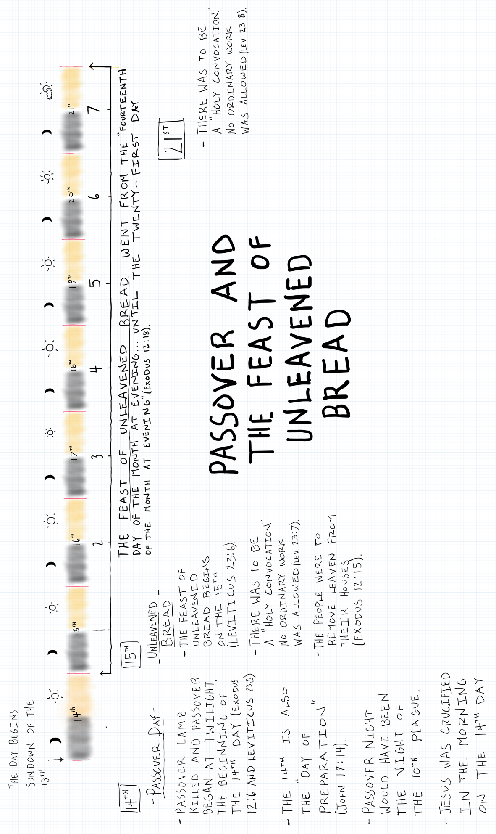
- Pilate brought Jesus out to the Jews and presented Him as their king.
- The Jews responded by proclaiming their sole allegiance to Caesar, which Pilate would have known was a complete lie.
- They didn’t care what they had to say so long as it rid them of Jesus.
- SIDE NOTE:
  - The timing of Jesus death was not a convenient accident and is proof of the Bible’s divine inspiration.
  - What are the chances the “Lamb of God” (Jesus) whose blood would save the world from the wrath of God would die the same night the Jews were memorializing their salvation from Egypt and how they were saved from the wrath of God by the blood of a lamb?
    - The chances are really slim.
    - But the orchestration of Jesus’ death wasn’t left up to chance.
    - God organized all of the details to fulfill shadows and pictures He gave in the Old Testament.
    - The original Passover feast was created to give the Jews a picture of a greater freedom that was coming in the future.
  - God organized these details over a period of hundreds of years and now we have the privilege to look back at His work in wonder.

Joh 19:16 So he delivered him over to them to be crucified. So they took Jesus,
Joh 19:17 and he went out, bearing his own cross, to the place called The Place of a Skull, which in Aramaic is called Golgotha.

- This is what giving into temptation looks like.
  - Satan and the Jews wore Pilate down.
  - He grew weary in fighting for what was right.
  - 2Th 3:13 As for you, brothers, do not grow weary in doing good.
  - He takes the easy road and falls in line with the world.
  - APPICATION:
    - This is a similar to the offer the devil makes to us.
    - Stop living as part of the minority.
    - Stop fighting your desires.
    - Stop denying yourself.
    - Stop supporting things that are going to make people dislike you.
    - You don’t need to wake up and fight a war every day, you can be at peace here and now.
    - You don’t have to wear yourself out serving God.
    - Just join us and your life is going to get a lot easier!
    - There is a scene in the movie Jason and the Argonauts that illustrates what this looks like:
      - Jason and the argonauts are on a quest to find a golden fleece.
      - One of the first stops they make on their journey is the island of Lemnos.
      - Lemnos is an island populated entirely by beautiful women.
      - The argonauts quickly become enchanted by the women, finding themselves girlfriends, and finding reasons not to leave.
      - The women employ all kinds of tactics to keep them there enjoying the wine and pleasure.
      - They are faced with the choice of sailing off into a rough sea with little food, a damaged boat, and facing the discomfort and danger of the unknown or staying on an island full of attractive women, with plenty of food, and no immediate danger.
      - But if they stay, they will never complete their quest.
      - God and Jesus are very clear that the quest given to Christians is going to be hard, going to be dangerous at times, but it is necessary and the greatest purpose any human being can employ themselves in.
      - Satan is going to try to convince you to stay on Lemnos and abandon the quest God gives you to enjoy the pleasure and ease union with the world offers.
  - APPLICATION:
    - The wording of verse 16 is noteworthy, “he [Pilate] delivered him [Jesus] over to them.
    - Aren’t we tempted to do the same thing?
    - Give Jesus up to make friends with the world.
- Jesus carried His own cross to the place of crucifixion, at least part of the way.
  - Mark’s gospel tells us a man, Simon of Cyrene, was made to carry Jesus’ cross part of the way.
  - Cyrene was a city of North Africa
  - Simon was probably in Jerusalem for the Passover celebration.
  - 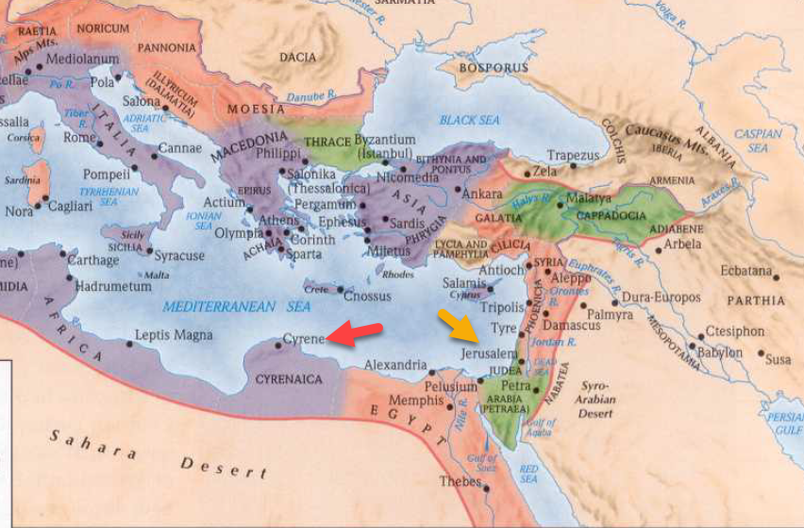
  - You can imagine the pictures of crosses you’ve seen in crucifixes or history books and how heavy they must have been.
  - The whole cross probably weighed over 300lbs.
  - The crossbeam which many of the condemned were made to carry was likely 100lbs.
  - That may not have been an impossible burden for Jesus on a healthy day but after the sleepless night, scourging, and other abuses, it would have felt like a 1,000lbs.
- Although no one knows the exact location of Golgotha with 100% certainty, there is a commonly accepted location just outside the wall of Jerusalem.
  - 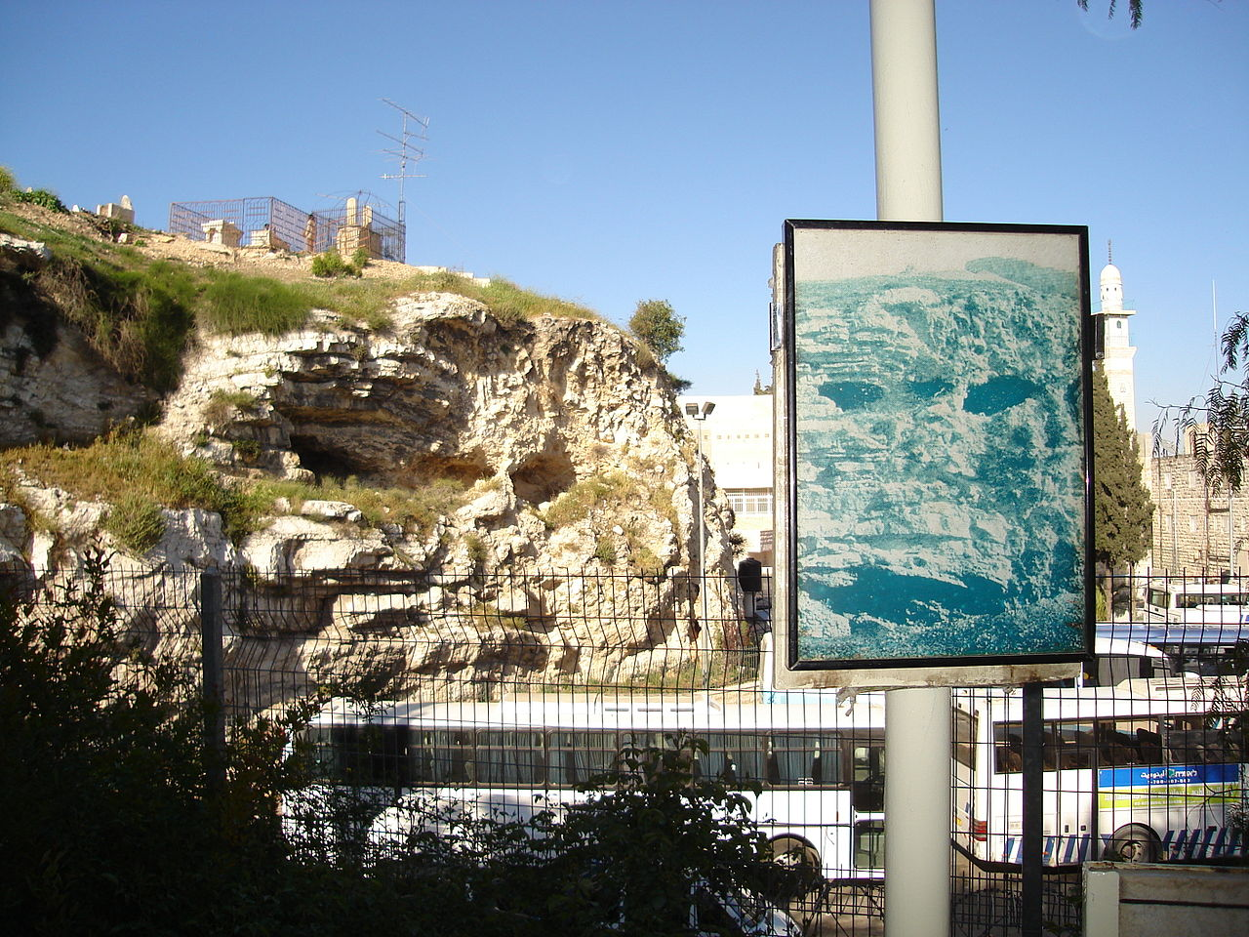
  - The identification of the location is attributed to Constantine’s Mother, Helena, in 325, but her information probably came from local people who were familiar with the area.
  - Queen Mother Helena spent her later years searching out important biblical locations and Christian relics.

Joh 19:18 There they crucified him, and with him two others, one on either side, and Jesus between them.

- Crucifixion was a form of capital punishment.
- It involved tying or nailing a criminal to a wooden cross and elevating them in the air in sight of passersby.
- It was a very humiliating death and was meant to dissuade onlookers from participating in the crimes of the accused.
- The term “crucifixion” could refer to a number of different execution styles:
  - Being hung or nailed on a cross beam (like Jesus).
  - Being nailed to a tree.
  - Being nailed to a upright pole with your hands tied above your head.
  - Being impaled on a wooden stake.
  - Seneca the Younger wrote, “I see crosses there, not just of one kind but made in many different ways: some have their victims with head down to the ground; some impale their private parts; others stretch out their arms on the gibbet."
  - 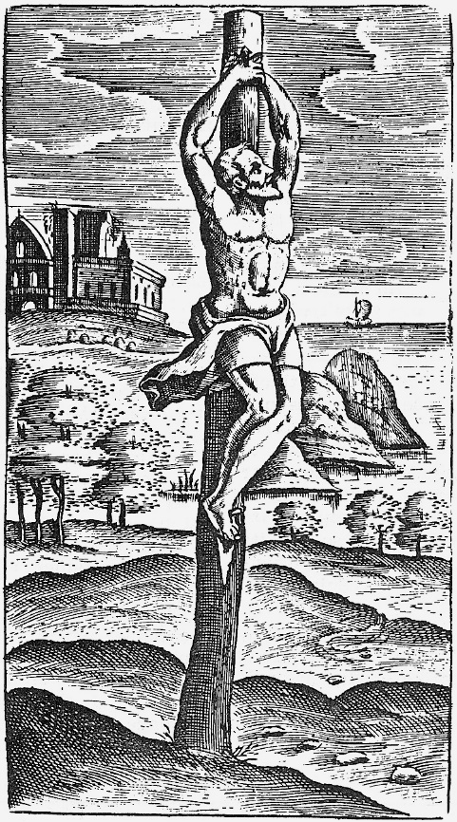
- Modern depictions of crucifixion are often inaccurate in their details.
  - Those crucified were usually stripped naked.
  - The nails piercing the hands of the crucified individual were probably not in the palms of the hands as often pictured.
    - The Greek word translated “hands” in John 20:25 can refer to any part of the forearm from the elbow to the fingertips.
    - It is thought the palms of a person’s hands would be insufficient to support the weight of the body.
  - Jesus’ hands and feet may not have both been nailed to cross before He was hoisted into the air.
    - It was common for the victim to be nailed to the crossbeam (patibulum) first (through the hands) and then to be hoisted on to the vertical beam.
    - It was then the feet were nailed.
    - “Once the victim is secured, the guards lift the patibulum and place it on the stipes already in the ground. As it is lifted, Jesus’ full weight pulls down on His nailed wrists and His shoulders and elbows dislocate (Psalm 22:14). In this position, Jesus’ arms stretch to a minimum of six inches longer than their original length” (www.apu.edu, The Science of the Crucifixion).
  - Those condemned were sometimes responsible for carrying their own cross.
- They were given a “titulus” which was a sign bearing the name of the condemned and the committed crime.
- How long a person remained on a cross before their death depended on a number of variables:
  - Their physical condition.
  - How badly they had been flogged.
  - Whether they were tied or nailed and the position of their body.
  - Whether the attending soldiers expedited their death:
    - This was done by breaking the legs of the person of the condemned to keep them from lifting themselves up to breath.
    - A spear stabbed into the heart.
    - Soldiers lighting a fire at the base of the cross so the smoke would suffocate the victim.
- Some people hung on the cross for a few hours.
- Some people hung on the cross for days.

Joh 19:19 Pilate also wrote an inscription and put it on the cross. It read, “Jesus of Nazareth, the King of the Jews.”
Joh 19:20 Many of the Jews read this inscription, for the place where Jesus was crucified was near the city, and it was written in Aramaic, in Latin, and in Greek.
Joh 19:21 So the chief priests of the Jews said to Pilate, “Do not write, ‘The King of the Jews,’ but rather, ‘This man said, I am King of the Jews.’”
Joh 19:22 Pilate answered, “What I have written I have written.”

- Jesus’ “titulus” reads, “Jesus of Nazareth, the King of the Jews.”
  - His name – Jesus of Nazareth
  - His crime – King of the Jews
- In the Old Testament, the Jews had rejected God as their king.
- Instead, they requested a human king.
- Over the next 1,000 years the Jewish nation fell into ruin.
- But when offered another opportunity, they reject God again.
- They didn’t want Jesus as the King of the Jews.
- They didn’t want to give God His throne back.
- The Kingdom of Heaven that Jesus talked so much about, especially in Matthew’s gospel, is for those who do want God as their king.
  - Those who look back at the Old Testament and learn from it.
  - Learn that God is the one and only capable king.
- The Jews objected to Pilate’s description of Jesus’ crime.
  - They wanted it adjusted to say, “This man said, I am the King of the Jews.”
  - It’s interesting that what Pilate wrote was true.
  - He was the king of the Jews and it was for that reason they were killed Him.
  - Like their fathers, they wanted another king.
- Pilate refused to change what he had written.

Joh 19:23 When the soldiers had crucified Jesus, they took his garments and divided them into four parts, one part for each soldier; also his tunic. But the tunic was seamless, woven in one piece from top to bottom,
Joh 19:24 so they said to one another, “Let us not tear it, but cast lots for it to see whose it shall be.” This was to fulfill the Scripture which says, “They divided my garments among them, and for my clothing they cast lots.” So the soldiers did these things,

- Apparently the belongings of the crucified person went to the soldiers who did the crucifying.
- They took Jesus’ garments and divided them 4 ways.
- But when they noticed His tunic didn’t have seams, they decided not to tear it.
  - Instead the cast lots for it
  - Casting lots may have been similar to drawing straws or rolling dice.
- Jesus tunic:
  - Jesus’ tunic was unique in that it was seamless.
  - Most tunics in those days had a seam and were made by sowing pieces of cloth together.
  - Was there any significance in Jesus’ tunic.
  - Perhaps.
  - Jesus’ garment was similar to another prominent Jew’s garment, the High Priest.
    - 1. Seamless garment.
      - Josephus writes about the High Priest’s garment in Antiquities 3.159.
      - “Now this vesture was not composed of two pieces, nor was it sewed together upon the shoulders and the sides, but it was one long vestment so woven as to have an aperture for the neck;”
    - 2. Garment wasn’t torn.
      - Jesus’ garments weren’t torn and the High Priest’s garments were not to be torn.
      - Lev 21:10 “The priest who is chief among his brothers, on whose head the anointing oil is poured and who has been consecrated to wear the garments, shall not let the hair of his head hang loose nor tear his clothes.
  - The idea of Jesus as a High Priest will be presented more fully in the book of Hebrews but John may be alluding to it here by including these details.
- The casting lots and division of Jesus’ garments had been prophesied in the book of Psalms.
- Psa 22:18 they divide my garments among them, and for my clothing they cast lots.
- SIDE NOTE:
  - There is an interesting parallel between the tree in the garden of Eden and Adam’s nakedness bringing about shame and the tree (cross) on Golgotha and Jesus’ nakedness taking away our shame.

Joh 19:25 but standing by the cross of Jesus were his mother and his mother's sister, Mary the wife of Clopas, and Mary Magdalene.
Joh 19:26 When Jesus saw his mother and the disciple whom he loved standing nearby, he said to his mother, “Woman, behold, your son!”
Joh 19:27 Then he said to the disciple, “Behold, your mother!” And from that hour the disciple took her to his own home.

- Matthew records the names of three specific women present at the scene:
  - Mary Magdalene
  - Mary, mother of James and Joseph (Joses)
  - Zebedee’s wife, mother to of James and John.
  - It also mentions “many women” were there who had followed and ministered to Jesus in Galilee.
- John and Mark’s gospel give us a bit more information.
  - Mark 15:40 another woman named Salome was present.
  - John 19:25 records the presence of Jesus mother, her sister (Jesus aunt), and Mary the wife of Clopas.
  - *There may be some overlap between the characters. The gospels may all be describing distinct people or may be describing the same people in unique ways.*
- It is difficult to imagine how horrible this scene would have been for them to observe.
- Here we see Jesus caring for other people even while He is in intense agony.
  - He wanted to ensure His mother was cared for after His death.
  - This is part of the reason most people believe Joseph, Jesus’ father, was dead.
  - Jesus entrusts the care of His mother to the disciple “whom He loved” (John) and from that day on she lived with him.
- SIDE NOTE:
  - It is interesting to me to think about all the things John learned from Mary about Jesus and His upbringing but didn’t record in his book.
  - It goes to show us the Holy Spirit wanted the readers of the Bible to focus on the important facts of God’s plan to redeem men.
  - The Bible was never intended to be a book to satisfy all our curiosities.
  - If it were, it would probably spend less time talking about genealogies and more time talking about dinosaurs.

Joh 19:28 After this, Jesus, knowing that all was now finished, said (to fulfill the Scripture), “I thirst.”

- Some time later, when Jesus knew He had accomplished almost all the work He had intended, He said, “I thirst.”
- John tells us He said this to fulfill a scripture.
  - But what scripture?
  - It may be Psalm 22:15. There are several passages in Psalm 22 that relate to the crucifixion, including the opening verse of the Psalm.
    - Psa 22:15 my strength is dried up like a potsherd, and my tongue sticks to my jaws; you lay me in the dust of death.
  - Jesus may also have been referencing Psalm 69:21.
    - Psa 69:21 They gave me poison for food, and for my thirst they gave me sour wine to drink.

Joh 19:29 A jar full of sour wine stood there, so they put a sponge full of the sour wine on a hyssop branch and held it to his mouth.
Joh 19:30 When Jesus had received the sour wine, he said, “It is finished,” and he bowed his head and gave up his spirit.

- The drink given to Jesus was probably posca.
- Posca was a mixture of wine vinegar (made from poor quality wine or wine gone bad) and water and was very common in the Roman army.
- Sometimes herbs were added for taste.
- Posca was only drunk by the lower classes but there were occasions when generals and emperors would drink it to show solidarity with their soldiers.
- The drink is well attested to by ancient historians including Celsus and Suetonius.
- A possible recipe:
  - 2 tbsp red wine vinegar.
  - 250ml/1 cup of water.
  - Herbs to taste.
- Some of this wine was offered to Jesus via a sponge on a hyssop branch.
- After tasting the sour wine, Jesus said, “It is finished,” bowed His head, and died.
  - He had repeatedly told His followers He had come to do His Father’s will.
  - It was God’s will and Jesus’ desire to be a sacrifice for people’s sins.
  - To make it possible for people to have eternal life with God.
  - Sin demanded a punishment.
  - Jesus took the punishment on Himself and now all people who believe in Jesus and are “in Him” benefit by being forgiven.
  - Jesus saved us by not saving Himself from the cross.
- And now, it was finished.
- The work complete.
- 33 years culminating in a cross.
- The Lamb’s blood was spilled so that the wrath of God could passover them.
- Jesus had:
  - made a “way” to God (John 14:6).
  - opened the “door” to eternal life (John 10:9).
  - acted as the “good shepherd” laying down His life for the sheep (John 10:11).
  - become the life giving “vine” (John 15:1).
- Jesus still had work to do on earth (we can’t forget about the resurrection) but I think it is safe to say the hardest part was over.

Joh 19:31 Since it was the day of Preparation, and so that the bodies would not remain on the cross on the Sabbath (for that Sabbath was a high day), the Jews asked Pilate that their legs might be broken and that they might be taken away.

- As we mentioned earlier, it wasn’t uncommon for Roman soldiers to break the legs of those who had been crucified to expedite their death.
  - If their legs were broken, they would have a harder time pushing themselves up to exhale the air in their lungs.
  - “Normally, to breathe in, the diaphragm (the large muscle that separates the chest cavity from the abdominal cavity) must move down. This enlarges the chest cavity and air automatically moves into the lungs (inhalation). To exhale, the diaphragm rises up, which compresses the air in the lungs and forces the air out (exhalation). As Jesus hangs on the cross, the weight of His body pulls down on the diaphragm and the air moves into His lungs and remains there. Jesus must push up on His nailed feet (causing more pain) to exhale” (www.apu.edu, The Science of the Crucifixion).
- The Jews approached Pilate and asked Him to permit this brutal form of mercy.
- Jesus was crucified on the Day of Preparation (the 14th) and the Jews wanted the bodies off the cross before the high Sabbath beginning at sundown (the 15th).
- Take another look at the Feast of Passover and Unleavened Bread chart we went over earlier in the chapter.
  - The 15th day of the month was the first day of the Feast of Unleavened Bread.
  - There was to be a “holy convocation” on the 15th day and no work was to be performed.
  - So the Jews needed the criminals to come off the cross before sunset.

Joh 19:32 So the soldiers came and broke the legs of the first, and of the other who had been crucified with him.
Joh 19:33 But when they came to Jesus and saw that he was already dead, they did not break his legs.
Joh 19:34 But one of the soldiers pierced his side with a spear, and at once there came out blood and water.

- Pilate gave the Jews his permission and the soldiers began breaking legs.
  - The first criminal’s legs were broken.
  - The second criminal’s legs were broken.
  - But there was no need to break Jesus’ legs because He was already dead.
- In order to ensure Jesus was dead, the soldier took a spear and pierced Jesus’ side, probably driving the spear all the way to His heart.
- No doubt this was a common practice, especially considering an assigned Roman guard wasn’t allowed to leave their post until crucified individuals were confirmed dead.
- There is a good scientific explanation for the blood and water.
  - If the heart was pieced the source of blood is obvious.
  - The water may have come from the pericardium.
    - The pericardium is a sac that encloses and protects the heart.
    - 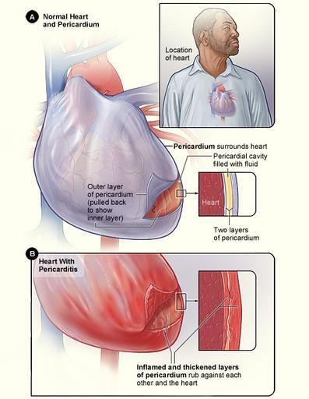
    - Certain factors can cause dangerous fluid buildup in the pericardium, this is known as pericardial effusion.
    - “Pericardial effusion (per-e-KAHR-dee-ul uh-FU-zhun) is the buildup of excess fluid in the sac-like structure around the heart (pericardium). The pericardium has two layers. The space between the layers normally contains a thin layer of fluid. But if the pericardium is diseased or injured, the resulting inflammation can lead to excess fluid. Fluid can also build up around the heart without inflammation, such as from bleeding after a chest trauma” (Mayo Clinic).
  - If a soldier pierced Jesus’ heart the fluid from the pericardium and the blood from the heart would have flowed out.
- A lot has been made of these two liquids by Bible interpreters.
  - Many suggest they symbolize spiritual truths.
    - Some say water represents baptism and blood represents the Lord’s Supper.
    - Some say water represents life and blood represents redemption.
  - Personally, I’m not certain if they symbolize anything, or if they do, what they symbolize.
  - I’ve not been seen a strong enough connection them and any spiritual parallel.
  - Although I will admit blood and water are the two most important liquids in the Biblical text.

Joh 19:35 He who saw it has borne witness—his testimony is true, and he knows that he is telling the truth—that you also may believe.
Joh 19:36 For these things took place that the Scripture might be fulfilled: “Not one of his bones will be broken.”
Joh 19:37 And again another Scripture says, “They will look on him whom they have pierced.”

- In verse 35, John reaffirms the truth of things he is writing in his gospel.
  - John was an eye witness to these events.
  - He was with Jesus’ mother as Jesus was dying.
  - This wasn’t hearsay.
- The soldiers not breaking Jesus’ legs was significant because it paralleled God’s instructions about the Passover lambs.
  - When God told the Israelites (Jews) how to keep the Passover 1500 years earlier in Egypt, part of His instruction was that the Passover lamb’s bones weren’t to be broken.
  - Exo 12:46 It shall be eaten in one house; you shall not take any of the flesh outside the house, and you shall not break any of its bones.
  - It is therefore significant that Jesus’ bones weren’t broken in the process of Him dying.
  - It is one more foreshadowing picture from the Old Testament we see fulfilled in Jesus’ death.
- John then references another scriptural fulfillment from the Old Testament.
  - “They will look on him whom they have pierced.”
  - Zechariah 12:10 “And I will pour out on the house of David and the inhabitants of Jerusalem a spirit of grace and pleas for mercy, so that, when they look on me, on him whom they have pierced, they shall mourn for him, as one mourns for an only child, and weep bitterly over him, as one weeps over a firstborn.
- We need to take a minute and appreciate all of the Old Testament scriptures and prophecies that describe Jesus.
  - In the moment when it appears Jesus might have lost control (when He dies) prophecies are still being fulfilled that prove He is in control.
  - And it is important to keep in mind, the men who were part of the fulfillments, the Jewish authorities, Pilate, the Roman soldiers, they were bringing about the fulfillments without knowing it.
  - These weren’t Jesus’ friends.
  - These were Jesus’ enemies.
  - It is a display of the power of God that He can bring about His will even through those who think they are resisting His will!

Joh 19:38 After these things Joseph of Arimathea, who was a disciple of Jesus, but secretly for fear of the Jews, asked Pilate that he might take away the body of Jesus, and Pilate gave him permission. So he came and took away his body.
Joh 19:39 Nicodemus also, who earlier had come to Jesus by night, came bringing a mixture of myrrh and aloes, about seventy-five pounds in weight.

- We are here introduced to a new disciple, Joseph of Arimathea.
  - He was a follower of Jesus but he kept it a secret because he feared the Jews.
  - The Jewish authorities had power to do significant damage to people’s spiritual life, communal life, and probably their business life.
  - We know Joseph wasn’t the only secret disciple.
  - Matthew 27 informs us Joseph was rich and he owned the tomb in which he laid Jesus.
  - Luke 23:50 says he was a member of “the council,” which is probably a reference to the Sanhedrin (the Jewish council comprised of Pharisees and Sadducees).
- We are also here reintroduced to significant Jewish character, Nicodemus.
  - Remember Nicodemus from chapter 3?
  - He was the Pharisee who came during the night to ask Jesus questions.
  - I think Nicodemus needs to be commended for his actions here.
    - He was a Pharisee.
    - Most of his Pharisee friends hated Jesus.
    - He probably came to Jesus during the night in chapter 3 because he didn’t want his friends to find out he was curious about the Jesus’ message.
    - But now he is publicly honoring Jesus by burying Him.
    - The sun hadn’t gone down when Jesus’ body was taken off the cross.
    - It was still light out.
    - And we know the Jewish leaders knew where Jesus was buried.
    - So it seems very unlikely they didn’t see their friend Nicodemus participating in the burial.
    - This would have been a bold move on Nicodemus’ part.
    - He was probably putting his livelihood and respect in the Jewish community at risk.
    - But isn’t it cool to see a man’s convictions come out of the darkness (chapter 3) and into the light (chapter 19)?
- Together, Joseph and Nicodemus buried Jesus in a tomb located close to Golgotha.
  - The tomb’s proximity to place of Jesus’ death was key because they didn’t have much time before the sun went down and the day of “holy convocation” began.
  - This wasn’t a grave like you’d find in a modern cemetery, it was a tomb cut out of a rock formation.
  - Matthew tells us a “great stone” was rolled in front of the mouth of the tomb, probably to keep animals and grave robbers out.
  - Jesus was wrapped in linen cloths.
  - The spices brought by Nicodemus would have been tucked into the folds of the cloth.

.

https://www.bible-history.com/past/flagrum.html
http://www.asor.org/anetoday/2018/12/What-Do-We-Know-About-Scourging-Jesus/
https://en.wikipedia.org/wiki/Gabbatha
https://www.logosapostolic.org/bible_study/RP455-SixthHour.htm
https://www.christianstudylibrary.org/article/johns-gospel-counting-time
https://www.ancient-origins.net/myths-legends-europe/smelliest-women-ancient-greece-jason-and-argonauts-get-fragrant-008398
https://en.wikipedia.org/wiki/Jason#The_Isle_of_Lemnos
https://en.wikipedia.org/wiki/Calvary
https://en.wikipedia.org/wiki/Helena_(empress)
https://en.wikipedia.org/wiki/Crucifixion
https://stpaulcenter.com/jesus-as-high-priest-the-significance-of-the-seamless-robe/
http://perseus.uchicago.edu/perseuscgi/citequery3.pl?dbname=GreekTexts&query=Joseph.%20AJ%203.168&getid=1
https://www.romae-vitam.com/roman-posca.html
https://www.romanobritain.org/2-arl_food/arl_roman_recipes-posca.php
https://pass-the-garum.blogspot.com/2013/09/posca.html
https://qz.com/quartzy/1372506/posca/
https://en.wikipedia.org/wiki/Posca
https://godasagardener.com/tag/hyssop-reed/
https://davidbahn-reflections.com/2016/09/28/the-eighth-i-am-statement-in-johns-gospel/
https://www.mayoclinic.org/diseases-conditions/pericardial-effusion/symptoms-causes/syc-20353720
https://en.wikipedia.org/wiki/Pericardium
https://blog.biblesforamerica.org/what-does-the-blood-and-water-that-came-out-of-jesus-pierced-side-mean/

