JOHN 2
Joh 2:1 On the third day there was a wedding at Cana in Galilee, and the mother of Jesus was there.
Joh 2:2 Jesus also was invited to the wedding with his disciples.

- This probably means third day after Jesus’ encounter with Philip and Nathanael at the end of chapter 1.
- Cana was to the west of the Sea of Galilee, northeast of Nazareth.
- 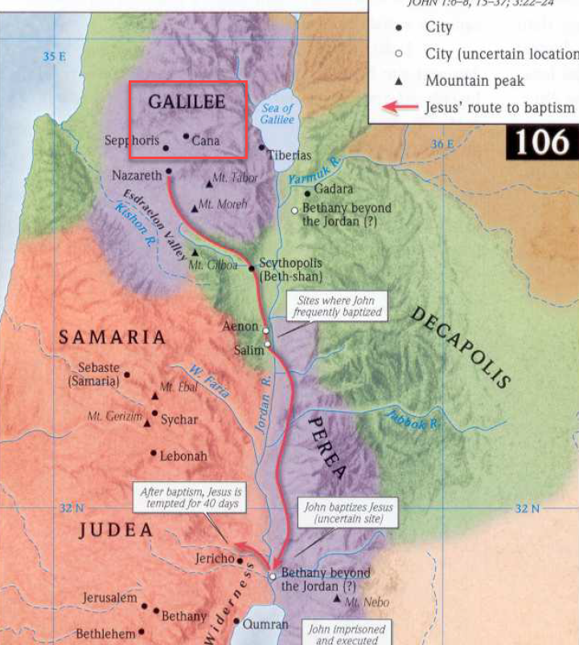
- We aren’t told who was getting married, but Jesus’ mother was in attendance at the feast.
- SIDE NOTE: Joseph, Jesus’ earthly father, is never mentioned in Jesus’ adult years. Many suspect He may have died before Jesus revealed Himself as the Messiah.
- 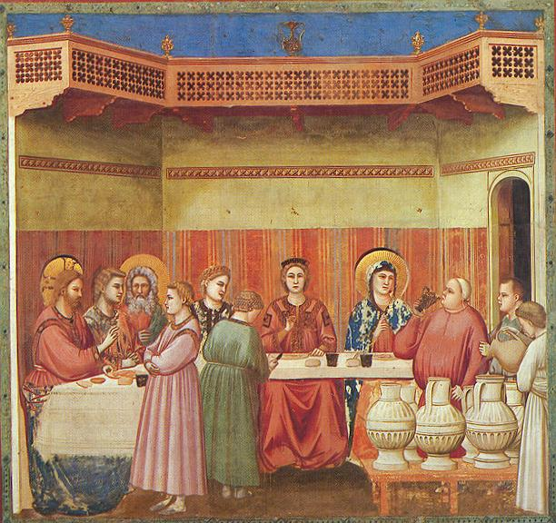Marriage at Cana, Giotto di Bondone, 14th Century.
- 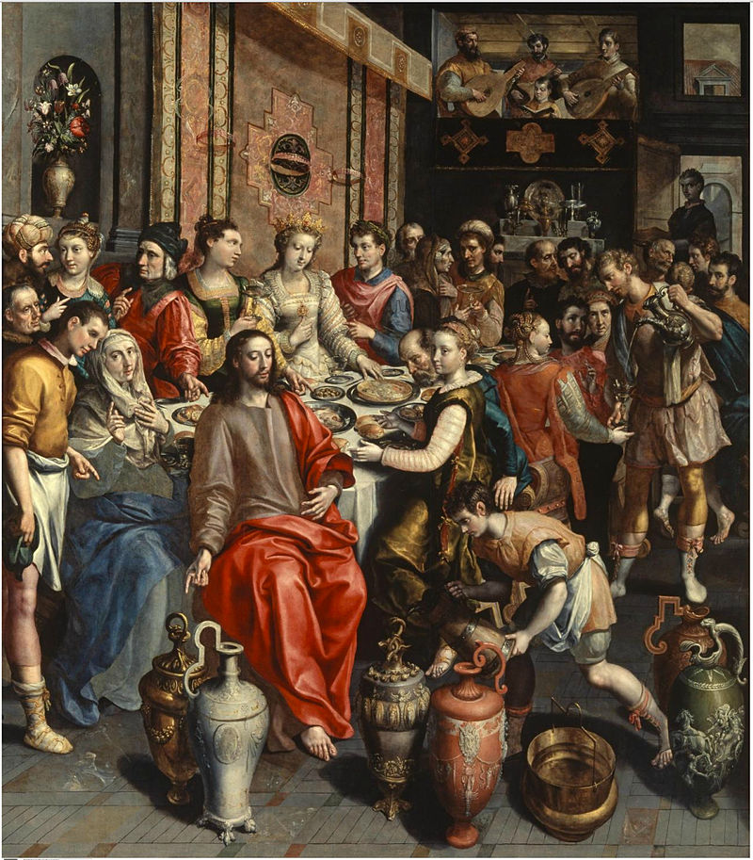Marriage at Cana, Maerten de Vos, 16th Century.

Joh 2:3 When the wine ran out, the mother of Jesus said to him, “They have no wine.”

- In our culture, marriages typically last anywhere from a few hours to a full day.
- But ancient Jewish weddings lasted multiple days.
- Something had gone wrong in the planning process and the hosts had run out of wine for their guests.
  - As in a modern wedding, it would have been embarrassing for the host to have to admit to their guests they had run out of drinks.
  - It wasn’t as if you could just run over to the grocery store across the street and buy some more tea and lemonade.
- Mary, Jesus’ mother, approaches Him with the dilemma, saying, “They have no wine.”
  - Some people suspect one of Mary and Jesus’ relatives were getting married and that’s how she was privy to this information (they probably didn’t announce it far and wide).
  - We will see in the next few verses that Mary’s words, “They have no wine” were more than a statement of fact, they were a request for Jesus to remedy the situation.

Joh 2:4 And Jesus said to her, “Woman, what does this have to do with me? My hour has not yet come.”
Joh 2:5 His mother said to the servants, “Do whatever he tells you.”

- Jesus responded, “Woman, what have I to do with thee? mine hour is not yet come.”.
- SIDE NOTE: In our culture, calling your mother “woman” would be considered highly disrespectful but not so in the 1st Century. Jesus calls Mary “woman” in John 19:26 in circumstances where it is clear He is honoring His mother.
- The next two sentences of Jesus are difficult to understand.
- “What does this have to do with me? My hour has not yet come.
  - KJV – “What have I to do with thee? mine hour is not yet come.”
  - I understand Jesus to be saying, “The hosts have run out of wine, what concern is that to me? I have not come to the earth to provide people with wine. Divine power is not for resolving simple domestic matters. I came down from Heaven for a greater hour than this one and that hour (sacrifice on the cross) has not yet come!
  - Jesus’ mother is concerned with this earthly dilemma, but Jesus wanted it clarified He that had come to fix bigger problems.
- That being said, Jesus’ clarification was just that, a clarification, not a refusal to act assist His mother with the problem at hand.
- Mary, knowing her Son as mothers do, understood this to be His intention.
  - Mothers can read between the lines of their children’s words better than anyone else.
  - She seems to have taken Jesus’ point while understanding He was still willing to help her.
  - This prompted her to tell the servants, “Do whatever he tells you.”
- ILLUSTRATION: (I’m not sure if this illustration is helpful. If not, just discard it!).
  - Let’s say you work for a big company and your supervisor doesn’t always respect the roles and responsibilities for which you were hired.
    - He commonly asks you to do things outside of your job description.
    - You decide today is the day you’re going to start trying to get things cleared up.
  - He comes up to your desk on Friday afternoon hands you a flier and says, “This flier is an advertisement for my son’s school fundraiser. I need you to make me 500 copies so he can hand them out this weekend.”
    - You gently respond, “I wasn’t aware this was the reason the company hired me.”
    - Then you get up and make 500 copies and drop them on your boss’ desk.
  - You responded to your boss with a statement that was meant to clarify your role to Him in the future.
  - But you still went ahead and completed his request because it was within your power to do so and you didn’t mind helping him out.
  - I think this is what Jesus doing.

Joh 2:6 Now there were six stone water jars there for the Jewish rites of purification, each holding twenty or thirty gallons.

- Similar stone vessels were probably common place in ancient Israel.
- In our Matthew and Mark studies, we discussed the Jew’s use of water for ceremonial cleansing as well as their strict adherence to ritualistic hand washing.
- Each jar held 20-30 gallons of water.
  - I couldn’t find a good picture of a 30 gallon container but you are probably familiar with the standard 55 gallon drum (there is still some debate about the exact size).
  - These water jars would have held the volume of 3 drums, roughly.
  - 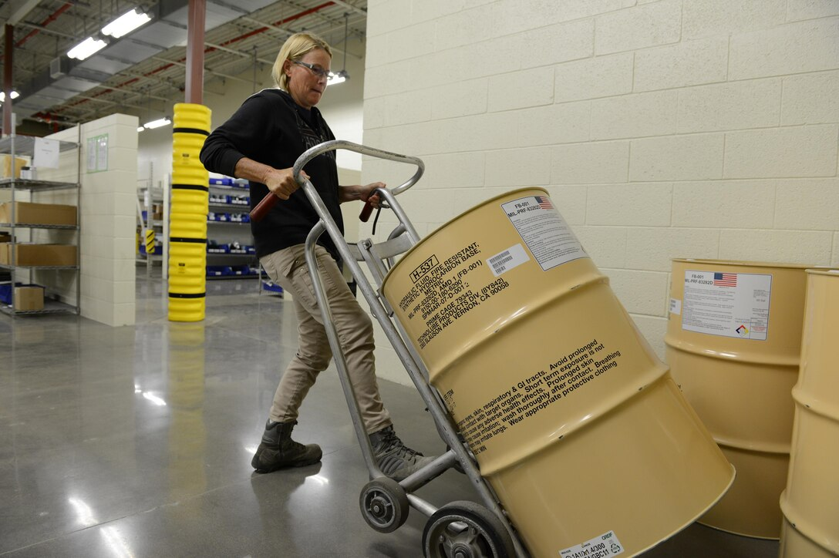

Joh 2:7 Jesus said to the servants, “Fill the jars with water.” And they filled them up to the brim.
Joh 2:8 And he said to them, “Now draw some out and take it to the master of the feast.” So they took it.
Joh 2:9 When the master of the feast tasted the water now become wine, and did not know where it came from (though the servants who had drawn the water knew), the master of the feast called the bridegroom.

- It is easy to skip over verse 7 without giving it much thought but imagine being the servants who had to go to the well, pull up 150 gallons of water, and bring it all back to the wedding feast.
- When the jars had been filled to the brim, Jesus told them to take some of it and give it to the master of the feast.
  - KJV – “governor of the feast.”
  - This individual was probably not altogether different than a modern day wedding planner.
- It is not clear if the water had already been turned to wine at this point or if the change occurred sometime between them drawing it and the master of the feast tasting it.
- When the master of the feast tasted the wine, he was shocked.
  - Apparently, it was delicious.
  - The master of the feast called the groom and asked Him why he had saved the best wine for last.
  - Why?
    - When you first taste something, all of the flavors are very new and potent on your pallet.
    - But as you continue eating/drinking, the taste dulls a bit.
    - The 1st taste is definitely more powerful than the 10th (goes for food/drink that taste good/bad).
  - Generally, at a wedding feast, the best wine was served first to impress the scrutinizing pallets of the newly arrived guests. The not-so-good wine was served towards the end when people’s taste buds were less sensitive.
  - In creating such good wine, Jesus turned the shame that awaited the wedding party into honor.

Joh 2:11 This, the first of his signs, Jesus did at Cana in Galilee, and manifested his glory. And his disciples believed in him.
Joh 2:12 After this he went down to Capernaum, with his mother and his brothers and his disciples, and they stayed there for a few days.

- This was the first miracles performed by Jesus in Cana of Galilee.
- The miracle “manifested” (made known) his glory.
  - The miracle was an announcing of Jesus “glory.”
  - Synonyms for glory include:
    - Praiseworthiness.
    - Renown.
    - Magnificence.
  - This miracle created faith in the disciples and they believed in Jesus because of it.
- Following the feast, Jesus, His mother, His brothers, and His disciples went to Capernaum for a few days.
- 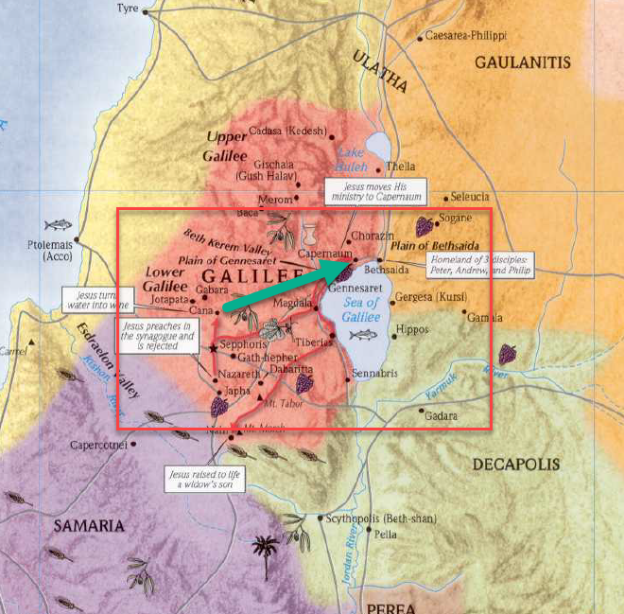

Joh 2:13 The Passover of the Jews was at hand, and Jesus went up to Jerusalem.

- The Passover was a celebration/memorial of God’s deliverance of the Jews from Egyptian slavery (about 1500 years before Jesus was born).
- Every year, in the springtime (March/early April) Jews travelled to Jerusalem for Passover.
- Jerusalem was where the Temple of the Jews was located (see model below).
- 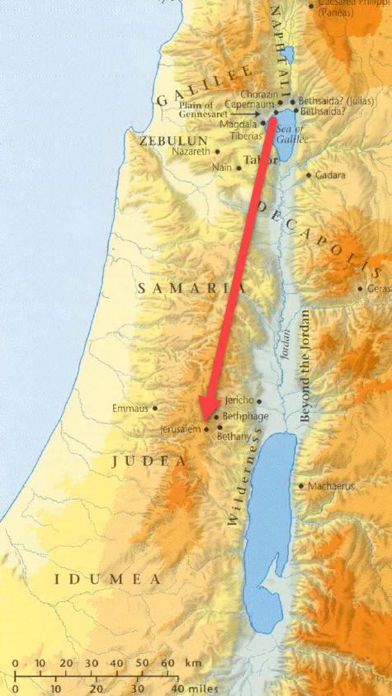
- 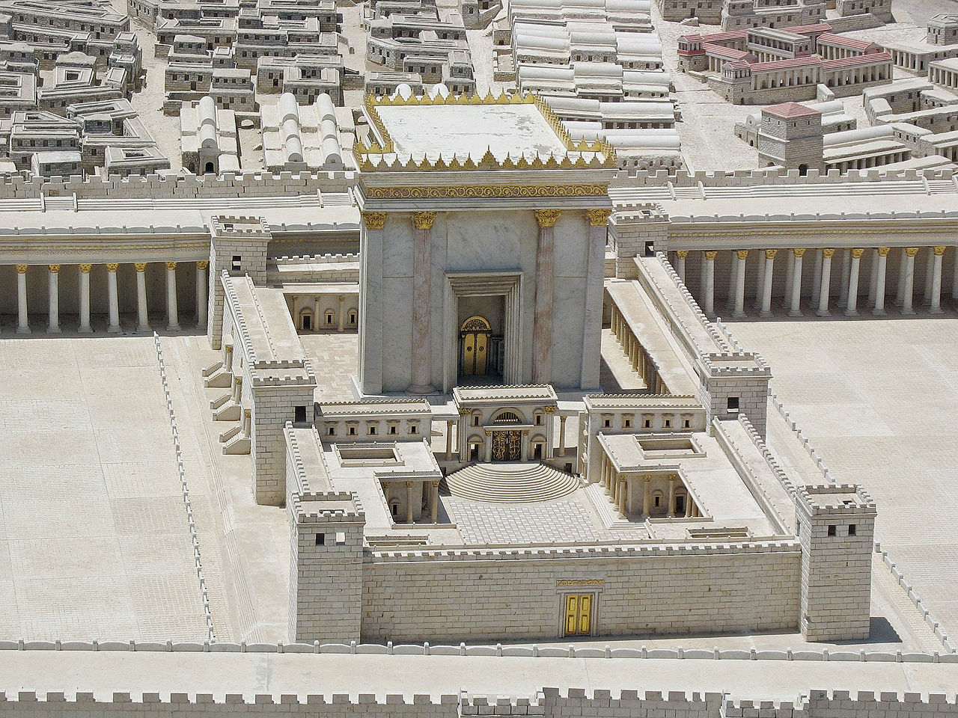

Joh 2:14 In the temple he found those who were selling oxen and sheep and pigeons, and the money-changers sitting there.
Joh 2:15 And making a whip of cords, he drove them all out of the temple, with the sheep and oxen. And he poured out the coins of the money-changers and overturned their tables.
Joh 2:16 And he told those who sold the pigeons, “Take these things away; do not make my Father's house a house of trade.”

- Why was Jesus so angry?
  - The text tells us there were money changers and animal salesmen in the Temple complex but why did that insight the anger of the Lord?
  - Didn’t people need those services?
  - What was the big deal?
  - Isn’t Jesus going a bit overboard here?
- In order to understand a little better, I did some research into the ancient Temple and its practices to give the story some context.
- The Three Temples:
  - (1) Without going into too much Temple history… The original temple built by Solomon was no longer standing. It had been destroyed when the Babylonians conquered Judah.
  - (2) Upon returning from Babylonian captivity, the Jews built a new Temple but it didn’t compare to the glory of the first.
  - (3) In order to win the favor of the Jews, Herod the Great greatly “improved” the existing Temple to once again put it on the map as an architectural wonder.
- But Herod, with the help of the Jewish elite, had turned the new and “improved” Temple into a money making machine… which, was not its intended purpose!
- The Temple made money a few different ways:
  - (1) Temple Tax
    - A half-shekel (about a days wage) was collected annually from most Jewish men for the upkeep of the Temple.
    - Estimating the total:
      - Let’s use modern numbers and say every man made $10/hour.
      - They worked 8 hours a day.
      - Approximately 3 million taxpayers around the world.
      - = $240,000,000.
    - This tax was collected throughout the Roman Empire and shipped via armed guards back to Jerusalem.
  - (2) Money Changers
    - The temple tax was not paid in common money, it was only paid with the Tyrian shekel (from the region of Tyre).
    - The Tyrian shekel bore the image of Melkart, their equivalent of Baal.
    - Most people weren’t coming through Tyre so they had to get their money changed.
    - Apparently there was a bit of extortion going on.
    - Apparently the Jews made tons of money doing this.
    - Note the words of Titus the Roman general (and later emperor) in a speech to the Jews just before the fall of Jerusalem:
      - "We [Romans] have given you leave to gather up that tribute which is paid to God [the Temple tax], with such other gifts that are dedicated to him: nor have we called those that carried these donations to account, nor prohibited them; till at length you became richer than we ourselves, even when you were our enemies" (Josephus, Wars, VI.6,2).
  - (3) Animals sales
    - Jews sold animals used for sacrifice to fellow Jews in the Temple complex.
    - Why was this a profitable business?
    - If you remember the Old Testament commands about sacrifices, the animals couldn’t be blemished
    - There would be great risk of this on a long journey.
    - Even Jesus had to travel 75+ miles to get to Jerusalem for the feast.
    - It would be much easier to travel light and buy an animal in Jerusalem.
    - Who wants to haul a sheep around for several hundred miles?
    - In addition, it was the corrupt priests who were responsible for inspecting the animals, which would have been an opportunity to make a little extra profit…
  - So you can kind of see this playing out? People would come to the Temple, they would pay to get their money changed and then they would have to pay a high price to buy an animal with that money, and then they would be required to give their half-shekel tax… triple dipping
  - Ancient historian Josephus calls Annas the high priest “a great hoarder up of money.”
    - The position of High Priest was a position acquired through bribery and political appointment.
    - The priestly line from the Old Testament no longer existed.
  - Josephus (Antiq. 14.105-109) reported that in 54 B.C. the Roman general Crassus raided the Temple, taking cash reserves weighing about 2000 talents (about 176,000 pounds) (roughly 3.5 billion dollars)
  - Keep this in mind when you read the rest of the New Testament and the Gospels
  - Jesus is going around telling people that they aren’t going to need to go to the Temple anymore (women at the well).
  - Paul would later preach WE are the Temple of God
  - Why were the Jewish elite so bent on discrediting Paul?
    - Was it because they really cared about the souls of their Jewish friends?
    - No! Paul was directly attacking their money making ability with this new Christian teaching.
  - In the Old Testament, we read about how the people had become so corrupt they started moving idols into the Temple.
  - Were the Jewish elite of the 1st Century any better? They had brought their idolatries and worship of money into the Temple complex.
- In light of all of this, Jesus was enraged, created a whip of cords, drove the salesmen (probably the animals too) out of the Temple, and flipped the tables of money-changers.
- He made His motives known to the pigeon salesmen when He said, “…do not make my Father’s house a house of trade.”
  - People in every age and generation have had a tendency to turn worship into a money making operation.
  - People who see business opportunities in the devotion of others.
  - You can imagine how people would have dreaded coming to worship God on the feast days knowing it was going to cost them a large sum of money.
  - Worship was never intended to be a financial burden.
  - Jesus is angry that these individuals are more interested in making a profit than God being worshipped.

Joh 2:17 His disciples remembered that it was written, “Zeal for your house will consume me.”

- This quotation comes from Psalm 69.
  - Psa 69:9 For zeal for your house has consumed me, and the reproaches of those who reproach you have fallen on me.
- Zeal: “great energy or enthusiasm in pursuit of a cause or an objective.”
  - Jesus showed great enthusiasm for the pure worship of God.
  - His pursuit of that objective animated Him to create the whip and drive out the corruption.

Joh 2:18 So the Jews said to him, “What sign do you show us for doing these things?”
Joh 2:19 Jesus answered them, “Destroy this temple, and in three days I will raise it up.”
Joh 2:20 The Jews then said, “It has taken forty-six years to build this temple, and will you raise it up in three days?”
Joh 2:21 But he was speaking about the temple of his body.
Joh 2:22 When therefore he was raised from the dead, his disciples remembered that he had said this, and they believed the Scripture and the word that Jesus had spoken.

- The Jewish leaders then confronted Jesus, asking Him what evidence He could provide to show He had authority to cause such an uproar in their Temple.
- Jesus didn’t give them the immediate “sign” they were looking for.
  - He knew they weren’t interested in legitimate signs of authority.
  - If they were, they could have gone back to the authority of the Old Testament Law and prophets and realized their actions were wrong.
- Jesus wouldn’t provide them with an immediate sign, but there would be a future sign that would signify His actions in the Temple were a legitimate display of God’s displeasure with their greed.
- Jesus would be shown to have had the approval of God when God raised Him from the dead 3 days after His crucifixion.
  - Jesus tells the Jews as much but uses veiled language.
  - “Destroy this temple, and in three days I will raise it up” (John 2:19).
  - The Jews, who had no interested in discovering the truth behind Jesus’ words, immediately mocked the idea, assuming He was talking about the Temple in Jerusalem.
  - The Temple had been under renovation for decades thanks to King Herod’s financial backing.
- As we mentioned in chapter 1, the Jews had long reverenced the Temple as the dwelling place of God on earth.
  - But now Jesus (God) had come to the earth.
  - Jesus’ body contained the presence of God.
    - This is why Jesus refers to His body as “this temple.”
    - It would be killed (destroyed) but it would be resurrected (rebuilt) after only 3 days.
  - If the Jews wanted to know God, they needed to turn their attention away from the physical Temple and set their eyes on Christ.
  - They thought it was a ridiculous thing to suggest a building as great as the Temple, which had taken 46 years to renovate, could be built in 3 days.
  - They acted like it was the most ridiculous thing they had ever heard.
    - But Jesus was telling them He was going to accomplish something even more out of the ordinary.
      - Structures as great as the Temple had been built by humans before, but no human had ever possessed the power to raise the dead.
      - Which would be more miraculous? A Temple being built in 3 days? Or a body resurrected in 3 days?
    - Given time, men can build a temple, but no amount of time is enough time for men to resurrect the dead, not 3 days, not 1,000 years, not 10,000 years.
    - Jesus would accomplish the greater.
- Jesus’ disciples didn’t understand Jesus’ intention either but they didn’t jump to condemn Jesus due to their lack of understanding.
  - They had to wait almost 3 years before they got to the bottom of these words.
  - That is a long time!
  - But when they finally got their heads wrapped around it, they were in a better place than the Jews who had written off Jesus long ago.
  - APPLICATION:
    - Just because something doesn’t makes sense to us the first time we hear it, doesn’t make in nonsense.
    - The Jewish leaders immediately dismissed Jesus’ words as nonsense
    - The Apostles didn’t understand but withheld judgement.
    - It took 3 more years for them to realize the words were true (John 2:22)
    - They were willing to investigate and were slow to speak (James 1:19).
    - Are we humble enough to admit we may not be smart enough or have enough facts to pass immediate judgement on everything we hear? Are we patient enough to wait for the truth?
- SIDE NOTE: I thought Jesus drove the money changers out of the Temple just before His death (Matthew 21, Mark 11, Luke 19).
  - If you’ve studied the other three accounts of Jesus life, you may remember that Jesus did something very similar to this in the last week of His life, also during Passover.
  - Here we find Jesus cleansing the Temple during Passover, but this is taking place at the beginning of His earthly ministry.
  - What is going on here?
    - Some people suggest this is a contradiction.
    - But upon closer inspection, we find out these accounts are describing separate events.
  - Something to consider… just because the stories are similar doesn’t mean they refer to the exact same occurrence.
    - If you’ve ever read the Old Testament prophets, you’ll find God saying very similar things to people in different generations.
    - This was because the Jews continuously struggled with the same sins and needed continuous correction.
    - Jesus continuously corrected the Pharisees, Sadducees, and scribes over the similar issues within His three year ministry.
    - Apparently, those in the Temple needed the same continuous correction.
    - Jesus cleansed the Temple at the beginning of His ministry (John 2) and then had to teach the lesson again towards the end of His time on earth (Matthew 21, Mark 11, Luke 19).
    - Repeating the action taken at the beginning of His ministry at the end of His ministry, would have driven home the point that the Jewish leaders had failed to learn anything after listening to years of Jesus’ preaching.
    - And if you are familiar with the OT prophets, you will know that that hard headedness was consistent with their track record.
    - So it actually makes a lot of sense for Jesus to cleanse the Temple twice to reiterate their unwillingness to repent.
  - There are also differences in the accounts.
    - In John 2, Jesus makes a “whip of cords” to cleanse the Temple. There is no mention of this in Matthew, Mark, and Luke.
    - In John 2, Jesus tells the merchants, “’Take these things away! Do not make My Father’s house a house of trade!’” In Matthew, Mark, and Luke, Jesus says, “‘My house shall be called a house of prayer,’ but you make it a den of robbers” (Matthew 21:13; Mark 11:17; Luke 19:46).
    - In John 2, the Jewish officials confront Jesus immediately after He cleanses the Temple and He makes the statement, “Destroy this temple, and in three days I will raise it up” (John 2:19). There is no mention of this immediate confrontation or Jesus’ statement in Matthew, Mark, and Luke.
  - These facts suggests two separate Temple cleansings during the ministry of Jesus, one in the beginning and one towards the end.

Joh 2:23 Now when he was in Jerusalem at the Passover Feast, many believed in his name when they saw the signs that he was doing.
Joh 2:24 But Jesus on his part did not entrust himself to them, because he knew all people
Joh 2:25 and needed no one to bear witness about man, for he himself knew what was in man.

- It is interesting that Jesus wasn’t willing to give the Jewish officials a sign, but was more than willing to perform signs (miracles) for the common people who were willing to believe.
- Having seen the miracles, many of them “believed” in Him.
- I find the next few verses a bit tricky.
- Verse 24 and 25 seem to modify the “belief” of the people in verse 23.
  - The people accepted Christ willingly, but as we know from the rest of the gospel, their faith was shallow.
  - Many “believed” in Christ but only because they loved to see His miracles.
  - A great number of these “believers” turned away from Christ when He began teaching difficult things and didn’t fulfill their assumptions and expectations for the Messiah.
  - Their belief was very shallow.
- Jesus knowing the fragility of their “belief” did not “entrust” Himself to them.
  - The word translated “entrust” in verse 24 is the same word translated “believed” in verse 23.
  - 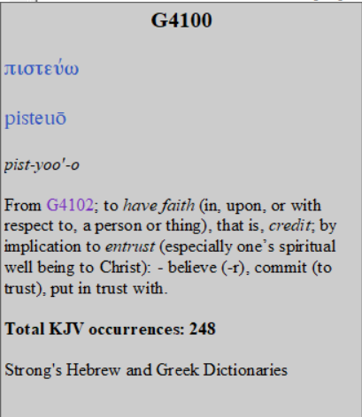
  - We entrust ourselves to Christ because we know He is a trustworthy.
    - John 3:16 “For God so loved the world, that he gave his only Son, that whoever believes in him should not perish but have eternal life.
    - The word translated “believes” in John 3:16 is the same word found in this text.
  - Verse 24, seems to be saying Jesus is doing the opposite.
    - He was unwilling to put His trust in the strength of the people’s commitment.
    - We might say, “He wasn’t banking on it.”
    - The reason? Because he knew what people were like.
    - He created everything, including all human beings, and He was aware of their fickle nature.
    - He knew, not only the nature of the collective group, but also the unique faith of every individual in the group.

https://en.wikipedia.org/wiki/Marriage_at_Cana#/media/File:Giotto_-_Scrovegni_-_-24-_-_Marriage_at_Cana.jpg
https://en.wikipedia.org/wiki/Marriage_at_Cana#/media/File:Marten_de_Vos_Cana.jpg
https://answersingenesis.org/jesus/when-did-jesus-cleanse-the-temple/

