JOHN 20

Joh 20:1 Now on the first day of the week Mary Magdalene came to the tomb early, while it was still dark, and saw that the stone had been taken away from the tomb.

- We left off in chapter 19 with Joseph of Arimathea and Nicodemus burying Jesus’ body in the Garden tomb at the end of the Day of Preparation (14th of the month).
- We pick back up after the Sabbath day (Saturday) on the first day of the week (Sunday).
- Mary Magdalene went to Jesus’ tomb.
  - In the other gospel accounts we are given additional information.
  - Matthew and Mark tells us Mary intended to bring spices to the tomb to “anoint” Jesus and there were other women accompanying her.
- The women came very early in the morning.
  - Luke says, “early dawn” (Luke 24:1).
  - Mark says, “very early… when the sun had risen” (Mark 16:2).
  - Matthew says, “towards the dawn” (Matthew 28:1).
  - John says, “early, while it was still dark” (John 20:1).
    - Some people have tried to suggest this is a contradiction because Mark says the sun had risen and John says it was still dark.
    - But, as anyone who has ever seen a sunrise knows, there is a period after the sun has broken the horizon when the world is still dark. Especially if you are in an area with hills or tree cover.
- The women arrived and saw the stone had already been rolled away from the tomb.
  - We know the women were concerned about the size of the stone and their ability to roll it.
    - Mar 16:3 And they were saying to one another, “Who will roll away the stone for us from the entrance of the tomb?”
    - Mark 16:4b ...it was very large.
  - It must have been a pretty large stone if multiple women didn’t think they were capable of moving it.
  - Matthew tells us an angel had rolled away the stone.
    - Mat 28:2 And behold, there was a great earthquake, for an angel of the Lord descended from heaven and came and rolled back the stone and sat on it.

Joh 20:2 So she ran and went to Simon Peter and the other disciple, the one whom Jesus loved, and said to them, “They have taken the Lord out of the tomb, and we do not know where they have laid him.”

- It is my understanding Mary Magdalene leaves the other women and sets off on her own to find Peter and the “other disciple” (John).
- This is an important detail when attempting to harmonize the 4 resurrection accounts, which we will do later on in the chapter.
- When she found Peter and John she told them the body of the Lord had been taken out of the tomb.

Joh 20:3 So Peter went out with the other disciple, and they were going toward the tomb.
Joh 20:4 Both of them were running together, but the other disciple outran Peter and reached the tomb first.
Joh 20:5 And stooping to look in, he saw the linen cloths lying there, but he did not go in.
Joh 20:6 Then Simon Peter came, following him, and went into the tomb. He saw the linen cloths lying there,
Joh 20:7 and the face cloth, which had been on Jesus' head, not lying with the linen cloths but folded up in a place by itself.

- As soon as Mary Magdalene informed Peter and John, they took off in the direction of the tomb.
- Mary must have followed them (per the upcoming verses).
- John outran Peter to the tomb.
  - I think John included this detail because he wanted to memorialize his victory for all people to read for all time .
- John stooped and looked into the tomb but didn’t enter.
- When Peter caught up, he ran directly into the tomb.
  - Jesus wasn’t there.
  - John saw the linen burial clothes Jesus had been wrapped in in one spot and Jesus’ linen face cloth folded in another place.
  - “Observe here the boldness of Peter, and how God dispenses his gifts variously. John could out-run Peter, but Peter could out-dare John. It is seldom true of the same persons, what David says poetically of Saul and Jonathan, that they were swifter than eagles, and yet stronger than lions, 2Sa 1:23. Some disciples are quick, and they are useful to quicken those that are slow; others are bold, and they are useful to embolden those that are timorous; diversity of gifts, but one Spirit;… John followed Peter in venturing. It should seem, he durst not have gone into the sepulchre if Peter had not gone in first. Note, It is good to be emboldened in a good work by the boldness of others. The dread of difficulty and danger will be taken off by observing the resolution and courage of others. Perhaps John's quickness had made Peter run faster, and now Peter's boldness makes John venture further, than otherwise either the one or the other would have done (Matthew Henry).

Joh 20:8 Then the other disciple, who had reached the tomb first, also went in, and he saw and believed;
Joh 20:9 for as yet they did not understand the Scripture, that he must rise from the dead.
Joh 20:10 Then the disciples went back to their homes.

- After Peter went into the tomb John followed.
- John writes that he “saw and believed.”
  - He saw Jesus wasn’t there anymore and all of His burial cloths had been removed.
  - But what was it John “believed”?
  - Verse 9 seems to say Peter and John didn’t understand the scriptures which spoke about the Messiah rising from the dead.
  - So what was it John “believed”?
  - A few options to consider:
    - 1. John believed Mary Magdalene that the body had in fact been taken away.
    - 2. John believed Jesus rose from the dead but hadn’t yet made the connection with the Old Testament’s predictions of the Messiah’s resurrection.
    - 3. You may be able to translate the beginning of verse 9 as, “Up until now they did not understand the Scripture” or “Up to this point they didn’t understand the Scripture.”
      - Meaning John was beginning to connect the dots between what was transpiring before his eyes and the words of the scriptures.
      - Up to this point, he hadn’t been able to make the connection.
- After observing the scene at the tomb, Peter and John went to their homes.

Joh 20:11 But Mary stood weeping outside the tomb, and as she wept she stooped to look into the tomb.
Joh 20:12 And she saw two angels in white, sitting where the body of Jesus had lain, one at the head and one at the feet.
Joh 20:13 They said to her, “Woman, why are you weeping?” She said to them, “They have taken away my Lord, and I do not know where they have laid him.”

- Mary Magdalene returned to the tomb with Peter and John (we don’t know if she was running or not).
- Peter and John left to go home but Mary remained.
- She was crying outside the tomb.
- Mary’s affection for Jesus is beautifully communicated through her tears.
- APPLICATION
  - Jesus wept with those who mourned Lazarus.
  - Mary Magdalene wept when she thought she lost Jesus.
  - The gospel creates friendships worthy of our tears and both stories teach us a day is coming when death is conquered and we will never cry again.
- As she cried, she stooped down to look into the mouth of the tomb and saw two angels sitting where Jesus’ body had been.
- They asked her why she was crying and she told them it was because someone had taken away Jesus body and she didn’t know where they put Him.

Joh 20:14 Having said this, she turned around and saw Jesus standing, but she did not know that it was Jesus.
Joh 20:15 Jesus said to her, “Woman, why are you weeping? Whom are you seeking?” Supposing him to be the gardener, she said to him, “Sir, if you have carried him away, tell me where you have laid him, and I will take him away.”

- When Mary was done talking to the angels she turned around and saw Jesus but she didn’t recognize Him.
- That may seem really odd considering Mary had been following Jesus for years.
  - Some people suggest she didn’t recognize Jesus on account of her grief and the tears in her eyes.
  - Others suggest Jesus concealed His identity from her.
- In a previous chapter we mentioned how Jesus’ post resurrection appearances were going to be somewhat different than the way He appeared to people during His pre-death ministry.
  - On at least one other occasion, Jesus concealed His identity from those He was with, only to reveal it sometime later (see Luke 24:16).
  - Jesus is also going to move around in a more supernatural way, like the angels at the tomb, Jesus will appear places and then disappear.
    - This type of movement wasn’t completely absent in His pre-death ministry.
    - Jesus had supernaturally hid Himself from the Jewish authorities when they attempted to kill Him.
    - But for the most part, He chose to move in more human ways (walking between towns, taking a boat across the sea, etc…).
- For whatever reason, Mary didn’t recognize Jesus when He asked her, “Woman, why are you weeping? Whom are you seeking?”
  - She assumed Jesus was the gardener.
  - Remember, the tomb was located in a garden (John 19:41).
- Mary asked Jesus if He had moved Jesus body from the tomb.
- I supposed He would have to answer in the affirmative lol.

Joh 20:16 Jesus said to her, “Mary.” She turned and said to him in Aramaic, “Rabboni!” (which means Teacher).
Joh 20:17 Jesus said to her, “Do not cling to me, for I have not yet ascended to the Father; but go to my brothers and say to them, ‘I am ascending to my Father and your Father, to my God and your God.’”
Joh 20:18 Mary Magdalene went and announced to the disciples, “I have seen the Lord”—and that he had said these things to her.

- When Jesus said Mary’s name she immediately recognized Him.
- Verse 17, has been the subject of a lot of discussion.
- Why didn’t Jesus want Mary to “cling to” Him?
  - Some suggest Jesus was a type of phantom or not fully human after His resurrection, but as we will see from verse 27, Jesus didn’t have any problem with people touching Him and He had a full human body.
  - We already pointed out Mary’s obvious affection for Jesus.
  - She may have been clinging to Jesus already or about to do so when Jesus spoke these words (I read the Greek construction allows for either of these possibilities).
  - But Jesus had a task for her to complete.
  - Rather than stay there with Him, she was to go inform the disciples of Jesus’ resurrection.
  - He hadn’t ascended to God yet and there would still be time for Mary to see Him again, but first, she had a job to do.
- She was to go to the disciples and tell the Jesus had risen from the dead and was going to be ascending back to God.
- Mary went and did exactly as instructed.

HARMONY OF THE RESURRECTION ACCOUNTS:

- Details about the resurrection are found in all 4 gospels.
- It isn’t difficult to make sense of the story when reading 1 account, but harmonizing all 4 and the unique details of each can be challenging.
- This challenge has led some Bible skeptics to declare the stories contradictory.
- But if you take the time to think through the various accounts, you will find harmony between all of the details.
- The outline below is my current understand of how all the details fit together. I have included the verse numbers where each detail is mentioned in each gospel.

- THE STONE IS ROLLED AWAY
  - There was a great earthquake and an angel, who had an appearance like lighting and a white robe descended, and rolled away the stone (Matthew 28:2).
  - The guards, in fear, trembled and became like dead men.
- THE WOMEN ARRIVE AT THE TOMB
  - Sunday morning Mary Magdalene (and other women) came to the tomb while it was dark (John 20:1; Luke 24:1; Mark 16:2; Matthew 28:1).
  - The other women included:
    - Joanna.
    - Mary the mother of James.
    - Salome (Mark 16:1).
    - Other women (Luke 24:10).
  - The women were concerned about who would roll away the stone for them (Mark 16:3).
  - The women saw the stone had been rolled away (John 20:1; Luke 24:2; Mark 16:4).
- MARY MAGDALENE DEPARTS TO FIND PETER
  - Mary Magdalene left the other women and told Peter and John the tomb was empty (implied from John 20:2; 20:13).
    - It seems Peter and John were not with the other disciples.
    - This is reasonable considering they were the only Apostles specifically mentioned to have remained in Jerusalem during the crucifixion.
    - In addition, Peter is singled out from the other Apostles in Mark 16:7, suggesting he was not with them.
- THE OTHER WOMEN ENCOUNTER TWO ANGELS
  - The women were perplexed (Luke 24:4).
  - The remaining women look inside the tomb.
  - Two men stood by them in dazzling apparel (Luke 24:4).
    - Mark says they saw “a young man sitting on the right side, dressed in a white robe, and they were alarmed” (Mark 16:5)
    - Mark probably chose only to focus on the angel who spoke.
    - Mark does not say there was only one angel.
    - Is it a contradiction that Luke says they “stood by them” and Mark says the angel was sitting.
      - Not necessarily, the angels could have stood up.
      - It is also not the case that the Greek work translated “stood by” always refers to physically standing.
      - It is translated various ways in a number of passages:
        - Luk 2:9 And an angel of the Lord appeared to them, and the glory of the Lord shone around them, and they were filled with great fear.
        - Luk 10:40 But Martha was distracted with much serving. And she went up to him and said, “Lord, do you not care that my sister has left me to serve alone? Tell her then to help me.”
        - 2Ti 4:2 preach the word; be ready in season and out of season; reprove, rebuke, and exhort, with complete patience and teaching.
        - 2Ti 4:6 For I am already being poured out as a drink offering, and the time of my departure has come.
  - The angels knew who the women were looking for and one of them asked them why they were seeking the living among the dead (Luke 24:5; Mark 16:6; Matthew 28:5).
  - The angels reminded the women that Jesus had said, “the Son of Man must be delivered into the hands of sinful men and be crucified and on the third day rise again” (Luke 24:7).
  - The women remembered the words (Luke 24:8).
  - The angel told the women to go tell the disciples and Peter Jesus would meet them in Galilee (Mark 16:7; Matthew 28:7).
- PETER AND JOHN VISIT THE TOMB
  - Peter and John ran to the tomb (John 20:3; Luke 24:10).
  - Mary returned with them (Mark 16:9; John 20:11).
  - John beat Peter to the tomb (John 20:4).
  - Peter went into the tomb first (John 20:6).
  - They saw the linen cloths laying in the tomb (John 20:5-6).
  - The face cloth was folded and by itself (John 20:7; Luke 24:12).
  - The disciples went back home (John 20:10; Luke 24:12).
- JESUS APPEARS TO MARY MAGDALENE
  - Mary Magdalene stood outside the tomb weeping (John 20:11).
  - Mary Magdalene looked into the tomb and saw two angels sitting where Jesus’ body had been, one at the head and one at the feet” (John 20:12).
  - The angels asked why Mary Magdalene was weeping (John 20:13)
  - Mary Magdalene turned around and saw Jesus but didn’t recognize Him (John 20:14).
  - Jesus revealed Himself to Mary (John 20:16; Mark 16:9).
  - Jesus tells Mary Magdalene to tell His “brothers” of His resurrection and imminent ascension (John 20:17).
- JESUS APPEARS TO THE OTHER WOMEN
  - On their way back from the tomb, Jesus appeared to the other women (Matthew 28:9).
  - The women worship Jesus (Matthew 18:9).
  - Jesus instructs them to tell His “brothers” He will meet them in Galilee (Matthew 28:10).
  - The women returned to the Apostles and told them they had seen the Lord (Luke 24:9).
- MARY MAGDALENE RETURNS TO THE APOSTLES
  - Probably sometime after the return of the other women, Mary Magdalene returned and told the Apostles she had seen Jesus (John 20:18; Luke 24:10; Mark 16:10).
  - The Apostles did not believe Mary’s testimony or that of the other women (Luke 24:11; Mark 16:11).

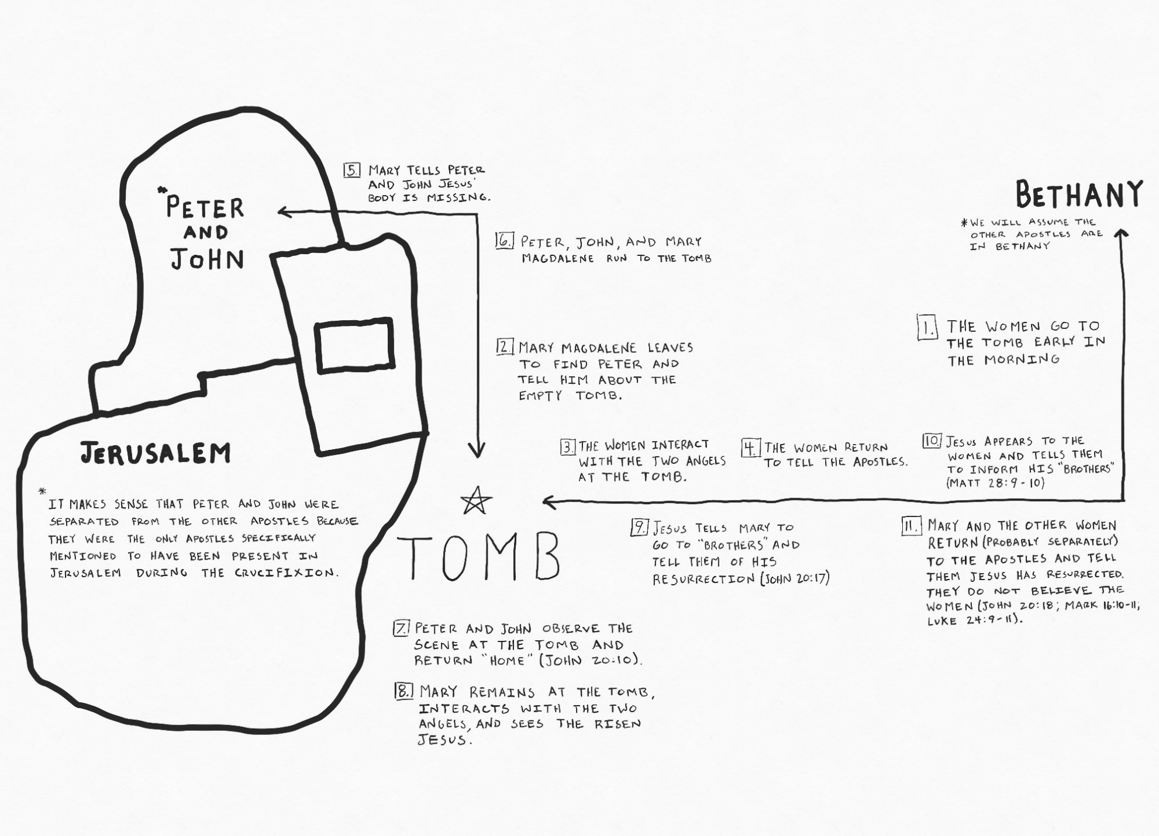

Joh 20:19 On the evening of that day, the first day of the week, the doors being locked where the disciples were for fear of the Jews, Jesus came and stood among them and said to them, “Peace be with you.”

- We know from the other gospels accounts Jesus made several appearances that day which are not recorded in John’s gospel.
  - He spoke with 2 disciples as they were travelling to a place called Emmaus.
  - He also made an appearance to Simon Peter (Luke 24:34).
- That evening, He made a miraculous appearance to His Apostles.
  - The Apostles were afraid of the Jewish leaders and the repercussions of their faithfulness to Jesus.
  - Out of fear, they were meeting in a locked house.
- Suddenly Jesus appeared among them and greeted them saying, “Peace to you.”
  - Luke tells us the Apostles were frightened and thought Jesus was a spirit (Luke 24:37).
  - Jesus had generally constrained himself to the limitations of human movement during His ministry but here came and went as He wished unhindered by locked doors.
- They were shocked to see Jesus but His arrival had certainly not come unannounced.
  - Mar 8:31 And he began to teach them that the Son of Man must suffer many things and be rejected by the elders and the chief priests and the scribes and be killed, and after three days rise again.
  - Mar 9:31 for he was teaching his disciples, saying to them, “The Son of Man is going to be delivered into the hands of men, and they will kill him. And when he is killed, after three days he will rise.”
  - Mar 10:34 And they will mock him and spit on him, and flog him and kill him. And after three days he will rise.”

Joh 20:20 When he had said this, he showed them his hands and his side. Then the disciples were glad when they saw the Lord.
Joh 20:21 Jesus said to them again, “Peace be with you. As the Father has sent me, even so I am sending you.”

- Jesus didn’t have any problem being inspected by curious eyes.
  - Generally magicians and slight of hand artists only allow you to see what they want you to see.
  - They aren’t usually to keen to allow people to closely examine the scene.
  - But Jesus didn’t have anything to hide, He wasn’t faking a resurrection, He wasn’t a figment of their imagination, He had a body of real flesh, with real wounds.
- Jesus then briefly mentions the work in store for the Apostles.
  - God had sent Jesus to the world to make salvation possible.
  - The Apostles were going to be sent out by Jesus to tell people about God’s offer of salvation.

Joh 20:22 And when he had said this, he breathed on them and said to them, “Receive the Holy Spirit.

- Why did Jesus breathe on them?
  - The word translated “Spirit” in this verse is “pneuma” which means a current of air, breath, or a breeze. Figuratively, a spirit or soul.
  - 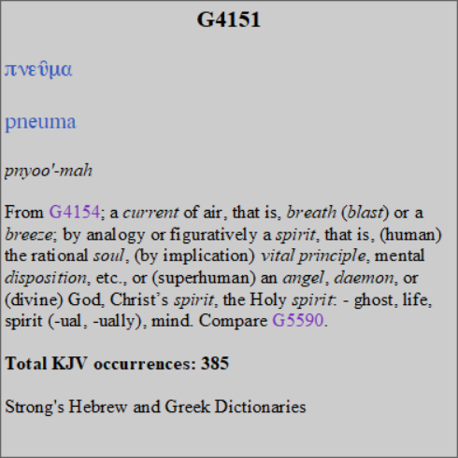
  - The Hebrew words describing God’s Spirit is very similar.
  - 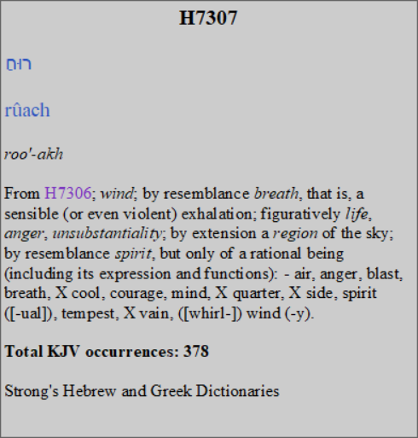
  - How did God give life to man when He was first created in Genesis 2?
    - God “breathed into his nostrils the breath of life (Genesis 2:7).
    - Job 33:4 The Spirit of God has made me, and the breath of the Almighty gives me life.
    - God’s breath was the life giving force.
  - Here Jesus breathes on the Apostles giving them God’s Holy “pneuma,” the Holy Spirit.
  - They were given new life on account of Jesus’ sacrifice and the Holy Spirit in them would enable them to preach the life giving message to others.
  - They were agents of God’s new creation, the Holy Spirit assisting them to bring the dead to life.
  - Those “born again” in Christ are a new creation (John 3; 2Corinthians 5:17).
- Evidently, the Apostles received a portion of the Holy Spirit’s power here along with a guarantee of additional power in the near future.
  - This is a bit more clear in Luke’s account.
    - Luk 24:49 And behold, I am sending the promise of my Father upon you. But stay in the city until you are clothed with power from on high.”
  - On this occasion, we know Jesus opened the Apostle’s minds to give them clarity about the scriptures which may have been a result of receiving the Spirit.
    - Luk 24:45 Then he opened their minds to understand the Scriptures,

Joh 20:23 If you forgive the sins of any, they are forgiven them; if you withhold forgiveness from any, it is withheld.”

- Did the Apostles have the right in themselves to absolve a person of their sins?
  - No.
  - Forgiveness of sins came only through Jesus’ sacrifice.
- We never read of the Apostles suggesting the power of forgiveness resides in them.
- I think what Jesus is saying here is the Spirit would enable them to speak with authority about the forgiveness of sins.
  - When a person’s sins were forgiven and when a person was still in sin.
  - The Holy Spirit would enable them to speak with precision on the issue.
- Up to this point, the Apostles weren’t in a positions to speak with any comprehension or authority about the work of Jesus.
- Three days ago they thought He had failed and His work was over.
- But the Holy Spirit would enable them with comprehension of spiritual realities, like the forgiveness of sins.

Joh 20:24 Now Thomas, one of the twelve, called the Twin, was not with them when Jesus came.
Joh 20:25 So the other disciples told him, “We have seen the Lord.” But he said to them, “Unless I see in his hands the mark of the nails, and place my finger into the mark of the nails, and place my hand into his side, I will never believe.”

- Thomas must have had a twin brother or sister.
- Thomas is also called Didymus (John 11:16; 21:2).
- You’ll notice John still calls the Apostles “the twelve” even though there were only 11.
- The terms “the eleven” and “the twelve” are used to refer to the whole group, even when some are absent.
- Thomas wasn’t with the other Apostles when Jesus met with them Sunday evening and he refused to believe they had seen the Lord.
- He wanted to touch Jesus and see the wounds for himself.
- Sometimes Thomas gets a bad wrap for this response, but the other Apostles responded very similarly.
  - Did they believe the women when they told them Jesus had appeared to them?
  - No, they had to see Jesus for themselves.

Joh 20:26 Eight days later, his disciples were inside again, and Thomas was with them. Although the doors were locked, Jesus came and stood among them and said, “Peace be with you.”
Joh 20:27 Then he said to Thomas, “Put your finger here, and see my hands; and put out your hand, and place it in my side. Do not disbelieve, but believe.”
Joh 20:28 Thomas answered him, “My Lord and my God!”
Joh 20:29 Jesus said to him, “Have you believed because you have seen me? Blessed are those who have not seen and yet have believed.”

- Eight days later, Jesus appeared in another locked room where the disciples had gathered.
- This time Thomas was with them.
- Jesus gave Thomas the same opportunity He had given the other Apostles, to touch the wounds left by His crucifixion.
- Like the others, Thomas believed.
- He confessed Jesus as His Lord and God.
- SIDE NOTE:
  - There are some who teach Jesus wasn’t equal with God.
  - The absence of a correction of Thomas by Jesus confirms Jesus had no problem accepting the title of God.
  - Also relevant to this discussion is the response of the women who were returning from the tomb when Jesus appeared to them.
  - Matthew 28:9 tells us they “took hold of his feet and worshiped him.”
  - So Jesus had no problem with being called God or being worshiped.
- No doubt, Jesus was happy Thomas had expressed his faith but Jesus tells him and us, “Have you believed because you have seen me? Blessed are those who have not seen and yet have believed.”
  - Thomas was given a special privilege to see the risen Messiah.
  - But his privilege would be the exception instead of the rule.
  - Billions of people would follow after Thomas on the earth who wouldn’t have the privilege of physically seeing Jesus.
  - That fact is why John wrote us this book… watch…

Joh 20:30 Now Jesus did many other signs in the presence of the disciples, which are not written in this book;
Joh 20:31 but these are written so that you may believe that Jesus is the Christ, the Son of God, and that by believing you may have life in his name.

- How would the world come to believe in Jesus’ resurrection if they couldn’t see the wounds in Jesus’ hands, feet, and side for themselves?
- John’s answer… he would write them a book.
- He would tell them about Jesus.
- What He did, what He taught, about His miracles, about His plan.
- So when the world read and believed, they could “have life in His name.”
- Jesus empowered John with the Holy Spirit to write this book to do exactly the thing He wanted, for them to go out together and create life, breathe knew life into a dead world.

