JOHN 3

Joh 3:1 Now there was a man of the Pharisees named Nicodemus, a ruler of the Jews.
Joh 3:2 This man came to Jesus by night and said to him, “Rabbi, we know that you are a teacher come from God, for no one can do these signs that you do unless God is with him.”

- This story is only recorded in John’s gospel.
- A Pharisee named Nicodemus paid Jesus a visit.
- We haven’t discussed the Pharisees at length in John, but if you are familiar with the other gospels, you’ll know the Pharisees were some of the most outspoken critics of Jesus.
- Nicodemus met Jesus at night.
- It is likely he chose to meet Him at night because his fellow Pharisees wouldn’t have been too happy to find out one of their own was friendly with the enemy.
- Our minds may suspect a trap!
- But the way Nicodemus greets Jesus reveal his true intentions.
  - Nicodemus calls Him “Rabbi” (teacher).
  - Nicodemus had come to learn from Jesus.
  - His greeting is especially significant when you think that many of Nicodemus’ contemporaries probably called him “rabbi.”
  - Nicodemus was humbling himself by acknowledging he had things to learn from this young Galilean prophet.
- Nicodemus had been convinced, at least in part, by Jesus’ miracles.
  - He couldn’t deny the obvious.
  - No man was able to perform the miraculous deeds Jesus had done without God’s power.
  - And if God’s power was with Jesus, Nicodemus knew he needed to ask Jesus a few questions.
- APPLICATION:
  - The group a person runs with doesn’t always represent them as an individual.
  - The mindset of “their group” isn’t always their mindset.
  - As a group, the Pharisees were hard hearted, stubborn, proud, just like their Jewish ancestors.
  - Nicodemus was part of the that group, but his hear was significantly different than theirs.
  - The Bible tells us about people who came from all kinds of backgrounds before becoming followers of Christ.
    - Looking for lost souls is probably more often a search for individuals (not groups of people).
    - We share the gospel so people who aren’t satisfied in their current circumstances, who are trapped in despair, and who realize the way they’ve been living isn’t taking them anywhere can finally see the light.
    - Those people are searching for something better and people like that can be found in every group.
    - Every social strata, every nationality, every gang, every group of school friends, every sports team, etc…
- APPLICATION:
  - Sometimes people will have conversations in private they would never have in public.
  - When we are in public, we have reputations to maintain.
  - But this narrative illustrates and I’ve found it true in my own life, people are usually much more open to constructive conversation when they don’t have an audience.

Joh 3:3 Jesus answered him, “Truly, truly, I say to you, unless one is born again he cannot see the kingdom of God.”

- Why does Jesus immediately provide Nicodemus with the answer to a question he never asked?
  - Hard to say.
  - Perhaps Nicodemus did ask a related question and John just doesn’t record it for us.
  - I think it is more likely Jesus knew the heart of Nicodemus and provided him with the answers he was looking for before asking.
    - He may not have known the right questions to ask.
    - Jesus would have been better able to articulate Nicodemus’ questions better than he could have anyway.
  - APPLICATION:
    - There are times we want to pray to God for help but we don’t know exactly what we need.
    - Don’t let your inability to articulate your condition hinder you from praying.
    - God can see what your soul needs better than you can articulate it with your mouth.
- Let us now look at Jesus’ statement.
- “unless one is born again he cannot see the kingdom of God.”
  - The idea of being “born again” is found throughout the New Testament.
  - Rather than run off to all those other texts, let’s let Jesus describe the new birth to us, as He did for Nicodemus.
- We are told up front, if a man isn’t “born again” he will not see the “Kingdom of Heaven.”
  - The Kingdom of Heaven was a major theme during our Matthew study.
  - The Kingdom of Heaven refers to the reign of God.
- Lets think about this from Nicodemus’ seat.
  - He is a Pharisee.
  - He, along with many other Jews, are expecting the Messiah to come to earth and establish a kingdom.
    - They thought this would be an earthly kingdom.
    - That it would restore the Jewish people to world prominence.
  - Jesus now tells Nicodemus, “If you want to see/take part in the Kingdom of God, you need to be born again.”
    - Ok…
    - Nicodemus probably thought he understood the part about the Kingdom of God but he wasn’t so certain about this being “born again” business.
    - He may have also been surprised by this “born again” talk, as many of the Jews believed their birth as a Jew (the people of God) secured their place in heaven.
    - So he asks Jesus…

Joh 3:4 Nicodemus said to him, “How can a man be born when he is old? Can he enter a second time into his mother's womb and be born?”

- I imagine this is the question I would ask if I was in Nicodemus’ shoes.
- Can a person go back into their mother’s stomach and be born again?
- That would be exceptionally odd.

Joh 3:5 Jesus answered, “Truly, truly, I say to you, unless one is born of water and the Spirit, he cannot enter the kingdom of God.
Joh 3:6 That which is born of the flesh is flesh, and that which is born of the Spirit is spirit.

- The birth Jesus was talking about wasn’t a birth of flesh. The answer to Nicodemus’ question was, “No.”
- Jesus was talking about a spiritual birth.
- One that was brought about by “water and the Spirit.”
- Where have we seen water and the Spirit paired up before?
  - John spoke of these two in the first chapter.
  - Joh 1:33 I myself did not know him, but he who sent me to baptize with water said to me, ‘He on whom you see the Spirit descend and remain, this is he who baptizes with the Holy Spirit.’
  - The Jews baptized people for ritual cleansing.
  - There is also some research showing the Jews baptized proselytes (converts to the Jewish faith).
  - John baptized people in water.
  - Jesus was the only one capable of baptizing with the Spirit.
  - Jesus said, both are necessary for the new birth.
- This parallels Peter’s sermon on the day of Pentecost when the Church opened its doors.
  - In Acts 2, he told the people about repentance, baptism, and the Holy Spirit.
  - Act 2:38 And Peter said to them, “Repent and be baptized every one of you in the name of Jesus Christ for the forgiveness of your sins, and you will receive the gift of the Holy Spirit.
  - He was calling the sinful people who had crucified Jesus to be born again by water and the Spirit.
- It also parallels some verses we’ve already studied in Matthew and Mark.
  - Mat 28:19 Go therefore and make disciples of all nations, baptizing them in the name of the Father and of the Son and of the Holy Spirit,
  - Mar 16:15-16 And he said to them, “Go into all the world and proclaim the gospel to the whole creation. Whoever believes and is baptized will be saved, but whoever does not believe will be condemned.
  - The Apostles were sent to baptize, God would handle sending the Spirit.
- There is no being “born again” without baptism and the work of the Holy Spirit in a person.
  - I know that is a somewhat controversial position.
  - I think if you’ll hang with us until we study Acts, you’ll find that was the understanding of the Apostles and Christians in the early Church.
  - I am tempted to toss in numerous other passages in the Bible that have something to say about this topic… but I won’t.
  - And yes, I am aware of what is in Romans and Ephesians and the Works/Faith debate.
  - But we will deal with those verses in context when we approach them in our study.
  - Proof-texting doctrinal positions is not the way we’ve been learning in this study and it isn’t the way we are going to learn.
  - If we have the patience to study the Bible with this approach, we will have a much better grasp on what the Bible actually says than if we jump around text-to-text chasing rabbits.
  - Let’s stay in John 3 and try to find out what Jesus is saying.
- “That which is born of the flesh is flesh, and that which is born of the Spirit is spirit.”
  - Those who are only born once (physical birth) are fleshly, concerned about the affairs of this life, and will eventually pass away (die) like all fleshly things.
  - Those who have been born again (spiritual birth by water and Spirit) are concerned about spiritual affairs and will not die when they leave their flesh behind.
  - Ephesians 2:1-5 is a good verse to tie in here.
    - Paul addresses the Christians in Ephesus about their old life when they were spiritually dead in sin and their new life following their being “born again.”
    - Eph 2:1-5 And you were dead in the trespasses and sins in which you once walked, following the course of this world, following the prince of the power of the air, the spirit that is now at work in the sons of disobedience—among whom we all once lived in the passions of our flesh, carrying out the desires of the body and the mind, and were by nature children of wrath, like the rest of mankind. But God, being rich in mercy, because of the great love with which he loved us, even when we were dead in our trespasses, made us alive together with Christ—by grace you have been saved—

Joh 3:7 Do not marvel that I said to you, ‘You must be born again.’
Joh 3:8 The wind blows where it wishes, and you hear its sound, but you do not know where it comes from or where it goes. So it is with everyone who is born of the Spirit.”

- I wonder if Nicodemus’ mouth was hanging open with the gears of his mind running at 1,000 miles an hour, because Jesus tells him not to marvel or be surprised at the concept of this new birth.
- Based on Jesus’ next statement, it seems it wasn’t the water that had him confused, it was the “Spirit” part.
- Interestingly, Jesus doesn’t launch into a discussion of the intricacies of the work of the Spirit in the life of a citizen of the Kingdom of God.
- Instead, He tells Nicodemus’ the work of the Spirit is observed the same way the wind is observed.
  - You cannot see the wind.
  - You can only see and hear its effect.
    - Tall grass in the field bent over by a gust.
    - The sound of rustling leaves.
    - Waves growing in size from nearby storm winds.
    - The windchime in the window.
  - “So it is with everyone who is born of the Spirit.”
    - You can see a person go under water while being baptized but you can’t see the Spirit in them.
    - You can’t pinpoint its exact work.
    - You know of the Spirit’s presence by the effect it has on a person’s life.
- Not knowing how something works isn’t a reason to reject that it works.
  - The wind is unseen but produces important changes.
  - The Spirit is unseen but produces important changes.
- “The fact [that the Spirit works] is plain, the manner of His operations inexplicable.” – John Wesley.
- You’ll notice this here and in other locations in the Old and New Testament, God doesn’t feel the need to explain everything to us.
  - There are some things God doesn’t reveal to us.
  - And I think that is important to recognize lest we begin to think we have our minds wrapped around everything in the spiritual world and every movement of God in the physical world.
  - We don’t!
  - We have been told everything we need to know in order to live as God prescribes (2 Peter 1:3), but that doesn’t mean we’ve been told everything!

Joh 3:9 Nicodemus said to him, “How can these things be?”
Joh 3:10 Jesus answered him, “Are you the teacher of Israel and yet you do not understand these things?

- Nicodemus and the Pharisees fancied themselves the religious guides of the Jewish people.
- They probably thought they were doing a pretty good job at preparing the people for the arrival of the Messiah and His Kingdom.
- Yet, when Jesus tells Nicodemus how to enter the Kingdom of Heaven, he can’t get his mind wrapped around it.
- He may not have been as prepared for the Messiah as he thought.

Joh 3:11 Truly, truly, I say to you, we speak of what we know, and bear witness to what we have seen, but you do not receive our testimony.
Joh 3:12 If I have told you earthly things and you do not believe, how can you believe if I tell you heavenly things?
Joh 3:13 No one has ascended into heaven except he who descended from heaven, the Son of Man.

- Who is the “we” Jesus is talking about?
- I suspect it is a reference to Jesus and His followers.
- Nicodemus thought he was a teacher of Israel and knowledgeable about the coming Kingdom, but it turned out he wasn’t even able to understand the work God was doing on earth, in his community, directly in front of his eyes.
- Jesus asked him how he would be able to understand greater heavenly truths, things he couldn’t see, if his eyes were incapable of processing the scenes before him on earth.
- If Nicodemus was ever going to discover the truths he was seeking, he would have to understand them through Jesus.
- No one except Jesus could reveal the secrets of heaven because no one but Him had come from heaven.

Joh 3:14 And as Moses lifted up the serpent in the wilderness, so must the Son of Man be lifted up,
Joh 3:15 that whoever believes in him may have eternal life.

- Jesus now shares one of the future works of heaven with Nicodemus through a reference to the Old Testament.
- The story about Moses and the serpent can be found in Numbers chapter 21.
  - God was angry with the Israelites (Jews) because of their sins and He sent poisonous serpents into their camp as punishment.
  - When the people acknowledged their sin, God told Moses to build a bronze serpent and put it on a pole.
  - Any person dying from the serpent’s venom could look at the bronze serpent and be healed.
  - Flag of the World Health Organization (WHO)
- Can you see any parallels between the serpent on the pole and Jesus being “lifted up?”
  - Like the serpent, Jesus would be “lifted up” on a cross for all to see.
  - And like the serpent, He provides healing to all those who look to Him.
  - Those who looked at the serpent received physical life.
  - Those who look to Christ receive eternal spiritual life.
- John 12:32-34 suggest the people of this time associated the phrase “lifted up” with crucifixion/death.

Joh 3:16 “For God so loved the world, that he gave his only Son, that whoever believes in him should not perish but have eternal life.

- Probably the most famous verse in the entire Bible.
- While many people can quote the verse by memory, significantly fewer know the context in which the verse is located.
- Question: Why would God send Jesus, who He loves (3:35), to the earth to be “lifted up” and suffer terribly?
- Answer: Because he loves us too! And Jesus was willing to suffer to keep us from perishing from the poison of sin.
  - Like the Israelites, we are infected by the deadly consequences of sin because of our disobedience to God.
  - God would have been just to let all the Jews die at the fangs of the serpents.
  - But He had mercy on them and made a way for them to be saved.
  - In the same way, God would be just in making sinners face the consequences of their sins (spiritual death and separation from God).
  - But He had mercy on us and made a way for us to be saved.
- Rom 6:23 For the wages of sin is death, but the free gift of God is eternal life in Christ Jesus our Lord.
- God’s motivation for saving us? Love!

Joh 3:17 For God did not send his Son into the world to condemn the world, but in order that the world might be saved through him.
Joh 3:18 Whoever believes in him is not condemned, but whoever does not believe is condemned already, because he has not believed in the name of the only Son of God.

- God didn’t send Jesus to the earth to condemn everybody.
- He had every right to do that in heaven.
- The only reason Jesus came down to earth is to be our bronze serpent. To give us a way to be saved.
- Those who believe in what Christ has done for them and are born again, will be saved, just like those who looked on the bronze serpent.
- But whoever refuses to accept the forgiveness of sins available through Jesus, is already condemned.
- They are already condemned because the poison of sin still runs through their veins and they’re walking around like, “Oh, I’m fine… I don’t need Jesus.”
- What is going to happen to them? What would happen to an Israelite who got bit by a snake with fatal poison proceeded to walk around like, “Oh, I’m fine… I don’t need that dumb bronze snake?”
- Dead man walking!

Joh 3:19 And this is the judgment: the light has come into the world, and people loved the darkness rather than the light because their works were evil.
Joh 3:20 For everyone who does wicked things hates the light and does not come to the light, lest his works should be exposed.
Joh 3:21 But whoever does what is true comes to the light, so that it may be clearly seen that his works have been carried out in God.”

- Here is the reason because are judged and condemned: because God offered a way to be saved (the light, Jesus) but men would rather enjoy the pleasures of sin in the darkness, than come to the light.
- Light exposes things.
- When your camera lets too much light in through the lens, your image is “over-exposed.”
- People who do wicked things don’t like to be exposed.
  - Jesus exposes everything about a person.
  - People who love evil aren’t interested in their flaws being exposed.
- But an honest, god-seeking person welcomes the light.
  - They want to know where they’ve been wrong.
  - They want to know how to be clean from their sin and guilt.
  - They don’t want to be deceived by themselves or others.
  - There are lights by our mirrors in the bathroom. Why? Because we need to be well lit to see what we needed to fix.
  - An honest man walks towards the source of light to see himself more clearly, even when the sight isn’t pretty.
- This type of person is glad to have all of their actions exposed and approved of by God.
- APPLICATION:
  - What are you keeping in the dark?
  - Think about your life and think about the things you do that you don’t really want people knowing about.
  - You devote some level of effort to keeping them hidden.
  - What does God think about those areas?
  - Lets start bringing some of those to light and getting them resolved so we can walk upright before God and men.
- SIDE NOTE:
  - Do you find it curious that Jesus concludes His conversation with Nicodemus by talking about the light when they are sitting in the dark.
  - Maybe that is why John includes the detail about him coming at night.
  - Nicodemus is literally and symbolically in the dark.
    - He is part of a group of people (Pharisees) who, in many ways, love the darkness.
    - He needs to acknowledge Jesus as the Light in the light of day.

Joh 3:22 After this Jesus and his disciples went into the Judean countryside, and he remained there with them and was baptizing.
Joh 3:23 John also was baptizing at Aenon near Salim, because water was plentiful there, and people were coming and being baptized
Joh 3:24 (for John had not yet been put in prison).

- Following the conversation with Nicodemus, Jesus and His disciples went to the Judean countryside and were baptizing people.
- John the Baptist was also baptizing.
- Mark 1:4 tells us John was “proclaiming a baptism of repentance for the forgiveness of sins.”
- John was baptizing in Aenon.
  - This is the only reference Aenon in the whole Bible.
  - There is still some debate about the exact location.
  - Some suggest it was about 30 miles north of the dead sea (see square on the map).
  - 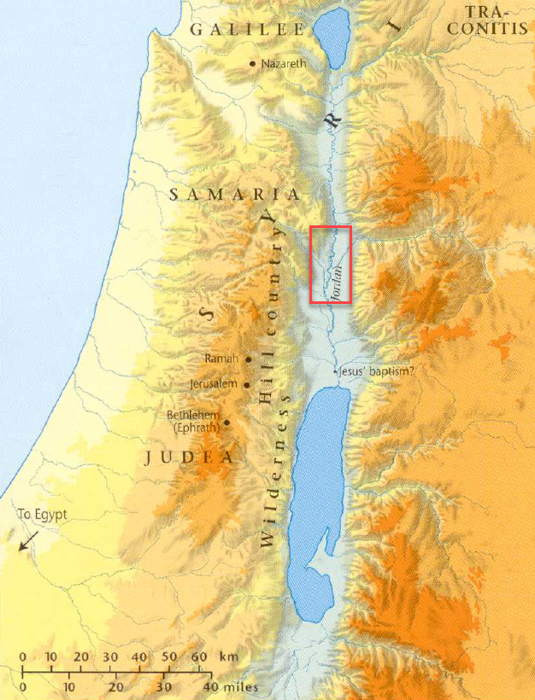
  - From verse 26, we can gather it must have been on the west side of the river (see also John 1:28).
- John the Baptist had not been thrown into prison at this point but it would not be long.
  - Matthew 14:1-12 gives the reader more insight into John’s arrest and eventual execution.
  - He was imprisoned and killed because he boldly preached against the ungodly marriage of Herod Antipas and Herodias.

Joh 3:25 Now a discussion arose between some of John's disciples and a Jew over purification.
Joh 3:26 And they came to John and said to him, “Rabbi, he who was with you across the Jordan, to whom you bore witness—look, he is baptizing, and all are going to him.”

- As we discussed previously, in some ways, baptism was linked back to the ceremonial washings of the Jews.
- Therefore, it makes sense a discussion about ritual purification would arise when the Jews saw what John the Baptist was doing.
- We aren’t told the specifics of their question but it evidently had something to do with the relationship between what John was preaching and what Jesus was preaching.

Joh 3:27 John answered, “A person cannot receive even one thing unless it is given him from heaven.
Joh 3:28 You yourselves bear me witness, that I said, ‘I am not the Christ, but I have been sent before him.’
Joh 3:29 The one who has the bride is the bridegroom. The friend of the bridegroom, who stands and hears him, rejoices greatly at the bridegroom's voice. Therefore this joy of mine is now complete.
Joh 3:30 He must increase, but I must decrease.”

- John was not envious that people were following Christ instead of him (which is admirable).
- When his disciples pointed out that “all are going to him (Jesus),” John didn’t launch a campaign to win the people back.
- His answer revealed his humility and his willingness to fulfill the role God gave him without overstepping.
- APPLICATION:
  - There are many who step into godly roles and do good work for the Lord.
  - But there are many who, after achieving some notoriety and praise, forget their place and their pride carries them to places they shouldn’t go.
  - John probably struggled with personal pride just like every other man.
  - It would have been exceptionally difficult to be the center of attention of “all Jerusalem” and then sink back into the shadows upon the arrival of Jesus.
  - John deserves some credit for the way he acted.
- In verse 27, I understand John to be saying, “My role and success as a teacher came from God and now Jesus’ role and success as a teacher is being given by God.
  - John didn’t come to build a following.
  - He came to get the people ready to be followers of Christ.
  - Jesus could not have accomplished the works He was doing without the approval of God.
  - John recognized that fact and submitted to heaven’s decision to move attention away from himself and on to Christ.
- John’s disciples should not have been surprised by this shift.
  - This was the message John had been preaching in the wilderness.
  - He was not the Messiah, he was only preparing the road for the King.
- John then gives an illustration from a wedding.
  - The friend of the bridegroom (we would say groom) is not the one getting married.
  - It is not his “big day.”
  - But he is happy/joyous to see the wedding day arrive because he is excited for his friend, the groom.
  - John says he has experienced this happiness/joy.
- What does the illustration mean?
  - We’ve seen in other gospels the picture of Jesus as a bridegroom (See Matt 9:15).
  - The events transpiring in Judaea at this time were not going to culminate in John the Baptist being honored (and John knew it).
  - This was Jesus’ appearance, the Messiah’s big day.
  - And John rejoiced at its arrival.
  - SIDE NOTE: Can you imagine if John had taken the opposite attitude? If he had begrudged Jesus’ coming? He would be like a best man at a wedding who spent the whole day complaining that He wasn’t the one getting married.
- “He must increase, but I must decrease.”
  - Jesus would continue to increase and John would fade into history.
  - In my opinion, these might be some of the greatest words ever spoken.
  - I don’t know if any words could better summarize the Christian life.
    - We receive the grace of Christ, not because we are great, but because Christ is great.
    - What should be our response?
    - We should give our lives to uplifting Christ so others can see how great He is!
    - We should be content to fade into history, to not make a name for ourselves, so that where we should have been in the history book, there is only Jesus.

Joh 3:31 He who comes from above is above all. He who is of the earth belongs to the earth and speaks in an earthly way. He who comes from heaven is above all.

- John knew he and Christ were fundamentally different.
- John was a man born on the earth with limited understanding, preaching only what God revealed to him.
- John knew only so much, just like the prophets who came before him.
- Jesus was from above (heaven).
- He had come from God, He was God, and His preaching flowed from His divinity.
- He had the understanding to reveal everything.

Joh 3:32 He bears witness to what he has seen and heard, yet no one receives his testimony.

- Bear witness – to show that something exists or is true.
- Christ, having come from heaven and not earth, was the unique witness to the nature and plan of God.
- The prophets had heard the voice of God, but Jesus had dwelt in the presence of God since eternity past.
  - He was part of the Godhead.
  - He knew every intricate detail of all the sovereign plans.
  - No one could witness to God better than God!
  - Joh 1:18 No one has ever seen God; the only God (Jesus), who is at the Father's side, he has made him known.
- Yet, very few people accepted what He had to say.
- APPLICATION:
  - When we don't have a lot of positive results, it's easy to think that maybe we aren't communicating God properly to the people we're trying to reach.
  - And while we should definitely be continuously evaluating our approach, Our approach may not be the problem.
  - Jesus, who had been with God for an infinite amount of time, came to earth to tell people who God was and they wouldn’t listen.
  - You aren’t going to communicate God better than Jesus.
  - So don’t let poor results convince you you are doing something wrong.
    - I think that is an idea the devil plants in our heads very effectively.
    - He gets some people to stop preaching truth by getting them to think they’ve done something wrong because no one is responding.

Joh 3:33 Whoever receives his testimony sets his seal to this, that God is true.
Joh 3:34 For he whom God has sent utters the words of God, for he gives the Spirit without measure.
Joh 3:35 The Father loves the Son and has given all things into his hand.

- As just stated, most rejected Jesus’ teaching.
- But those who accept it put their seal on the fact that “God is true.”
- What does that mean?
  - Think of a seal like the old Medieval movies.
  - The king wore a special ring which was pressed into wax to stamp a design.
  - If a letter or document possessed that seal, the recipient knew it had the approval of the king.
  - 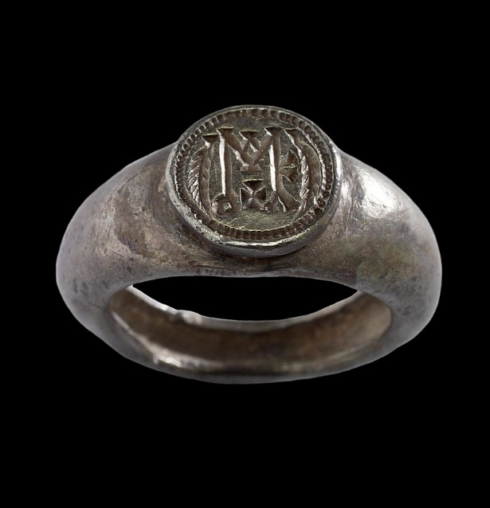
  - Similar stamps/seals are still used in place of signatures today.
  - The Japanese “hanko” is used for a similar purpose.
  - These seals are signs of approval and acknowledgment.
  - Those who receive the testimony of Jesus, are those who recognize Him as coming from heaven and acknowledge that His words and teachings are from God.
  - When they recognize those things, they set their seal (give their approval and acknowledgement) to the fact that God is true.
  - God is faithful. He kept all of His promises in the Old Testament and all of those promises have been kept through Jesus.
  - When we become a Christian, we are figuratively putting our seal in the wax as a formal recognition that Jesus is who He says He is and that He is the source of God’s promised salvation.
- Moving on to verse 34, Jesus came with the words of God.
  - Hence John’s title for Jesus, “The Word,” at the opening of the book.
  - God’s Spirit enabled the prophets in the Old Testament to know and share God’s message with the people.
    - The Spirit gave them words to speak.
    - Gave them some insight into the heart of God.
    - Sometimes gave them the ability to perform miracles and speak of future events.
  - But what was given to those men was always limited.
  - They were given only a portion of God’s Spirit to accomplish a very specific work.
  - Examples:
    - Deliver the Jews from slavery.
    - Prophecy of the coming Messiah.
    - Or warns people about the consequences of their sin.
  - In contrast, Jesus was not limited in the same way.
    - He knew God fully.
    - Possessed the full Spirit of God.
    - And was not limited in power.
- Verse 35, drives this home.
  - The relationship between God and Jesus is much more intimate than any relationship God had with the prophets.
  - It is illustrated for us in the father/son relationship.
  - God’s servants, the prophets, were given some things.
  - None but Jesus possessed “all things.”

Joh 3:36 Whoever believes in the Son has eternal life; whoever does not obey the Son shall not see life, but the wrath of God remains on him.

- It is up to us whether we accept Christ as coming from heaven and setting our seal to the truth of God.
- But the reality is, no one will have eternal life without Christ.
- Jesus’ words are the way to life (remember John 1?)
- Jesus left heaven and came to earth to give us the words of God that provides light to lead us to eternal life when we make the trip from earth to heaven.
- Those who do not obey the words of Christ have no hope of eternal life.
- The anger of God is directed towards them because they are unwilling to be obedient to Jesus and receive forgiveness.
  - Imagine giving someone an incredible gift and them turning their nose up at it and rejecting it.
  - The forgiveness God offers through Jesus (which we will discover more about in the upcoming chapters) is an incredible gift.
  - Snubbing the gift of your Creator, as if you don’t need it and you can get by without it, is highly disrespectful.
- APPLICATION:
  - Notice the exclusivity of Jesus.
  - The Bible doesn’t teach the idea of many pathways to God.
  - It teaches there is only one way to God (through acceptance and obedience to Jesus).

