JOHN 4

- A significant portion of John 4 describes Jesus’ encounter with a Samaritan woman, often called the “women at the well.” As we work through this chapter, compare and contrast Jesus’ encounter with Nicodemus, the Pharisee, in chapter 3.
- The women at the well and Nicodemus were from very different social strata and of very different reputation in their communities. Take note of the way Jesus talked to each of them, the things He talked about, and the way they responded.

Joh 4:1 Now when Jesus learned that the Pharisees had heard that Jesus was making and baptizing more disciples than John
Joh 4:2 (although Jesus himself did not baptize, but only his disciples),
Joh 4:3 he left Judea and departed again for Galilee.
Joh 4:4 And he had to pass through Samaria.
Joh 4:5 So he came to a town of Samaria called Sychar, near the field that Jacob had given to his son Joseph.

- In John 3:22, Jesus was in the Judean country baptizing.
  - John 4:2 informs us Jesus Himself was not baptizing (it was His disciples).
  - Why didn’t Jesus baptize people?
  - I suspect it was a precaution to avoid the situation that would later arise in Corinth (see 1 Corinthians 1).
    - The Christians in Corinth were divided and one of their points of division centered around who had baptized them.
    - It seems some who had been baptized by prominent Apostles were holding that over the heads of those who had been baptized by less prominent Church members.
    - No doubt, some people would have held their baptism by Jesus above the heads of others.
  - I could also be that this was a work God wanted men to accomplish.
    - Going forward, baptizing people would be the responsibility of the Apostles and disciples.
    - Jesus may have been reinforcing that point by not baptizing people Himself.
- When Jesus heard that the Pharisees had heard that He was making more disciples than John, He decided to leave Judea and go back up to Galilee.
  - The Pharisees had been concerned about the success of John the Baptist.
  - Jesus was now more successful than John.
  - The Pharisees loved the praise of men and would have been angry to see Jesus stealing their attention.
  - Apparently, Jesus didn’t want to incite the Pharisees at this point in His ministry, so He decided to leave Judea and go to Galilee.
- In order to get to Galilee, the text says in verse 4, He had to pass through Samaria.
  - The area where Jesus spent most of His life can be broken down into three large territories.
    - Judea in the South
    - Samaria in the Middle
    - Galilee in the North
  - The most direct route from Judea to Galilee was to go through Samaria, but the Jews hated the Samaritans and many chose to take an alternative route around Samaria.
  - 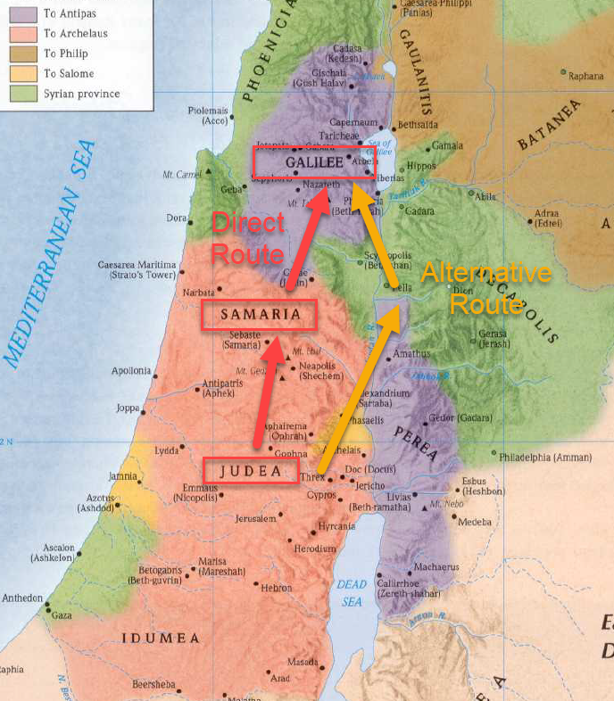
  - Who were the Samaritans?
    - The Samaritans were a people who inhabited northern Israel.
    - In 2 Kings 17:24, after taking Israel captive, the Assyrian empire moved foreigners into Israel’s land.
    - The foreigners married and intermixed with the Israelites that were not sent into captivity.
      - 2Ki 17:24 - And the king of Assyria brought people from Babylon, Cuthah, Avva, Hamath, and Sepharvaim, and placed them in the cities of Samaria instead of the people of Israel. And they took possession of Samaria and lived in its cities.
      - 2Ki 17:28-29 - So one of the priests whom they had carried away from Samaria came and lived in Bethel and taught them how they should fear the LORD. But every nation still made gods of its own and put them in the shrines of the high places that the Samaritans had made, every nation in the cities in which they lived.
    - So the Samaritans were partial-Jews who partially followed the Law of Moses but also worshipped idols.
  - Why did the Jews hate the Samaritans?
    - As mentioned, they changed the Law of Moses and the worship of the one true God into a mish-mash of the Jewish religion mixed with idolatry.
    - Racial tension between “true-Jews” and “half-blood Jews.”
    - The Jews saw the land of Israel as their land, their “Promised Land,” and didn’t probably didn’t want to share it with foreigners.
    - After returning from Babylonian captivity, the Jews set to work rebuilding the city of Jerusalem. At one point, the Samaritans offered to help with the rebuilding of the Temple but were turned away by the Jews. Because of this rejection, the Samaritans ended up opposing the rebuilding effort (Ezra 4 and Nehemiah 4).
    - In Nehemiah 13:28-29, we are told the grandson of the high priest, Eliashib, married the daughter of Sanballat, a Samaritan.
      - Neh 13:28-29 And one of the sons of Jehoiada, the son of Eliashib the high priest, was the son-in-law of Sanballat the Horonite. Therefore I chased him from me. Remember them, O my God, because they have desecrated the priesthood and the covenant of the priesthood and the Levites.
      - Lev 21:13-14 And he shall take a wife in her virginity. A widow, or a divorced woman, or a woman who has been defiled, or a prostitute, these he shall not marry. But he shall take as his wife a virgin of his own people,
      - In doing this, he profaned the priesthood and Nehemiah threw him out of Jerusalem.
      - The Samaritans then built a temple of their own on Mount Gerizim where Eliashib’s grandson officiated as priest.
      - These events solidified the divide between the southern Jews and their Samaritan neighbors to the north.
    - Moving closer to the time of Jesus, the Samaritans allied themselves with the Seleucids (enemies of the Jews) during the Maccabean rebellion.
    - About 110 years before Jesus’ birth, the Jews destroyed the Samaritan temple on Gerizim and ransacked Samarian lands under the military leadership of John Hyrcanus.
    - Shortly after Jesus’ birth, some Samaritans snuck into the Temple and profaned it by scattering human bones inside of it.
      - Now (about 9 AD) when Judea was administered by Coponius, who was sent out by Quirinius [the Roman governor of Syria]...these things occurred: During the celebration of the feast of Unleavened Bread, which we call Passover, in a custom of the priests the gates of the temple [in Jerusalem] were opened after midnight. And then, when their opening first occurred, Samaritan men coming into Jerusalem in secret, began to scatter human bones in the porticoes and throughout the temple. (So, the priests), who were not accustomed to such things before, managed the temple with greater care.
      - Josephus - Antiquities 18.29-30
    - According to Josephus, Samaria became a safe harbor for Jewish law breakers (Antiquities 11.340-346)
      - “But if anyone was charged by Jerusalemites with eating unclean things, or with violating the Sabbath or some other such sin, he fled to the Shechemites, saying he had been unjustly banished”.
      - Shechem was the capital of Samaria.
    - Some discussion of the Samaritans is included in the Babylonian Talmud.
      - Why are Samaritans [kuthim] excluded from entering Israel?
      - --Because they were mixed up with the priests of the high places.
      - Rabbi Ishmael said:
      - "They were righteous proselytes in the beginning."
      - Why are they excluded?
      - --Because they marry illegitimate women but not a brother's widow.
      - When will they be accepted?
      - --When they deny Mount Gerizim and confess Jerusalem and the resurrection of the dead. After this, he who robs a Samaritan is like one who robs an Israelite.
      - Babylonian Talmud – Kuthim 2.7
  - If you have a chance, please read 2Kings 17:24-41.

Joh 4:5 So he came to a town of Samaria called Sychar, near the field that Jacob had given to his son Joseph.
Joh 4:6 Jacob's well was there; so Jesus, wearied as he was from his journey, was sitting beside the well. It was about the sixth hour.
Joh 4:7 A woman from Samaria came to draw water. Jesus said to her, “Give me a drink.”
Joh 4:8 (For his disciples had gone away into the city to buy food.)

- Sychar sat between Mt. Ebal and Mt. Gerizim.
- The proximity to Mt. Gerizim (where the Samaritan temple was located) is important to keep in mind for the next few verses.
- Sychar is in the same location as the ancient city of Shechem.
- 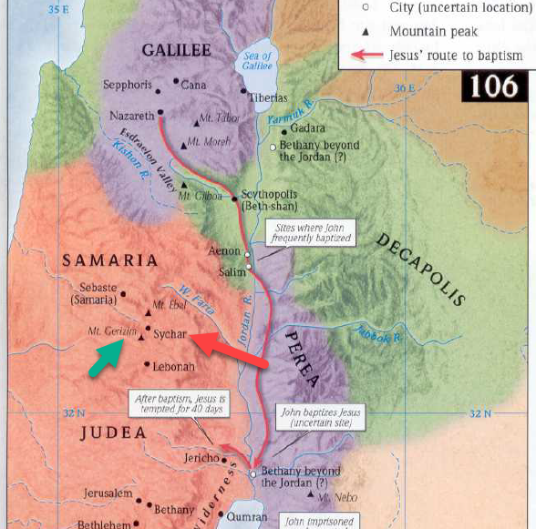
- Jesus was tired from the journey and sat down by “Jacob’s well” around noon.
- His disciples had gone into the city to buy food (makes sense, it was about lunch time).
  - SIDE NOTE: I wonder how the Apostles bought food if they were so adverse to talking with Samaritans (verse 9 and 27).
- As He was relaxing, a woman from the city (a Samaritan) came to draw water from the well.
- Jesus asked her for a drink.

Joh 4:9 The Samaritan woman said to him, “How is it that you, a Jew, ask for a drink from me, a woman of Samaria?” (For Jews have no dealings with Samaritans.)
Joh 4:10 Jesus answered her, “If you knew the gift of God, and who it is that is saying to you, ‘Give me a drink,’ you would have asked him, and he would have given you living water.”
Joh 4:11 The woman said to him, “Sir, you have nothing to draw water with, and the well is deep. Where do you get that living water?
Joh 4:12 Are you greater than our father Jacob? He gave us the well and drank from it himself, as did his sons and his livestock.”
Joh 4:13 Jesus said to her, “Everyone who drinks of this water will be thirsty again,
Joh 4:14 but whoever drinks of the water that I will give him will never be thirsty again. The water that I will give him will become in him a spring of water welling up to eternal life.”

- The woman was shocked to hear Jesus ask her anything.
- Her shock was on account of the tension between the Jews and the Samaritans. She must have assumed she would draw her water in silence and Jesus would sit in silence.
- APPLICATION:
  - How often do people sit across from each other in silence because they assume the other doesn’t want to talk to them?
  - Jesus spoke through the awkward tension and changed this woman’s life (spoiler).
  - If we do the same, we might find doors to introduce people to Jesus so He can change their lives too.
- She asked Jesus why He was asking her for a drink of water, but Jesus tells her she would have asked Him for a drink of “living water” if she knew His true identity.
- If she understood the opportunity in front of her (a private audience with God), she would be the one with questions and requests.
- The woman was confused.
  - She didn’t know who Jesus was.
  - She didn’t know what “living water” Jesus was talking about.
  - All she knew was Jesus didn’t have any kind of container to get water out of Jacob’s well or any well.
- The Jews used the term “living water” to refer a spring of pure, clean, flowing water.
  - The Jews considered living water superior to stagnant “dead” water.
  - They used living water in their Mikveh for ceremonial washings.
- In a purely physical sense, Jesus was telling her He could provide her with better water than she was pulling up from the well.
  - This seems to be the way she interprets His words.
  - She was thinking, “Where will He find living water?”
  - “If Jacob, as great as he was, couldn’t find it and he and his family and animals all drank from this well, what makes this man think He can do better?
  - “Is he greater than our father Jacob?”
- The quick answer to her question was, “Yes!”
  - Jesus was the God of Abraham, Isaac, and Jacob.
    - Luk 1:32 He will be great and will be called the Son of the Most High. And the Lord God will give to him the throne of his father David, and he will reign over the house of Jacob forever, and of his kingdom there will be no end.
  - But Jesus didn’t respond with such directness, at least not yet.
- It is hard to distinguish the attitude of the woman at this point in the conversation. What is her tone? Was it cynical? Or was it curious?
- Whatever her attitude, Jesus continued.
  - Anyone who drank water from Jacob’s well would be thirsty again.
    - No doubt, the woman was very familiar with that fact.
    - She probably had to come to the well multiple times a week.
  - Jesus then said, “whoever drinks of the water that I will give him will never be thirsty again.
  - A person who drinks the water Christ offers will themselves will become springs of water “welling up to eternal life.”
    - Jesus says something similar in John 7
    - Joh 7:37 On the last day of the feast, the great day, Jesus stood up and cried out, “If anyone thirsts, let him come to me and drink. Whoever believes in me, as the Scripture has said, ‘Out of his heart will flow rivers of living water.’” Now this he said about the Spirit, whom those who believed in him were to receive, for as yet the Spirit had not been given, because Jesus was not yet glorified.
  - Jesus’ illustration may have been more obvious to those living in the middle east where deserts are much more common.
    - In a spiritual sense, this world is a lot like a desert.
      - We wander in the desert desperately thirsty for joy and happiness and satisfaction.
      - We see mirages, lies, the devil places in front of us in hopes we will pursue them endlessly. Always looking satisfying from a distance but, when reached, never fulfilling our souls thirst.
    - A spring of water in the desert is life saving and life sustaining.
    - Jesus told this woman He could give her this life giving water, it would remain in her, and she would never thirst again.
      - What is Jesus saying?
      - In Jeremiah 2 and 17, God is said to be the source of living water.
      - Anyone who searches for satisfaction outside of God will not be able to find it.
      - Every other source of joy and happiness and satisfaction is a mirage.
      - If we pursue them, we will die.
      - But if we give up chasing mirages, are made a new creation by the life giving power of Jesus (John 1; 2 Corinthians 5:17), are born again to new life by water and the Spirit (John 3), walk by the Spirit and in step with the Spirit (John 7; Gal 5), our souls will find the joy and peace for which they’ve been thirsting.
      - There is a joy and peace which comes from knowing you are in alignment with the Creator of the universe.
        - I think those who have experienced real peace with God know there isn’t anything like it.
        - There is something about knowing you are ok in life and in death, that the promises of God are true for you, that you are watched over by extraordinary power.
        - That isn’t to say you will never be tempted again.
        - But deep down, those who’ve experienced that peace, know there isn’t anything in the world that can duplicate that feeling.
      - Jesus made that peace possible by coming, dying for us, resurrecting, and sending the Spirit of God.
      - The Spirit bears witness with our spirit that we are the children of God (Rom 8:16).
        - We were made for more than dying after 80 years of pursuing petty earthly pleasures.
        - We were made to be the children of God. To have eternal life with Him.
        - Jesus told the Samaritan women He had come to accomplish this work.
        - The water Jesus was offering was constant, always inside a person, not running short of supply like physical provisions, but an every gushing stream, sufficient in this life, and even into eternal life.
        - He could show the weary what their hearts had been longing for. Something better than the temporary joys earth could offer.
        - Sin always leaves a person thirsty, wanting more, not forever fulfilled.
        - Jesus had come to bring the water of life to a wasteland of sin, so the thirsty and wandering seekers could finally find the satisfaction they long pursued in the mirages of the desert.
        - Satan leads you into the desert to die. Jesus will lead you to the oasis to live as you never have before.
        - And He will put that living water within you, continuously flowing from your heart, and based on John 7, that appears to be accomplished by the Spirit of God.
- This is one of many occasions when Jesus used everyday conversation to lead into a spiritual discussion.
  - How can we develop this skill?
  - “One way to acquire the art is to have the mind full of the subject; to make religion our first and main thing; to carry it with us into all employments and into all society; to look upon everything in a religious light, and out of the abundance of the heart the mouth will speak, Mat 12:34.” (Albert Barnes).

Joh 4:15 The woman said to him, “Sir, give me this water, so that I will not be thirsty or have to come here to draw water.”
Joh 4:16 Jesus said to her, “Go, call your husband, and come here.”
Joh 4:17 The woman answered him, “I have no husband.” Jesus said to her, “You are right in saying, ‘I have no husband’;
Joh 4:18 for you have had five husbands, and the one you now have is not your husband. What you have said is true.”

- Upon hearing about Jesus’ eternally satisfying water, the woman wanted some and asked Jesus to give it to her.
  - She didn’t understand the spiritual meaning behind Jesus’ use of water.
  - She thought He was offering magical water that would save her a trip to the well everyday.
- I once thought Jesus’ next statement was disconnected from the first part of their conversation, but having studied it further, I see a connection.
- Jesus tells the woman to get her husband and bring him to the well.
- She tells Jesus she doesn’t have a husband.
- Jesus, knowing this already, responded, “You are right in saying, ‘I have no husband’; for you have had five husbands, and the one you now have is not your husband.”
  - This woman had been married 5 times.
  - She was now with a man who wasn’t her husband.
    - Perhaps she was sleeping with him.
    - Perhaps she was living with him.
- She hadn’t told Jesus any of this information. He revealed His knowledge of her to prove He was a man worth listening to.
- Why does Jesus start talking about her husbands? What does that have to do with living water?
  - You don’t get married 5 times and then go out and find a lover unless you are looking for something and you aren’t finding it, right?
  - She was thirsty for something, she evidently believed men were a way to satiate that thirst, but she had been chasing down mirages in the desert.
  - Jesus is very direct and lays the problem out plainly.
  - This woman came to the well thirsty in body and thirsty in her soul.
    - She expected to find a remedy for the first, but little did she know she would find two wells where she only anticipated one.
    - Jacob’s well and Jacob’s God (the source of living water).

Joh 4:19 The woman said to him, “Sir, I perceive that you are a prophet.
Joh 4:20 Our fathers worshiped on this mountain, but you say that in Jerusalem is the place where people ought to worship.”

- If the woman was skeptical before, she wasn’t skeptical after Jesus revealed her own secrets to her.
- She concluded Jesus was a prophet.
- She then asks a question about worship.
- SIDE NOTE: Mt. Gerizim would have been within eyesight of Sychar.
- Why?
  - I once believed her question was an attempt to change the subject.
    - Who wants to talk to a stranger about their marriage failures and sex life?
    - Maybe she threw out a question about worship to skirt the issue.
  - But having studied the text again, I’m not sure if that is true.
  - Put yourself in the woman’s shoes.
    - Imagine a person comes up to you and tells you they have the thing for which you’ve been searching.
    - They can show you how to have joy and inner peace with God.
    - And they even have miraculous power to share with you intimate details about your life.
    - It is clear they have the power of God.
    - But what if they are a Muslim and you are a Christian.
    - What is the first thing you are going to do?
      - You don’t deny they have unexplainable power.
      - But you’ve got a few points of contention you need to get resolved before you can buy into the idea that this person is from God.
      - So you would probably immediately start talking about the biggest difference between your faith and theirs.
    - What was the first thing the woman did?
    - What was the biggest point of contention between the faith of Jesus (who was a Jew) and this woman (who was a Samaritan)?
    - Answer: The location of worship.
      - The Jews said it was in Jerusalem.
      - The Samaritans said it was on Mt. Gerizim.
      - And both sides argued that the “fathers” approved of their location (verse 20).
- APPLICATION:
  - Here is an example of a woman who is religiously confused.
  - She’s probably been told her entire life the “fathers” taught Mt. Gerizim was the true place of worship.
  - If she knew the Old Testament writings, she would have known that was correct.
  - But it goes to show, just as we see in the religious world today, many people believe things because they were raised in a community that believed those things.

Joh 4:21 Jesus said to her, “Woman, believe me, the hour is coming when neither on this mountain nor in Jerusalem will you worship the Father.

- Lets break these verses down one by one.
- Jesus tells her the time is coming when neither Jerusalem nor Mt. Gerizim will be God’s dedicated place of worship.
- The long debate between the Jews and the Samaritans wouldn’t be relevant in the near future.

Joh 4:22 You worship what you do not know; we worship what we know, for salvation is from the Jews.

- “You worship what you do not know…”
  - Jesus doesn’t let the Samaritans off the hook.
  - He tells this woman the Samaritans do not know the God they claim to worship.
  - They accepted the books of Moses but rejected the prophets.
  - They worshiped God, in a fashion, but also introduced numerous corruptions and included the worship of false Gods.
  - Their Mt. Gerizim was not the true place of worship.
- “We worship what we know…”
  - We (the Jews) know God better than the Samaritans.
  - They certainly were not perfect but they accepted the messages of the prophets of God.
  - They accepted the Scriptures that revealed the will of God.
  - Their Temple was the true place of God’s presence and the location at which He desired to be worshiped.
- “for salvation is from the Jews.”
  - God had promised to work through the Jews (specifically the tribe of Judah, through which the Samaritans did not descend) to bring about the salvation of His people.
  - It was through their religion, their sacred writings, their prophets, that God was working.

Joh 4:23 But the hour is coming, and is now here, when the true worshipers will worship the Father in spirit and truth, for the Father is seeking such people to worship him.
Joh 4:24 God is spirit, and those who worship him must worship in spirit and truth.”

- When will the debate about the location of worship no longer be relevant?
- Jesus tells the woman the “hour is coming, and is now here.”
- Jesus had come to the earth to make this change.
- The Old Testament scriptures were being fulfilled in Jesus and He was going to bring the Kingdom of Heaven to earth.
  - Unlike the Kingdom of Israel, where the children of the kingdom (Jews) were required to worship in Jerusalem, the Kingdom of Heaven is a spiritual Kingdom centered in Heaven, its citizens (the children of God) worship “in spirit and in truth.”
  - How can we worship “in spirit.”
  - How can you worship God (who is a spirit) in a spiritual Kingdom?
  - Answer: The only way to do it is to become spirit yourself!
  - Don’t believe me?
    - Remember Jesus’ words to Nicodemus in John 3:5-6
    - Joh 3:5-6 Jesus answered, “Truly, truly, I say to you, unless one is born of water and the Spirit, he cannot enter the kingdom of God. That which is born of the flesh is flesh, and that which is born of the Spirit is spirit.
    - Only a person “born of the Spirit” can worship God “in spirit.”
    - Those born again to new life by the Spirit of God.
    - Because only a person “born of the Spirit” is a citizen of the Kingdom of God.
    - You cannot be a part of a spiritual kingdom if you are not spirit yourself.
  - My next question would be… What does that mean? How does that work? What does it mean I’m a spirit?
    - That seems very abstract!
    - Jesus doesn’t tell Nicodemus how it works.
    - Joh 3:8 The wind blows where it wishes, and you hear its sound, but you do not know where it comes from or where it goes. So it is with everyone who is born of the Spirit.”
    - You know the wind blows but you cannot explain the particular manner of its acting… “So it is with everyone who is born of the Spirit.”
    - I think that is an answer we should be content with.
    - I think we need to be careful not to oversimplify Jesus’ meaning so we can have a nice, concise, easy to explain interpretation
  - What does it mean to worship “in truth.”
    - Jesus was talking to a woman whose community had been worshiping God incorrectly for centuries.
    - In the future, God was not going to be worshiped with the ignorance and corruption of the Samaritan’s religion.
    - Neither was He going to be worshiped with the ceremonies, types, and shadows of the religion of the Jews.
    - Jesus had come to make the Father known (John 1:18) so that He could be worshiped “in truth.”

Joh 4:25 The woman said to him, “I know that Messiah is coming (he who is called Christ). When he comes, he will tell us all things.”
Joh 4:26 Jesus said to her, “I who speak to you am he.”

- The Samaritan woman may not have been completely satisfied with Jesus’ answer but she knew one thing.
- When the Messiah arrived, He would clarify everything.
- Jesus’ response was direct and impossible to misunderstand, “I who speak to you am he!”
- It is interesting to see Jesus speak so plainly about His identity to a Samaritan woman.
- His language was hardly ever so straightforward with His countrymen.

Joh 4:27 Just then his disciples came back. They marveled that he was talking with a woman, but no one said, “What do you seek?” or, “Why are you talking with her?”

- This verse is easily explained now that we explored the tensions between the Jews and Samaritans.
- Jesus’ disciples, returning from the city, revealed they shared their fellow countrymen’s distaste for the Samaritans.
- They couldn’t understand why Jesus was even willing to engage in conversation with this woman.

Joh 4:28 So the woman left her water jar and went away into town and said to the people,
Joh 4:29 “Come, see a man who told me all that I ever did. Can this be the Christ?”
Joh 4:30 They went out of the town and were coming to him.

- It was important for the disciples to witness this woman’s belief.
- Although they didn’t know it at the time, they would soon be participants in a Church comprised of all nations.
  - The “God’s people” as they knew it under the Old Law was going to go through a definition change.
  - The children of God following Jesus’ resurrection would include people of all ethnicities.
- The Samaritan woman was so excited about her encounter with Jesus she ran back into the city and started telling everyone about Him.
- APPLICATION:
  - How excited are we that we’ve found Jesus?
  - Have you told anybody?

Joh 4:31 Meanwhile the disciples were urging him, saying, “Rabbi, eat.”
Joh 4:32 But he said to them, “I have food to eat that you do not know about.”
Joh 4:33 So the disciples said to one another, “Has anyone brought him something to eat?”
Joh 4:34 Jesus said to them, “My food is to do the will of him who sent me and to accomplish his work.

- As I hope you know, food and drink sustain human life.
- They give us energy to continue with the activities of the day.
- It was lunchtime and the disciples had probably been walking all morning.
- They were hungry (like any of us would have been) so they went to find some food to keep them going.
- But when they brought the food to Jesus He must not have shown a great deal of interest.
- They “urged” Him to eat, but He told them He had food to eat they didn’t about.
- The disciples were confused, “Has anyone brought Him food to eat” they asked.
- Jesus then clarifies His meaning.
  - There are few things humans crave more often than food and drink.
  - Jesus’ greatest desire, what energized Him, what kept Him going, was accomplishing God’s work.
- Jesus wanted His Apostle’s hearts tuned in a similar way.
  - He wanted the completion of God’s work to be nearer their hearts than the physical work of the everyday.
  - People’s souls more important to them than satisfying a physical craving.
  - To find their ultimate satisfaction and source of life in God.
- Why was Jesus the only one who stayed behind at the well when everyone else went into the city?
- Because He knew a soul needed cared for and He knew it would also afford Him the opportunity to teach his disciples this lesson.
- Several times in Jesus’ ministry we see Him practice what He is preaching here.
  - Jesus would make a trip across the sea of Galilee to rest, but upon finding a crowd of needy people at His destination, His compassion would move Him to forgo resting to help them.
  - Jesus would sacrifice sleep so He could stay up late to pray.
- APPLICATION:
  - I think there is a lot of application here for us (I know there is for me)!
  - How often do we use the excuse…
    - “I’m to tired.”
    - “I need rest.”
    - “I need to get some sleep.”
    - “I’ve got other things I’ve got to take care of.”
    - “I haven’t eaten in ___ hours.”
    - Etc…
  - …to excuse ourselves from God’s work? From going to worship? From making a visit? From supporting an event?
  - I know I’ve used that excuse many times.
  - Just something to consider… We don’t often see Jesus utilizing that excuse.

Joh 4:35 Do you not say, ‘There are yet four months, then comes the harvest’? Look, I tell you, lift up your eyes, and see that the fields are white for harvest.

- Staying on the topic of food, Jesus brings up the topic of harvesting.
- It probably would have been more natural for a 1st Century Jew to connect the idea of food to the harvesting of a field. It doesn’t come as naturally for us 21st Century humans who go the grocery store (not the field) to bring food home.
- Jesus compares the work of God to bringing in the harvest.
- Experienced farmers could anticipate how long it would take their crops to be ready to harvest.
- In the case of wheat, the tops of the wheat flower can appear white in the sun as they approach harvesting time.
- Jesus knew the wheat fields weren’t yet ripe to harvest but He is making a spiritual comparison.
- Unlike the physical fields, there was a spiritual field ready for harvesting.
- An earthly farmer harvests grain and his crop feeds him throughout the year.
- A spiritual harvester participates in God’s harvest and his work provides him the better, spiritual food, Jesus told his disciples they didn’t know about.
- The Apostles would find a greater satisfaction in God than in physical food.
- This was their opportunity to participate in the harvest, accomplish God’s work, and be filled with the satisfaction of something much greater than whatever they had purchased for lunch in the city that day.

Joh 4:36 Already the one who reaps is receiving wages and gathering fruit for eternal life, so that sower and reaper may rejoice together.
Joh 4:37 For here the saying holds true, ‘One sows and another reaps.’

- “Already” in verse 36, seems to contrast the spiritual work in front of the disciples which was awaiting their immediate participation with the physical wheat harvest for which the farmers were still patiently waiting.
- There was already work needing done in the field of souls and those who labored were collecting wages and fruit for eternal life.
  - Those who serve God by gathering souls into His Kingdom earn a reward from God.
  - And unlike earthly food, which rots or molds after a period of time, those who work in the spiritual field gather souls (fruit) for eternal life.
- The sower and the reaper will rejoice together.
  - Someone sows the seed (preaches the gospel).
  - In this case it was Jesus.
  - Someone else comes along later and builds on their work.
  - In our Christian walk, we typically have multiple people who contribute to our spiritual growth and maturity.
    - Someone may teach us about Jesus for the first time.
    - Later, someone may help understand the scriptures more accurately.
    - Someone else may help us overcome a temptation.
    - Then, a person will bear our burden with us.
  - All of these people play a part in our Christian walk.
  - There are multiple roles just as in the farming process.
  - Just as there is rejoicing after a harvest is brought into the farmer’s barn, there will be rejoicing when the saved are gathered in heaven and the work of God is complete.
  - God and all of His servants will rejoice together.

Joh 4:38 I sent you to reap that for which you did not labor. Others have labored, and you have entered into their labor.”

- The disciples were being sent out to complete work started by someone else.
- Who were the laborers who had started the work?
- Jesus doesn’t tell us exactly who He had in mind here but I think we can figure it out.
  - In the immediate sense, Jesus had started the work.
    - He had talked to the Samaritan woman, initiated the conversation, and turned her mind towards spiritual things.
    - The disciples would be engaged in the work Jesus started for the next 2 days (see verse 40).
  - In a broader sense, the disciples were entering into the work of God to save the world through the Messiah.
  - God’s sovereign plan to save had already been working itself out for 1,000s of years:
    - Through Abraham
    - Joseph
    - Moses
    - The Judges
    - The Kings
    - John the Baptist
    - Jesus
  - Jesus is inviting His Apostles to be participants in God’s work (verse 34).
  - To join the story.
- APPLICATION:
  - God is sovereign, meaning He has the power to control everything and is successful at anything He wants to accomplish.
  - Whether we choose to be a servant of the Lord’s will not make Him more or less successful.
  - But God offers us the opportunity to join His story.
  - The story of His reign and supremacy.
  - The story of the Kingdom of Heaven and how the Kingdom of Heaven will eventually put down all enemies and God will reign as the uncontested King.
  - We have to choose.
    - Reject God and go down with the losing side.
    - Or join ranks with the unstoppable Kingdom.

Joh 4:39 Many Samaritans from that town believed in him because of the woman's testimony, “He told me all that I ever did.”
Joh 4:40 So when the Samaritans came to him, they asked him to stay with them, and he stayed there two days.
Joh 4:41 And many more believed because of his word.

- Here is a woman, not of high social status, probably not of high reputation in the minds of her neighbors, but a woman who brought her whole community to Jesus.
- Her willingness to be open to Jesus’ teaching and her excitement after accepting it, led to the joy of a great many people.
- APPLICATION:
  - You aren’t too sinful to be a servant of God.
  - This woman is one of the first individuals Jesus used in a powerful way during His ministry and her past was all messed up.
- APPLICATION:
  - Our excitement about Jesus will rub off on other people.
  - If we are full of joy and excitement about finding Jesus, it will have a contagious affect.
  - If we act like being a Christian is a drag, other people will assume it’s a drag.

Joh 4:42 They said to the woman, “It is no longer because of what you said that we believe, for we have heard for ourselves, and we know that this is indeed the Savior of the world.”
Joh 4:43 After the two days he departed for Galilee.

- A significant number of people believed in Jesus after hearing Him for themselves.
- Jesus stayed in Samaria for two days.
- Can you imagine the culture shock of the disciples?
  - They go from refusing to hold a conversation with a Samaritan, to being their house guests for a few nights.
  - The man they respected most, their rabbi, their teacher, pushed them out of their comfort zone in order to teach them and the Samaritans about the work of God.
  - From this time onward, they would always remember how the Samaritans, who they had believed inferior to themselves, had accepted Christ, while the “superior” Jews didn’t want anything to do with Him.
- Moving outside your comfort zone is often where greater perspective and growth are found.
- Jesus wasn’t afraid to make His disciples uncomfortable to encourage growth.
- The Apostles needed to know what it was like to be part of a class of people the Jews rejected, they would soon be experiencing similar treatment.
- APPLICATION:
  - It would be hard to argue Jesus coddled His Apostles.
  - He pushed them… pretty hard!
  - Are we doing the same for each other in our congregations?
  - Pushing each other for growth and new perspective?
  - In my experience, we to often justify each other’s reasons not to take a step out of the comfort zone.
  - Trying something new and being uncomfortable isn’t the worst thing in the world.
  - But always remaining comfortable might be!
  - We should be like Jesus!

Joh 4:44 (For Jesus himself had testified that a prophet has no honor in his own hometown.)
Joh 4:45 So when he came to Galilee, the Galileans welcomed him, having seen all that he had done in Jerusalem at the feast. For they too had gone to the feast.

- 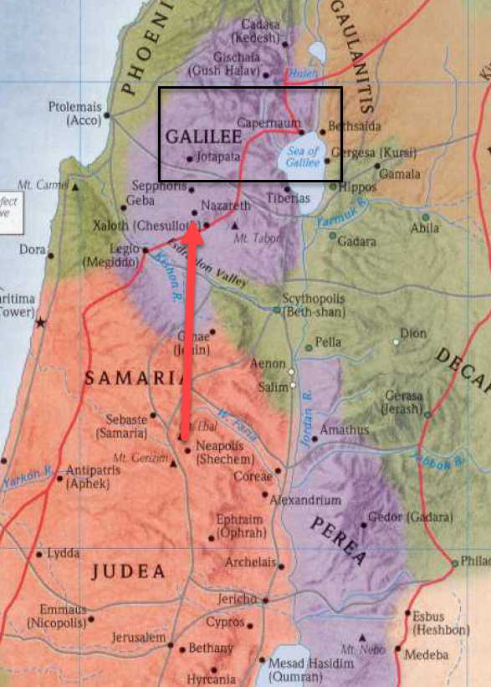
- It would have been pretty natural for Jesus to go through Nazareth on his way to Galilee.
- Nazareth was His hometown (you usually don’t drive around your hometown when you pass by).
- We are told here and in the other gospels, the reason Jesus didn’t spend much time in Nazareth was because the people who lived there would not accept His message.
- Their familiarity with Jesus, His upbringing, and family prevented them from seeing Him as anything other than a local boy.
- Unlike the Nazarenes, the people of Galilee, who were much less familiar with Jesus, were open to giving Him a fair hearing.

Joh 4:46 So he came again to Cana in Galilee, where he had made the water wine. And at Capernaum there was an official whose son was ill.
Joh 4:47 When this man heard that Jesus had come from Judea to Galilee, he went to him and asked him to come down and heal his son, for he was at the point of death.

- Instead of Nazareth, Jesus went a bit more North to Cana (this is where Jesus had turned the water to wine).
- 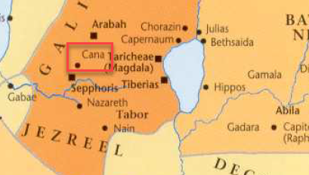
- There was an official from the city of Capernaum who had a sick son, so sick he was at the point of death.
- When he heard Jesus was in Cana, he went looking for Him and found Him.
- APPLICATION:
  - How did this man know about Jesus?
  - He heard!
  - If he heard it, it means someone must have been talking about it.
  - I think there are a lot of people in the world like this man.
    - They have a need.
    - But they don’t know where to go to solve the problem.
    - They need to hear about the solution from someone.
  - If no one had been excitedly talking about Jesus in Capernaum that day, this man wouldn’t have heard the solution to his problem.
  - We don’t know how the man heard.
    - We don’t know if someone told him directly.
    - Perhaps he overhead the excited conversation of his neighbors.
  - The point is, he found what he was looking for because people were discussing Jesus.
  - If no one (or if we) are not excitedly talking about Jesus, how can we expect anyone to know where to go to solve their problems.
    - It doesn’t even have to be a direct conversation.
      - Someone might overhear your conversation about Jesus with your friend.
      - Someone might catch one sentence you say as they walk next to you on the street.
    - That small exposure to Jesus may be enough for a person in desperate need to go search Him out.
    - Don’t you know, God can providentially arrange for a person to hear the 5 seconds of your conversation that will change their life.
  - The more Jesus roles off your tongue, the more opportunities for people to hear about Him.

Joh 4:48 So Jesus said to him, “Unless you see signs and wonders you will not believe.”
Joh 4:49 The official said to him, “Sir, come down before my child dies.”
Joh 4:50 Jesus said to him, “Go; your son will live.” The man believed the word that Jesus spoke to him and went on his way.

- Verse 48 is a bit tricky to me.
  - Jesus says to the man, “Unless you see signs and wonders you will not believe.”
  - How do we interpret that?
    - It is clear the man had some level of belief/faith (otherwise he wouldn’t have come to Jesus.
    - We can’t understand this statement to be directed at all the Galilean Jews because verse 48 reads, “Jesus said to him.”
  - The man had some measure of faith but it must have been lacking in some way.
  - From Jesus’ statement, his faith was too dependent on the witnessing of miracles and supernatural wonders.
    - Several times in the gospels, Jesus makes it clear He wasn’t looking for followers who are devoted to Him for no reason other than to witness amazing things.
    - Their faith needed to be based on the Scriptures, on His words, on His presentation of God, and their love for the God He revealed.
    - I think part of the reason I find this tricky is because, most of the time, when people asked Jesus for healing, He commended their faith.
    - But here we seem to find a critique.
    - APPLICATION:
      - In the 1st Century, there was a difference between those who followed Jesus because He was able to show them amazing things and those who followed Jesus because He was able to show them the Father.
      - Today, there is a difference between us following Jesus because we are amazed by and love the quality, the aesthetics, the beauty, of contemporary Christian worship and following Jesus because we are amazed by and love the beauty of the God revealed to us in Christ.
  - This man’s faith must have needed some maturing in those areas.
- We don’t know how the official took Jesus’ words based on His response in verse 49, all we know is he asked Jesus again to heal his son.
- Jesus, unopposed to helping the man, tells Him, Go; your son will live.”
  - This may be the first step in Jesus’ refinement of his faith.
  - He doesn’t go with the man.
  - He doesn’t perform a miracle in front of him..
  - There was nothing observable.
  - Jesus tells the man to trust His word.
- The nobleman then returned home having “believed the word that Jesus spoke.”

Joh 4:51 As he was going down, his servants met him and told him that his son was recovering.
Joh 4:52 So he asked them the hour when he began to get better, and they said to him, “Yesterday at the seventh hour the fever left him.”
Joh 4:53 The father knew that was the hour when Jesus had said to him, “Your son will live.” And he himself believed, and all his household.
Joh 4:54 This was now the second sign that Jesus did when he had come from Judea to Galilee.

- On his trip home, one of the official’s servants met him and told him his son was recovering.
- Knowing roughly the time he had spoken with Jesus, he asked his servant what time the boy had started to recover.
- The servant told him it was at the 7th hour.
- The correlation was exact.
- Jesus’ word had healed his son.
- He and all of his household “believed.”

https://housetohouse.com/jews-samaritans-hate-one-another-much/
https://en.wikipedia.org/wiki/List_of_disqualifications_for_the_Jewish_priesthood
https://en.wikipedia.org/wiki/Mount_Gerizim
https://www.thetorah.com/article/purity-of-priests-contamination-through-marriage
http://www.antiquities.org.il/Article_eng.aspx?sec_id=36&subj_id=286&id=472
https://en.wikipedia.org/wiki/John_Hyrcanus
https://www.thattheworldmayknow.com/living-water-en-gedi
https://www.bridgesforpeace.com/article/mayim-chaim-living-waters/
https://www.hebrew4christians.com/Meditations/Mayim_Chayim/mayim_chayim.html
https://www.oneforisrael.org/bible-based-teaching-from-israel/living-water/

