MARK 11
Mar 11:1 Now when they drew near to Jerusalem, to Bethphage and Bethany, at the Mount of Olives, Jesus sent two of his disciples
Mar 11:2 and said to them, “Go into the village in front of you, and immediately as you enter it you will find a colt tied, on which no one has ever sat. Untie it and bring it.
Mar 11:3 If anyone says to you, ‘Why are you doing this?’ say, ‘The Lord has need of it and will send it back here immediately.’”
Mar 11:4 And they went away and found a colt tied at a door outside in the street, and they untied it.
Mar 11:5 And some of those standing there said to them, “What are you doing, untying the colt?”
Mar 11:6 And they told them what Jesus had said, and they let them go.

- Jesus left Jericho, healed blind Bartimaeus on the way out, and approached Bethphage and Bethany.
- 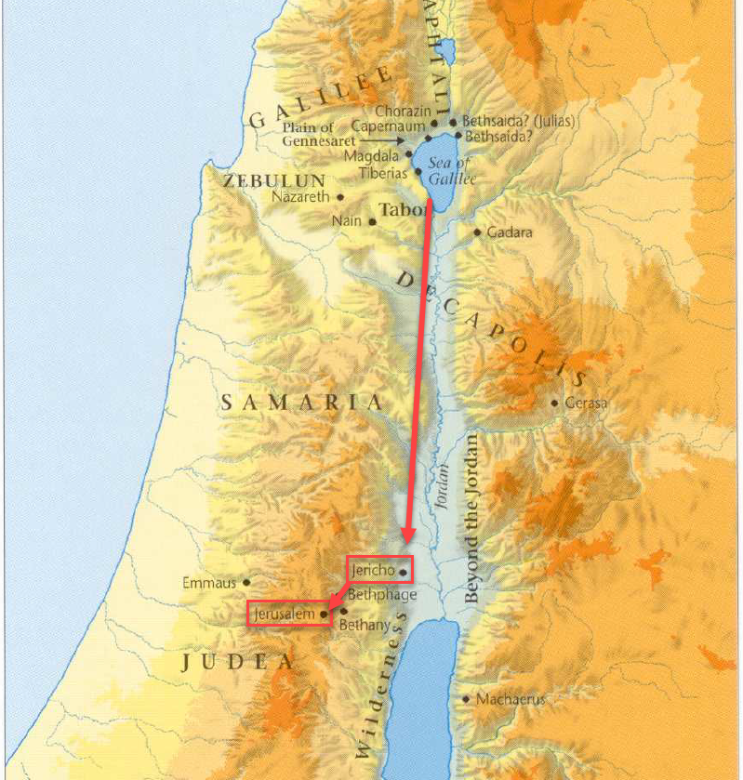
- 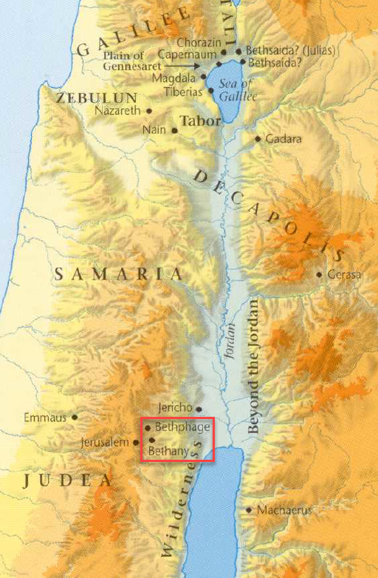
- 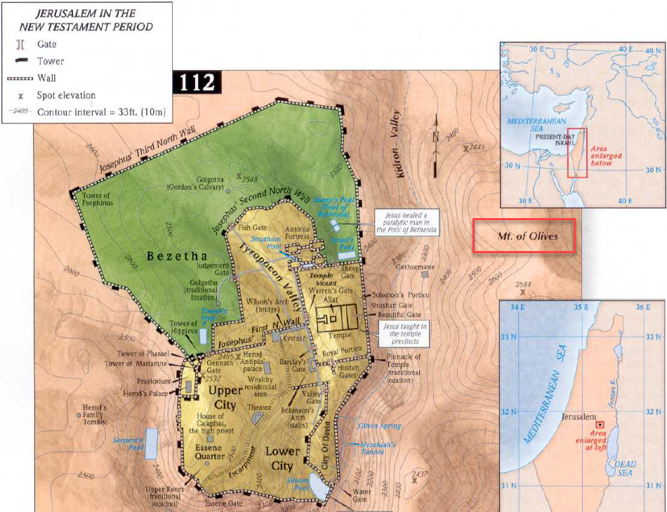
- He then sent 2 of His disciples into the village ahead and told them to bring Him a colt.
  - But not just any colt.
  - They would find a specific colt, one on which no one had ever ridden, tied up and waiting for them.
  - If anyone asked them why they were taking the colt, they were to respond, “The Lord has need of it.”
- This is exactly what happened.
  - The disciples went to the village.
  - Found a colt tied up.
  - Someone people asked them why they were taking it.
  - They told them the Lord needed it.
  - The people accepted the answer.
  - The disciples brought it to Jesus.
- What is a colt?
  - Colt: Male donkey under 4 years old.
  - Filly: Female donkey under 4 years old.
  - Foal: Baby male or female donkey under 1 year old.
  - Gelding: Castrated male donkey.
  - Stallion: Uncastrated male donkey.
  - Yearling: Male or female donkey between 1 and 2 years old.

Mar 11:7 And they brought the colt to Jesus and threw their cloaks on it, and he sat on it.
Mar 11:8 And many spread their cloaks on the road, and others spread leafy branches that they had cut from the fields.
Mar 11:9 And those who went before and those who followed were shouting, “Hosanna! Blessed is he who comes in the name of the Lord!
Mar 11:10 Blessed is the coming kingdom of our father David! Hosanna in the highest!”
Mar 11:11 And he entered Jerusalem and went into the temple. And when he had looked around at everything, as it was already late, he went out to Bethany with the twelve.

- It is important to recognize that chapter 11 takes place at the beginning of the last week of Jesus’ life.
- And the events of the next few chapters all take place in Christ’s last week.
- Jesus was going to use the colt to enter the city of Jerusalem in an event commonly referred to as the Triumphal Entry.
  - The people will recognize Him as their Savior.
  - He will be welcomed as a King.
- I don’t know about you, but when I think about a King, I typically envision him riding a mighty steed, not a colt.
  - Alexander rode the mighty Bucephalus who was killed in the Battle of Hydaspes (June 326 BC) and after which Alexander named a city.
  - 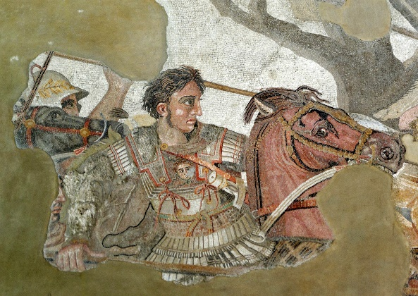
  - Julius Caesar rode Genitor (named after his father).
  - 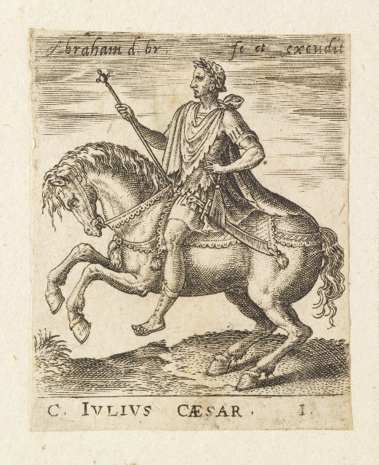
- Why did Jesus choose a colt?
- Because Jesus wasn’t a king like most kings!
  - He was humble and His animal communicated something different than the pride of most earthly kings.
  - Matthew tells us this choice fulfilled the prophecy of Zechariah 9:9
  - Zec 9:9 Rejoice greatly, O daughter of Zion! Shout aloud, O daughter of Jerusalem! Behold, your king is coming to you; righteous and having salvation is he, humble and mounted on a donkey, on a colt, the foal of a donkey.
- Jesus entered the city knowing He would receive a king’s welcome but without the personal pride of other kings.
  - Christ was entering their city as a king but a king clothed in humility.
  - He was their King, but He would also play the lowly role of being their sacrifice.
  - The voices that glorified Him as He entered the city would soon curse Him as He was led out of the city to His death.
- It is interesting to contrast Jesus’ first appearance on a donkey in Jerusalem to His appearance on a white horse in Revelation.
- If we look back to the story of Jehu in 2 Kings 9:13 it reveals the practice of laying clothing on the ground was something done for royalty.
- Others laid leafy (palms) branches on the ground (where we get the term Palm Sunday).
- The crowds surrounding Jesus were all shouting a term we haven’t encountered yet, “Hosanna.”
  - If my research is correct, the word translated “hosanna” comes from the Hebrew term “Hoshia-na” (yasha’na), meaning “please save.”
  - Although originally a cry for help, the people now used the phrase as a statement of praise for help arriving.
    - Psa 118:25-26 - Save (yasha) us (‘na), we pray, O LORD! O LORD, we pray, give us success! Blessed is he who comes in the name of the LORD! We bless you from the house of the LORD.
    - Mar 11:9-10 And those who went before and those who followed were shouting, “Hosanna! Blessed is he who comes in the name of the Lord! Blessed is the coming kingdom of our father David! Hosanna in the highest!”
    - We already know the Jews associated the term “Son of David” with the Messiah.
    - The people appear to have connected the dots. Their prayer of “save us” was being answered by the One who came in the name of the LORD, Jesus, who was the Son of David!
- One thing I took notice of when studying this chapter was that this is the first really public proclamation of Jesus’ identity as the Christ (to the Jews).
  - Even in chapter 8, when Peter made his confession about Christ, Jesus told the Apostles not to tell anyone about the truth of His identity.
  - One question I’ve had for years is, “Why is Jesus always telling people not to tell others about Him being the Messiah.”
  - Why is it a secret?
- I think this text may be part of that answer.
- Christ wanted His Jewish audience to accept Him as the Messiah based on the evidence of His life.
  - There is a difference between someone telling you something is true and you reaching that conclusion based on evidence.
  - Perhaps part of the reason Jesus didn’t widely proclaim His identity publicly was because He wanted the Jews to come to their own conclusion based on evidence.
- And what was the conclusion of the Jews?
- Answer:
  - “Jesus is the answer to our hosanna.”
  - “The Son of David is here to save us!”
  - This was their conclusion.
    - They weren’t told to believe it.
    - They weren’t brainwashed to believe it.
    - This was the identity of the man from Nazareth based on the evidence.
- The Jews concluded Jesus to be the Christ.
- Mark is writing to a gentile audience and telling them to believe Jesus was the Jewish Messiah, not just because he is telling them to believe it, but because the Jew’s (who had anticipated this Messiah for 100s of years, believed it!
- Now, it would be less than a week before the conviction of the Jews faltered and they ended up turning against God.
  - Jesus didn’t turn out to be the Messiah they expected.
  - How typical of the Jews, how historically consistent, for them to turn to God and then so quickly lose their way.
  - But this time, God had built their salvation into their mistake.
- Mark isn’t trying to convince his readers Jesus was the Messiah the Jews expected, he is trying to convince them He was the Messiah they needed.
  - God knew His people (the Jews) so well He prepared a way of salvation for them based on their consistent habit to sin against Him.
  - Was that not the Messiah the Jews needed?
  - Any gentile reading Mark’s gospel who had any knowledge of Jewish history would have been able to see God’s incredible Messianic design.
  - Why do you think God gave us the Old Testament?
- In verses 11, upon entering the city, Jesus went into the Temple to look around and then departed back to Bethany for the night.

Mar 11:12 On the following day, when they came from Bethany, he was hungry.
Mar 11:13 And seeing in the distance a fig tree in leaf, he went to see if he could find anything on it. When he came to it, he found nothing but leaves, for it was not the season for figs.
Mar 11:14 And he said to it, “May no one ever eat fruit from you again.” And his disciples heard it.

- *We will wait to address these verses until we get to verses 20-25.
- Just note that these events take place the next day (after the Triumphal Entry).

Mar 11:15 And they came to Jerusalem. And he entered the temple and began to drive out those who sold and those who bought in the temple, and he overturned the tables of the money-changers and the seats of those who sold pigeons.
Mar 11:16 And he would not allow anyone to carry anything through the temple.
Mar 11:17 And he was teaching them and saying to them, “Is it not written, ‘My house shall be called a house of prayer for all the nations’? But you have made it a den of robbers.”
Mar 11:18 And the chief priests and the scribes heard it and were seeking a way to destroy him, for they feared him, because all the crowd was astonished at his teaching.
Mar 11:19 And when evening came they went out of the city.

- Upon entering his hometown a typical king would go to his palace but Christ goes to the spiritual seat of God, the Temple.
- And in a scene that probably shocked much of the adoring crowd, Jesus, in righteous anger, upends the tables of the Temple market.
  - Instead of marching to the Roman garrisons and demanding freedom from their injustice, Jesus’ fury is poured out on His own people.
  - He is enraged at their extortion and greed.
- Lets ask a question… Should a Jew have been shocked that God acted this way?
  - What should they have expected?
  - Did the God of the Old Testament just pat the Jews on the back and tell them they were doing a great job?
  - What about the prophets? Some of the Jews may have only thought Jesus was a great prophet, what should they have expected?
  - Did the prophets spend their time telling the Jews how well they were doing?
  - Answer: No!
  - If the Jews knew anything about the God they claimed to serve they would have known He had been verbally flipping tables for generations.
  - Only a person who didn’t know the God of the kings and prophets would believe God would come to the earth and not correct the Jews first-and-foremost.
- This is perhaps why the prophets are so often quoted in the gospels.
  - Jesus actions are consistent with the God of the Old Testament and are evidence He came from God.
  - A Messiah who went easy on the Jews would be the Messiah whose identity should be questioned.
- Let’s ask another question… Why was Jesus so angry?
  - The text tells us there were money changers and animal salesmen in the Temple complex but why did that insight the anger of the Lord?
  - Didn’t people need those services?
  - What was the big deal?
  - Isn’t Jesus going a bit overboard here?
- In order to understand a little better, I did some research into the ancient Temple and its practices to give the story some context.
- The Three Temples:
  - (1) Without going into too much Temple history… The original temple built by Solomon was no longer standing. It had been destroyed when the Babylonians conquered Judah.
  - (2) Upon returning from Babylonian captivity, the Jews built a new Temple but it didn’t compare to the glory of the first.
  - (3) In order to win the favor of the Jews, Herod the Great greatly “improved” the existing Temple to once again put it on the map as an architectural wonder.
- But Herod, with the help of the Jewish elite, had turned the new and “improved” Temple into a money making machine… which, was not its intended purpose!
- The Temple made money a few different ways:
  - (1) Temple Tax
    - A half-shekel (about a days wage) was collected annually from most Jewish men for the upkeep of the Temple.
    - Estimating the total:
      - Let’s use modern numbers and say every man made $10/hour.
      - They worked 8 hours a day.
      - Approximately 3 million taxpayers around the world.
      - = $240,000,000.
    - This tax was collected throughout the Roman Empire and shipped via armed guards back to Jerusalem.
  - (2) Money Changers
    - The temple tax was not paid in common money, it was only paid with the Tyrian shekel (from the region of Tyre).
    - The Tyrian shekel bore the image of Melkart, their equivalent of Baal.
    - Most people weren’t coming through Tyre so they had to get their money changed.
    - Apparently there was a bit of extortion going on.
    - Apparently the Jews made tons of money doing this.
    - Note the words of Titus the Roman general (and later emperor) in a speech to the Jews just before the fall of Jerusalem:
      - "We [Romans] have given you leave to gather up that tribute which is paid to God [the Temple tax], with such other gifts that are dedicated to him: nor have we called those that carried these donations to account, nor prohibited them; till at length you became richer than we ourselves, even when you were our enemies" (Josephus, Wars, VI.6,2).
  - (3) Animals sales
    - Jews sold animals used for sacrifice to fellow Jews in the Temple complex.
    - Why was this a profitable business?
    - If you remember the Old Testament commands about sacrifices, the animals couldn’t be blemished
    - There would be great risk of this on a long journey.
    - Even Jesus had to travel 75+ miles to get to Jerusalem for the feast.
    - It would be much easier to travel light and buy an animal in Jerusalem.
    - Who wants to haul a sheep around for several hundred miles?
    - In addition, it was the corrupt priests who were responsible for inspecting the animals, which would have been an opportunity to make a little extra profit…
  - So you can kind of see this playing out? People would come to the Temple, they would pay to get their money changed and then they would have to pay a high price to buy an animal with that money, and then they would be required to give their half-shekel tax… triple dipping
  - Ancient historian Josephus calls Annas the high priest “a great hoarder up of money.”
    - The position of High Priest was a position acquired through bribery.
    - The priestly line from the Old Testament no longer existed.
  - Josephus (Antiq. 14.105-109) reported that in 54 B.C. the Roman general Crassus raided the Temple, taking cash reserves weighing about 2000 talents (about 176,000 pounds) (roughly 3.5 billion dollars)
  - Keep this in mind when you read the rest of the New Testament and the Gospels
  - Jesus is going around telling people that they aren’t going to need to go to the Temple anymore (women at the well).
  - Paul would later preach WE are now the Temple of God
  - Why were the Jewish elite so bent on discrediting Paul?
    - Was it because they really cared about the souls of their Jewish friends?
    - No! Paul was directly attacking their money making ability with this new Christian teaching.
- In the Old Testament, we read about how the people had become so corrupt they started moving idols into the Temple.
- Were the Jewish elite of the 1st Century any better? They had brought their idolatries and worship of money into the Temple complex.

Mar 11:12 On the following day, when they came from Bethany, he was hungry.
Mar 11:13 And seeing in the distance a fig tree in leaf, he went to see if he could find anything on it. When he came to it, he found nothing but leaves, for it was not the season for figs.
Mar 11:14 And he said to it, “May no one ever eat fruit from you again.” And his disciples heard it.
Mar 11:20 As they passed by in the morning, they saw the fig tree withered away to its roots.
Mar 11:21 And Peter remembered and said to him, “Rabbi, look! The fig tree that you cursed has withered.”
Mar 11:22 And Jesus answered them, “Have faith in God.
Mar 11:23 Truly, I say to you, whoever says to this mountain, ‘Be taken up and thrown into the sea,’ and does not doubt in his heart, but believes that what he says will come to pass, it will be done for him.
Mar 11:24 Therefore I tell you, whatever you ask in prayer, believe that you have received it, and it will be yours.
Mar 11:25 And whenever you stand praying, forgive, if you have anything against anyone, so that your Father also who is in heaven may forgive you your trespasses.”

- If you were like me, this text probably left you a little confused.
- Why did Jesus curse the fig tree?
- Did Jesus regularly go around murdering trees?
- No, He used the fig tree as a parable to teach His Apostles important lessons.
- In Matthew’s text we are told Jesus approaches the tree after seeing its leaves but doesn’t find any fruit.
  - Mark chapter 11 includes a confusing additional line.
  - “…for it was not the season for figs.”
  - So Jesus went looking for figs when it wasn’t fig season, got mad, and cursed it?
  - Seems a bit strange, right?
- To understand this passage, we need to put our botany hat on for a few minutes and dig into fig tree science.
- The following information comes from the International Standard Bible Encyclopedia:
  - Fig-trees are cultivated all over the Holy Land, especially in the mountain regions.
  - Fig-trees are usually of medium height, 10 or 15 ft. for full-grown trees, yet individual specimens sometimes attain as much as 25 ft.
  - In Palestine and other warm climates the fig yields two crops annually--an earlier one, ripe about June, growing from the "old wood," and a second, more important one, ripe about August, which grows upon the "new wood," By December, fig-trees in the mountainous regions of Palestine have shed all their leaves, and they remain bare until about the end of March, when they commence putting forth their tender leaf buds (Mt 24:32; Mr 13:28,32; Lu 21:29-33), and at the same time, in the leaf axils, appear the tiny figs.
  - Early Figs: These tiny figs develop along with the leaves up to a certain point--to about the size of a small cherry--and then the great majority of them fall to the ground, carried down with every gust of wind. These immature figs are known to the fellahin (farmer or agricultural worker in Palestine) as taksh, by whom they are eaten as they fall; they may even sometimes be seen exposed for sale in the markets in Jerusalem. In the case of many trees the whole of this first crop may thus abort, so that by May no figs at all are to be found on the tree, but with the best varieties of fig-trees a certain proportion of the early crop of figs remains on the tree, and this fruit reaches ripe perfection about June. Such fruit is known in Arabic as dafur, or "early figs," and in Hebrew as bikkurah, "the first-ripe" (Isa 28:4; Jer 24:2; Ho 9:10). They are now, as of old, esteemed for their delicate flavor (Mic 7:1, etc.).
  - The miracle of our Lord (Mt 21:18-20; Mr 11:12-13,10,21) which occurred in the Passover season, about April, will be understood (as far as the natural phenomena are concerned) by the account given above of the fruiting of the fig-tree, as repeatedly observed by the present writer in the neighborhood of Jerusalem. When the young leaves are newly appearing, in April, every fig-tree which is going to bear fruit at all will have some taksh ("immature figs") upon it, even though "the time of figs" (Mr 11:13 the King James Version), i.e. of ordinary edible figs--either early or late crop--"was not yet." This taksh is not only eaten today, but it is sure evidence, even when it falls, that the tree bearing it is not barren.
- 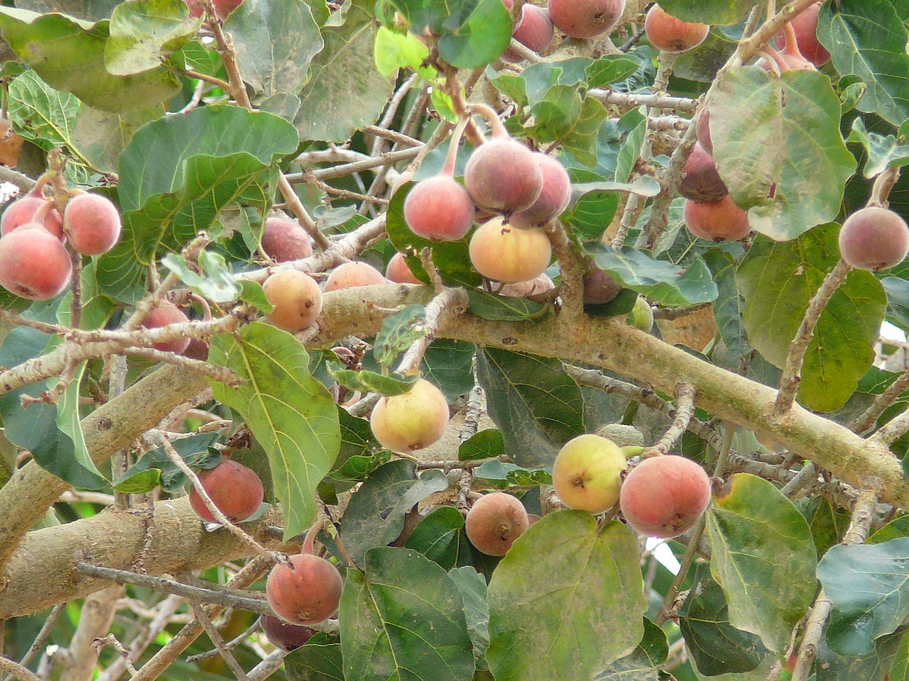
- In light of all this, Jesus approached the fig tree probably expecting some of these delicious “early figs.”
  - The foliage on the tree suggested He would find something.
  - When He found nothing, it was an indication the tree wasn’t going to bear fruit during the June harvest.
  - His condemnation of the tree is based off what His findings tell Him about the tree in the future.
  - The tree looked good from a distance but upon closer inspection it was revealed to be fruitless.
- What might Jesus be teaching His Apostles with this tree? I think there are at least 2 things.
  - First, lets deal with the obvious lesson as explained by Jesus.
    - Jesus curses the tree to show the power of prayer in God’s creation.
    - Prayer prayed in faith is immensely powerful because we are petitioning the God who has the power to move His creation as He desires.
  - Second, Jesus is reiterating a point He’s made in the past about judgement on the fruitless.
    - The fruitlessness of the Pharisees, scribes, and Sadducees has already been well established.
    - They, like the full-leafed fig tree, looked good from a distance but were ultimately fruitless (Jesus will condemn them even more strongly in the upcoming chapters).
    - But Jesus may also be alluding to the fruitlessness of the common Jews.
    - They had all gathered in the Jerusalem to practice their religious devotions but what were those worth considering they were going to turn around and kill the Son of God in a few days.

Mar 11:24 Therefore I tell you, whatever you ask in prayer, believe that you have received it, and it will be yours.
Mar 11:25 And whenever you stand praying, forgive, if you have anything against anyone, so that your Father also who is in heaven may forgive you your trespasses.”

- So does verse 24 mean I can pray for a new 10 bedroom house and God is going to deliver?
  - I think we all know from past experience that that isn’t true.
  - Implied here is our prayer’s alignment with the will of God.
  - If our prayer is aligned with the will of God, no matter how great the request, God has the power to give it to us.
- While talking about prayer, Jesus brings another important point into the discussion, the issue of forgiveness.
  - If you remember the model prayer in Matthew 6, you’ll remember Jesus taught His disciples to pray about forgiveness.
    - Mat 6:12 and forgive us our debts, as we also have forgiven our debtors.
    - Mat 6:14-15 For if you forgive others their trespasses, your heavenly Father will also forgive you, but if you do not forgive others their trespasses, neither will your Father forgive your trespasses.
  - When we come to God with a request, we must be ready to forgive those who have sinned against us.
  - When you think about it, the only reason we have access to God through prayer is because of the forgiveness we have in Christ. Which aught to be something we cherish and appreciate.
  - But how can we say we cherish and appreciate being forgiven by God if we aren’t willing to forgive others for personal offenses?
  - If we knew how much forgiveness we’ve received, extending forgiveness to someone else would be the easiest thing in the world.

Mar 11:27 And they came again to Jerusalem. And as he was walking in the temple, the chief priests and the scribes and the elders came to him,
Mar 11:28 and they said to him, “By what authority are you doing these things, or who gave you this authority to do them?”
Mar 11:29 Jesus said to them, “I will ask you one question; answer me, and I will tell you by what authority I do these things.
Mar 11:30 Was the baptism of John from heaven or from man? Answer me.”
Mar 11:31 And they discussed it with one another, saying, “If we say, ‘From heaven,’ he will say, ‘Why then did you not believe him?’
Mar 11:32 But shall we say, ‘From man’?”—they were afraid of the people, for they all held that John really was a prophet.
Mar 11:33 So they answered Jesus, “We do not know.” And Jesus said to them, “Neither will I tell you by what authority I do these things.”

- Jesus enters the Temple and was confronted by the Jewish authorities.
- The chief priests, scribes, and elders wanted to question Him.
  - They asked Him who gave Him authority to overturn the market tables and teach a new law.
  - Was this an honest question?
  - It wasn’t (are you surprised?)
- In order to expose their dishonesty, Jesus commits to answering their question if they can provide an answer to His first.
  - “The baptism of John, from where did it come? From heaven or from man.”
  - Essentially, He was asking if John made up his teaching or if he was a prophet with a message from God.
- The Pharisees discussed it amongst themselves and found out they were in a bind.
  - They couldn’t say John made it up because it would put them out of favor with the common people. The common people believed John was a prophet.
  - They couldn’t say it was from God because they had rejected John. If they admitted it was from God, Jesus would ask them why they didn’t heed John’s words. Not to mention, they would have to accept Jesus as the Christ because John confirmed His identity as such.
- They were stuck. Like any good politician, they dodged the question.
- They responded, “We do not know.”
- Their dishonesty had been exposed and because of their inability to answer Jesus’ question, Jesus does not answer theirs.
- APPLICATION:
  - Jesus spoke boldly about the nature of God, right vs wrong, and truth vs. error.
    - His bold speech led to His physical death.
  - The Pharisees, scribes, chief priests, Sadducees, and elders refused to take a stand on controversial issues.
    - Their cowardice and silence preserved their safety and reputation with the people.
  - But at the end of time, the script will be flipped.
    - Those who spoke boldly for God will be preserved in God’s love for eternity.
    - Those who remained silent to preserve their reputation with other people will experience spiritual death.

https://gustavomirabalcastro.online/en/horses/genitor-julius-caesar-horse/
https://politicaltheology.com/the-politics-of-the-kings-donkey-luke-1928-40/

