MARK 14
Mar 14:1 It was now two days before the Passover and the Feast of Unleavened Bread. And the chief priests and the scribes were seeking how to arrest him by stealth and kill him,
Mar 14:2 for they said, “Not during the feast, lest there be an uproar from the people.”

- We are now two days out from the Passover and Jesus’ enemies have had enough.
- In secret they were devising a way to have Jesus killed.
- However, did not want to arrest Him during the feast because they feared the response of the Jewish people.
- What was the Passover?
  - The Passover was a Jewish feast celebrated annually to commemorate God delivering the Jews from Egyptian slavery (book of Exodus).
    - It was celebrated on the in the 1st month on the 14th day.
    - Exo 12:14 “This day shall be for you a memorial day, and you shall keep it as a feast to the LORD; throughout your generations, as a statute forever, you shall keep it as a feast.
  - Before God delivered His people, He sent 10 plagues to punish Egypt.
  - The last plague killed all of the first born in Egypt.
  - But God made a way for His people to save their firstborn.
  - They were told to kill a lamb and paint its blood on their door post.
  - When God saw the blood, He would “pass over” their house and their firstborn would be spared.

Mar 14:3 And while he was at Bethany in the house of Simon the leper, as he was reclining at table, a woman came with an alabaster flask of ointment of pure nard, very costly, and she broke the flask and poured it over his head.

- 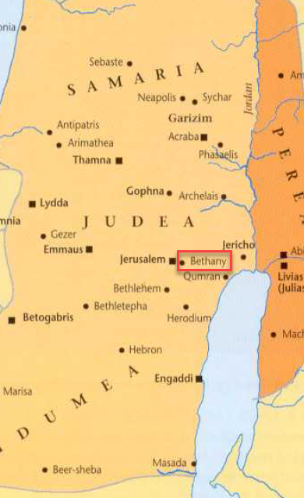
- It is a bit of a challenge to reconcile Matthew and Mark’s account of this event with John’s gospel.
  - See John 12:1-8
- I think the easiest way to understand it is to recognize Matthew and Mark’s accounts of this anointing are not in chronological order (and there is a good reason).
  - There is a subject break between verses 2 and 3.
  - The Jewish rulers plotted to kill Jesus 2 days before Passover but this anointing occurred 6 days before the Passover.
  - It makes sense for Mark to insert the anointing story here because it is relevant to the greed of Judas Iscariot which we will read about in verses 10-11.
- We don’t have a lot of information about “Simon the leper” but it is almost certain he was a man healed by Jesus (otherwise no one would have eaten in his house).
- A woman appears in the scene with a very expensive alabaster box of ointment.
  - What is alabaster?
    - Alabaster is a light colored semi-translucent stone which as been used in carvings and pottery for 1,000s of years.
    - Alabaster is semi-soluble in water and is almost exclusively used for indoor vessels and art.
    - 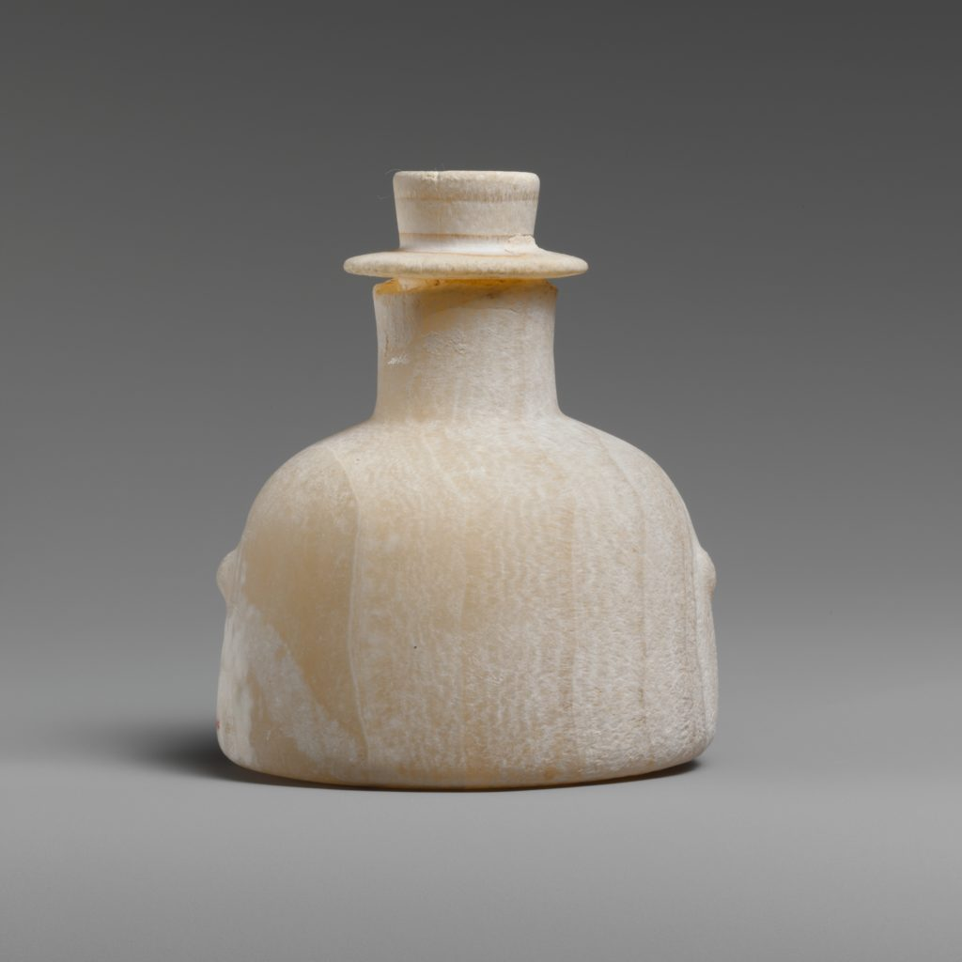
    - 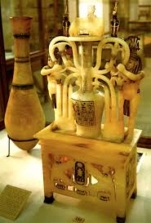 (Alabaster perfume bottle from the tomb of King Tut)
  - What was in the box?
    - Another gospel says the box was filled with pure nard.
    - This is likely a reference to spikenard.
    - Spikenard grows in the Himalayas.
    - It is found at altitudes between 9,800–16,400 ft
    - The difficulty of harvesting it and the cost of importing it all would have contributed to its value.
    - In Song of Solomon, nard was worn as a perfume. (SS 1:12)
- The combination of the fancy vessel and the imported perfume made this a very expensive package.
- The woman took the ointment and poured it on Jesus head while He was at the table.
  - If someone poured smelly liquid on my head at a dinner party, I would probably be offended.
  - But in the ancient Jewish culture this wasn’t disrespectful or out of place.
  - Remember Psalm 23?
    - David says God anointed his head with oil at the table.
    - Psa 23:5 - You prepare a table before me in the presence of my enemies; you anoint my head with oil; my cup overflows.
  - You may remember Jesus’ words in Matthew 6 about fasting.
    - Mat 6:16-18 - “And when you fast, do not look gloomy like the hypocrites, for they disfigure their faces that their fasting may be seen by others. Truly, I say to you, they have received their reward. But when you fast, anoint your head and wash your face, that your fasting may not be seen by others but by your Father who is in secret. And your Father who sees in secret will reward you.
    - Putting oil on your head was to make a person “look presentable,” like they had gotten out of bed and actually cared about the way they looked.
- If I understand correctly, this oil was worn in the hair to give the wearer a pleasant aroma (not much different than today’s scented shampoo).
- The anointing of Christ by this woman was definitely a step above normal.
- She was honoring Him.

Mar 14:4 There were some who said to themselves indignantly, “Why was the ointment wasted like that?
Mar 14:5 For this ointment could have been sold for more than three hundred denarii and given to the poor.” And they scolded her.

- When the disciples (John 12:4 reveals it was Judas Iscariot) saw the expensive ointment being used this way, they grumbled.
- John reveals Judas was angry, not because he cared about poor people but because he was a thief and probably thought he could skim a little off the top.

Mar 14:6 But Jesus said, “Leave her alone. Why do you trouble her? She has done a beautiful thing to me.
Mar 14:7 For you always have the poor with you, and whenever you want, you can do good for them. But you will not always have me.
Mar 14:8 She has done what she could; she has anointed my body beforehand for burial.
Mar 14:9 And truly, I say to you, wherever the gospel is proclaimed in the whole world, what she has done will be told in memory of her.”

- Rather than rebuking the women for her neglect of the poor, Jesus rebukes the disciples.
- This woman had taken a unique opportunity to honor God.
- A miniscule percentage of human beings had the privilege of seeing the Son of Man face-to-face and the woman responded in a way fitting to her privilege.
- The poor have been present from the beginning of time and will be present to the end of time but this was a unique moment worthy of being marked at any expense.
- Jesus makes two statements which reiterated to the disciples Jesus’ near future.
  - (1) “But you will not always have me.”
    - Jesus would be leaving them soon.
    - First, to go to the cross.
    - Second, to return to His Father in Heaven.
  - (2) “…she has anointed my body beforehand for burial”
    - It is not clear how much the woman knew.
    - She may have listened to Jesus’ teachings and concluded His death was near.
    - Or it may be that Jesus took her actions and applied this construction to them to use it as an opportunity to teach His disciples about His passion.
- No matter her comprehension, her actions were a beautiful display of her faith and the value she ascribed to her relationship with Jesus.
- Jesus tells His disciples her actions will be remembered by future generations (which is why we are talking about them now).

Mar 14:10 Then Judas Iscariot, who was one of the twelve, went to the chief priests in order to betray him to them.
Mar 14:11 And when they heard it, they were glad and promised to give him money. And he sought an opportunity to betray him.

- We’ve just seen the character of Judas and this helps explain his actions in verses 10-11.
- His love of money consumed him to the point He was willing to betray the most loving Man he knew for a low price.
- Reminds me of those who struggle with substance abuse and are willing to steal from the only people who still love them just to get another high.
- APPLICATION:
  - It is possible to be surrounded by the best examples in the world and for them not to rub off on you.
  - Satan is cunning and wants us to fall in love with the idols around us (in this case money) rather than fall in love with the One True God (Jesus).
- APPLICATION:
  - It is possible to spend years listening to the words of Jesus and for them to never change our hearts.
  - Judas listened to Jesus speak for three years but the truths he heard did not penetrate his greed hardened heart.
  - Christians can be “good students” of God’s word but are we allowing it to change us from the inside out.
  - Simply hearing and “studying” is not enough.
  - Like the way side soil, the seed can bounce right off of us and get snatched up by the birds.

Mar 14:12 And on the first day of Unleavened Bread, when they sacrificed the Passover lamb, his disciples said to him, “Where will you have us go and prepare for you to eat the Passover?”

- What was Unleavened Bread (capitalized)?
  - Following the Passover evening, 7 days were dedicated to the Feast of Unleavened Bread.
  - This was to remind the people of their departure from Egypt and how God delivered them from Pharaoh.
  - Deu 16:3 - You shall eat no leavened bread with it. Seven days you shall eat it with unleavened bread, the bread of affliction—for you came out of the land of Egypt in haste—that all the days of your life you may remember the day when you came out of the land of Egypt.
  - Lev 23:5-6 - In the first month, on the fourteenth day of the month at twilight, is the LORD's Passover. And on the fifteenth day of the same month is the Feast of Unleavened Bread to the LORD; for seven days you shall eat unleavened bread.

Mar 14:13 And he sent two of his disciples and said to them, “Go into the city, and a man carrying a jar of water will meet you. Follow him,
Mar 14:14 and wherever he enters, say to the master of the house, ‘The Teacher says, Where is my guest room, where I may eat the Passover with my disciples?’
Mar 14:15 And he will show you a large upper room furnished and ready; there prepare for us.”
Mar 14:16 And the disciples set out and went to the city and found it just as he had told them, and they prepared the Passover.

- It was now the day of the Passover and preparations had to be made.
- Jesus sends His Apostles into the city to locate a man with a water jar and who had a suitable room (remember they couldn’t eat it at their houses because they lived in Galilee).
- This was probably pretty common practice considering the number of people who travelled to Jerusalem for Passover.

Mar 14:17 And when it was evening, he came with the twelve.
Mar 14:18 And as they were reclining at table and eating, Jesus said, “Truly, I say to you, one of you will betray me, one who is eating with me.”
Mar 14:19 They began to be sorrowful and to say to him one after another, “Is it I?”
Mar 14:20 He said to them, “It is one of the twelve, one who is dipping bread into the dish with me.
Mar 14:21 For the Son of Man goes as it is written of him, but woe to that man by whom the Son of Man is betrayed! It would have been better for that man if he had not been born.”

- The scene then skips to Jesus eating the Passover with His Apostles.
- Jesus foretells of the betrayal of one of His Apostles but doesn’t call the man by name.
- Obviously, we know it is going to be Judas.
- All of the Apostles inquire whether they are the man and Jesus tells them it is the one “one who is dipping bread into the dish with me.”
- Jesus’ words in verse 24 are scary.
  - It would have been better if Judas had never lived.
  - Jesus, as the Creator had made Judas but then tells Him it would have been better if He hadn’t been born.
  - Judas chose to betray his Creator.
  - Judas’ betrayal was a serious rejection of God and the judgement it merited would be serious.
  - APPLICATION:
    - I’m not sure how universally Jesus wanted that statement applied but I think it is biblically accurate to say a person whose life is lived apart from or in rebellion to God is a person who will wish they had never been born.
    - Because if Hell is the end result…
  - We will see that although the end of Judas was tragic, his betrayal and rebellion in no way hindered God’s plan.
  - God accounted for Judas’ actions and He accounts for the actions of all those who seek to undermine His goals and they will not be the slightest roadblock to His accomplishing every detail of His desire.
- SIDE NOTE: We will see in the other gospels that Judas’ question to Christ and Christ’s response must have been somewhat private because most of the Apostles still don’t appear to know the identity of the betrayer when Judas later gets up and departs the room into the night.

Mar 14:22 And as they were eating, he took bread, and after blessing it broke it and gave it to them, and said, “Take; this is my body.”
Mar 14:23 And he took a cup, and when he had given thanks he gave it to them, and they all drank of it.
Mar 14:24 And he said to them, “This is my blood of the covenant, which is poured out for many.
Mar 14:25 Truly, I say to you, I will not drink again of the fruit of the vine until that day when I drink it new in the kingdom of God.”

- Have you ever wondered why Christians eat little pieces of unleavened bread and drink grape juice when worshipping?
  - From an outsider perspective, I can understand how weird that sounds.
  - What can sound even stranger is when we describe it as Jesus’ body and blood.
  - But when you understand this passage and its background, you will have a much better understanding of the Church’s practice.
- Jesus takes the Passover symbolism all the Jews were familiar with and gives it a new meaning.
- They had all gathered around a lamb who had given its blood to reminded them of their salvation from God’s wrath on the Egyptians.
- While they were eating the lamb, Jesus takes bread, gives it to the Apostles, and says, “This is my body.”
  - They put down the lamb’s body.
  - They ate the bread representing Jesus’ body.
- Ultimately, the lamb killed in Egypt to save the people from God’s wrath was a shadow of a greater Lamb.
  - If you’ve ever heard Jesus called the “Lamb of God” this is why!
  - Jesus allowed Himself to be killed to offer salvation from God’s wrath on sin.
- He then takes a cup of grape juice or wine and gives it to the Apostles.
  - He tells them to drink from it because it represents His blood.
  - This was the second Passover picture.
  - The blood of the lamb in Egypt covered the Jew’s doorposts and kept them safe.
  - Jesus’ blood is what covers Jesus’ followers and keeps them safe by forgiving their sins.
- They had gathered to eat the Passover and everything had been prepared.
- But their lamb was going to be substituted out mid-meal and replaced.
- Jesus was the Lamb of God and He institutes this new memorial so all of His followers remember what He did for the world.
- So that is why Christians eat little pieces of bread and drink little cups of juice.
  - It is not the physical body and blood of Jesus (although some argue that interpretation).
  - It is a picture to help us in the memorial of our Lamb and God’s deliverance.
- Did the Apostle’s understand exactly what Jesus was doing?
  - Probably not!
  - But after seeing Jesus sacrifice Himself on the cross, the pieces would fall into place.
  - Jesus certainly never felt the need to spell out every details of everything He tried to communicate.
  - I wonder if that is because when you put all the pieces in place on your own and finally see the big picture it is always more impactful than someone just telling you all the details up front.
- Jesus’ last statement in verse 25 indicates the nearness of His death, resurrection, and departure.
  - I find the exact meaning of this statement hard to lock down.
  - To what is Jesus referring?
  - I will propose two possibilities:
    - (1) Jesus is making a general statement about communing with the Apostles over an ordinary cup of wine (at a meal).
      - He will not sit down to eat or drink with them until the Old Law is nailed to the cross and He has resurrected.
      - We know Jesus ate and drank with His Apostles following His death and resurrection.
    - (2) Jesus is making a reference to communing with them again in this special memorial feast.
      - He would not participate in this memorial meal with them again until the realities it was meant to memorialize had come to pass.
      - They were not able memorialize Jesus’ death because He hadn’t died yet.
      - Following His death and resurrection He would have fellowship with them again as the slain Lamb of God in their feasts.
  - I suspect it is the second interpretation.

Mar 14:26 And when they had sung a hymn, they went out to the Mount of Olives.

- I usually associate singing with the NT Church life.
- But the Jews had many songs associated with their religious celebrations.
- It seems God has a love of singing.
- Jesus and the Apostles then departed the upper room and went to the Mount of Olives.

Mar 14:27 And Jesus said to them, “You will all fall away, for it is written, ‘I will strike the shepherd, and the sheep will be scattered.’
Mar 14:28 But after I am raised up, I will go before you to Galilee.”

- The night ahead of Christ and His Apostles was not going to be an easy one.
- The events of the coming hours would result in ALL of the Apostles scattering and abandoning Christ’s side.
- The verse about the shepherd and the sheep is found in Zechariah 13:7
  - Zec 13:7 - “Awake, O sword, against my shepherd, against the man who stands next to me,” declares the LORD of hosts. “Strike the shepherd, and the sheep will be scattered; I will turn my hand against the little ones.
- Jesus’ prediction was grim but it was not to be the end of the story.
- Christ would be abandoned and killed but would meet the disciples again around their home in Galilee (see Matthew 28:7).

Mar 14:29 Peter said to him, “Even though they all fall away, I will not.”
Mar 14:30 And Jesus said to him, “Truly, I tell you, this very night, before the rooster crows twice, you will deny me three times.”
Mar 14:31 But he said emphatically, “If I must die with you, I will not deny you.” And they all said the same.

- Peter must not have learned the lesson from chapter 8 that contradicting Christ wasn’t a wise move.
- He speaks up and proclaims his dying allegiance to Christ.
- We find out later Peter wasn’t bluffing. He drew His sword against those who came to arrest Jesus.
- But Christ told Him to put his sword away.
- Peter didn’t lack courage, he lacked understanding of Jesus’ actions, which is what eventually led to His “falling away.”
- The rest of the Apostles rose to match Peter’s courage (Matt 26:35).
- APPLICATION:
  - We should pray God would give us courage AND understanding.
  - Courage cannot replace understanding and visa-versa.
  - Some of the boldest people I know lack understanding of Christ’s words (just look at the Mormons)!
  - They boldly believe they are defending Him but they are actually really disillusioned to His true intentions.
  - Let’s constantly ask God for an increase of boldness and an increase of understanding.
- APPLICATION:
  - Boldness is contagious even boldness that contradicts Christ.
  - Boldness is attractive.
  - This is why it is so important to have a boldness with understanding.

Mar 14:32 And they went to a place called Gethsemane. And he said to his disciples, “Sit here while I pray.”
Mar 14:33 And he took with him Peter and James and John, and began to be greatly distressed and troubled.
Mar 14:34 And he said to them, “My soul is very sorrowful, even to death. Remain here and watch.”

- The exact location of Gethsemane is known with some certainty (but still debated).
- If you go to Jerusalem today, you can visit the garden of ancient olive trees.
- 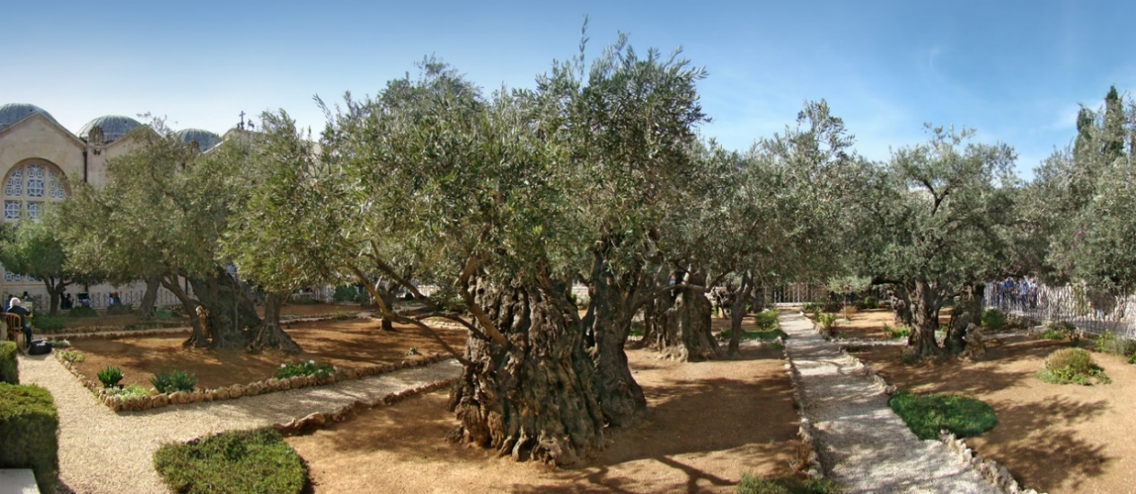
- Jesus took the 11 Apostles with Him (all except Judas) but chose Peter, James, and John to accompany Him further into the garden.
- He told them to watch and pray.
- Jesus began to be very distressed and troubled over the events He was about to endure.
- His beatings and crucifixion were only a sleepless night away.

Mar 14:35 And going a little farther, he fell on the ground and prayed that, if it were possible, the hour might pass from him.
Mar 14:36 And he said, “Abba, Father, all things are possible for you. Remove this cup from me. Yet not what I will, but what you will.”

- Here we see Jesus praying to God the Father.
- Although Jesus, in His divine nature, had foretold His death and knew it to be the eternal plan of God, here we see His human nature dreading the physical pain.
- He asks God for another way but submits Himself to God’s will.
- APPLICATION:
  - God encourages us to make our requests known to Him.
  - But those requests should always be made with a humility and submission to the will of God.
  - If God chooses not to give us what we request, it is because, in His infinite wisdom, His mind is directing us down another (better) path.
- We needed a Savior who could sympathize with our distresses and pain.
- Can you image if God decided to judge humans but never experienced how hard it was to be a human?
- That describes the gods of most religions.

Mar 14:37 And he came and found them sleeping, and he said to Peter, “Simon, are you asleep? Could you not watch one hour?
Mar 14:38 Watch and pray that you may not enter into temptation. The spirit indeed is willing, but the flesh is weak.”

- Jesus then returned to Peter, James, and John, but instead of finding them in devotional prayer, He finds them sleeping.
- We know the Passover meal wasn’t eaten until twilight.
- It was probably getting late but Jesus encouraged His Apostles to prioritize prayer over sleep.
- This was a common practice for Jesus.
- He wanted them to pray so they would not be tempted.
  - Jesus’ trials were going to be a temptation for them too.
  - Temptation to desert Christ and renounce knowing Him.
- Would Peter have denied Christ if he had stayed up and prayed?
  - It is hard to say!
  - But apparently some of the temptations the Apostle’s faced could have been avoided.
- Would we accomplish great things through the power of God or avoid detrimental pitfalls if we prioritized prayer over sleep?
- It is hard to say!
- I think it is worth noting, even though the plans of Judas, the chief priests, and elders are already in motion, Jesus suggests their prayers could change certain variables in the way those events played out.
- I’ve heard people suggest prayer is worthless once the wheels of circumstance are in motion.
- I think there is also a lesson here about God’s foreknowledge.
  - Jesus told them in verse 27 they would all fall away.
  - Jesus tells them in verse 38 to pray to avoid temptation to fall away.
  - Jesus knows the ultimate end of a given situation and can announce the ultimate end of any given situation.
  - He knows the choices everyone will make in any and every given situation from now till eternity.
  - But He still leaves that choice up to us and there is no indication the choice is only an illusion.
  - When Jesus finds the Apostle’s sleeping, He doesn’t say, “I know I told you to stay awake but I was just kidding, you didn’t really have any choice in the matter, you were sovereignly made to fall asleep.”
  - God knows all the choices human beings will make and He weaves His will through those choices (the orchestration of the crucifixion is case-and-point).
- In verse 41, Jesus tells the Apostles their spirit was willing but their flesh was weak.
  - Mentally, they had the zeal and conviction to follow Christ.
  - But were hindered by weak flesh. Their internal convictions were too easily mastered by their bodily cravings (in this case a desire for sleep).
  - They should have deprived the flesh to care for the physical.
    - This may illustrate one of the reasons the New Testament talks about fasting.
    - It is a chance for us to practice denying the body to elevate the spiritual.
  - Many of us, including myself, struggle with the same thing the Apostles struggled with here.

Mar 14:39 And again he went away and prayed, saying the same words.
Mar 14:40 And again he came and found them sleeping, for their eyes were very heavy, and they did not know what to answer him.
Mar 14:41 And he came the third time and said to them, “Are you still sleeping and taking your rest? It is enough; the hour has come. The Son of Man is betrayed into the hands of sinners.
Mar 14:42 Rise, let us be going; see, my betrayer is at hand.”

- Jesus returns to His place of prayer and prays a similar prayer of submission to the will of the Father.
- He returned again to find Peter, James, and John asleep again.
- The gospel of Mark says, “…they did not know what to answer him” (Mark 14:40).
- When Jesus returned for the final time He woke the Apostles to a scary reality.
  - The time had come!
  - Judas, the betrayer, approached accompanied by an angry mob of Jews bent on murder.
- APPLICATION:
  - Have you ever slept on a friend who needed you?
  - Perhaps they needed your help but you were too tired or wanted to relax or just weren’t feeling social.
  - I know I’ve done that before and then learned later they really needed someone there for them.
  - I felt bad.
  - I bet the Apostles felt bad they slept on Jesus in His time of need.
  - Let’s try our best to push through the selfishness of our fleshly weakness to be there for people.

Mar 14:43 And immediately, while he was still speaking, Judas came, one of the twelve, and with him a crowd with swords and clubs, from the chief priests and the scribes and the elders.
Mar 14:44 Now the betrayer had given them a sign, saying, “The one I will kiss is the man. Seize him and lead him away under guard.”
Mar 14:45 And when he came, he went up to him at once and said, “Rabbi!” And he kissed him.
Mar 14:46 And they laid hands on him and seized him.

- The angry mob was led by Judas and his angry, shamed, and coward allies, the chief priests and elders.
- APPLICATION:
  - We should not underestimate the power of addiction, lust, and greed.
  - Judas had watched Jesus humiliate the chief priests and elders earlier this week and now he sides with them because they waived a little bag of money in front of his face.
  - If these things master us they have the power to make us act in the most irrational ways.
  - Are we so easily bought?
- Why did the chief priests and elders need Judas to betray Jesus?
- It isn’t as if they needed Judas to point Jesus out, they were well acquainted with his appearance.
- I can think of at least three reasons:
  - (1) They my have needed Judas to show them where Jesus was that night.
    - He hadn’t eaten the Passover in Jerusalem.
    - They may have had difficulty finding Him fast enough to avoid a riot if they didn’t have an inside man.
    - Act 1:16 - “Brothers, the Scripture had to be fulfilled, which the Holy Spirit spoke beforehand by the mouth of David concerning Judas, who became a guide to those who arrested Jesus.
  - (2) They used Judas as an insult to Jesus.
    - The Jews offered to pay Judas, not because it was necessary for their plan, but because betrayal stings.
    - It is a slap in the face to be betrayed by your friend and the Jews wanted use Judas to disrespect Jesus.
  - (3) They may have found Judas a convenient scapegoat.
    - If asked they could denied they were the ones who initiated the arrest.
    - “Oh no, He was turned over by one of His own followers for claims against the Judaism and the state!”
- In a scene familiar to Christians and non-Christians alike, Judas kissed Jesus.
- This may sound really odd to modern audiences, specifically those of us in the states, but kissing someone on the cheek as a greeting was common in the ancient world and is still practiced in many places in modern times.

Mar 14:47 But one of those who stood by drew his sword and struck the servant of the high priest and cut off his ear.
Mar 14:48 And Jesus said to them, “Have you come out as against a robber, with swords and clubs to capture me?
Mar 14:49 Day after day I was with you in the temple teaching, and you did not seize me. But let the Scriptures be fulfilled.”
Mar 14:50 And they all left him and fled.

- Matthew includes a bit more information between verses 47 and 48.
  - Mat 26:52 - Then Jesus said to him, “Put your sword back into its place. For all who take the sword will perish by the sword.
  - Mat 26:53 - Do you think that I cannot appeal to my Father, and he will at once send me more than twelve legions of angels?
  - Mat 26:54 - But how then should the Scriptures be fulfilled, that it must be so?”
- One of Jesus Apostles (another gospel reveals it was Peter) took out his sword and started swinging.
  - Jesus had told them the hour was upon them and he probably thought the day of battle had finally come.
  - In his zeal, his sword lopped off the ear of the servant of the high priest (probably would have been his head if Peter had been a soldier instead of a fisherman.
- But in a move that probably surprised Peter and likely Jesus’ captors, Jesus told him to put his sword away.
  - We aren’t told in Matthew’s text but Jesus actually healed the man’s ear.
  - He then makes it abundantly clear that the last thing He needs is Peter’s little sword.
  - If He wanted, He could have replaced His 12 followers with 12 legions of angels and wiped Palestine clean.
- He tells them His refusal to go to war is according to the will of God and the statements of their prophets.
- In order for prophecy to be fulfilled, He must permit the injustice He is about to endure.
  - Jesus permitted His arrest.
  - Joh 10:17-18 - For this reason the Father loves me, because I lay down my life that I may take it up again. No one takes it from me, but I lay it down of my own accord. I have authority to lay it down, and I have authority to take it up again. This charge I have received from my Father.”
  - This was hugely important for Apostles to recognize but also modern readers.
  - Human beings can only accomplish what God permits.
- Although Jesus permitted it, He rebuked those who came to arrest Him.
  - He had been sitting in the Temple and in Jerusalem without any protection for days.
  - He is calling out their cowardice.
  - How ridiculous it was for these men who pretended to be so strong to bring an army under the cover of night to arrest an unarmed man.
- In most epic adventure films this is where Jesus (the hero) would whip out His superpowers and takes these fools to school.
- That is the hero the world expected.
- Those are the heroes we idolize.
- But Jesus’ wasn’t that hero.
  - Jesus is our hero because He didn’t call the 12 legions.
  - He didn’t call the punishing power of God’s wrath down from Heaven.
  - He didn’t execute judgement on those who disrespected and undervalued Him.
  - Jesus is our hero because we are the mob.
  - And He sacrificed Himself to the mob so their doorposts could be covered with His blood when the angels finally come.
  - 2Th 1:7b-8 - when the Lord Jesus is revealed from heaven with his mighty angels in flaming fire, inflicting vengeance on those who do not know God and on those who do not obey the gospel of our Lord Jesus.
  - This verse appears in one of Paul’s letters in a discussion of the end of time.
  - See also Matthew 25:31-32.
- Killing Jesus was an essential part of fulfilling the Law the Jews claimed to be defending, Jesus tells them as much.
  - They were playing directly into the hands of God, completing His mission for Him, although they were clueless to their role.
  - They were filling up the cup of their sinful fathers and reiterating their desperate need for a savior who could save them from themselves.
- At the end of verse 50, we see Jesus’ previous statement become reality when “they all left him and fled.”

Mar 14:51 And a young man followed him, with nothing but a linen cloth about his body. And they seized him,
Mar 14:52 but he left the linen cloth and ran away naked.

- These two verses are unique to Mark’s gospel.
- There is a significant amount of speculation as to the identity of the young man.
  - Some say it was Mark writing about himself.
  - A soldier
  - A neighbor who had a house by the garden of Gethsemane.
- There is really no way to know for sure.
- It is, however, a detail that may contribute to the authenticity of the account.
  - This detail is not essential to the narrative but is included none-the-less.
  - There would be no reason to add the detail about the young man unless it actually happened.
  - When people make up stories, they don’t usually add extra details like this one.

Mar 14:53 And they led Jesus to the high priest. And all the chief priests and the elders and the scribes came together.
Mar 14:54 And Peter had followed him at a distance, right into the courtyard of the high priest. And he was sitting with the guards and warming himself at the fire.

- Jesus was led to Caiaphas, the high priest, who we were introduced to at the beginning of the chapter.
- Although Peter fled, he didn’t go very far.
  - He stayed within eye sight of Jesus.
  - You can imagine how confused he must have been.
  - He had been preparing to defend the Kingdom of God for years, but when the hour of his expectation came, Jesus told him he was wasting time.

Mar 14:55 Now the chief priests and the whole council were seeking testimony against Jesus to put him to death, but they found none.
Mar 14:56 For many bore false witness against him, but their testimony did not agree.
Mar 14:57 And some stood up and bore false witness against him, saying,
Mar 14:58 “We heard him say, ‘I will destroy this temple that is made with hands, and in three days I will build another, not made with hands.’”
Mar 14:59 Yet even about this their testimony did not agree.

- The Jewish elite didn’t clearly didn’t spend a whole lot of time trying to make this trial appear legitimate.
- The whole scene was fueled by their personal envy and their injured pride.
- Rather than make the reforms necessary to be in a right relationship with God, they would kill their conscience (Jesus) and continue living the way they always had.
- APPLICATION:
  - We should be extremely careful when suppressing our conscience.
  - God has given us our consciences as a guide.
  - Although it is often easier to suppress convictions that step on our toes, doing so may be the worst decision of our lives.
- False witnesses were called to try to drum some sham charges against Jesus but not even the false witnesses could agree with each other.
- Finally, two false witnesses came forward charging Jesus with blasphemy and threatening the Temple.
  - They used Jesus statement recorded in John 2:19 as evidence.
  - Joh 2:19 Jesus answered them, “Destroy this temple, and in three days I will raise it up.”
  - John tells us Jesus was speaking about the “temple of His body,” but this was proof enough for Jewish officials.
- Mark tells us even the stories of these two false accusers didn’t match up but they were good enough for they hypocritical

Mar 14:60 And the high priest stood up in the midst and asked Jesus, “Have you no answer to make? What is it that these men testify against you?”
Mar 14:61 But he remained silent and made no answer. Again the high priest asked him, “Are you the Christ, the Son of the Blessed?”
Mar 14:62 And Jesus said, “I am, and you will see the Son of Man seated at the right hand of Power, and coming with the clouds of heaven.”
Mar 14:63 And the high priest tore his garments and said, “What further witnesses do we need?
Mar 14:64 You have heard his blasphemy. What is your decision?” And they all condemned him as deserving death.
Mar 14:65 And some began to spit on him and to cover his face and to strike him, saying to him, “Prophesy!” And the guards received him with blows.

- Jesus didn’t bother responding to the accusation.
  - He knew they weren’t interested in the deeper meaning of statement and its future fulfillment in His resurrection.
  - Rather than casting pearls to the pigs, He remained silent.
- SIDE NOTE:
  - In the Old Testament, the high priests job was to offer sacrifices on behalf of the people before God.
  - Isn’t it interesting and ironic that God uses the corrupt high priest of Jesus’ day to offer the Lamb as a sacrifice for the sins of all people.
  - The more you study the crucifixion and the events surrounding it the more your realize it is its own apologetic.
- Caiaphas wasn’t content with Jesus’ silence and demands He answer his questions
  - “Are you the Christ, the Son of the Blessed?”
  - “I adjure you by the living God, tell us if you are the Christ, the son of God” (Matthew 26:63).
  - Adjure - urge or request (someone) solemnly or earnestly to do something.
  - If there is any blasphemy in this text it is found in the godless high priest evoking the name of God to undermine God.
- Jesus response is fitting to Caiaphas’ question.
  - Caiaphas wanted an answer and called God as his witness.
  - So Jesus quoted God’s words back to Him.
  - Although not a direct quote (at least in our English Bibles), Jesus’ words parallel the words of Daniel 7:13 when the Son of Man came to the Ancient of Days.
  - Jesus was using the Old Testament scriptures to affirm Caiaphas’ question.
  - He was the Christ, the Son of God!
- The answer Jesus gave was the truth, but Jesus also knew it was the answer Caiaphas wanted.
  - Caiaphas put on a big show of religious offense and tore his garments as if he was distraught over the disrespect God had received from these words.
  - “What further witness do we need?” he exclaimed.
  - And then asking his fellow Jewish religious leaders for their opinion on the sentence, they determined He had to die.
- I hope you can see the ridiculousness of this scene.
- The high priest just condemned Jesus for quoting scripture.
- APPLICATION:
  - I think there is an important lesson here.
  - Notice, there wasn’t any evaluation of Jesus’ use of scripture.
  - They didn’t take the time to evaluate if His life fit the claim.
    - They were just outraged by it because it didn’t fit their view.
    - They were offended because they didn’t like it.
  - LESSON TO BE LEARNED: Outrage and offense are not truth.
    - Just because something offends you doesn’t make it right/wrong.
    - Just because something outrages you doesn’t make it right/wrong.
- Following Caiaphas’ outburst, physical abuse is added to the legal abuse Jesus is already enduring.
- They hit him and taunted Him by asking Him to guess which one of them had done it.
- One day, on Judgement Day, Jesus will look a man in the eye and say, “It was you!”
  - The beautiful thing about Jesus was He practiced what He preached.
  - Mat 5:39 - But I say to you, Do not resist the one who is evil. But if anyone slaps you on the right cheek, turn to him the other also.
  - The men hitting Him were given a chance to be forgiven and live with Jesus forever.
  - Because the 12 legions never came.
- Jesus is pretty great, yeah?

Mar 14:66 And as Peter was below in the courtyard, one of the servant girls of the high priest came,
Mar 14:67 and seeing Peter warming himself, she looked at him and said, “You also were with the Nazarene, Jesus.”
Mar 14:68 But he denied it, saying, “I neither know nor understand what you mean.” And he went out into the gateway and the rooster crowed.

- Peter’s denial of Christ is one of the saddest stories in the Bible but it is a story that eventually has a happy ending.
- As mentioned earlier, the confused Peter has been hovering around the area of Jesus’ trial.
- He is recognized by a servant girl who asks if he had been with Jesus in Galilee.
- Peter, probably afraid he will be turned over to the Jews if he answers in the affirmative, denies his relationship with Jesus.

Mar 14:69 And the servant girl saw him and began again to say to the bystanders, “This man is one of them.”
Mar 14:70 But again he denied it. And after a little while the bystanders again said to Peter, “Certainly you are one of them, for you are a Galilean.”
Mar 14:71 But he began to invoke a curse on himself and to swear, “I do not know this man of whom you speak.”
Mar 14:72 And immediately the rooster crowed a second time. And Peter remembered how Jesus had said to him, “Before the rooster crows twice, you will deny me three times.” And he broke down and wept.

- When leaving the courtyard, another servant girl recognized him and was telling some of the bystanders who he was.
- But again, Peter denied that he knew Jesus, this time with an oath.
- A little while later, the bystanders approached Peter with the same question.
- They had recognized his accent which must have been a give-away he was a Galilean.
- Now more scared than ever, Peter denied a third time with swearing and curses.
- The rooster crowd as soon as the words escaped his lips and Peter realized what he had done.
  - He told the Lord he would never deny Him and he had just done it three times.
  - Mat 26:33-34 - Peter answered him, “Though they all fall away because of you, I will never fall away.” Jesus said to him, “Truly, I tell you, this very night, before the rooster crows, you will deny me three times.”
  - Mat 10:28 And do not fear those who kill the body but cannot kill the soul. Rather fear him who can destroy both soul and body in hell.
  - Mat 10:32-33 - So everyone who acknowledges me before men, I also will acknowledge before my Father who is in heaven, but whoever denies me before men, I also will deny before my Father who is in heaven.

- If you were with us for our Matthew study, you may have picked up on the difference between Matthew and Mark’s account.
  - In Mark, Jesus tells Peter he will deny Him 3 times before the rooster crows twice.
  - In Matthew, Jesus tells Peter he will deny Him 3 times before the rooster crows.
- Many have suggested the Bible contradicts itself with these two accounts.
- But there are plausible explanations for the difference.
- I would encourage you to check out the following article for one example of how these two texts can be reconciled.
  - How Many Times Did the Rooster Crow? – Eric Lyons – Apologetics Press
  - Link - https://www.apologeticspress.org/apcontent.aspx?category=6&article=759

