MARK 2

Mar 2:1 And when he returned to Capernaum after some days, it was reported that he was at home.
Mar 2:2 And many were gathered together, so that there was no more room, not even at the door. And he was preaching the word to them.
Mar 2:3 And they came, bringing to him a paralytic carried by four men.
Mar 2:4 And when they could not get near him because of the crowd, they removed the roof above him, and when they had made an opening, they let down the bed on which the paralytic lay.

- Following His preaching trip through Galilee, He returned to Capernaum and the news of His return spread rapidly.
- The house was quickly surrounded to the point no one could get in or out because of the density of the crowd.
- This was unfortunate for a group of friends who had brought their paralyzed friend on a bed to be healed by Jesus.
- Having no other option, and unwilling to be deterred, the friends decided to climb up on the roof of the house, take the roof apart and lower the paralyzed man down to Jesus.
- This may be hard for a modern reader to picture.
  - If you were going to send someone down through the roof of a modern house you would need to scale the side of the structure, tear off the shingles, cut through the wood frame with your hacksaw, and then destroy the drywall ceiling while navigating electrical dangers.
  - But 1st century homes were a little different.
  - They were usually made of a combination of stone, mortar, and earth and had flat roofs with a stairway allowing easy access (no shaky ladder required).
  - Their roofs were used for all kinds of things:
    - Drying fruits
    - Hanging Laundry
    - Sleeping
    - Relaxing
    - Praying
    - When the Lord called Peter to go to Cornelius’ house he was up on the housetop (Acts 10:9)
  - The ancient roof was a functional part of the home.
- You can imagine the commotion they must have made as they “made an opening” in the roof, not to mention the ridiculing eyes of those who thought they were rude for interrupting Jesus’ teachings.
- When they had a sufficient opening, they let their friend down through the ceiling to Jesus.
- APPLICATION:
  - Do you think Jesus was interrupted by this man? Do you think He was caught mid-sentence when He was trying to articulate an important point?
    - Probably not!
    - Jesus knew ahead of time the man was coming through the roof and he knew exactly when the dust from the ceiling was going to start falling on His head.
    - I’m certain, Jesus had said all He intended to say by the time the paralytic descended to see Him.
    - Jesus had taught them with His words and would now teach them through His actions.
  - Sometimes we perceive the events around us as “interruptions” to God’s plan for us.
    - But I think that would be a mistake.
    - Rather, we should recognize the “interruption” must have come because God has taught us all He intended to teach us in that phase of our lives and it is now time for Him to teach us something new with different methods.
    - What appear as interruptions to us may be important parts of God’s providential plan.

- APPLICATION:
- This man had persistent friends.
  - Not only had they carried him all this way to Jesus…
  - They were willing to try repeatedly to get him to Jesus.
  - I wonder if the paralyzed man was worried about his friend’s response when they saw the crowds.
    - “Well we tried but it looks like we aren’t going to be able to see Jesus today.”
    - What if they had given up after the seeing the crowd?
    - How crushed do you think the paralyzed man would be?
    - All this hope had built up inside of him.
    - If had friends had quit, they wouldn’t be any worse off. They still had working legs to go about their business.
  - But we see the man had persistent friends.
  - What was important to their friend was important to them.
    - Are we that kind of friend?
    - Are we quick to quit when something isn’t important to us?
    - Or are we persistent because we know how much our persistence means to our friends?
    - Would we accomplish more in the Church or in our marriages if what was important to someone else became important to me?
    - Or if an expression of what was important to me was met with a rally from my friends.
  - My wife is so much better than me in this way.
    - I can be a cup half-empty, critical, cynical person.
      - When someone comes up to me with an idea I am often quicker to respond with reasons it won’t work than reasons it will.
      - I honestly dislike that about myself and have been working to get better at it.
    - But whenever I propose some hairbrained crazy idea to my wife that I dreamed up, she immediately gets behind it and expresses her confidence in my ability.
    - And then she will help me accomplish it.
  - It is the most refreshing, makes me feel like I can do anything, kind of experience.
  - What if the Church was more like that?
    - We would get more stuff done!
    - The Church wouldn’t look the same!
    - Let’s make it that way!
  - Let’s be persistent about what is important to God and what is important to each other in accomplishing God’s work.
- APPLICATION:
  - This man’s friends persisted in accomplishing good although met with initial difficulty.
  - It is so easy to set out to accomplish something but to get turned around at the first sign of resistance.
  - This happens to all kinds of people trying to live a godly life.
    - Those who are new to Christ and trying to put sins behind them.
    - Those who are seasoned in the Church and meet resistance trying to push on towards godliness.
  - Not quitting at the first sign of resistance is one of the attributes possessed by everyone who has been successful.
  - These men exhibit a proper attitude in that, when met with difficulty, rather than quit and go home, they found another way around.
  - When we start thinking the same way, we will make more individual progress and collective church progress towards accomplishing our Christian mission.

Mar 2:5 And when Jesus saw their faith, he said to the paralytic, “Son, your sins are forgiven.”
Mar 2:6 Now some of the scribes were sitting there, questioning in their hearts,
Mar 2:7 “Why does this man speak like that? He is blaspheming! Who can forgive sins but God alone?”
Mar 2:8 And immediately Jesus, perceiving in his spirit that they thus questioned within themselves, said to them, “Why do you question these things in your hearts?
Mar 2:9 Which is easier, to say to the paralytic, ‘Your sins are forgiven,’ or to say, ‘Rise, take up your bed and walk’?
Mar 2:10 But that you may know that the Son of Man has authority on earth to forgive sins”—he said to the paralytic—
Mar 2:11 “I say to you, rise, pick up your bed, and go home.”
Mar 2:12 And he rose and immediately picked up his bed and went out before them all, so that they were all amazed and glorified God, saying, “We never saw anything like this!”

- I love that, when people come to Christ in honest faith or through significant difficulty, Jesus never turns them away.
  - It gives me hope Jesus isn’t going to turn me away when I finally meet Him.
- I also love that when people come asking Jesus for miracles, Jesus grants those miracles based on the faith of the individual in the moment of the request.
  - We don’t know hardly anything about the backstories of the people who approached Jesus for healing.
  - I’m sure not all of them had lived spotlessly perfect lives.
  - But you don’t ever see Jesus go digging in their past and bringing up some old sin as a reason He won’t heal them.
  - It is the faith of the moment Jesus recognizes.
  - I’ll be honest, sometimes I imagine myself standing before Jesus and Him going back through my past and coming up with a reason He isn’t going to offer me any grace.
  - That isn’t the picture we see in the gospels for those who put their trust in Him.
- Jesus commends the faith of the man and his 4 friends and tells the paralytic, “your sins are forgiven!”
  - As we discussed in the Matthew study, that probably wasn’t what the man really wanted to hear!
  - But Jesus is taking this opportunity to teach a lesson.
    - We see His priorities being communicated once again.
    - He didn’t just come to heal oppressive diseases and physical maladies, He came to save men from their ultimate oppressor, Satan and sin.
  - When the scribes heard this, they were offended and accused Jesus of blasphemy (disrespecting God) in their hearts.
    - They thought Jesus had spoken out of line because only God could forgive sins.
    - They were partially right and partially wrong.
      - What they got right was that God was the only one who could forgive sins.
      - Sin is an offense to God and only the offended party can extend forgiveness for the offense.
      - But they were wrong about Jesus’ blasphemy guilt.
      - Why? Jesus is about to show them, and in the process, unmistakably claim His identity as God.
- Jesus asks the scribes, “which is easier, to say to the paralytic, ‘Your sins are forgiven,’ or to say, ‘Rise, take up your bed and walk’?
  - Anyone could walk around claiming to forgive sins (forgiveness of sins is an unobservable spiritual reality).
  - What proof did Jesus have?
  - In order to prove His ability to forgive sins, He put forward a physical and miraculous sign.
  - He heals the legs of the paralytic man in front of the crowd and they all observe as the man picks up his bed up and walks out of the house.
- Jesus’ miracles proved two things, (1) He had not blasphemed God, (2) He had the power to forgive sins because He was God.
  - The Pharisees acknowledged a man would be unable to perform these signs without the power of God.
  - John 3:2 – Rabbi we know that you are a teacher come from God, for no one can do these signs that you do unless God is with him.
  - Jesus would not have been able to heal a man with the power of God if He had just blasphemed God.
  - If God’s power still rested on Jesus after claiming He could forgive sins, He must really have had the power to forgive sins.
  - And the Pharisees had already mentally acknowledged that only God could forgive sins.
  - 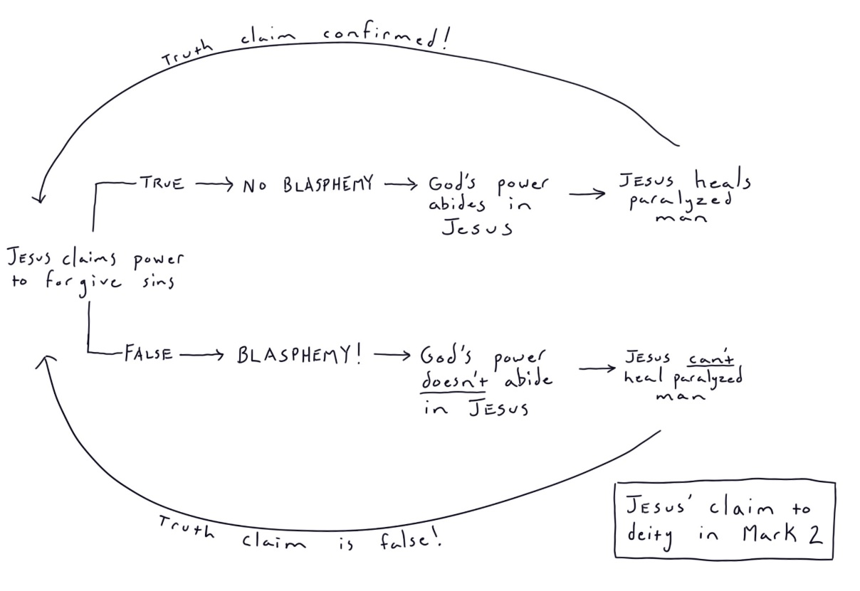
  - Can you imagine having Jesus read your mind, create an argument against what you were thinking, and then present it directly to your face?
  - That would be hard to forget!

Mar 2:13 He went out again beside the sea, and all the crowd was coming to him, and he was teaching them.
Mar 2:14 And as he passed by, he saw Levi the son of Alphaeus sitting at the tax booth, and he said to him, “Follow me.” And he rose and followed him.
Mar 2:15 And as he reclined at table in his house, many tax collectors and sinners were reclining with Jesus and his disciples, for there were many who followed him.
Mar 2:16 And the scribes of the Pharisees, when they saw that he was eating with sinners and tax collectors, said to his disciples, “Why does he eat with tax collectors and sinners?”
Mar 2:17 And when Jesus heard it, he said to them, “Those who are well have no need of a physician, but those who are sick. I came not to call the righteous, but sinners.”

- We talked about many of the social dynamics between the Jews, Pharisees, scribes, and tax collectors in our Matthew study. I will reference you back to that information. You can find it in the Matthew 9 notes located at https://www.2belikechrist.com/bible-study-notes.
- The tax collectors were a despised as sellouts to the Roman government and the call of Matthew (Levi) would have been a powerful lesson to the crowds following Christ.
  - Jesus wanted hearts ready to follow Him and He called them from every stripe and background.
  - Even those who sold out against God’s chosen people were not outside of the Messiah’s call.
- I find it interesting that Jesus called Matthew while he was at work (same with the first 4 apostles).
  - I wonder why?
  - I wonder if it was because it isn’t uncommon for people at work to ask the question, “Is this all there is?”
  - Is it really about waking up for 40 years and going to my job, getting some promotions, making more money, having a nicer car, getting bigger house, retiring at 65, and living out the rest of your life on some beach or golf course somewhere?
  - Is that what we were made to do?
- Evidently, the money that came with Matthew’s position wasn’t enough to satisfy his desire for “more.”
  - He probably had more than most but he didn’t find his answer in his bank account.
  - It didn’t take a lot to convince him to leave his work.
- If you are in that position, wondering if there isn’t more to life than the “American Dream” can offer you, I would encourage you to take a good hard look at what Jesus says about the meaning of our lives.
- I think you’ll find a much greater reason for living in your Creator’s explanation than the default explanation of the world.
- Jesus then went to Matthew’s house for a meal, at which many other “tax collectors and sinners” were present.
- APPLICATION:
  - Jesus’ one connection brings many others to hear His message.
  - This is one of the greatest opportunities new Christians bring to the table.
  - They still have all their friends in the world.
  - It isn’t uncommon to hear people say new converts just need to sit in the church building and learn for a few years before they’re ready to bring someone else to Christ.
  - But it is a huge mistake to lock your new brothers and sisters in the church building and pretend they can’t reach people.
  - Every person is a door to a particular community or cultural group and if we are wasting that door, shame on us.
  - New Christians can open doors old Christians can’t and they often have more zeal to do so than the older Christians.
- APPLICATION:
  - You may be the only person in your church who can reach a certain group of people with the gospel.
  - The tax collectors came to the table because Matthew was at the table.
    - The Pharisees weren’t going to go call the tax collectors to Christ.
    - The common Jews weren’t going to call the sell-outs to Christ.
  - If your congregation is stuck or it feels like it isn’t growing, it might be because everyone looks the same.
    - If all of your members have doors into middle-class suburban America and you haven’t seen any growth in years, maybe you need a new door.
    - Maybe you look around and say, “We don’t have any doors into the homeless community. We need a connection to reach those people.”
    - What do you do?
    - Apply yourself to reaching a single person or a few people who have a door into that community.
    - Sometimes our evangelism doesn’t have any intention behind it.
      - We can have the “whoever falls into our lap” mentality.
      - But Jesus went out and found Matthew where he worked to call Him to follow Him and reach his tax collector community.
- The Pharisees and scribes were hostile to the idea the Messiah would eat with tax collectors and sinners and made their sentiments known to Jesus’ disciples.
- Jesus had just shown them He had the power to forgive sins but evidently they weren’t anxious for Him to extend that grace to anyone.
  - How easy is it to make God into our image?
  - The Pharisees were graceless people.
  - They imagined a graceless Messiah.
  - Don’t be like these people.
  - If you aren’t open to the idea that God might not act like you.
  - You aren’t going to find God!

Mar 2:18 Now John's disciples and the Pharisees were fasting. And people came and said to him, “Why do John's disciples and the disciples of the Pharisees fast, but your disciples do not fast?”
Mar 2:19 And Jesus said to them, “Can the wedding guests fast while the bridegroom is with them? As long as they have the bridegroom with them, they cannot fast.
Mar 2:20 The days will come when the bridegroom is taken away from them, and then they will fast in that day.
Mar 2:21 No one sews a piece of unshrunk cloth on an old garment. If he does, the patch tears away from it, the new from the old, and a worse tear is made.
Mar 2:22 And no one puts new wine into old wineskins. If he does, the wine will burst the skins—and the wine is destroyed, and so are the skins. But new wine is for fresh wineskins.”

- If you remember from chapter 1, verse 14, John the Baptist was thrown into prison.
- Some of John’s followers came to Jesus and wanted to know about fasting.
- In the Old Testament, fasting was commanded on the Day of Atonement (Lev 16:29-31) but many of the Jews practiced additional religious fasting.
- We know Jesus fasted before the temptations in Matthew 4.
- According to these disciples, both the followers of John and the Pharisees participated in voluntary fasting.
  - Many “pious” Jews fasted on Monday and Thursday as a special spiritual discipline.
- These men wanted to know why Jesus didn’t teach His disciples to fast.
- To understand Jesus’ response, it is important to understand a little bit about fasting. Why was it done? When was it done?
  - Fasting and prayer were often coupled together
  - It was often done when a big decision was to be made, a person was seeking the guidance of God, or during times of trial and sorrow.
- Jesus uses an illustration that appears several times in the Scriptures, Him as a bridegroom and His followers as a bride.
  - Jesus appears to be saying, “This is not a time for My followers to fast and be sorrowful, God, the Messiah is here to bring salvation to the world.
  - “And if My disciples need guidance of any kind they can come directly to Me and ask.”
- Jesus presents two pictures
  - (1) You don’t put a new piece of cloth on an old garment
    - Why?
    - Have you ever bought a new sweater at the store, it fits great, you wear it one time and love it, but then you put it in the washer and it shrinks 3 sizes?
    - In contrast, your old sweaters, the ones you’ve had for 7.5 years, they don’t shrink anymore, they completed that process a long time ago.
    - In the same way, you don’t use a new piece of cloth to patch up an old garment
      - Let’s say you use a new piece of cloth to patch up an old garment.
      - What will happen when the garment is washed for the first time?
      - Answer: the patch of new cloth will shrink, the old garment will not shrink, and the threads will tear and make the original hole even bigger.
  - (2) You don’t put new wine in old wineskins
    - This is a bit more difficult for modern readers to understand (unless you work at a vineyard)
    - This illustration involves the principles of fermentation
    - In the 1st Century, grape farmers took their fresh grape juice and put it into a wineskin (usually made of animal hides)
    - 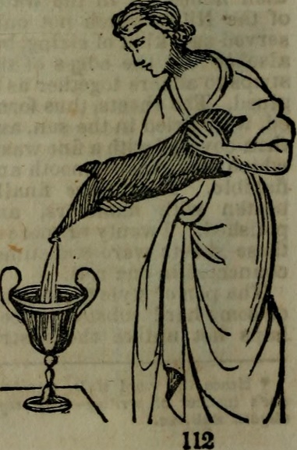
    - 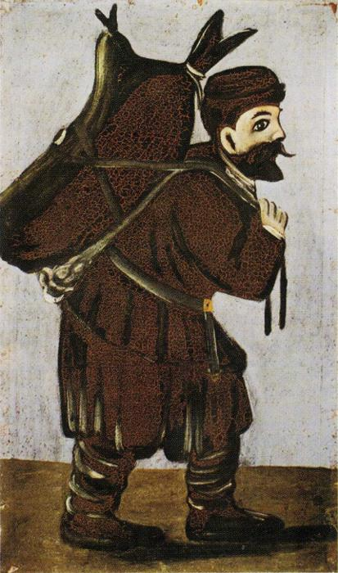(man carrying a wineskin)
    - You don’t put new wine (new grape juice) into an old wineskin.
      - Why? Answer: For the same reason as the first illustration.
      - New grape juice expands as it ferments.
      - But an old wineskin is no longer flexible and pliable, and it will not expand with the juice.
      - So, if you put new juice into an old wineskin it will eventually burst the skin and all your juice will leak out.
    - But if you put new juice into a new wineskin, that new skin is flexible enough to expand as the fermentation process takes place.
- Now that we understand the pictures Jesus is describing, we can begin to understand what He is trying to communicate.
  - In my Matthew 9 notes, I provided a more specific interpretation about the incompatibility of the Old and New Testament systems.
  - The New Covenant (New Testament) could not be contained in the forms, traditions, and rituals of the Old Covenant.
  - I still believe that to be a valid interpretation but in Mark’s gospel I would like to look at a broader interpretation.
  - Jesus is using these pictures to tell His listeners they need to consider the events occurring around them and act appropriately.
  - Continuing to act/do the same as they always had was unreasonable. Just like someone fasting at a wedding feast.
    - They needed to discern the signs of the times.
    - Jesus condemned the Pharisees for being unable to this in Matthew 16:3.
    - Mat 16:3b “You know how to interpret the appearance of the sky, but you cannot interpret the signs of the times.”
  - Using a new patch on an old garment or putting new wine in old wineskins was a failure to recognize key elements of the situation in front of them.
  - So too was their insistence on fasting when they should have been rejoicing.
    - No doubt, Judah had had many years in the recent past when fasting was appropriate.
    - They had neglected God and were trapped in the consequences of their sins.
  - But for the first time in a long time, someone had arrived to give them some hope.
  - They were continuing a practice just because it was what they had always participated in it.
  - They were failing to evaluate the world around them to see if a continuation of their practice made sense.
  - Jesus needs them to look up, take their tradition off autopilot, and observe the going-ons in the world.
  - APPLICATION:
    - Christians and churches collectively can put their faith in autopilot.
    - We can become blind to the world, sitting inside church buildings carrying on with old tradition and never evaluating whether our devotions make any sense.
    - Are we doing things just because we’ve always done them (whether we have any success with them or not).
    - It is not uncommon to see a congregation continuing to devote energy to a project or program that hasn’t garnered results in years.
      - They continue the program, not based on an evaluation of its value, but because they’ve “always done it.”
      - Their attention and time are consumed with ineffective work when necessary value-add work is being neglected.
    - It isn’t uncommon for Christians to put their faith and work in autopilot.
      - When we don’t consider methods of evangelism that are relevant to our modern world (still teaching like it’s the 1950s).
      - When we only give answers to questions that were relevant 10 years ago and never speak to the present world surrounding us.
      - When the church just drifts along 20 years behind the real world.
      - Ask yourself, am I really any better than those in this text?
        - Am I (or my church) in autopilot?
        - Are we in tune with the real-world events occurring all around us?
        - Am I (or my church) even equipped to reach a modern world with the gospel?
        - Are we just coasting along doing the same stuff we’ve always done without giving it any critical evaluation?
        - Imagine if Jesus sat down with the leadership of your congregation and asked, “Ok, show me your strategy. In light of the current world, show me why you’ve set this congregation up this way? Tell me why you are involved in the activities you’re involved in and why you think those activities are the best way to spend your time to accomplish the mission.”
        - Would you be excited to show Him your plans? Or would your strategy look like a last will and testament overdue for an update since the 1950s?
  - Jesus wants them to act appropriately for the time at hand.
  - Jesus would not be with them forever and there would be time for fasting when He departed, but now was not the time.
  - They were wise enough to discern when new/old patches and new/old wineskins should be used, they should apply the same discernment to their religious devotions.
  - APPLICATION:
    - If we measured the amount of critical thought we applied to our earthly affairs (work, hobbies, etc.) to the amount of critical thought we applied to our work for the Lord and His church, how would they compare?
    - Answer that question for yourself and remedy any lopsidedness so that ratio makes sense in light of the importance of God’s work.

Mar 2:23 One Sabbath he was going through the grainfields, and as they made their way, his disciples began to pluck heads of grain.
Mar 2:24 And the Pharisees were saying to him, “Look, why are they doing what is not lawful on the Sabbath?”
Mar 2:25 And he said to them, “Have you never read what David did, when he was in need and was hungry, he and those who were with him:
Mar 2:26 how he entered the house of God, in the time of Abiathar the high priest, and ate the bread of the Presence, which it is not lawful for any but the priests to eat, and also gave it to those who were with him?”
Mar 2:27 And he said to them, “The Sabbath was made for man, not man for the Sabbath.
Mar 2:28 So the Son of Man is lord even of the Sabbath.”

- This account is recorded in Matthew, Mark, and Luke with progressively decreasing detail.
  - Matthew gives the most details and dialog while Luke gives the least.
  - That being said, it is important to read all three in order to get the complete picture.
  - For example, although Matthew’s account is the most detailed, it does not include Jesus’ statement in Mark 2:27, “The sabbath was made for man, and not man for the sabbath.”
- Jesus and His disciples were walking through the corn fields on the sabbath day.
  - The reference to “corn” here isn’t intended to bring to your mind a field of corn on the cob. Corn (as in maize) wasn’t grown in that area of the world during this period of history.
  - This is the old English style “corn.”
  - This corn is a general reference to grain.
  - Luke 6:1 – “On a Sabbath, while he was going through the grainfields, his disciples plucked and ate some heads of grain, rubbing them in their hands.”
- In the scene we find the Pharisees tagging along with Jesus, watching His every move, just waiting to pounce at the slightest violation of the law.
  - Did they have nothing better to do?
  - They spend their time following Jesus around, not to learn, but to catch Him in error so they can call it out.
  - Jesus made it clear in Matthew, He would rather them spend their time tending to the weightier matters of the law rather than trying to catch Him on technicalities.
  - Rather than their religion transforming them into people who care about justice, mercy, and faithfulness (Matt 23:23) they’ve weaponized religion as a means to squash people they don’t like.
- APPLICATION:
  - We are going to find out in a few moments that Jesus wasn’t pleased with the Pharisees.
  - There are people in the church, and I hope you aren’t one of them, that spend all their time policing other Christians.
    - Evidently, they don’t have anything better to do than stalk fellow Christians who are trying to serve the Lord and keep their eyes peeled in anticipation of the slightest infraction.
    - Then they announce the violation to a wide audience as a sort of public service announcement.
  - This has been amplified with the rise of social media, where people can sit behind their computer screens and act like they are the defenders of the faith (not because they’ve done anything to benefit it but because they are calling out the “heretics”)
  - Don’t be a person who busies themselves policing the errors of those who are actually trying.
  - If you are someone who isn’t a member of the church, know that people like this do exist within churches.
    - But don’t let that discourage you.
    - The church is full of imperfect people.
    - Don’t let this be a reason for you turning your back on Christ or the church.
    - These types of people don’t act the way they do because God instructs them to be that way, they do it because they misunderstand and have perverted the intent of God’s design.
- APPLICATION:
  - When religious commands are weaponized to condemn others, while being stripped of any God focused meaning, we’ve got a problem with our religion.
  - The Pharisees observed the Sabbath but not in devotion to God
  - They observed the Sabbath so they could look down their noses at other people who didn’t do it as well.
  - We can observe “religious commands” without worship in our hearts but instead so that we can claim to be the best “Bible followers” and look down our noses at others.
  - Being a “Bible authoritarian” and a true worshipper of God are two different things.
  - Jesus is about to lay this out for the Pharisees
- It was the Sabbath Day (Saturday) and the Pharisees accused Jesus’ disciples of doing “work,” which they were forbidden to do on Sabbath.
- Moses had permitted the actions of the disciples (picking grain in the field) and had given no specific command forbidding the action on Sabbath, but the Pharisees had interpreted the Sabbath law to prohibit it on the Sabbath day.
  - Instead of directly responding to the Pharisees misinterpretation on this specific point, Jesus moves to show them they have a fundamental misunderstanding of the heart of the Old Testament Law.
  - Their deep-rooted misunderstanding corrupts all of their interpretation.
  - APPLICATION:
    - This is why the big picture of the Bible is so important.
    - People can misinterpret verses of scripture because their wider understanding of God is somehow faulty.
    - We need to be open to the idea that our big picture may need adjusting.
      - This is why it is important not lock down a lens through which you read the Bible before you’ve read the Bible
      - People read the Bible through lenses and we need to be willing to change those lenses or refocus them based un what we find in the Biblical details:
        - Common lenses:
          - Calvinist
          - Armenians (free will)
          - Jehovah witness
          - Mormon
          - Atheists (The Bible is foolishness)
    - When studying with someone, it isn’t wrong to go through each individual misinterpretation and show the person what needs to be changed, but it might be more beneficial to step away from that specific problem and look at the big picture.
    - In our personal study, when we come across a text that just doesn’t seem to make sense based on our interpretation of the Bible or seems to contradict what we believe, it may be time to evaluate our big picture of the Bible.
    - It is easy to just run off to a Christian commentator from your particular denomination and have them explain the verse for you, but those moments might be God’s prompting for us to evaluate what we believe and why.
    - SIDE NOTE: Bible commentaries are one of the most dangerous books a person can own, because if we use them incorrectly, they will teach us how to think, instead of aiding us in learning to think for ourselves.

I am going to do something a little different for this text. I want to include the text of Matthew for this discussion because it gives us the fullest picture of this discussion which I think is important for interpretation

Mat 12:3 - He said to them, “Have you not read what David did when he was hungry, and those who were with him:
Mat 12:4 - how he entered the house of God and ate the bread of the Presence, which it was not lawful for him to eat nor for those who were with him, but only for the priests?
Mat 12:5 - Or have you not read in the Law how on the Sabbath the priests in the temple profane the Sabbath and are guiltless?
Mat 12:6 - I tell you, something greater than the temple is here.
Mat 12:7 - And if you had known what this means, ‘I desire mercy, and not sacrifice,’ you would not have condemned the guiltless.
Mat 12:8 - For the Son of Man is lord of the Sabbath.”

Verse 3-4
- Verse three describes a situation where King David ate the “holy bread.”
  - You can read this account in 1Sam 21:1-7
  - The holy bread was a special bread made by the priest and was only to be eaten by priests (Lev 24:5-9)
- David was not a priest but was in need of food when he ate the bread.
- Why does Jesus bring up this story?
- I will present two explanations of Jesus words and later I will tell you which I prefer.
  - (1) Some argue Jesus brought this example up because David’s actions were condemnable.
    - But the Jewish elite held David in high respect and never condemned him for eating the holy bread
    - In excusing David, they revealed their hypocrisy when they condemned Jesus’ Apostles.
  - (2) Others argue Jesus brought this example up because David’s actions were not condemnable.
    - Although not found in Matthew’s record of this event, Mark records another statement of Jesus in this discourse.
    - Mar 2:27 And he said to them, “The Sabbath was made for man, not man for the Sabbath.
    - Jesus is saying the Pharisees don’t understand the Sabbath command.
    - They don’t understand Sabbath because they have a fundamental misunderstanding of the heart of the Old Testament Law.
      - To them, it is nothing more than a ritual that must be observed no matter what the cost in human suffering and inconvenience.
      - Jesus appears to say otherwise.
      - Men were not created to be servants of the Sabbath. The Sabbath was created as a day of rest for the benefit of men.
      - The example of David is an example of a time an exception was made to a specific Old Testament command.
      - The circumstances of the event merited the exception.
      - David and the priest who gave David the bread were not condemned.
      - Why? Because God’s design in creating the Old Law wasn’t to lift up stringent law keeping as the highest good even in the face of human need.
      - There were times when the ritual was put aside for the good of God’s servants.
      - God had designed the Law this way.
      - We will see another example of this in Jesus’ next statement about the priests in the Temple.
    - In condemning Jesus’ Apostles they reveal their ignorance about the true heart of the Law of God.
    - Similar in many ways to His Sermon on the Mount.
- In my view, the second of the two interpretations is correct.
  - If verses 3-4 stood alone without context, I would favor the first interpretation.
  - But in light of the following verses, especially Matthew 12:7 and Mark 2:27, I believe the second interpretation is more likely correct.

Verse 5
- Jesus again proves the Pharisees don’t understand the laws of God surrounding the Sabbath.
- According to the Pharisee’s interpretation of “profaning” the Sabbath, their very own priest profaned the Sabbath every Saturday.
- Why does Jesus bring this up?
  - The priests performed “work” on the Sabbath and it was part of God’s Law.
  - They killed animals and offered sacrifices (Num 28:9-10)
  - And they did it in the most sacred location on earth, the Temple.
  - So, if the Pharisees’ stringent interpretation of the law was valid, the Temple was profaned every week, yet the Pharisees weren’t busting down the Temple gates to punish the sinful priests.
  - The Pharisees understood much less than they thought they understood about the Law.
  - It seems He is making the point made with His example of David, contrary to the self-righteous interpretation of Sabbath put forward by the Pharisees, there was more to the Sabbath law than just ritual and it was not an absolute law for absolutely every situation.

Verse 6
- What was greater than the Temple?
- Jesus was greater than the Temple.
  - The Temple had been the place of God’s presence on earth during the Mosaic era.
  - But now Christ was the embodied presence of God on earth.
- If the priests were profaning the most holy Temple by breaking the Sabbath, it was definitely something to be concerned about.
- If the Apostles were profaning the Sabbath in the presence of something even greater than the Temple (Jesus), it was definitely something to be concerned about… And yet, Jesus wasn’t concerned.
- No violation of the Law had occurred.
- If the Sabbath made an exception for the work in the Temple, it would certainly make exception for Christ.

Verse 7
- “I desire mercy, and not sacrifice” is quoted from Hos 6:6 and you may also recognize it from Matthew 9:13.
  - Hos 6:6 For I desire steadfast love and not sacrifice, the knowledge of God rather than burnt offerings.
- If the Pharisees had a better grasp of this scripture’s meaning, they would not have condemned the innocent Apostles.
- What does it mean?
  - The Sabbath command was a direct command from God and was to be heeded.
  - Loving your neighbor was a direct command from God and was to be heeded.
  - The sabbath command was instituted for the good of man
  - If presented with the choice between the good of man and the stringent keeping of the Sabbath law, the good of man was to take priority.
  - The Sabbath law was designed with this in mind, therefore, laying aside a ritual so that love could take its place was not contrary to Sabbath (this being the exception, rather than the rule).
  - God would rather have mercy and love shown to your neighbor than the expense of them in order to keep the ritual.
- Imagine you were walking on the road and you saw a man who had been trampled by a cow. What would Jesus have you do if it was Sabbath?
    - Leave the man because carrying him and walking him to the hospital would violate Sabbath?
    - Or show mercy?
- Imagine you were driving to worship and saw a man hit by a car?
  - You are caught between two commands.
    - The command to worship (sacrifice)
    - Or the command to love your neighbor, the golden rule, and the command that reads, “the one who knoweth to do good and doeth it not, to him it is sin.” (James 4:17)
  - To which command are you obedient?
  - I think the answer is right here!
- The Pharisees had this completely backward.
  - They put all the importance on the ritual
  - They put none of the importance on the mercy and love (accusing Jesus of healing on Sabbath and violating the Law.)
- Side Note: It should be noted that the Apostle’s actions were not in any way opposed to God’s Sabbath law. The Pharisees had taken God’s Sabbath law and created more stringent traditions about what could and couldn’t be done. In this text their accusation is only based off of their personal traditions about how to keep Sabbath. Even so, Jesus was able to use it as a teachable moment to reveal their deep misunderstanding of God’s Law.
Verse 8
- Jesus’ claim here is bold and should not be understated.
- He claims deity in front of the Pharisees
- He had authority to speak on the interpretation of Sabbath law because He was the Lord of the Sabbath.
- Only God could claim authority over the laws of God.

https://www.ligonier.org/learn/devotionals/wine-fresh-wineskins/
https://christiananswers.net/dictionary/corn.html

