MARK 5

Mar 5:1 They came to the other side of the sea, to the country of the Gerasenes.
Mar 5:2 And when Jesus had stepped out of the boat, immediately there met him out of the tombs a man with an unclean spirit.
Mar 5:3 He lived among the tombs. And no one could bind him anymore, not even with a chain,
Mar 5:4 for he had often been bound with shackles and chains, but he wrenched the chains apart, and he broke the shackles in pieces. No one had the strength to subdue him.
Mar 5:5 Night and day among the tombs and on the mountains he was always crying out and cutting himself with stones.

- Where were the Gerasenes?
  - If you look in Matthew’s record of this story, he uses the name “the Gadarenes.”
  - Most people believe this area was located on the east side of the Sea of Galilee around the city of Gergesa (see the red square on the map below). This makes sense for several reasons:
    - (1) The area is on the “other side” of Galilee (verse 1).
    - (2) It is in the region of the Golan heights which explains the presence of a windstorm (end of chapter 4).
    - (3) There are several steep banks in the area that lead down into the sea (verse 13) (Check out Google Earth).
- This was an area largely inhabited by Gentiles.
  - In the text below, we will notice they were pig herdsman.
  - Pigs were unclean to the Jews.
- 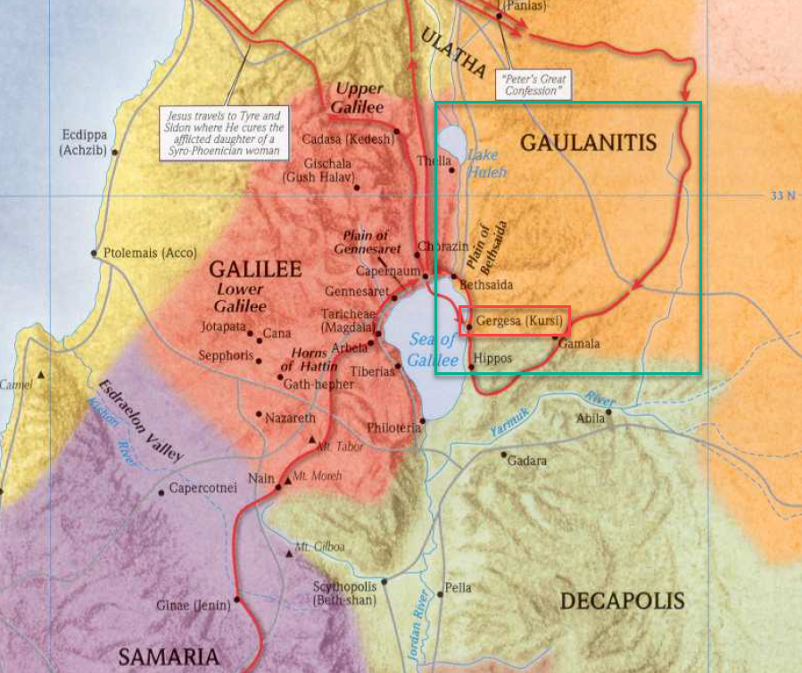
- Upon reaching land, Jesus got out of the boat and was immediately met by a man with an unclean spirit.
  - Matthew says there were two men (Matthew 8:28).
  - But Mark chooses to focus only on the one.
- We don’t know all the details our minds are curious about when it comes to the demons, but the New Testament does provide us a bit of information:
  - The demons were sent by Satan (Mark 3:23).
  - These demons appeared to have minds of their own. They spoke to Jesus and had knowledge of Jesus that their hosts did not have (Mark 5:29).
  - Mark’s account mentions this particular demon giving super-human strength to its host (Mark 5:4)
  - The demons could inhabit animals.
  - The Jews in the Bible appear somewhat familiar with demon possession.
  - Outside of the early years of the Church, I am not aware of any biblical references to casting out demons.
  - It is possible that Zechariah 13:2 refers to the disappearance of evil spirits at the time of the Messiah and the establishing of the Church.
  - Some people equate evil spirits with mental illness. Personally, I do not equate the two based on the facts above.
  - We know demons and spiritual enemies of God exist even today (Eph 6:12), but I do not see evidence that demon possession is still occurring.
- This man ran wild in the tombs because no one had the ability to bind Him.
- He spent his days “crying out and cutting himself with stones.”

Mar 5:6 And when he saw Jesus from afar, he ran and fell down before him.
Mar 5:7 And crying out with a loud voice, he said, “What have you to do with me, Jesus, Son of the Most High God? I adjure you by God, do not torment me.”
Mar 5:8 For he was saying to him, “Come out of the man, you unclean spirit!”
Mar 5:9 And Jesus asked him, “What is your name?” He replied, “My name is Legion, for we are many.”
Mar 5:10 And he begged him earnestly not to send them out of the country.
Mar 5:11 Now a great herd of pigs was feeding there on the hillside,
Mar 5:12 and they begged him, saying, “Send us to the pigs; let us enter them.”
Mar 5:13 So he gave them permission. And the unclean spirits came out and entered the pigs; and the herd, numbering about two thousand, rushed down the steep bank into the sea and drowned in the sea.

- Although Jesus hadn’t revealed His identity as the Messiah to the general public, this demon already knows He is the Son of God.
- The demon puts up no resistance.
  - He knows who Jesus is and knows He has no power to resist the command of God.
  - He begs Jesus not to torment him (verse 7)
  - Matthew quotes the demon as saying, “Have you come here to torment us before the time?”
    - This is probably a reference to the day of Judgement.
    - The demon knew the eventual fate of all those who side with Satan, but also knew that day wasn’t upon them yet.
    - SIDE NOTE: I find it interesting that the demons seem to know they can’t win.
      - Why resist God if you know you can’t succeed?
      - Is it just to do as much damage to His cause as possible?
    - Maybe it was just because the demon wanted to do his own thing. Wanted to live its own way instead of God’s.
      - It believed in God.
      - It knew he wasn’t a match for God.
      - But it also knew it wasn’t judgement day yet.
      - It didn’t know Jesus was going to show up that day.
    - Is that so far from the attitude of a lot of people.
      - Many people believe in God.
      - They know they are no match for Him.
      - But they also know it isn’t judgement day yet.
      - So they are going to do their own thing.
      - Some end up surprised when they meet Jesus sooner than they expected.
    - Maybe our motivations aren’t much different.
- Jesus asked the demon its name, to which it responded, “Legion, for we are many.”
  - This man may have been oppressed by many demons who were all speaking through this representative voice.
  - Creepy, yep!
- The demons knew Jesus would not allow them to continue to oppress the man.
  - Curiously, the they requested to be sent into a herd of pigs nearby and even more curiously, Jesus obliged.
  - When Jesus had banished the demon, it entered into the pigs and they all ran down a steep cliff and drowned in the Sea of Galilee
- APPLICATION:
  - God doesn’t always satisfy our curiosities.
  - In this case, God doesn’t fill in all the details of why Jesus interacted with this demon the way He did.
  - I find it tempting to try to fill in those gaps with speculations.
  - But that may not always be the most helpful thing.
  - There are times it is ok to say, “we don’t know.”
  - If God wanted us to know the details of His relationship with the demons, He would have told us.

Mar 5:14 The herdsmen fled and told it in the city and in the country. And people came to see what it was that had happened.
Mar 5:15 And they came to Jesus and saw the demon-possessed man, the one who had had the legion, sitting there, clothed and in his right mind, and they were afraid.
Mar 5:16 And those who had seen it described to them what had happened to the demon-possessed man and to the pigs.
Mar 5:17 And they began to beg Jesus to depart from their region.

- The pig herdsmen go into the city and tell everyone what happened.
- Upon hearing, the people came to see Jesus.
- But when they saw the man healed and in his demon-less state, they were afraid and asked Jesus to leave.
- Why were they afraid?
  - It is hard to say for sure.
  - I can think of a few possibilities.
    - (1) They were afraid Jesus would cause more damage to their livelihood. Two thousand pigs were enough loss for one day.
    - (2) They were overwhelmed by the miracle.
      - They didn’t know what they were dealing with.
      - Rather than take the time to get to know Jesus, they asked Him to leave so their lives could return to normal as soon as possible.
      - “We don’t know what went on here, but we don’t want to be involved!”
    - (3) This may describe a proper “fear of God.”
      - They may have asked Jesus to leave because they didn’t feel worthy of His presence.
      - Similar to Peter’s words in Luke 5:8 after Jesus filled his net with fish.
      - Luk 5:8 But Simon Peter, when he saw it, fell down at Jesus' knees, saying, Depart from me; for I am a sinful man, O Lord.
      - According to Strong’s Concordance, the word can be understood as “to be in awe of, that is, revere”

Mar 5:18 As he was getting into the boat, the man who had been possessed with demons begged him that he might be with him.
Mar 5:19 And he did not permit him but said to him, “Go home to your friends and tell them how much the Lord has done for you, and how he has had mercy on you.”
Mar 5:20 And he went away and began to proclaim in the Decapolis how much Jesus had done for him, and everyone marveled.

- As Jesus was departing, the man He helped begged Him to go with Him.
  - But Jesus doesn’t permit it.
  - Jesus tells the man to go into the city, to his home, and to his friends and tell them about the mercy of the Lord.
  - So that’s exactly what he did!
  - 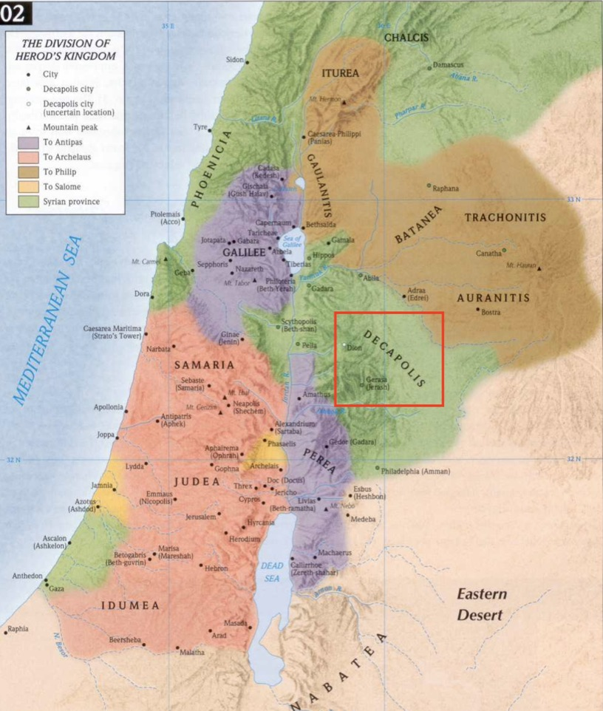
- APPLICATION:
  - The man probably thought following Jesus was the best route he could possibly take.
  - But Jesus redirects Him for a greater purpose.
  - You may attempt to set your life on a God honoring trajectory with full confidence your direction is the best way for you and to accomplish the work of God.
  - God may change your plans to accomplish more through you than you ever thought possible.
- One final thought on this passage…
- I wonder if the gospel writer intended to draw our minds back to Jesus’ words in Mark 3:27?
  - Mar 3:27 But no one can enter a strong man's house and plunder his goods, unless he first binds the strong man. Then indeed he may plunder his house.
  - Jesus is the only one powerful enough to bind the strong man (Satan) and free those enslaved to sin.
  - In the same way, no one was able to bind this strong man except Christ.
  - He then freed the man from Satan’s bondage.
  - I’m not sure if the author intended that connection, but it is an interesting parallel.

Mar 5:21 And when Jesus had crossed again in the boat to the other side, a great crowd gathered about him, and he was beside the sea.
Mar 5:22 Then came one of the rulers of the synagogue, Jairus by name, and seeing him, he fell at his feet
Mar 5:23 and implored him earnestly, saying, “My little daughter is at the point of death. Come and lay your hands on her, so that she may be made well and live.”
Mar 5:24 And he went with him. And a great crowd followed him and thronged about him.

- Returning from the Gerasenes, Jesus arrived at Capernaum to large crowds.
  - Several times, the gospels mention people waiting and watching at the shore for Jesus to arrive.
  - There were probably sick people who couldn’t wait for Jesus to come back so he could take them out of their pain and suffering.
  - What will Jesus arrival mean to you?
    - Do you dread the thought of Jesus coming back because your life isn’t right?
    - Or are you like these people, anxiously awaiting His arrival so he can take you out of a world of pain and suffering?
- A man, Jairus, approached Him and earnestly implored Him to come to his house and heal his daughter, who was close to death.
- The text says, “He went with him.”
  - Jesus seemed to have respect for bold faith and bold requests.
  - Jesus was the most important man in Capernaum.
  - It probably would have taken some courage to approach Jesus and ask Him to follow you.
  - The man may have thought, “who am I to ask for Jesus’ time?”
  - There were probably plenty of other things Jesus could have been doing.
  - Probably plenty of important people who wanted Jesus’ time.
  - But Jesus rewards the man with the bold request and goes with him to his house.
- What would Jesus be willing to do for us and with us if we came to Him so boldly?
  - Have you ever felt like you’ve asked Jesus for too much?
  - Like your prayer is to bold or too big?
  - I wonder if this man struggled with the same doubt when considering whether to ask Jesus.
  - But look at the way Jesus answered Him!

Mar 5:24 And he went with him. And a great crowd followed him and thronged about him.
Mar 5:25 And there was a woman who had had a discharge of blood for twelve years,
Mar 5:26 and who had suffered much under many physicians, and had spent all that she had, and was no better but rather grew worse.

- On the way to Jairus’ house, a large number of people surrounded Jesus.
- But Mark, and the other gospel writers draw our attention to this woman with a “discharge of blood.”
  - We are told her ailment had caused her great suffering and she had spent all of her money on doctors who were ultimately no help.
  - If this woman was a Jew, this ailment would have been particularly troubling, as it likely would have made her ceremonially unclean and would have excluded her from a significant amount of Jewish life.
    - Put yourself into the position of a person like this, someone who was perpetually “unclean” according to the Law of Moses.
    - They lived in a constant state of unwelcomeness.
    - They couldn’t go to the Temple, they couldn’t participate in the feasts, etc.
      - What if you weren’t allowed over to your families house for thanksgiving and Christmas dinner. If you were banned from going into the church building where you once worshipped.
      - This would have been true for the lepers Jesus healed.
      - Can you imagine contracting leprosy and, in an instant, having your invitation revoked to everywhere you were once welcome.
    - And it wasn’t their fault. This woman didn’t choose to have a discharge of blood.
    - Imagine how much a miracle of healing would have meant to this kind of person.
    - To finally have a chance to be welcome again.
    - In healing our sins, God gives us all a place to be welcome, the Church.
      - The Church should be where healed people find a home.
      - So, if you’ve gone through life feeling unwelcome everywhere you go, Jesus invites you to a place you can belong.
    - And of course, that is only a shadow of what Heaven will be.

Mar 5:27 She had heard the reports about Jesus and came up behind him in the crowd and touched his garment.
Mar 5:28 For she said, “If I touch even his garments, I will be made well.”
Mar 5:29 And immediately the flow of blood dried up, and she felt in her body that she was healed of her disease.

- Having heard of the power of Jesus, she determined He was her best hope.
- She made her way through the crowd, confident she could be healed if she only touched the hem of Jesus’ clothes.
- When she had managed it, her faith was confirmed and she could felt the healing inside her.

Mar 5:30 And Jesus, perceiving in himself that power had gone out from him, immediately turned about in the crowd and said, “Who touched my garments?”
Mar 5:31 And his disciples said to him, “You see the crowd pressing around you, and yet you say, ‘Who touched me?’”
Mar 5:32 And he looked around to see who had done it.
Mar 5:33 But the woman, knowing what had happened to her, came in fear and trembling and fell down before him and told him the whole truth.
Mar 5:34 And he said to her, “Daughter, your faith has made you well; go in peace, and be healed of your disease.”

- Jesus immediately recognized “power had gone out of Him.”
  - Rather than an unclean person touching Jesus and making Him unclean, the unclean received His cleanliness by touching Him.
  - Rather than lepers touching Jesus and giving Him leprosy, the lepers touched Jesus and they were made healthy.
  - It’s a powerful picture of Jesus’ untarnishable power and purity.
- He asked the crowd, “Who touched my garments?”
- The disciples were confused why Jesus would ask this considering He was surrounded by a crowd and was likely being touched by dozens of people.
- But Jesus, and this woman, knew this was a different kind of touch than the average shoulder rubbing against another.
- In fear, the woman emerged from the crowd and admitted to her actions.
  - But there was no reason for fear.
  - Jesus spoke kindly to her and commended her faith.
- Of course, Jesus knew who it was who had touched Him, so why did he ask? Why reveal the identity of the woman?
- I can think of at least 3 reasons:
  - (1) To bring glory to God for the miracle.
    - The people in the city may have known this woman and her affliction.
    - They may have known she had been to every doctor in the city.
    - They couldn’t heal her, but Jesus did.
  - (2) To give the people a picture of great faith.
  - (3) For the benefit of the woman.
    - Jesus may have exposed her out of generosity.
    - Here was a woman, who if a Jew, had been ceremonially unclean with an unobservable disease for 12 years.
    - It would be suspicious if she showed up one day out of the blue claiming her ailment had disappeared.
    - Jesus may have done this out of kindness, to inform the people she had been healed.
- Compare the boldness of Jairus to the timidity of this woman.
  - Jairus came in boldness asked Jesus to take time out of His day to come to his house.
  - This woman, in secret, ran her fingers across the hem of Jesus’ garment while He walked by. Probably the most unobtrusive way of touching somebody ever!
  - I love that Jesus honors the requests of both.
  - There are people with great boldness of faith who approach God’s throne knowing they are His children and have His ear.
  - There are people who come to God in deep humility and poverty of spirit.
  - God hears them both and will bless them both.

Mar 5:35 While he was still speaking, there came from the ruler's house some who said, “Your daughter is dead. Why trouble the Teacher any further?”
Mar 5:36 But overhearing what they said, Jesus said to the ruler of the synagogue, “Do not fear, only believe.”

- While Jesus was commending the faith of the woman, messengers from Jairus’ house arrived to tell him it was too late. His daughter was dead.
- The messengers told Jairus there was no need to bother the “Teacher” (Jesus).
  - It is one thing to have power over disease.
  - It is another to have power over death.
  - Disease is a physical bodily problem.
  - But raising someone from the dead requires command of a person’s spirit.
- Jesus overheard the conversation and tells Jairus not to worry, only believe.
  - To Jairus’ credit we don’t read that he did anything but believe.
  - We don’t read about him complaining the woman with the issue of blood slowed things down.

Mar 5:37 And he allowed no one to follow him except Peter and James and John the brother of James.
Mar 5:38 They came to the house of the ruler of the synagogue, and Jesus saw a commotion, people weeping and wailing loudly.
Mar 5:39 And when he had entered, he said to them, “Why are you making a commotion and weeping? The child is not dead but sleeping.”
Mar 5:40 And they laughed at him. But he put them all outside and took the child's father and mother and those who were with him and went in where the child was.
Mar 5:41 Taking her by the hand he said to her, “Talitha cumi,” which means, “Little girl, I say to you, arise.”
Mar 5:42 And immediately the girl got up and began walking (for she was twelve years of age), and they were immediately overcome with amazement.
Mar 5:43 And he strictly charged them that no one should know this, and told them to give her something to eat.

- Arriving at the house, Jesus took only 3 of the Apostles with Him, Peter, James, and John.
- Together they entered the house with Jairus and his wife.
- There they encountered several mourners.
  - Jesus asked them, “Why are you making a commotion and weeping? The child is not dead but sleeping?”
  - Scientifically, the mourners knew the girl was dead but they didn’t know the Creator of science and the Conqueror of death was standing in front of them.
  - They laughed at Jesus question.
    - I don’t think it was right for them to laugh at Jesus.
    - They clearly didn’t know who He was.
    - But imagine if you were at the funeral of a loved one and a man you didn’t know showed up and said, “Why are you all crying? Your loved one isn’t dead; they are just sleeping!”
    - Would you laugh? Or mock?
      - Those who heard Paul’s preaching in Acts 17 mocked the idea of resurrection from the dead.
      - Many today mock and laugh at the idea there is life after death.
    - We would be wise evaluate who it is claiming the power of resurrection before we laugh. We might be laughing in the face of our Creator.
  - Jesus obviously knew the girl was physically dead but He was about to wake her up as if she were only asleep.
- He took His small audience into the room where the girl was laying, took her by the hand, saying “Little girl, I say to you, arise.”
  - As the word of God had put life into all things in the beginning, Jesus words put life back in the body.
  - Consider the complexity of restarting a dead human body.
  - All the organs kickstarting at once, function coming back to the brain, pushing blood through cold veins, restoration of decaying organ tissue, oxygen starved muscles firing at full capacity, eyes re-dilating, blood pressure and oxygen levels stabilizing?
  - Jesus managed the complexity in a word.
- Side effects were nonexistent, the girl wasn’t even dizzy, she got up immediately and started walking around (as if she had been asleep).
- I’m sure the statement “they were immediately overcome with amazement” is not an understatement.
- And again, we find Jesus telling people not to talk about the miracle publicly.
  - He is not yet ready for His identity as the Messiah to be made known.
  - Contrast this with what He told the demon-possessed man in verse 19.
  - Why the difference?
  - It may have come down to location and audience.
    - Unless I’m mistaken, Jesus usually tells Jews not to spread the news about His miracles.
    - But he encourages their spread when performed in non-Jewish areas.
      - Man healed of the demons in Mark 5.
      - Woman at the well in John 4.
    - *There may be exceptions to this. I will continue to evaluate this theory as we go through our study.
- Two additional observation from the second half of chapter 5.
  - (1) Take a moment to contrast the healing of the woman with the issue of blood and Jairus’ daughter.
    - Jairus had enjoyed the joy of his daughter for 12 years.
    - The woman had been afflicted with the discharge of blood for 12 years.
    - Jairus was an important man in the community (ruler of the synagogue).
    - The woman was no one of significance. We don’t even know her name.
    - Jairus probably had money.
    - The women had no money.
    - Jairus approached Jesus and made his request publicly.
    - The women came up behind Jesus in secret.
    - Jairus wanted Jesus to physically come to his house to perform a healing.
    - The women only wanted her finger to graze the hem of Jesus’ clothing. He didn’t even have to break stride.
    - The healing of Jairus’ daughter was delayed.
    - The woman was healed immediately.
    - Jairus’ daughter was raised to life in a private room.
    - The woman was healed in the midst of a throng of people.
    - These stories are recorded in all three synoptic gospels and are always placed together in the text.
    - Is this contrast part of their significance?
  - (2) Also consider Jesus’ delay in arriving at Jairus’ house.
    - Jesus knew exactly how much life Jairus’ daughter had in her when Jairus initially approached Him.
    - He knew if He decided to walk to Jairus’ house and encountered the women with the issue of blood Jairus’ daughter would die on the way.
    - I’m sure Jairus was in a hurry but Jesus wasn’t.
    - This wasn’t the only time Jesus would delay healing someone and allow them to die.
      - The same thing happened to Lazarus (John 11).
      - Lazarus’ sisters didn’t understand why Jesus hadn’t arrived earlier to save their brother.
      - The Jews also said, “Could not he who opened the eyes of the blind man also have kept this man from dying” (John 11:37)?
    - Why didn’t Jesus speed things up?
      - Jesus told His Apostles He was glad He “was not there, so that you may believe.”
      - The Apostles had witnessed many healings but seeing a living person healed from sickness isn’t as amazing as seeing someone brought back to life from the dead.
    - Jesus may have delayed to have an opportunity to perform a greater miracle and create stronger faith in those who witnessed it.
    - Is it possible He still behaves this way today?
      - Have you ever been in a situation or witnessed a situation where people were anxiously awaiting God to show up and save them?
      - They knew they needed God’s help, their faith was in the right place, but God was delaying.
      - Why?
      - Maybe He delays to build greater faith when He provides a more astounding salvation.

