MARK 7
Mar 7:1 Now when the Pharisees gathered to him, with some of the scribes who had come from Jerusalem,
Mar 7:2 they saw that some of his disciples ate with hands that were defiled, that is, unwashed.
Mar 7:3 (For the Pharisees and all the Jews do not eat unless they wash their hands properly, holding to the tradition of the elders,
Mar 7:4 and when they come from the marketplace, they do not eat unless they wash. And there are many other traditions that they observe, such as the washing of cups and pots and copper vessels and dining couches.)
Mar 7:5 And the Pharisees and the scribes asked him, “Why do your disciples not walk according to the tradition of the elders, but eat with defiled hands?”
- The fact that these Pharisees and scribes came from Jerusalem is not insignificant.
  - It likely shows the growing influence of Jesus and an increase in the concern of the Pharisees and scribes.
  - Capernaum was not a short day trip from Jerusalem. It was 80-85 miles.
  - 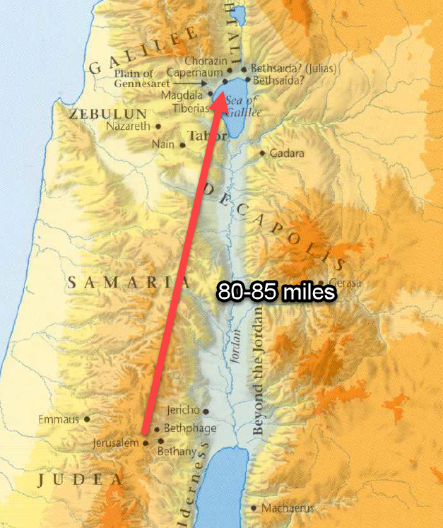
- It wasn’t wrong for the Pharisees, Sadducees, and scribes to evaluate the ministry of Jesus.
  - They did it under the guise of protecting God’s Law.
  - The problem with their evaluation was they had already made up their minds.
  - APPLICATION:
    - Are we any better as evaluators?
    - Do we enter religious discussions as genuine evaluators? Or do we enter into those discussions having our minds already made up?
- On their long journey, the Pharisees and scribes must have had a significant amount of time to consider which accusation they wanted to make against Christ and they decided on hand washing.
  - “Why do you disciples not walk according to the tradition of the elders, but eat with defiled hands?”
  - Notice what they cite as their authority for this practice, the “tradition of the elders.”
  - Their authority is important for the conversation that follows.
    - At this point in Jewish history, the Jews reviered two sources of authority.
      - (1) The written Law of God (Old Testament books).
      - (2) The oral traditions of the rabbis (Mishnah).
    - Some historians believe the Jewish leaders of the 1st Century gave these the same level of binding authority.
  - APPLICATION:
    - Does that ever happen in Churches today?
    - Human traditions get mixed in with God’s direct commands and people give them the same level of binding authority?
- What was hand washing?
  - If you’ve never read the Bible before or haven’t been introduced to Judaism, you may think this “hand washing” refers to the common practice most of us still hold to today.
    - We don’t want to eat with dirty hands because, well, germs and stuff, so we wash them with some soap and water before we eat.
    - But our common modern practice is not what was being asked about in this text.
  - Jewish hand washing is known as netilat yadayim (don’t ask me how to pronounce).
    - The practice is described in great detail in the Mishnah.
      - The Mishnah is a collection of the Jewish oral traditions.
      - These oral traditions were meant to explain and expound on the Torah.
      - The Torah is the written Law of God (Genesis, Exodus, Leviticus, etc)
    - The practice of hand washing began with a command given to the priests when they entered the Temple to perform their duties.
      - They were told in Exodus 30:17-21 to wash their hands and their feet in purification for their holy responsibilities.
      - Exo 30:17-21 - The LORD said to Moses, “You shall also make a basin of bronze, with its stand of bronze, for washing. You shall put it between the tent of meeting and the altar, and you shall put water in it, with which Aaron and his sons shall wash their hands and their feet. When they go into the tent of meeting, or when they come near the altar to minister, to burn a food offering to the LORD, they shall wash with water, so that they may not die. They shall wash their hands and their feet, so that they may not die. It shall be a statute forever to them, even to him and to his offspring throughout their generations.”
    - So the origin of the tradition originated in God’s Law, but the elders expanded on this command and created traditions demanding hand washing and ritual purification for common Jews doing common things.
    - They required the same ritual purification by water to take place at several occasions:
      - Before eating
      - After eating (if they had touched the “salt of Sodom.”)
      - When eating certain fruits and vegetables
      - After sleeping
      - Before prayer
    - They also created rituals about:
      - What type of water was required
      - How much water was required
      - How many times the water had to be poured on the hand
      - Blessings that must be quoted during the ritual
    - Hand washing was not about physical cleanliness, it was about a spiritual purification before the priest (the Jew) approached the altar (the table) to take part in the sacrifice (the bread).
  - APPLICATION:
    - We need to be really careful about taking a “principle” found in one context and creating rules to bind in other contexts.
    - Binding a principle laid down in one context in another context.
  - It is easy to be critical of this tradition and to see it as complete nonsense from our angle.
    - But we should be careful.
    - These traditions arise very subtly and they are built on seemingly good intentions.
    - Many traditions have an appearance of being build of good “spiritual logic.”
    - Put yourself in the place of 1st Century Jew as I ask the following questions.
      - Doesn’t God want us to honor Him in everything we do?
        - Answer: Yes!
      - Did God want the priests to wash their hands before serving Him?
        - Answer: Yes!
      - Should we not be equally as devoted as the priests and strive for their holiness?
        - Answer: Yes!
      - Aren’t meals an opportunity for us to make a sacrifice of praise to God?
        - Answer: Yes!
      - Shouldn’t we take every opportunity to make ourselves pure before the Lord?
        - Answer: Yes!
      - Doesn’t the Psalmist say, “Who may ascend into the hill of the LORD? Or who may stand in His holy place? He who has clean hands and a pure heart (Ps 24:3-4)?
    - It isn’t difficult to find yourself responding with a series of “yes” answers.
    - Then all of a sudden you’re binding a tradition Jesus wouldn’t bind.
- The Pharisees and scribes weren’t asking this question for general information, they were accusing Jesus and His Apostles of sinning by breaking the teachings of the elders.

Mar 7:6 And he said to them, “Well did Isaiah prophesy of you hypocrites, as it is written, “‘This people honors me with their lips, but their heart is far from me;
Mar 7:7 in vain do they worship me, teaching as doctrines the commandments of men.’
Mar 7:8 You leave the commandment of God and hold to the tradition of men.”

- The prophecy quoted in verse 6 and 7 is located in Isaiah 29:13.
- On the outside, the Pharisees and scribes appeared religious, but on the inside they were very far from God.
- Their devotion was vain.
  - Vain: producing no result, useless.
- They were more devoted to their own traditions about the Law than the Law itself.
- They had lost sight of whose words were more important.
  - Theirs and their elders?
  - Gods?

Mar 7:9 And he said to them, “You have a fine way of rejecting the commandment of God in order to establish your tradition!
Mar 7:10 For Moses said, ‘Honor your father and your mother’; and, ‘Whoever reviles father or mother must surely die.’
Mar 7:11 But you say, ‘If a man tells his father or his mother, “Whatever you would have gained from me is Corban”’ (that is, given to God)—
Mar 7:12 then you no longer permit him to do anything for his father or mother,
Mar 7:13 thus making void the word of God by your tradition that you have handed down. And many such things you do.”

- Jesus does not answer their question with an explanation but with an accusatory question of His own.
  - “Why do you break God’s Law to keep the elder’s traditions?”
  - He is “one-upping” them.
  - Which was more important? The commands of God or the commands of the elders?
  - The answer should have been obvious.
    - God’s laws have divine authority behind them.
    - The traditions were just that… traditions.
- Jesus then provided an example of how this was done.
  - God commands children to “honor your father and your mother” (one of the 10 commandments).
    - Jesus makes it clear that obedience to that command demands caring for your parents needs, financially or otherwise.
    - The punishment for failing to honor them was death.
  - On the flip-side, there were also commands in the Scriptures that required keeping oaths if those oaths were made to God.
  - The Pharisees and scribes emphasized one of these commands and discarded the other.
  - The tradition of the elders stated if a person dedicated his possessions to the service of God, they were no longer required to use those resources to fulfill their responsibility to their parents.
  - Mark calls the dedication “Corban?”
  - A dedication of this type only exists within the traditional teachings of the Jewish Rabbis, not in the written Law of God.
  - God would never have allowed such an oath to be made.
    - This is like saying, I made an oath to dedicate all of my time to the Lord, so I’m going to be neglecting my wife and kids from now on.
    - It doesn’t work like that.
  - Their made-up tradition voided the word of God.
  - Such an oath should never have existed!
  - They were elevating the words of their rabbis above the words of God.
  - Jesus boldly calls them hypocrites!
    - In an outward pretense of piety they dedicated their belongings to God.
    - But it wasn’t because they loved the LORD or His commands.
    - Their show of devotion was, at heart, just a self-serving round-about means to shirk God’s commands.
    - I like the way Albert Barnes defines their hypocrisy.
    - “Hypocrisy is the concealment of some base principle under the pretense or religion. Never was there a clearer instance of it than this an attempt to get rid of the duty of providing for needy parents under and appearance of piety towards God.”
- APPLICATION:
  - Whose words are more important to you?
  - Are you quicker to listen to a trusted teacher than to pick up the Bible and read God’s words for yourself?
  - Are you willing to ignore the written Scripture because someone told you it doesn’t apply?
  - The Pharisees and scribes had a very similar problem to many in the religious world today.
  - Are oral traditions more important to us than God’s written commands?
    - How often do you hear a religious teacher cite that some prominent religious figure from the past taught a particular doctrine, and many after him taught the same thing, and this teacher was educated at a seminary with highly educated people who taught the same thing, and that is why you should accept it?
    - What is that? Oral tradition! Tradition of the elders!
    - That isn’t to say that it is wrong… but it might be.
    - Which is why a study like this is so important
      - To examine the written word of God.
      - So that no matter what oral tradition you’ve heard about what you should believe and practice, you can make sure in doing it you aren’t violating the commands of God.
  - Why does Jesus spend so much time dealing with the Pharisees, Sadducees, and scribes in the New Testament?
    - Is it just because He liked beating up on them?
    - No, it is because in dealing with their problems He dealt with our problems.

Mar 7:14 And he called the people to him again and said to them, “Hear me, all of you, and understand:
Mar 7:15 There is nothing outside a person that by going into him can defile him, but the things that come out of a person are what defile him.”

- Picture this with me, Jesus just openly rebuked the most respected religious leaders in Judaism in front of all the people who respected them. He then calls all of the people over to Him and in front of the Pharisees, He teaches the people the direct opposite of everything the Pharisees and scribes held dear. SAVAGE!
  - Welcome to Galilee! They travelled 80 miles to get thrashed.
  - It was occurrences like this that enflamed the Pharisees and scribes hatred of Christ.
  - Religion was their turf and it only took one encounter for them to get taken to school and embarrassed by a 30 year old who never attended Mosaic Law seminary.
- In verse 2, I want you to think about how big of a shift this statement would be for a Jew who grew up under the Mosaic Laws of clean/unclean.
  - The Law of Moses taught that a person was clean or unclean based, many times, on their outward surroundings.
  - It mattered what they touched, who they were around, where they went, etc…
- Now Jesus is saying what makes a person clean or unclean, defiled or undefiled, isn’t the outside but the inside.
  - A person isn’t defiled if he eats bread without ritualistically washing his hands.
  - A person was defiled if his heart wasn’t right towards God.
- The Pharisees and scribes were case-and-point.
  - They looked great on the outside.
    - They washed their hands.
    - They recited the blessings.
    - They dedicated their possessions to God.
  - But their insides were rotten.
    - They sought loopholes around God’s commands.
    - They were hypocrites.
- They’re hearts were far from God.

Mar 7:17 And when he had entered the house and left the people, his disciples asked him about the parable.
Mar 7:18 And he said to them, “Then are you also without understanding? Do you not see that whatever goes into a person from outside cannot defile him,
Mar 7:19 since it enters not his heart but his stomach, and is expelled?” (Thus he declared all foods clean.)
Mar 7:20 And he said, “What comes out of a person is what defiles him.
Mar 7:21 For from within, out of the heart of man, come evil thoughts, sexual immorality, theft, murder, adultery,
Mar 7:22 coveting, wickedness, deceit, sensuality, envy, slander, pride, foolishness.
Mar 7:23 All these evil things come from within, and they defile a person.”

- The disciples (Matthew tells us it was Peter) approach Jesus and ask Him to explain this new concept to them.
- Jesus implies they should have been able to reason the words out for themselves but goes on to provide an explanation.
  - Food cannot defile a person.
  - Food is eaten and expelled from the body.
  - It is what is allowed to remain in the body, in the heart, that can defile a person.
    - This is very consistent with Jesus’ teaching on the Sermon on the Mount.
    - Lust and adultery and murder begin with what we allow to reside in us.
  - Our hearts are either springs of living water or poison water.
  - External factors cannot influence us unless we allow them entrance through the gate of our hearts to affect it’s output.
  - We can be surrounded by external uncleanliness and not be defiled.
    - This is the state of the Christian everyday.
    - We live in a world full of defiling influences.
    - We are told that we must live in this world but not permit it to live within us!
  - We are only defiled when we allow sin entrance or we are not vigilant and it slips in under our notice.
  - The heart is defiled when it becomes a harbor for wickedness.
  - If we find our heart in this state, we need to purify our hearts and affections (Matthew 5:8, “Blessed are the pure in heart, for they shall see God.)
- General principle: what is outside of you cannot defile you in the eyes of God. Only what is inside of you can defile you. Who decides what is allowed inside of you? You do!

Mar 7:24 And from there he arose and went away to the region of Tyre and Sidon. And he entered a house and did not want anyone to know, yet he could not be hidden.
Mar 7:25 But immediately a woman whose little daughter had an unclean spirit heard of him and came and fell down at his feet.
Mar 7:26 Now the woman was a Gentile, a Syrophoenician by birth. And she begged him to cast the demon out of her daughter.
Mar 7:27 And he said to her, “Let the children be fed first, for it is not right to take the children's bread and throw it to the dogs.”
Mar 7:28 But she answered him, “Yes, Lord; yet even the dogs under the table eat the children's crumbs.”
Mar 7:29 And he said to her, “For this statement you may go your way; the demon has left your daughter.”
Mar 7:30 And she went home and found the child lying in bed and the demon gone.

- *It’s worth reading Matthew’s account of this interaction, as it contains a few additional details about the interaction. I will be approaching Mark’s text with those details in mind. You can read the text in Matthew 15:21-28.
- At the end of chapter 6, Jesus was on the plain of Gennesaret.
- He now departs Galilee to go Northwest to Tyre and Sidon.
- 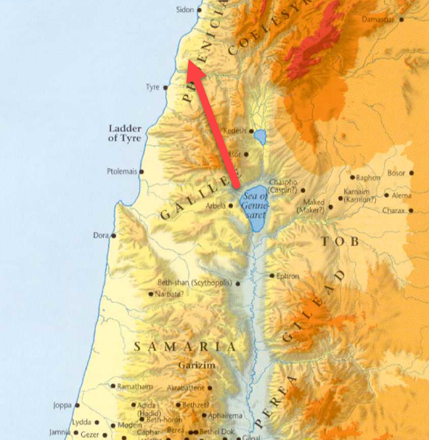
- Jesus’ intention for making this 40+ miles journey isn’t fully explained by Matthew or Mark.
  - The encounter we are about to read is the only significant event recorded from the journey.
  - This encounter may have been the primary purpose for visiting Tyre and Sidon.
- Sometime during His visit, Jesus is approached by a Canaanite woman.
  - Mark’s gospel calls her a Syrophoenician.
  - This woman was not a Jew, she was a gentile.
- She cried out to Jesus and addressed Him in a very curious way.
  - She calls Him the “Son of David.” (Matthew)
  - Why is that so curious?
  - Because this gentile woman appears to recognize Jesus as the Messiah.
  - “Son of David” is the term used in reference to Jesus in Matthew 1:2 when Matthew provides the genealogy of Jesus to prove Him to be the Messiah.
  - This could not have been a general greeting among the Jews because not all Jews were David’s descendants.
- The woman was requesting Jesus help for her daughter who was troubled by a demon.

*Mat 15:23 - But he did not answer her a word. And his disciples came and begged him, saying, “Send her away, for she is crying out after us.”

- Through all of her crying and pleading, Jesus did not respond.
  - The disciples were annoyed with her and asked Jesus to send her away.
  - Jesus’ unwillingness to send her away makes it clear He was not simply trying to dispose of the woman.

*Mat 15:24 - He answered, “I was sent only to the lost sheep of the house of Israel.”
Mat 15:25 - But she came and knelt before him, saying, “Lord, help me.”

- Why would John exclude these verses from His text? Well, it may have been because they were more relevant to a Jewish audience than a Gentile one.

- Eventually, Jesus responded, making His mission clear to the Canaanite woman.
- He had not come to preach and teach among the gentiles, only the Jews.
  - That isn’t to say Jesus never helped gentiles.
  - We’ve already encountered a few instances where gentiles received miracles from Jesus.
  - He said this to the woman to test her faith. To see how resolved she was to care for her daughter.
- The woman responded with a statement of great humiliation.
  - She acknowledged Jesus mission.
  - She knew that the Son of David was a Messiah to the Jewish nation.
  - But she begged that the abundance of the Messiah’s blessings might spill over to a gentile.
  - She is asking for something that doesn’t belong to her.
  - She is asking for grace.
  - If you know anything about Jesus, you know He isn’t in the business of withholding grace.
- In the King James Version (KJV), in Matthew 15:25, in place of “knelt before him,” the text says she “worshipped Him, saying, Lord, help me.”
- The way Jesus replies to the woman now kneeling at His feet is a bit shocking.
  - Jesus’ actions in coming to Tyre and Sidon and in what He is about to do for this woman prove that He didn’t say this to be derogatory towards the woman but, again, to test her resolve.
  - Referring to the Jews as “children” and the gentiles as “dogs,” He tells her it would not be right to take what belonged to the Jews and throw it the gentiles.
  - Paraphrase: “It wouldn’t be right for me to take what belongs to someone else and give it to someone who doesn’t deserve it.”
    - That is really interesting because right now, Jesus is on a mission to do that very thing.
    - To take what belongs to someone else and give it to someone who doesn’t deserve it.
    - What a lesson on grace for a Jewish audience of disciples who had been taught by their religious leaders they were the children of Abraham and the inheritors of the Kingdom of Heaven on account of their bloodline.
      - “Our blood keeps us in good standing with God!”
      - “We will enter the Kingdom because we are Jews”
      - They believed themselves entitled to it.
    - The woman acknowledges she doesn’t deserve what she is asking for but asks anyway in hope that Christ would give a gift!
    - Who approached God correctly? The entitled Jews or the grace desperate Syrophoenician woman?
      - The Jews needed to understand that they were in as desperate need for something they didn’t deserve as this woman was.
      - We need to understand that we are in as desperate need as this woman and approach God the same way.
    - The Jews thought their blood was everything.
    - The Syrophoenician woman knew her blood was nothing.
    - Jesus’ blood is the only blood that matters.
    - And that blood was spilled to give the undeserving the grace they don’t deserve.
- But people in our world don’t like to be told they are undeserving.
- At this point, if I was the Canaanite woman, I probably would have gotten off the ground and turned to Jesus and said, “forget you, if your are going to be a jerk, I don’t want your help!”
- Luckily for her daughter, this woman didn’t respond like me.
  - Upon hearing Jesus’ words, she humbled herself even further.
  - “Truth, Lord: yet the dogs eat of the crumbs which fall from their master’ table.”
- Her humility impressed Jesus!
  - He paid her a high compliment, saying, “O woman, great is thy faith…”
  - And He did as she requested in healing her daughter.
- Now I want to look at 2 reasons why Jesus may have traveled 40+ miles to encounter this woman with the Apostles.
  - (1) First, Jesus may be using this woman to illustrate the future of the Kingdom.
    - Jesus had just spent time in Nazareth and Galilee.
    - What had occurred there?
      - The Jews had rejected Him in Nazareth
      - The Jews had rejected Him in Galilee and even sent Pharisees and scribes all the way from Jerusalem to undermine Him.
    - Jesus then departed Jewry (I had to use this word at least once) and travelled to Tyre and Sidon.
    - What occurred there?
      - A gentile woman came crying after Jesus calling Him the Messiah.
      - She acknowledged Him as the only one who could help her.
    - The people who should have know the Messiah and worshipped Him didn’t…
    - The gentile who shouldn’t have know the Messiah fell down at His feet worshipping…
    - Does this in any way parallel what we will see as we follow Christianity through its 1st Century history?
      - Largely the Jews rejected their Christ, not being able to acknowledge their sinful state.
      - Paul will later write how the gospel was then taken to the gentiles because they gladly accepted the Savior.
    - Notice the Apostle’s attitude towards the two groups just discussed.
      - The Apostles came to Jesus earlier in the chapter concerned about the offended Pharisees and scribes.
      - On the other hand, the Apostles were quick to ask Jesus to turn this woman away.
    - It may be that Jesus took them up to Tyre and Sidon to help them adjust their thinking about those who would accept His message.
    - This may foreshadow the gentile acceptance of the gospel.
    - This is the second time Jesus highly complimented the faith of a gentile (Mat 8:10).
  - (2) To show His Apostles and unexpected picture of Himself!
    - Here we see a woman who was born into low social status, like Jesus.
    - This woman didn’t come for personal benefit but to seek the good of someone else, like Jesus.
    - This was a woman who was willing to make herself uncomfortable to accomplish her goal, like Jesus.
    - This woman, when she could have taken offense, humbled herself further to accomplish her mission, like Jesus.

Mar 7:31 Then he returned from the region of Tyre and went through Sidon to the Sea of Galilee, in the region of the Decapolis.

-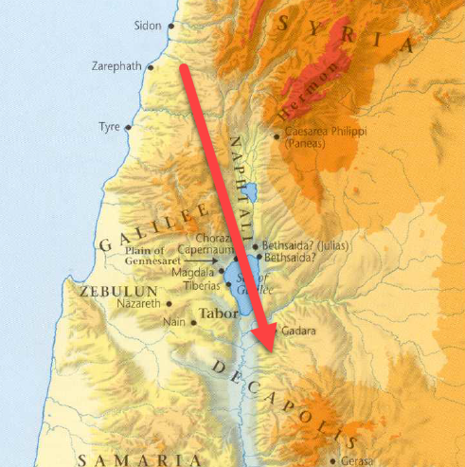

Mar 7:32 And they brought to him a man who was deaf and had a speech impediment, and they begged him to lay his hand on him.
Mar 7:33 And taking him aside from the crowd privately, he put his fingers into his ears, and after spitting touched his tongue.
Mar 7:34 And looking up to heaven, he sighed and said to him, “Ephphatha,” that is, “Be opened.”
Mar 7:35 And his ears were opened, his tongue was released, and he spoke plainly.
Mar 7:36 And Jesus charged them to tell no one. But the more he charged them, the more zealously they proclaimed it.
Mar 7:37 And they were astonished beyond measure, saying, “He has done all things well. He even makes the deaf hear and the mute speak.”

- A deaf man is brought to Christ for healing.
- Jesus pulls him aside privately and heals him, using one of the most unique methods recorded in any gospel.
  - Jesus put His fingers in the man’s ears.
  - He then spit and touched either His own tongue or the man’s tongue.
  - He then looked up to heaven, sighed, and said, “Be opened.”
  - And the man was healed.
- Why did Jesus use this method to heal the man?
  - I have not idea!
  - It may have been a way to communicate something (because obsiously the man was deaf). Or it may have been some kind of symbol that resonated with this particular man.
  - There is a lot of room for speculation but I don’t know if its profitable.
- Again, we see Jesus commanding the observers not to make the miracle public.
- But, again, we see a neglect of Jesus’ instruction and the account of the miracle published widely!

