MARK 8
Mar 8:1 In those days, when again a great crowd had gathered, and they had nothing to eat, he called his disciples to him and said to them,
Mar 8:2 “I have compassion on the crowd, because they have been with me now three days and have nothing to eat.
Mar 8:3 And if I send them away hungry to their homes, they will faint on the way. And some of them have come from far away.”
Mar 8:4 And his disciples answered him, “How can one feed these people with bread here in this desolate place?”
Mar 8:5 And he asked them, “How many loaves do you have?” They said, “Seven.”
Mar 8:6 And he directed the crowd to sit down on the ground. And he took the seven loaves, and having given thanks, he broke them and gave them to his disciples to set before the people; and they set them before the crowd.
Mar 8:7 And they had a few small fish. And having blessed them, he said that these also should be set before them.
Mar 8:8 And they ate and were satisfied. And they took up the broken pieces left over, seven baskets full.
Mar 8:9 And there were about four thousand people. And he sent them away.

- The miracles at the beginning of chapter 8 is so similar to the feeding of the 5,000 in chapters 6, many critics have suggested Mark was mixed the stories up and the even only occurred one time.
  - This claim of the critics is highly basically ridiculous.
  - Both Matthew and Mark record two miraculous feedings and the details are consistent across their accounts.
  - There is no reason to doubt Matthew or Marks account.
- But it does bring up a question… Why did Jesus perform the same miracle twice?
  - Have you ever had to fail at something more than once to learn your lesson?
  - Notice how the Apostles asked almost the exact question they asked in chapter 6.
  - Mar 8:4 And his disciples answered him, “How can one feed these people with bread here in this desolate place?”
  - They needed to see the miracle again to relearn the lesson.
  - Your own life will probably affirm lessons are not always learned the first-time-around.
- Isn’t it easy to forget all the times God delivered us in the past when some new trouble shows up in our lives?
  - The quote below communicates a similar sentiment (Notes on the Parables of Our Lord – Richard Trench).
  - “it is evermore thus in times of difficulty and distress. All former deliverances are in danger of being forgotten; the mighty interpositions of God’s hand in former passages of men’s lives fall out of their memories. Each new difficulty appears insurmountable; as one from which there is no extrication; at each recurring necessity it seems as though the wonders of God’s grace are exhausted and had come to an end.”
- In verse 2, it is a beautiful thing to observe Jesus’ compassion for those who followed Him.
  - It isn’t uncommon for a person who achieves popularity to get so caught up in their own “importance” and lose compassion for others.
  - Jesus, although wildly popular, didn’t neglect the needs, cares, and struggles of those around Him.

Mar 8:10 And immediately he got into the boat with his disciples and went to the district of Dalmanutha.
- Following the miracle Jesus took His disciples to the district of Dalmanutha.
- Matthew says, “region of Magadon.”
  - Magdala was on the NW coast of the Sea of Galilee.
  - It was also known as Taricheae.
  - 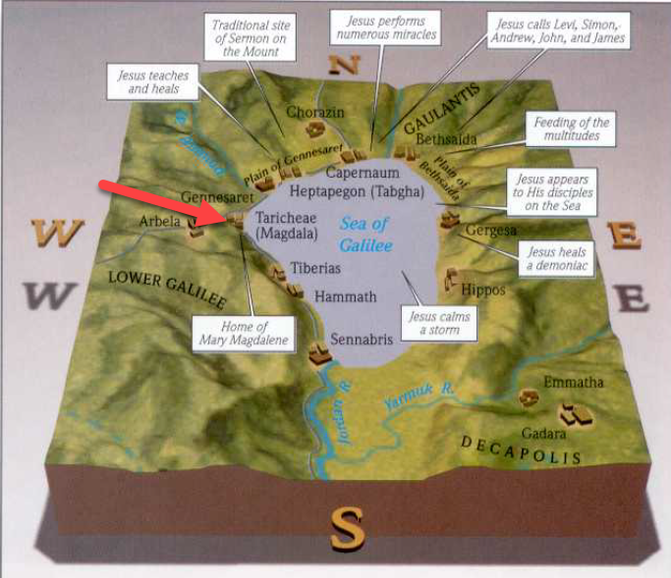
- The significance of the name “Dalmanutha” has been lost to history.
  - Some suggest it is a transliteration of the Syriac word for “harbor.”
  - According to Lexham Geographic Commentary on the Gospels, it was known as a place for salting fish.
- What kind of fish live in the Sea of Galilee?
  - Short Jaw Tristramella.
  - Long Jaw Tristramella.
    - This fish was unique to the sea of Galilee but the fish has not been seen since severe droughts struck the region in the 1990s.
    - It is feared extinct.
  - Redbelly Tilapia.
    - Also known as St. Peter’s Fish.
  - Jordan Amnon (Musht Lubad - Oreochromis aureus - Blue tilapia or Jordan St. Peter's Fish)
  - Longhead Barbel (Karsin - Barbus longiceps - Longhead barbel)

  - Large scale Barbel (Binit Kishri - Barbus canis -Large scale barbel)
  - Hafaf Israeli (Hafafi - Capoeta damascina - Damascus barbel)
  - Kinneret Lavnun (Tiberias sardine - Mirogrex terraesanctea terraesanctae - Kinneret bleak)
  - Low Eye Kassif (Kasif - Hypophthalmichthys molitrix - Silver carp)
  - Kifon Burri (Mullet - Mugil cephalus - Grey mullet - Burri).
  - Common Catfish (Barbout - Clarias gariepinus - Catfish) species of catfish - fish edible, but is not kosher.
  - All together, there are a total of 27 known species, 19 native and 8 introduced.

Mar 8:11 The Pharisees came and began to argue with him, seeking from him a sign from heaven to test him.
Mar 8:12 And he sighed deeply in his spirit and said, “Why does this generation seek a sign? Truly, I say to you, no sign will be given to this generation.”
Mar 8:13 And he left them, got into the boat again, and went to the other side.

- The Pharisees come to Jesus asking to see a “sign.”
- They wanted to see some kind of miracles as evidence of Jesus authority.
  - The problem was, and Jesus knew it, they were not genuine in their request.
  - These Pharisees had probably seen dozens, if not hundreds, of miracles.
  - They weren’t trying to find evidence to believe, they were testing Jesus to try to find a way to discredit Him.
- Their question is similar to the second temptation Satan presented to the Lord in Matthew 4.
  - Satan wanted Him to throw Himself off the Temple.
  - If He was indeed the Son of God, the angels would save Him.
  - He tested the identity of Jesus by challenging Him to prove it.
  - Jesus saw no need in Matthew 4 or Mark 8 to make a spectacle for those who did not have eyes to see.
- In this chapter, and throughout the whole book, we see a balance in Jesus nature.
  - On one hand, He is compassionate, caring, and kind (verse 2).
  - On the other hand, He is stern and unyielding (verse 12).
  - The attitude of His audience made a difference.
  - We would be wise to observe both side of His nature when forming our view of God.

Mar 8:14 Now they had forgotten to bring bread, and they had only one loaf with them in the boat.
Mar 8:15 And he cautioned them, saying, “Watch out; beware of the leaven of the Pharisees and the leaven of Herod.”
Mar 8:16 And they began discussing with one another the fact that they had no bread.
Mar 8:17 And Jesus, aware of this, said to them, “Why are you discussing the fact that you have no bread? Do you not yet perceive or understand? Are your hearts hardened?
Mar 8:18 Having eyes do you not see, and having ears do you not hear? And do you not remember?
Mar 8:19 When I broke the five loaves for the five thousand, how many baskets full of broken pieces did you take up?” They said to him, “Twelve.”
Mar 8:20 “And the seven for the four thousand, how many baskets full of broken pieces did you take up?” And they said to him, “Seven.”
Mar 8:21 And he said to them, “Do you not yet understand?”

- I would like to bring one additional verse over from Matthew’s account that Mark excludes.
  - Mat 16:12 Then they understood that he did not tell them to beware of the leaven of bread, but of the teaching of the Pharisees and Sadducees.
  - This verse is helpful in understanding Jesus’ statements.
- Rather than cast pearls before swine, Jesus departs and goes to the other side of the sea.
- Apparently the Apostles had forgotten to bring food along with them (only 1 loaf left).
  - This seems like a very human thing to do.
  - How often do you go somewhere and leave something important at the house?
  - Jesus uses it as an opportunity to teach.
  - APPLICATION:
    - We often find it difficult to bring up spiritual conversation with friends or nonbelievers.
    - Jesus used the occurrences of the everyday, the things people had their mind on, to segway into spiritual discussion.
    - In order to do that our minds need to be looking beyond the physical and into the spiritual.
- Jesus tells them, Watch out; beware of the leaven of the Pharisees and the leaven of Herod.
  - The Apostles need to “watch out” or be aware of the influence of the Pharisees and Herod.
  - This may seem like a “duh” statement to modern Bible readers but it is important to put yourself in a 1st Century Jewish context.
    - Many of the Jews likely respected the Pharisees, Scribes, Sadducees, and Herod (especially because he built them their Temple).
    - They may have read to them in their synagogues on Sabbath
    - The Jews probably went to them with questions of the Law.
    - They may have believed them to be honorable and godly men.
    - And only in Jesus were they beginning to see that they had been misled and misguided by individuals who perhaps didn’t know God as well as they had believed.
      - To help understand this better, think of how difficult it can be to get a long-standing member of a church (say the Mormon church) to see they’ve been misled.
      - They trust their leaders.
      - They believe their leaders are guiding them correctly.
      - And it isn’t easy for them to relinquish their confidence in those leaders even when shown the truth about God.
  - The Jewish religious hierarchy had significant pull with the people (as we see in the events of the crucifixion when they turned the people against Christ).
  - We’ve already discussed how the Pharisees had clout with the common people and the Sadducees cultivated friendship with the Romans.
- The Apostles don’t understand Jesus’ statement and assume it has something to do with their neglect of bringing bread to eat.
- Jesus says their lack of recognition of His true intention was due to them lacking faith.
  - They needed a mind more tuned to spiritual teaching.
  - Jesus wasn’t concerned with the fact they didn’t have any bread.
    - He asks them if they remembered when He fed 5,000 men and had leftovers.
    - He then asks them if they remembered when He fed 4,000 with just 7 loaves of bread.
    - Even the Devil knew He could turn stones to bread.
- Jesus wanted them to beware of the influence and teachings of the Pharisees and Herod.
  - Herod attempted to win the affections of the Jews but his heart wasn’t aligned with God’s.
  - While the Pharisees sounded good and probably used scripture when they spoke, they were misguiding people and making it difficult for people to know God.
- Leaven is an influential ingredient. One small pinch of leaven can make the all the difference in a loaf of bread.
- In the same way, a small bit of influence can have huge effects on a group of people.

Mar 8:22 And they came to Bethsaida. And some people brought to him a blind man and begged him to touch him.
Mar 8:23 And he took the blind man by the hand and led him out of the village, and when he had spit on his eyes and laid his hands on him, he asked him, “Do you see anything?”
Mar 8:24 And he looked up and said, “I see people, but they look like trees, walking.”
Mar 8:25 Then Jesus laid his hands on his eyes again; and he opened his eyes, his sight was restored, and he saw everything clearly.
Mar 8:26 And he sent him to his home, saying, “Do not even enter the village.”

- We already discussed a curious healing by Jesus at the end of chapter 7, but, in my opinion, this is the most curious in all the gospels.
- Jesus departs Dalmanutha and goes to Bethsaida with the Apostles.
- 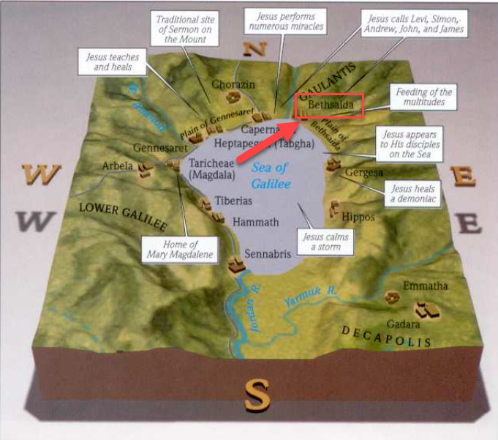
- Some of the people brought a blind man to Jesus for healing.
- Instead healing him on the spot, Jesus takes the man by the hand and leads him out of the village.
  - Jesus then spit on the man’s eyes and put his hands on him and asked him, “Do you see anything?”
  - The man responded that he did see, but, in the place of men, he saw trees walking around.
  - Jesus then touched his eyes again and his sight was perfectly restored.
  - After the healing, Jesus sent the man home and told him not to return to the village.
- What is going on here? Did Jesus have a power shortage?
- As with the parable at the end of chapter 7, it is difficult to say why Jesus performed the miracles the way He did.
- Mark’s gospel is the only account of this healing so there isn’t any additional information to be gathered from Matthew, Luke, or John.
- I have written down a few theories which may have some merit:
  - Jesus healed the man progressively as a lesson to illustrate our eyes opening progressively to the beauty of the gospel.
    - We don’t know all there is to know about the gospel, religion, spiritual things when we first come to Christ.
    - We develop vision of spiritual things over time as we grow and God molds us.
  - To teach us that while some are healed immediately, God determines to heal others on a progressive timeline.
    - There are problems in our lives God takes away quickly.
    - There are other problems with which He refines us over time.
    - “And so the grace of Christ, which had formerly been poured out suddenly on others, flowed by drops, as it were, on this man” (Calvin).
  - It may have been a lesson to Jesus’ Apostles.
    - In verse 18, Jesus asked the Apostles, “Having eyes do you not see…?”
    - They lacked spiritual vision.
    - They would not receive total clarity on all spiritual matters all at once (as Peter will prove in a minute), but the mysteries of the Kingdom would be slowly revealed to them in Jesus’ designated time.

Mar 8:27 And Jesus went on with his disciples to the villages of Caesarea Philippi. And on the way he asked his disciples, “Who do people say that I am?”
Mar 8:28 And they told him, “John the Baptist; and others say, Elijah; and others, one of the prophets.”
Mar 8:29 And he asked them, “But who do you say that I am?” Peter answered him, “You are the Christ.”
Mar 8:30 And he strictly charged them to tell no one about him.

- This discussion is recorded in more detail in Matthew 16.
  - If you want some more extensive notes, I would encourage you to download the notes for Matthew 16.
- Jesus and His disciples take a trip up north in verse 27 to Caesarea Philippi.
- 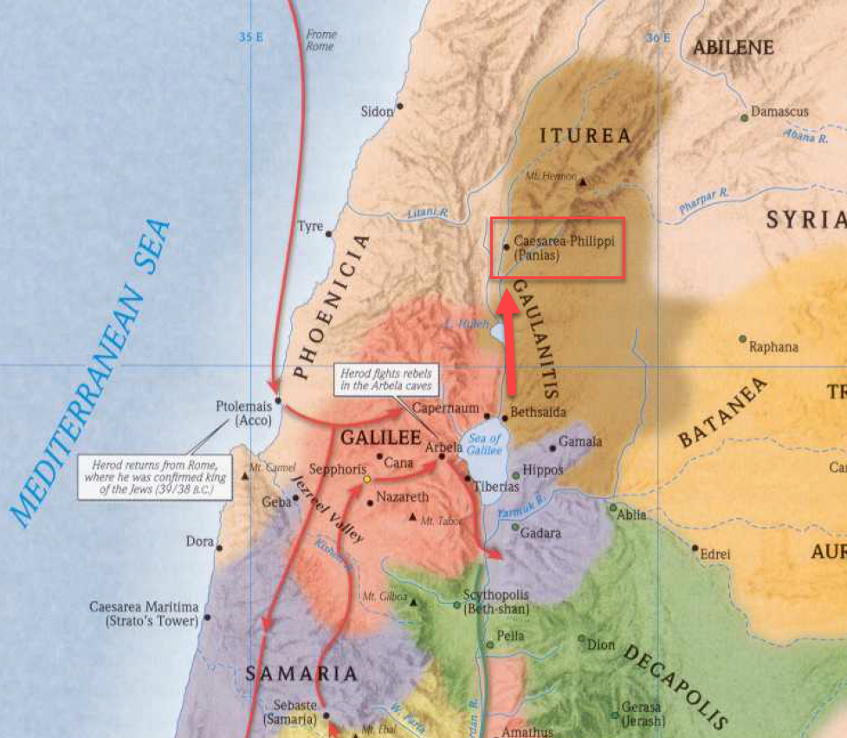
- On the way to Caesarea, Jesus asks them, “Who do people say that I am?”
- There were no shortage of rumors as to Jesus’ identity.
  - John the Baptist (Herod’s belief).
  - Elijah
  - Another prophet brought back from the dead.
- Jesus then asked them a more personal question, “But who do you say that I am?”
  - Peter was the quickest to respond.
  - “You are the Christ.”
  - Peter recognized Jesus as the anointed of God, the Messiah of the Jews.
- Jesus confirms the truth of the confession.
  - If I’m not mistaken, this is the first time Jesus has explicitly confirmed this fact.
  - To this point, His identity has been kept under wraps.
  - Although He reveals it to the Apostles here, He tells them not to tell others.
  - It would remain a secret to the general public until the time God had designated.
- Why did Jesus want His identity concealed?
  - That is something I’m trying to figure out too!
  - We are studying together.

Mar 8:31 And he began to teach them that the Son of Man must suffer many things and be rejected by the elders and the chief priests and the scribes and be killed, and after three days rise again.
Mar 8:32 And he said this plainly. And Peter took him aside and began to rebuke him.
Mar 8:33 But turning and seeing his disciples, he rebuked Peter and said, “Get behind me, Satan! For you are not setting your mind on the things of God, but on the things of man.”

- From the time of Peter’s confession, Jesus began explaining His purpose on earth.
- He was to be the sacrificial Lamb for the sins of the world.
  - This required Him to go to Jerusalem
  - Be abused in the courts
  - Die
  - Raise in 3 days
- Evidently, Peter didn’t like the idea of the Messiah he just confessed being killed by His religious enemies.
- He took Jesus aside and rebuked Him, saying, “This shall never happen to you” (Matthew 16:22).
- The Apostle’s didn’t yet understand Jesus’ role as the sacrificial Lamb and in their minds, Jesus being killed was the worst thing in the world.
  - You notice how no one seemed to be curious about the resurrection part of Jesus’ prophecy.
  - They seemed to have stopped listening at the part about Him dying, on account of their outrage.
- How could the Apostles have been so shocked when Jesus was killed and resurrected?
  - I think this goes to show the power of expectational filters.
  - How difficult it is for someone to change their mind when they approach a situation already believing they know what to expect.
  - The Apostles apparently had an idea about who the Christ was going to be and death wasn’t included in that idea.
  - They probably got this idea from their Mosaic Law teachers.
  - Even when Jesus explained His intentions with perfect clarity, they still could not understand.
- The same thing can happen to us.
  - We can approach the Bible or Christianity/religion with an expectation of what we are going to find.
    - Those outside the Church may have expectations about what really following Jesus looks like.
    - Those inside the Church may have expectations about what others believe and what the Bible teaches.
  - Those ideas are probably the result of some person who informed/taught us in the past.
  - We need to make sure we are evaluating Jesus and His Church accurately.
    - We need to be teachable
    - We need to pray that God would remove our blind spots.
- Jesus’ rebuke of Peter is harsh and Peter was probably shocked.
- Although He wouldn’t understand it until much later, Peter would learn Jesus’ death was the eternal plan of God and trying to hinder Jesus’ sacrifice was to participate in Satan’s work.

Mar 8:34 And calling the crowd to him with his disciples, he said to them, “If anyone would come after me, let him deny himself and take up his cross and follow me.
Mar 8:35 For whoever would save his life will lose it, but whoever loses his life for my sake and the gospel's will save it.
Mar 8:36 For what does it profit a man to gain the whole world and forfeit his soul?
Mar 8:37 For what can a man give in return for his soul?
Mar 8:38 For whoever is ashamed of me and of my words in this adulterous and sinful generation, of him will the Son of Man also be ashamed when he comes in the glory of his Father with the holy angels.”

- Jesus calls the crowds to Him and begins to teach.
- If anyone wants to be a follower of Jesus, they must be willing to take up their cross and follow Him.
- Jesus would sacrifice Himself on the cross for all men, but each follower would also be called to make sacrifices in His service.
  - There is no question we are saved by the grace of God (that is why Jesus is on the earth)
  - But notice here there are sacrifices we must be willing to make.
- It's easy for us to look at this statement and to understand exactly what Jesus is saying because we are on the far side of the cross, but imagine how shocking these words would have been to the Apostles who had yet to fully understand the sacrifice that Jesus was going to make.
- Jesus then makes the statement, “For whoever would save his life will lose it”
  - Matthew records a similar statement, “Whoever finds his life will lose it” (Matthew 10:39).
  - This can be a bit of a confusing (in my opinion).
  - When Jesus talks about saving life, I understand Him to be talking about where a person’s heart belongs.
    - Mat 6:21 – “For where your treasure is, there your heart will be also.”
    - A person’s “life” is what they live for and value.
    - If we live to enjoy and maximize the pleasures of this world and our greatest desire is to stay in this world to enjoy what it offers, the outcome isn’t going to be good for us.
    - Because eventually everyone dies and loses everything.
    - These are people who think the reason for living is to enjoy life on earth.
    - Who look to temporal things as their source of joy.
    - If you put all your stock in this world, you will lose it all in the end.
  - So Jesus is saying, if we find out highest affection to be something in this world (family, money, marriage, friends, etc) we will lose our lives. Meaning, when this world passes away, so will our highest affection, and we will have nothing left. Not to mention, our souls will be in danger because we did not acknowledge Christ as our greatest affection (therefore He will not acknowledge us).
- But if we find our highest affection in Jesus, our heart will not belong to a temporal world corrupted by moth and rust (Matthew 6:20), and when all of this passes away we will inherit new life (true, real, and lasting life) when Christ acknowledges us before the Father.
  - Whoever surrenders (loses) his life to Christ will find what it really means to “live” in Him.
- Compounding the thought, Jesus asks, “For what does it profit a man to gain the whole world and forfeit his soul? For what can a man give in return for his soul?”
  - Lets say you’re better at living for this world than anyone else!
    - You acquire all the money.
    - You get all the power.
    - You can procure for yourself anything you desire.
  - Anything physical that is…
  - How much is your paper money worth to God?
    - God spoke a word an created everything you worked so hard to acquire.
    - God doesn’t care about your paper money or powerful earthly influence.
    - Psalm 24:1 The earth is the LORD’s and the fullness thereof, the world and those who dwell therein,
    - Money can’t buy your soul.
- The only thing that can buy back your soul (redeem it) is the blood of Jesus.
  - If you aren’t covered by that blood, you don’t have any hope.
  - If you are ashamed of claiming Jesus or you believe yourself to be your own savior, Jesus’ blood will not save you.
  - On the flip-side, if you an unashamed of Christ and acknowledge Him as your only hope, He will acknowledge that you are covered by His blood when you stand before God at the end of time.
  - Then you’ll learn what real “life” is…

Notes on the Parables of Our Lord – Richard Chenevix Trench
https://en.wikipedia.org/wiki/Tristramella_sacra
https://en.wikipedia.org/wiki/Sea_of_Galilee#Flora,_fauna_and_ecology
https://en.wikipedia.org/wiki/Redbelly_tilapia
https://en.wikipedia.org/wiki/Clarias_gariepinus

