MARK 9
Mar 9:1 And he said to them, “Truly, I say to you, there are some standing here who will not taste death until they see the kingdom of God after it has come with power.”

- Whoever determined this verse belonged in chapter 9 and not at the end of chapter 8 made an odd decision (in my opinion).
  - Remember, the verses were added to the Bible later and are not inspired by God.
  - See Matthew 16:28.
- Jesus offers this encouragement to His Apostles who may have been discouraged and confused about Jesus’ previous teachings.
- 11 of the 12 apostles (Judas being the exception) would see the Kingdom of Heaven on earth in their lifetime (through the Church).
- Jesus’ teachings may have seemed difficult and abstract to them, but in a short time, their eyes would be opened and they would participate in bringing about God’s plan for the salvation of the world.

Mar 9:2 And after six days Jesus took with him Peter and James and John, and led them up a high mountain by themselves. And he was transfigured before them,
Mar 9:3 and his clothes became radiant, intensely white, as no one on earth could bleach them.
Mar 9:4 And there appeared to them Elijah with Moses, and they were talking with Jesus.
Mar 9:5 And Peter said to Jesus, “Rabbi, it is good that we are here. Let us make three tents, one for you and one for Moses and one for Elijah.”
Mar 9:6 For he did not know what to say, for they were terrified.
Mar 9:7 And a cloud overshadowed them, and a voice came out of the cloud, “This is my beloved Son; listen to him.”
Mar 9:8 And suddenly, looking around, they no longer saw anyone with them but Jesus only.

- The events of chapter 9 take place 6 days after the events of chapter 8.
- Jesus takes 3 of His Apostles up into a high mountain.
  - The exact location of the “mountain” is unknown
  - Some suggest it was Mount Tabor in southern Galilee while other point to Mount Hermon.

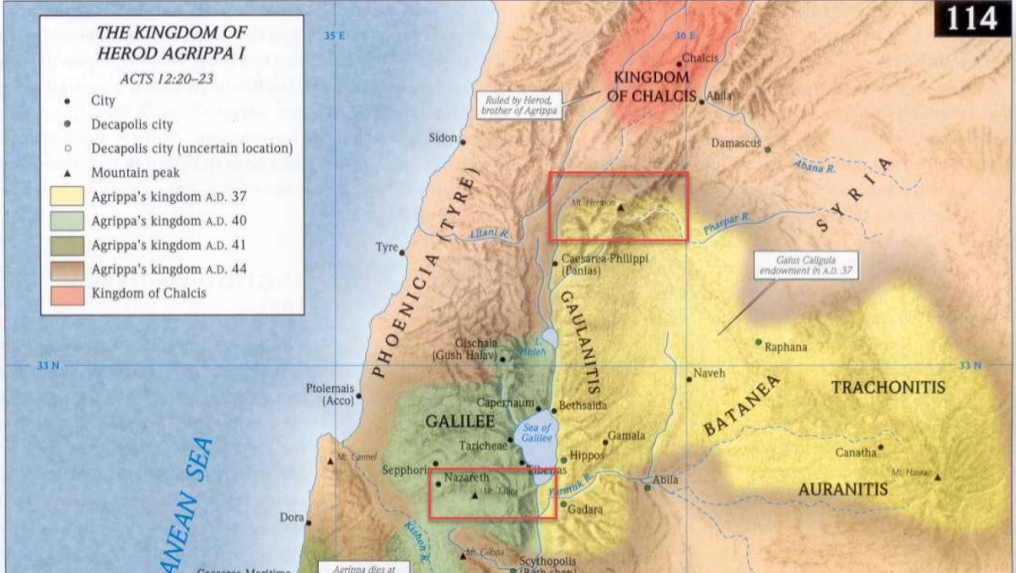
- Mount Tabor in 2011
- Mount Hermon
- In order to pick up all the small details of this event, it is important to read all three of the gospel writer’s accounts
  - Matthew 17
  - Mark 9
  - Luke 9
- Jesus took the three Apostle’s up into the mountain to pray (according to Luke’s gospel).
- While Jesus was praying, He was “transfigured.”
  - What does “transfigured” mean.
  - I found this etymology chart interesting for the origin of the English word.
    - To move “across figures”
    - Synonyms include: change, alter, metamorphoses.
  - What about the Greek?
    - According to Strongs, the term carries the same meaning, to transform or change.
    - The same word is used in 2 other familiar passages
      - Rom 12:2 - Do not be conformed to this world, but be transformed by the renewal of your mind, that by testing you may discern what is the will of God, what is good and acceptable and perfect.
      - 2Co 3:18 - And we all, with unveiled face, beholding the glory of the Lord, are being transformed into the same image from one degree of glory to another. For this comes from the Lord who is the Spirit.
      - SIDE NOTE: Notice, as we behold the glory of Christ we are transfigured.
- Don’t get tripped up on this passage because of the fancy word.
- While praying, Jesus’ appearance changed.
  - “His face shown like the sun” (Matthew)
  - “His clothes became radiant, intensely white”
  - If you read John’s vision of Christ in Revelation 1, you’ll see the similarities in the appearance of Jesus.
- Jesus’ appearance wasn’t the only thing that changed. The attendees at the prayer gathering also increased.
  - Along with the Apostles and Jesus, two new men were present.
  - Although we don’t know how, the 3 Apostles were able to recognize them as Moses and Elijah.
  - Why these two men?
    - There are many significant Old Testament characters so why did Jesus choose these two?
    - It is likely because they represented two pillars of the Old Testament system, the Law and the Prophets
    - Moses was God’s chosen law giver and Elijah represented the authority of God’s prophets.
    - Moses provided the people with the Laws of God and the prophets worked among the people throughout their history to encourage them to follow it.
  - Luke’s account tells they were speaking to Jesus about “His departure, which He was about to accomplish at Jerusalem” (Luke 9:31)
  - All three gospel accounts seem to suggest the guests did not stay with Jesus long.
- As Moses and Elijah were departing, Peter felt the need to say something.
  - He blurted out, “Let us make three tents, one for you and one for Moses and one for Elijah.”
  - Luke tells us that Peter said this when the men were departing.
  - Mark tells us he said this because, “he did not know what to say…”
- What does Peter mean “make three tents?”
  - The word for “tent” used here is the same word used for “tabernacle” in the New Testament (used a lot in Hebrews).
  - Before the Temple in Jerusalem replaced the tabernacle during the reign of Solomon.
  - The tabernacle was a tent (a very elaborate tent) where the Ark of the Covenant was kept during the period of the wilderness wanderings and the Judges.
  - The Jewish tabernacle was the place of God’s presence and a place of worship.
  - The same word is used to refer to other places of worship (idol worship) such as the “tent of Moloch” (Acts 7:43).
  - So what is Peter’s meaning?
  - He seems to be saying, “Lets construct a monument or a holy site in honor of Moses, Elijah, and Jesus.”
- An alternative view
  - If I understand correctly the Greek word used here for “tent,” although it can be used to talk about a holy site like the Jewish tabernacle, it can also be used to talk about an ordinary tent/hut in which people lived.
  - Notice how Peter offered to build the tents “as the men were parting from Him” Luke 9:33)
  - It is possible Peter wanted the men to stay.
    - If Moses or Elijah showed up in my neighborhood, I would offer to put them up in my house for the night because it isn’t everyday you get to spend an evening with Moses.
    - They probably wanted to talk to them.
    - Might have had some questions.
  - So Peter offered to build them a place to stay for a while.
- This question of Peter’s received an immediate response.
  - A bright cloud enclosed them (Luke says they were “encompassed”)
  - A voice came out of the cloud, saying, “This is my beloved Son, with whom I am well pleased; listen to Him.”
  - Whatever this voice sounded like, it must have been more than the voice of a human, because the Apostles are terrified and fall immediately on their faces (a very common response to hearing the voice of God in the Bible) (Matthew 17:6).
- What does God intend to communicate?
  - If you take the first interpretation of Peter’s question above, God is rejecting Peter’s offer to build three tabernacles.
  - Why?
    - For one, Jesus had no need of a physical tent/tabernacle.
    - For two, elevating Moses and Elijah to the level of Christ was a mistake.
      - Christ was greater than the Law giver and the prophets
      - Jesus was going to accomplish what the Old Law couldn’t and He was the fulfillment of all of its prophecies.
    - The voice distinguishes Christ from the other two and clarifies whose instruction they needed to heed.
    - With their presence, Moses and Elijah confirmed the identity of Christ and now the Father seals their confirmation with His unbreakable word.
    - An appearance of Moses and Elijah would be huge in convincing Matthew’s Jewish audience that Jesus really was the Messiah.
    - In a broader sense, this would have communicated a shift in the identity of God’s authorized messenger.
    - For thousands of years, Moses and the prophets were the authorized mouthpieces of God, but now God had given all authority over to His Son and had sent Him to the world as the “Word” of God (John 1).
  - God, with His voice, makes it clear Peter doesn’t need to hear the words of Moses and Elijah.
  - He has all he will ever need in the words of the Son of God.
- As quickly as the two guests, the cloud, and the voice came, they disappeared just as quickly.
- Jesus goes to the Apostles lying on their faces and lifts them up (Matthew 17:7).

Mar 9:9 And as they were coming down the mountain, he charged them to tell no one what they had seen, until the Son of Man had risen from the dead.
Mar 9:10 So they kept the matter to themselves, questioning what this rising from the dead might mean.
Mar 9:11 And they asked him, “Why do the scribes say that first Elijah must come?”
Mar 9:12 And he said to them, “Elijah does come first to restore all things. And how is it written of the Son of Man that he should suffer many things and be treated with contempt?
Mar 9:13 But I tell you that Elijah has come, and they did to him whatever they pleased, as it is written of him.”

- Jesus tells the Apostles they are not to tell anyone about what they had just witnessed until He had risen from the dead.
  - The reason is not specifically given.
  - Peter does make reference to his experience in 2Peter 1:16 and it seems his readers had at least some familiarity with the events on the “holy mountain.”
  - 2Pe 1:16-18 - For we did not follow cleverly devised myths when we made known to you the power and coming of our Lord Jesus Christ, but we were eyewitnesses of his majesty. For when he received honor and glory from God the Father, and the voice was borne to him by the Majestic Glory, “This is my beloved Son, with whom I am well pleased,” we ourselves heard this very voice borne from heaven, for we were with him on the holy mountain.
- I imagine Jesus’ 3 companions had about 6,000,000,000 questions to ask Jesus on their trek down the mountain but only one is recorded for us.
- Having just seen Elijah, they recalled a statement often made by the scribes.
  - “Why do the scribes say that first Elijah must come?”
  - The scribes probably took the prophecy of Malachi 4:5 literally and taught that the actual prophet Elijah was going to come back to earth to prepare the way for the Messiah.
  - In Matthew 11:14, Jesus taught that John was the “Elijah” of the prophecy. He represented Elijah in that he came with his spirit and power.
  - *I would refer you back to the notes on Matthew chapter 3 and 11 for more detail*
  - Evidently these 3 Apostles needed a little bit more clarification on that point.
  - Jesus explains how John, like Elijah, was mistreated by the powers of his day.

Mar 9:14 And when they came to the disciples, they saw a great crowd around them, and scribes arguing with them.
Mar 9:15 And immediately all the crowd, when they saw him, were greatly amazed and ran up to him and greeted him.
Mar 9:16 And he asked them, “What are you arguing about with them?”
Mar 9:17 And someone from the crowd answered him, “Teacher, I brought my son to you, for he has a spirit that makes him mute.
Mar 9:18 And whenever it seizes him, it throws him down, and he foams and grinds his teeth and becomes rigid. So I asked your disciples to cast it out, and they were not able.”
Mar 9:19 And he answered them, “O faithless generation, how long am I to be with you? How long am I to bear with you? Bring him to me.”
Mar 9:20 And they brought the boy to him. And when the spirit saw him, immediately it convulsed the boy, and he fell on the ground and rolled about, foaming at the mouth.
Mar 9:21 And Jesus asked his father, “How long has this been happening to him?” And he said, “From childhood.
Mar 9:22 And it has often cast him into fire and into water, to destroy him. But if you can do anything, have compassion on us and help us.”
Mar 9:23 And Jesus said to him, “‘If you can’! All things are possible for one who believes.”
Mar 9:24 Immediately the father of the child cried out and said, “I believe; help my unbelief!”
Mar 9:25 And when Jesus saw that a crowd came running together, he rebuked the unclean spirit, saying to it, “You mute and deaf spirit, I command you, come out of him and never enter him again.”
Mar 9:26 And after crying out and convulsing him terribly, it came out, and the boy was like a corpse, so that most of them said, “He is dead.”
Mar 9:27 But Jesus took him by the hand and lifted him up, and he arose.

- Jesus comes down from the mountain where He was transfigured and finds trouble.
  - His disciples and His religious enemies are arguing at the bottom.
  - Jesus asked, “What are you arguing about?”
  - A man came forward and told Jesus he had brought his demon possessed son to the disciples for healing but they were not able to cast it out.
  - The Apostles had, in the past, cast out demons and healed the sick in the name of Jesus but here they are unable.
- It seems Jesus is frustrated with His disciples.
  - He seems to imply they should have been able to cast out this demon.
  - “O faithless generation, how long am I to be with you? How long am I to bear with you? Bring him to me.”
- Jesus tells the father to bring his Son to Him.
  - Jesus commands the spirit to come out of the boy.
  - After “convulsing him terribly, it came out” and the boy was lifted up and presented to his father.
- Here we have a man who had heard about the power of Jesus and brought his son to be healed.
  - But because of an experience he had with the imperfect followers of Christ, he is struggling to believe.
  - His faith has been damaged.
  - We observe this in verse 22, “But if you can do anything, have compassion on us and help us.”
  - He has already had one bad experience with Jesus’ followers.
  - Now He come to Jesus Himself and his faith is a little shaky?
- Who’s power was called into question because of the failure of the disciples?
  - Jesus’!
  - The man lacked confidence in Christ because his followers had failed him.
- Don’t you know the scribes must have pounced at this opportunity!
  - They were probably quick to say, “Look! Jesus must not be as great as He says He is.”
  - “Just look at this example of these lousy followers He’s got!”
- Lets look at a couple applications from this text.
- The first application is for those who aren’t Christians (outside of the Church) and the next two are for people who are Christians (inside the Church).
  - APPLICATION (1)
    - If you aren’t a Christian, don’t let poor examples of Christlikeness turn you off from coming to Jesus.
    - Perhaps you’ve had a bad experience with a Christian and you’ve judged the whole Christian faith based on the way that one Christian treated you.
      - Remember, Christians are not perfect representations of Jesus all the time.
      - We are imperfect and often fail to represent Jesus accurately.
      - That is why we need Jesus to save us too!
    - Jesus came to save imperfect people, He didn’t come to miraculously make all of His follower perfect.
    - Make sure you are evaluating Jesus Himself (His teachings, actions, claims, etc) to properly evaluate the truth claims of Christianity.
    - This is also important to remember when consuming content that is hostile to Christianity.
      - Authors or speakers who attack Christianity by giving a long list of people who committed atrocities in the name of Christ are not providing real evidence against the Christian faith.
      - There will always (in every religion) those who abuse the religion for personal gain, power, etc.
    - As the actions of the Apostles negatively reflected what it was to be a follower of Jesus, Christians should be careful their lives do not negatively impact those who witness them.
  - APPLICATION (2)
    - We need to be careful where the foundation of our faith is built.
    - Many people build their faith on men.
      - A favorite preacher
      - Pastor
      - Priest
      - Bible student
      - Mentor
    - Unfortunately, men are not infallible.
    - It is not uncommon to see people’s faith crumble when their favorite mentor’s faith faulters.
  - APPLICATION (3)
    - There is a warning here for us not to encourage others to build their faith on us!
    - It is tempting to want others to look to you as a guide for their faith.
    - But, we aren’t great guides for other people because we have weaknesses of our own.
  - So, if it is the case Christians aren’t perfect and don’t always reflect Christ properly, where should we put our confidence and instruct others to put their confidence?
    - Luckily for us, the answer is given to us in the text.
    - Jesus says in verse 23, “All things are possible for the one who believes.”
      - Believes in who?
      - The imperfect disciples?
      - No, the perfect Jesus!
    - Don’t look to other men who can damage your faith and ability to believe, look to Christ.
    - Note Jesus’ words, “O faithless generation, how long am I to be with you? How long am I to bear with you? Bring him to me.”
    - If we are pointing people anywhere other than Christ, we are pointing them in the wrong direction.

Mar 9:28 And when he had entered the house, his disciples asked him privately, “Why could we not cast it out?”
Mar 9:29 And he said to them, “This kind cannot be driven out by anything but prayer.”

- The disciples were apparently confused about their inability to cast out the demon and they asked Jesus for the reason.
- Jesus told them it was because prayer was required to cast out a demon like the one He had just banished.
  - Prayer for what?
  - Matthew’s gospel records and additional part of Jesus’ answer
  - “Because of your little faith. For truly, I say to you, if you have faith like a grain of mustard seed, you will say to this mountain, ‘Move from here to there,’ and it will move, and nothing will be impossible for you.”
- Evidently, they needed to spend more time in prayer that they might have greater faith.
- From Matthew’s gospel, we know the Apostles were not always as diligent in prayer as they should have been.
  - Jesus told Peter, James, and John to “watch and pray” while He was praying in the garden (Matt 26).
  - Instead, they fell asleep.
- Putting the two responses of Jesus together, it seems clear there is a connection between faith and our prayer life.
  - As if the proportion of our faith depends on our prayer life.
  - That greater things could have been accomplished if prayer had been a priority.
- APPLICATION:
  - Are our churches accomplishing less than we want? Where is prayer on our priority list?
  - Are the mountains you want moved not moving? Where is prayer in your priorities?
  - Individually, are you continuously communicating with God?
  - Congregationally, can we really say our opening and closing prayers are showing the world what devotion to prayer looks like?

Mar 9:30 They went on from there and passed through Galilee. And he did not want anyone to know,
Mar 9:31 for he was teaching his disciples, saying to them, “The Son of Man is going to be delivered into the hands of men, and they will kill him. And when he is killed, after three days he will rise.”
Mar 9:32 But they did not understand the saying, and were afraid to ask him.

- Following the healing of the demon possessed boy, Jesus takes His disciples through Galilee in secrecy.
- It seems He desired secrecy so He could teach the Apostles about His crucifixion and resurrection (which he did not intended to reveal in such detail to the general Jewish public).
- The Apostles heard Jesus’ teaching but they did not comprehend His meaning.
  - Mark says they were afraid to ask Him.
  - They probably wanted to avoid another “Oh ye of little faith” rebuke.
- Again, it is hard for us to understand why they couldn’t understand what Jesus was saying.
  - But remember, Apostles weren’t expecting Jesus to die, they were expecting Him to reign.
  - Would you expect Jesus enemies to be able to kill Him?
  - He had the power to calm the sea, multiply bread to feed thousands, and raise the dead!
  - All of those signs of power probably didn’t lead them to conclude this would end on a cross.
  - God’s power + God’s power + God’s power = Dying on a cross?
  - The answer to that equation probably would have been lost on me too!

Mar 9:33 And they came to Capernaum. And when he was in the house he asked them, “What were you discussing on the way?”
Mar 9:34 But they kept silent, for on the way they had argued with one another about who was the greatest.
Mar 9:35 And he sat down and called the twelve. And he said to them, “If anyone would be first, he must be last of all and servant of all.”
Mar 9:36 And he took a child and put him in the midst of them, and taking him in his arms, he said to them,
Mar 9:37 “Whoever receives one such child in my name receives me, and whoever receives me, receives not me but him who sent me.”

- Arriving at Capernaum, Jesus asks His disciples what they had been discussion on the way?
  - They were embarrassed and didn’t answer because they were ashamed to tell.
  - They had been arguing about who was the greatest among them (not the most humble debate).
- Jesus tells them the “first” or the greatest in the Kingdom of Heaven is the one who makes himself the servant of all.
  - Jesus was the King of the Kingdom of Heaven and He was preparing Himself to die for the sins of the world.
  - He didn’t demand a pedestal and a throne.
  - He would serve the world by dying for the world.
- If the Apostles wanted to be great, they needed to be like the King.
- The King wasn’t concerned with the accolades of great, He was concerned with the needy.
- To illustrate, Jesus took a child in His arms and told His disciples, “Whoever receives one such child in my name receives me, and whoever receives me, receives not me but him who sent me.”
  - The one who served the most vulnerable among them was the one who had internalized the nature of Jesus (the King) and the one who had internalized the nature of God.
  - By humbling oneself to be a servant of the needy, one was accomplishing the Lord’s work.
- By doing this, the Apostles participated in a small picture of what God was doing for the world.
- God looked down at a weak and needy world, humbled Himself to be a servant, and gave His life to wash away sins.
- Trying to claim a position of greatness for ourselves on earth would be out of sync with the nature of Jesus as it has been displayed to us.

Mar 9:38 John said to him, “Teacher, we saw someone casting out demons in your name, and we tried to stop him, because he was not following us.”
Mar 9:39 But Jesus said, “Do not stop him, for no one who does a mighty work in my name will be able soon afterward to speak evil of me.
Mar 9:40 For the one who is not against us is for us.
Mar 9:41 For truly, I say to you, whoever gives you a cup of water to drink because you belong to Christ will by no means lose his reward.

  - This is an intriguing text.
  - Some of the Apostles had encountered a man who was casting out demons in Jesus’ name but, evidently, wasn’t a usual companion of Jesus.
  - John approaches Jesus about the issue and tells Him he told the man to stop.
  - But Jesus isn’t disturbed by the finding.
  - According to Jesus, there was no reason to stop the man.
  - Anyone who performed such a mighty work would only have been able to do so because of great faith and would not harm Jesus’ cause.
  - The man may not have been following them but he was evidently in alignment with the will of God and God was working through him.
  - In Matthew 12:30, Jesus said, “Whoever is not with me is against me, and whoever does not gather with me scatters.”
  - Here He says, “For the one who is not against us is for us.”
    - He doesn’t leave any room for neutrality.
    - If this man wasn’t against Christ, he was on His side.
  - APPLICATION:
    - We should be able to rejoice and encourage work done by those who serve Christ in ways we don’t.
    - John seemed to think being a follower of Jesus meant you had to physically follow Jesus around during His ministry.
    - But here we find a man who was faithful to Christ while serving in a different capacity.
      - We all have talents and resources to serve God in “our way.”
      - We shouldn’t discourage those who serve in another way.
  - I like verse 41 a lot.
    - You don’t have to do great things, like casting out a demon, to serve the Lord.
    - It can be something simple.
    - Like giving someone a drink of water.
      - Some people have the idea they need to do something big to serve God.
      - Sometimes it’s the simple things that make the biggest difference.

Mar 9:42 “Whoever causes one of these little ones who believe in me to sin, it would be better for him if a great millstone were hung around his neck and he were thrown into the sea.

- I find it really interesting that Mark decides to insert verses 38-41 in the middle of the conversation.
  - I can only assume it is because it represents the true natural flow of the conversation.
  - Matthews account have verses 37 and 42 back to back and it doesn’t include John’s statement about the man they found casting out a demon (Matthew 18:5-6).
- In contrast to those who receive a little child, the one who causes a child of God to sin is strongly condemned.
  - Christ says it would be better for him to be killed (removed from the picture entirely) than to go on leading others into sin.
    - Millstones are big heavy round stones used to grind wheat or grain
    - 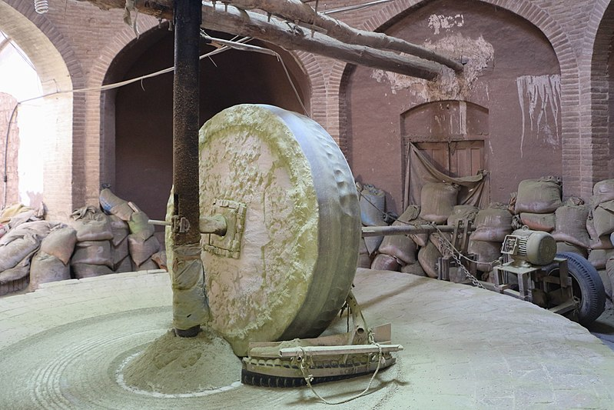
  - I don’t think Jesus is supporting murder or suicide in saying this, but rather using hyperbole to stress the severity of living this way.
  - In a sense, it would be better for a person who leads others into sin to be killed on the spot, because in living (assuming they don’t repent) they are only earning a harsher judgement on themselves by corrupting others.
  - Obviously, Jesus wants a person like that to repent, turn from their sins, and their bad influence.

Mar 9:43 And if your hand causes you to sin, cut it off. It is better for you to enter life crippled than with two hands to go to hell, to the unquenchable fire.
Mar 9:45 And if your foot causes you to sin, cut it off. It is better for you to enter life lame than with two feet to be thrown into hell.
Mar 9:47 And if your eye causes you to sin, tear it out. It is better for you to enter the kingdom of God with one eye than with two eyes to be thrown into hell,
Mar 9:48 ‘where their worm does not die and the fire is not quenched.’
Mar 9:49 For everyone will be salted with fire.
Mar 9:50 Salt is good, but if the salt has lost its saltiness, how will you make it salty again? Have salt in yourselves, and be at peace with one another.”

- Again, we see Jesus’ using some hyperbole to communicate the seriousness of removing tempting influences from our presence.
- We believe our hands, feet, and eyes to be pretty vital.
  - Jesus says, their not vital enough to keep them around if they lead you into sin.
  - Anything, no matter how essential we believe it to be must be cut off if it will damn our souls.
    - Perhaps you have a friend through whom “temptation comes” into your life. That friend, no matter how important to you, may need to be cut off
    - Perhaps there is a place in your life where “temptation comes.” No matter how vital you think the place may be it is not vital enough to go to hell over.
    - Perhaps you have a app or a website or a social media platform through which “temptation comes.” It’s not worth keeping around if it’s leading you to hell.
  - In verse 48, hell is described as a place where “their worm does not die and the fire is not quenched.”
    - This concept is probably pulled from Isa 66:24.
    - Isa 66:24 “And they shall go out and look on the dead bodies of the men who have rebelled against me. For their worm shall not die, their fire shall not be quenched, and they shall be an abhorrence to all flesh.”
    - Isaiah is talking about God’s wrath coming on the His enemies.
    - The picture is there will be so many slain by the Lord the worms will have endless food and never die and the fire that consumes the bodies will never lack fuel.
  - Verse 49-50 are tough.
    - One commentator I read suggested these verses give commentators more trouble than any other verses in the NT.
    - What does it mean that “everyone will be salted with fire”?
    - I will present two interpretation for your consideration:
      - 1st
        - It is thought the “everyone” refers to the faithful followers of Christ who, as verses 42-47 prescribe, make the sacrifices necessary to keep their souls from the fires of hell.
        - In the Old Testament, the people were instructed to offer their sacrifices with salt.
          - Lev 2:13 You shall season all your grain offerings with salt. You shall not let the salt of the covenant with your God be missing from your grain offering; with all your offerings you shall offer salt.
        - In Romans, Paul tells Christians to present their lives as sacrifices to God.
          - Rom 12:1 I appeal to you therefore, brothers, by the mercies of God, to present your bodies as a living sacrifice, holy and acceptable to God, which is your spiritual worship.
        - So Jesus is referring to the lives of the faithful being salted sacrifices to God.
      - 2nd
        - Salt tastes good but salt is also a preserving agent.
        - Verse 48 is about the eternal fire of spiritual punishment.
        - How can something burn eternally?
        - Well, it can’t unless it is miraculously preserved from burning up.
        - If you replace the word “salt” in verse 49 with the word “preserve” it helps to see the big picture.
        - Those who find themselves in hell will be in a place of eternal fire and that fire has a preserving effect on those in it, just like salt.
    - Verse 50 then starts in a similar way to Jesus’ comments in the Sermon on the Mount in Matthew 5.
      - Salt is good!
      - If you are like me, you like salt.
      - Why?
      - Because it adds an enjoyable taste to food.
      - But what if the salt lost its taste (its “saltiness”)?
        - I wouldn’t have any use for it.
        - I would throw it away!
      - In the same sense, Christians are supposed to influence the world for good the same way salt influences food for good.
      - But if Christians lose their desire to influence the world for good, what good are they?
      - In the same sense, what good is salt if it’s lost all of its preserving power?
      - What good is a Christian who doesn’t preserve harmony with his/her fellows
    - Jesus seems to be wrapping up the chapter in a way.
      - Jesus wants His followers to be concerned with serving the weak and lowly.
      - To have a salty influence among those who God cares about.
      - And to preserve harmony among themselves.
        - Not by arguing who is the greatest.
        - But by seeking the good of one another and others.

