MATTHEW 14
Mat 14:1 - At that time Herod the tetrarch heard about the fame of Jesus,
Mat 14:2 - and he said to his servants, “This is John the Baptist. He has been raised from the dead; that is why these miraculous powers are at work in him.”
Mat 14:3 - For Herod had seized John and bound him and put him in prison for the sake of Herodias, his brother Philip's wife,
Mat 14:4 - because John had been saying to him, “It is not lawful for you to have her.”
Mat 14:5 - And though he wanted to put him to death, he feared the people, because they held him to be a prophet.
Mat 14:6 - But when Herod's birthday came, the daughter of Herodias danced before the company and pleased Herod,
Mat 14:7 - so that he promised with an oath to give her whatever she might ask.
Mat 14:8 - Prompted by her mother, she said, “Give me the head of John the Baptist here on a platter.”
Mat 14:9 - And the king was sorry, but because of his oaths and his guests he commanded it to be given.
Mat 14:10 - He sent and had John beheaded in the prison,
Mat 14:11 - and his head was brought on a platter and given to the girl, and she brought it to her mother.
Mat 14:12 - And his disciples came and took the body and buried it, and they went and told Jesus.

- In Matthew 4:12, we discover John the Baptist had been arrested.
- In Matthew 11, John’s disciples come to Jesus to carry a message back to the teacher in prison.
- We discover in Matthew 14 that John has been killed by Herod.
- The first two verses of chapter 14 tell us Herod was worried that Jesus was actually John the Baptist raised from the dead.
- Verses 3-12 step back in time to give us the details surrounding John’s death.
- John’s arrest:
  - John had been arrested because Herod’s wife, Herodias, hated him.
  - Herodias had been married to Herod’s half-brother, Philip, before divorcing Him and marrying Herod.
  - As we discussed in the chapter 2 notes, this divorce was contrary to the custom of the Jews and contrary to God’s will.
  - John boldly opposed Herod’s marriage and his opposition landed him in prison.
- John’s death:
  - Herod and Herodias wanted John dead but Herod made the political decision to keep him alive, because he feared the response of the people.
  - Herod threw a party on his birthday at which his step-daughter (Salome) was part of the dancing entertainment.
  - She impressed Herod so much he promised to give her any gift of her choosing.
  - Evidently, Herodias (her mother) pulled her aside and encouraged her to ask for John the Baptist’s head on a platter.
  - When Herod heard the request, he must have been shocked, but not wanting to break his promise in front of his guests, he had John executed and his head brought to Salome and Herodias.
  - John’s disciples then took John’s body and buried it and delivered the sad news to Jesus.
- This story is a great example of how secular historical study can fill in the details of the Biblical narrative. We can deepen our knowledge of this passage and other biblical passages by diving into a history book.
  - Who was Herod the tetrarch (Antipas)?
    - Herod the tetrarch is also known as Herod Antipas (I will refer to him as Antipas from now on to avoid confusion).
    - His date of birth is unknown but was likely before 20 BC.
    - He reigned in Judaea from 1 AD to 39 AD
    - Relations:
      - Herod Antipas was the son of Herod the Great with Malthrace
      - Herod Archelaus was his full brother through Malthrace
      - Herod II (Philip) was his half brother through Mariamme II
    - Jurisdiction:
      - Herod Antipas ruled Galilee and Perea
      - 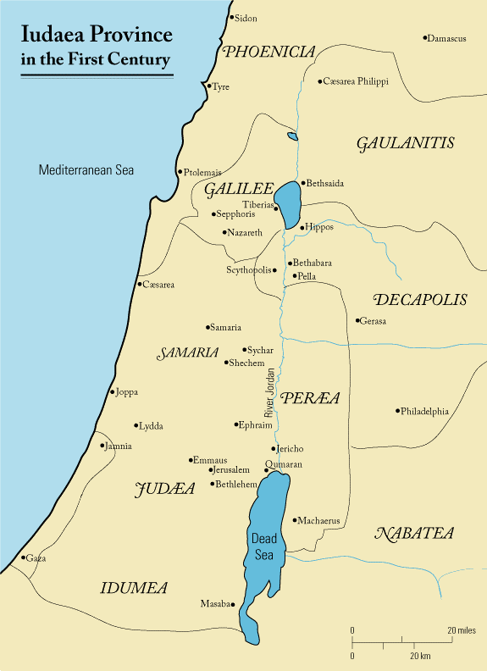
      - 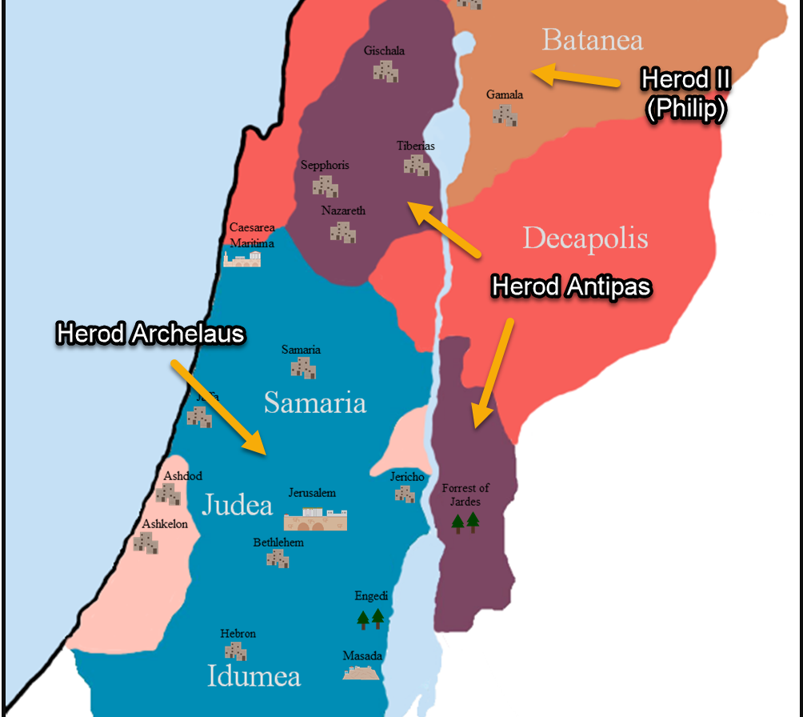
      - Antipas’ brother Archelaus ruled Judea until 6 AD (Mat 2:22)
      - Antipas’ half-brother Philip reigned in the area of the Golan Heights.
      - Understanding this division gives clarity to Joseph’s decision to move to Nazareth in Matthew 2
    - Marriage to Herodias
      - As we mentioned, Herodias was previously married to Philip but divorced him to marry Antipas
      - In order to marry Herodias, Herod Antipas divorced his first wife, Phasaelis, who was a Nabatean princess whose father Aretas Philopatris sat on the throne of Nabatea.
        - The divorce angered Aretas and he immediately invaded Antipas’ territory and defeated him with the help of some men who came from his half-brother Philip’s territory.
        - The war on the border of Nabatea went so poorly for Antipas he had to appeal to Rome for military support.
        - Side Note: the popular Al-Khazneh “the Treasury” of Petra is thought to be the mausoleum of Aretas Philopatris. (see how Bible history connects the dots).
        - 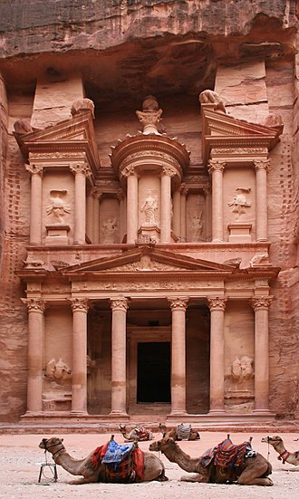
      - So not only did Antipas’ marriage to Herodias get him in moral trouble, it also had significant political consequences.
      - These insights may explain why tension existed between Pontus Pilate (a Roman governor) and Herod Antipas (Luke 23:12)
      - Antipas was responsible for keeping peace in Galilee and Nabatea but his foolish marriage threatened the peace the Romans desired.
      - Understanding the jurisdictions of each of the Herods also explains what is meant in Luke 23:6-7 when Pilate learned Jesus was from Galilee.
      - Luk 23:6-7 - When Pilate heard this, he asked whether the man was a Galilean. And when he learned that he belonged to Herod's jurisdiction, he sent him over to Herod, who was himself in Jerusalem at that time.
    - John’s imprisonment:
      - Josephus mentions John was held at the fortified hilltop palace of Machaerus located on the east side of the dead sea.
      - The palace had been destroyed but rebuilt by Herod the Great in 30 B.C.
      - 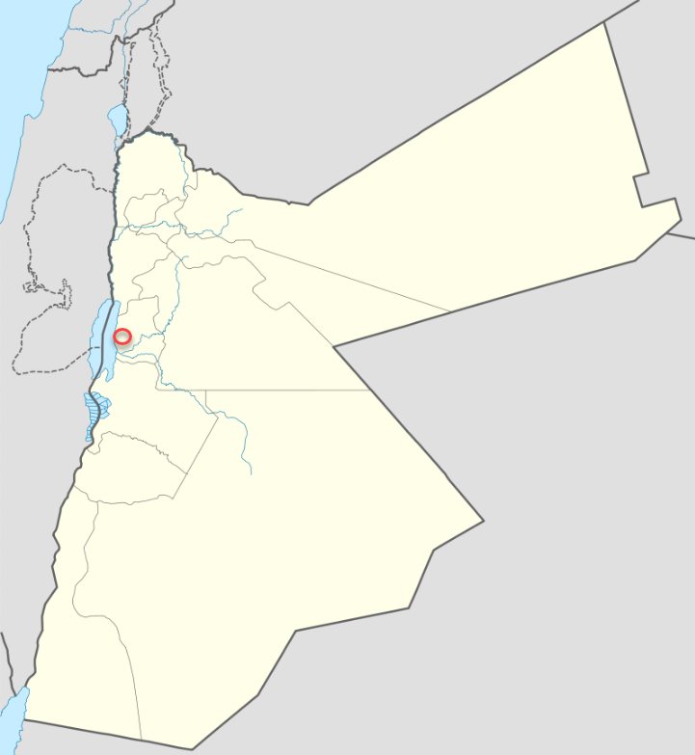
    - Antipas’ fate:
      - Emperor Tiberius died in 37 AD.
      - He was succeeded by Emperor Caligula
      - Antipas’ nephew, Agrippa I, accused Antipas of conspiring against the new emperor.
        - Agrippa I was the brother of Herodias
        - Agrippa I was the father of Agrippa II before whom Paul appears in the book of Acts
      - Antipas and Herodias were exiled to Spain
      - The date of Antipas’ death is unknown
    - Some people find history really boring because they feel like it doesn’t relate to them.
    - Hopefully throughout this study I can engender a bit of love for in you by showing you how much deeper our biblical understanding can be by adding a pinch of historical study.

Mat 14:13 - Now when Jesus heard this, he withdrew from there in a boat to a desolate place by himself. But when the crowds heard it, they followed him on foot from the towns.
Mat 14:14 - When he went ashore he saw a great crowd, and he had compassion on them and healed their sick.

- It is not 100% clear where Jesus was when He received the news of John’s death.
- He was in Nazareth at the end of chapter 13 but we are not told how much time past between those events and His hearing about John’s death. Luke’s gospel seems to suggest that some events took place between Nazareth and the departure to a desolate place.
- Luke 9:10 names this desolate place, Bethsaida.
- 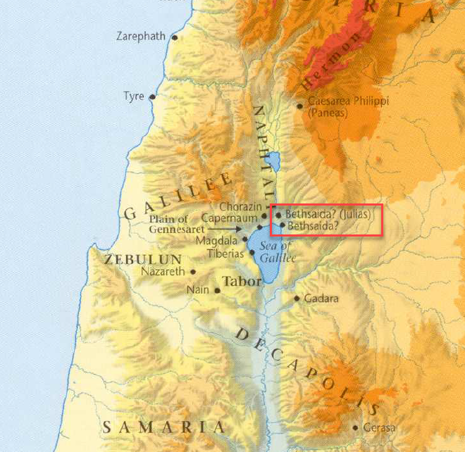
- Either way, upon hearing of the death, Jesus took a boat to a desolate place but was followed on foot by the crowd.
- Rather than expressing His annoyance with the crowd, the text says He had compassion on them.
- APPLICATION:
  - I am by nature an introvert and often find it annoying when someone lingers and won’t leave me alone.
  - But rather than focusing on His own inconvenience, Jesus’ focus is on the needs of the crowd.
  - Instead of being bothered by a person’s presence when I would rather depart to a desolate place, I ought to consider the needs and opportunities I have to serve the person God has put in front of me.

Mat 14:15 - Now when it was evening, the disciples came to him and said, “This is a desolate place, and the day is now over; send the crowds away to go into the villages and buy food for themselves.”
Mat 14:16 - But Jesus said, “They need not go away; you give them something to eat.”
Mat 14:17 - They said to him, “We have only five loaves here and two fish.”
Mat 14:18 - And he said, “Bring them here to me.”
Mat 14:19 - Then he ordered the crowds to sit down on the grass, and taking the five loaves and the two fish, he looked up to heaven and said a blessing. Then he broke the loaves and gave them to the disciples, and the disciples gave them to the crowds.
Mat 14:20 - And they all ate and were satisfied. And they took up twelve baskets full of the broken pieces left over.
Mat 14:21 - And those who ate were about five thousand men, besides women and children.

- The day is quickly passing away and the Apostles become concerned for the people.
- They ask Jesus to send the people away so they can find something to eat in the neighboring towns.
- Jesus looks back at them and says, “No need! You feed them.”
  - The text doesn’t describe an awkward pause at this point
  - Nor does it tell us the Apostle’s laughed thinking Jesus was joking
  - But there must have been some kind of shocked response on the Apostle’s faces when Jesus responded this way.
- Jesus, of all people, knew they neither had the bread or the money to pull off such a task.
- Jesus asked them to do the impossible.
  - So what did they do?
  - They started taking inventory of their resources and determined it couldn’t be done.
- John 6:6 tells us Jesus said this to test them.
  - Test them for what?
  - Probably to test where they believed their sufficiency to carry out God’s commands came from.
- In chapter 10, Jesus had given the Apostles power to heal the sick and cast out demons but when He asked them to feed 5,000 men they immediately looked at their wallets and proclaimed it couldn’t be done (John 6:7).
  - Did the money in their wallet help them cast out demons and heal the sick?
  - Why were they looking there now?
  - They should have looked right back at Jesus and said, “show us how!”
- APPLICATION:
  - How often does God tell us to accomplish something and we come back to him with a personal inventory and tell Him it can’t be done?
    - “Not enough talent!”
    - “Not enough money!”
    - “Not enough time!”
  - Instead of reading God’s commands in the Bible and responding to every one with, “show me how!”
    - It may seem out of our reach.
    - It may seem out of our wheelhouse.
    - It may seem like God is asking for the impossible.
    - But don’t you think God asks us to do great things sometimes to test us?
    - So that we can see, just as the Apostles learned here, “that the surpassing power belongs to God and not to us” (2Cor 4:7).
  - God doesn’t care about your empty wallet. In fact, your empty wallet makes you the perfect candidate for God’s work and ought to encourage you to look to God to give you what you need.
  - 2Cor 12:9 - Therefore I will boast all the more gladly of my weaknesses, so that the power of Christ may rest upon me.
- Jesus was about to remind the Apostles of His sufficiency to enable them to serve others.
- Jesus used something very ordinary (5 loaves and 2 fish) to do something extraordinary (feed thousands).
- The miracle fed the 5,000 men, but it also left behind a reminder of Jesus’ sufficient power in the 12 baskets of bread, one for each Apostle to gather and remember.
- God isn’t low on supply of grace to accomplish “impossible” things.
- The 12 baskets ought to encourage us when we’ve thought we’ve dreamed big enough, to dream a bit bigger for the glory of God.

Mat 14:22 - Immediately he made the disciples get into the boat and go before him to the other side, while he dismissed the crowds.
Mat 14:23 - And after he had dismissed the crowds, he went up on the mountain by himself to pray. When evening came, he was there alone,

- Jesus didn’t get any time to be alone earlier in the day so He made time in the evening.
- Remember from the last few verses that the day was quickly growing old when Jesus fed the 5,000 men (5,000 men, the number of women and children isn’t listed).
- The night was now upon them and Jesus dismissed the crowds to go back home or find some lodging elsewhere.
  - Like me, you may be wondering how long it would take them to get home.
  - The Sea of Galilee is about 33 miles (53 km) in circumference.
  - If you ever find yourself in the area, you can spend a few days hiking the Sea of Galilee Trail, which will take you on a 35 miles trek around the lake.
  - For reference, looking at the map above, it was probably around 5 miles from Bethsaida back to Capernaum.
- The Apostles returned home via boat but Jesus went up into a mountain to pray.
- You can see Jesus priorities in His actions.
  - He just spent a whole day working among the people.
  - Instead of going to sleep, He goes up into a mountain to pray
  - We will find out from verse 25 that He stayed up late into the night.

Mat 14:24 - but the boat by this time was a long way from the land, beaten by the waves, for the wind was against them.
Mat 14:25 - And in the fourth watch of the night he came to them, walking on the sea.
Mat 14:26 - But when the disciples saw him walking on the sea, they were terrified, and said, “It is a ghost!” and they cried out in fear.
Mat 14:27 - But immediately Jesus spoke to them, saying, “Take heart; it is I. Do not be afraid.”
Mat 14:28 - And Peter answered him, “Lord, if it is you, command me to come to you on the water.”
Mat 14:29- He said, “Come.” So Peter got out of the boat and walked on the water and came to Jesus.
Mat 14:30 - But when he saw the wind, he was afraid, and beginning to sink he cried out, “Lord, save me.”
Mat 14:31 - Jesus immediately reached out his hand and took hold of him, saying to him, “O you of little faith, why did you doubt?”
Mat 14:32 - And when they got into the boat, the wind ceased.
Mat 14:33 - And those in the boat worshiped him, saying, “Truly you are the Son of God.”

- We are told in John 6:17 the Apostles were headed back to Capernaum (going home).
- But the wind was hindering their progress.
  - This was likely not the same weather phenomenon that kicked up the storm in chapter 8.
  - If you remember, in chapter 8, the Apostle’s were headed to the east side of the sea.
  - Here they are headed in the opposite direction.
  - In chapter 8, the wind probably blew from the east, coming from the Golan Heights.
  - In chapter 14:24, in order for the wind to be “contrary” to them, it was likely coming out of the west.
- Jesus, leaving the mountain, walked out to meet the Apostles on the sea.
- The time is given as “the fourth watch of the night”
  - The Romans divided the night into 4 watches.
  - 6pm-9pm
  - 9pm-12am
  - 12am-3am
  - 3am-6am
  - So it was somewhere between 3am and 6am when Jesus met them on the water.
- The Apostles initially thought Jesus was a ghost
  - They may have been a bit sleep deprived.
  - Then again, it isn’t everyday someone WALKS up to your boat in the middle of a large body of water.
- Jesus calmed their fear by revealing Himself to them, at which point Peter asked to join Him on the water. He moves from fear to participation really fast.
- Peter gets out of the boat and starts walking towards Jesus on the water.
  - But instead of staying focused on Jesus, he started looking around at the waves and wind and having doubts.
  - As he doubted he began to sink.
  - Jesus immediately took hold of Peter and saved him but admonished him for doubting.
- As soon as they made it into the boat, the wind ceased and the Apostles worshipped.
- APPLICATION:
  - We should be careful before we criticize Peter for sinking in the sea.
  - I think the Church is at a place in its history where its members are more likely to err on the side of inaction than on the side of action.
    - We are more likely to sin by making excuses for not fulfilling our God given responsibilities than to sin because we are too ambitious and go-get’em in our goals.
    - We are really good at making excuses for why Jesus’ words don’t really demand of us what it sounds like they are demanding of us.
    - We are really good at looking down our noses at people we deem irresponsibly devoted to the gospel mission
  - I think we have room to learn from Peters zeal.
  - It is sinful not to take action
  - It can also be sinful to fail while taking action.
  - I would rather fail trying than be found failing to try.
- APPLICATION:
  - Fix your eyes on Jesus in the midst of storms
  - Peter’s mistake came when he looked away from Jesus and allowed the voice of the wind to speak louder than the voice of the wind’s master.
  - Do you remember what Jesus said in Mat 10:28?
    - Mat 10:28 – “And be not afraid of them that kill the body, but are not able to kill the soul: but rather fear him who is able to destroy both soul and body in hell.”
  - The waves and the water couldn’t have killed Peter, but he allowed their threat to get in His head.
  - As we go through our lives and our storms there will be loud voices of threat that surround us.
    - Disease
    - Enemies
    - Natural disasters
    - Anxieties
  - Jesus’ voice spoke all into existence.
  - And He tells us, like Peter, “come!”
    - Come to me through the waves
    - Come to me through the disease
    - Come to me through the anxiety
    - Come to me through the pain
    - “And I will give you rest!”
  - Let the voice of Jesus be the clearest and most resounding voice in your head.
  - And it is beautiful to know that Jesus will lift us up and bring us to safety when we believe the lying voices of threat.
  - We cannot criticize Peter because we are all Peter.
- APPLICATION:
  - We aren’t told the response of the other Apostles when Peter jumped over the side of that boat into the sea.
    - Some were probably impressed at his faith
    - Others probably though he was nuts
    - Some may have watched in skepticism of his commitment and wondered if he would let go of the side of the boat.
    - Others may have even gloated in seeing him sink.
  - But it doesn’t seem like asked them for their opinion.
  - His decision was based on his relationship and faith in Christ.
  - Our decision to “come” to Christ needs to be made in the same way.
  - I can assure you that you will experience all of the potential attitudes listed above if you are serious about your pursuit of Jesus.
    - Some people will look at you and be impressed by your faith
    - Some people will think you are nuts
    - Some people will say, “He is zealous now but we will see how far he/she makes it.”
    - Some people will love to see you fail.
  - But like Peter, we ought not let the opinions of those who aren’t even willing to step out of the boat sway our determination to follow Jesus’ call.
- APPLICATION:
  - It is better to be admonished after having tried and failed than to receive no feedback because you never take action.
  - Many never move past their fear and into a participatory role because they are afraid they may mess up.
  - What does the parable of the talents teach us about that attitude?
  - God would rather see us try and struggle than not try at all.

Mat 14:34 - And when they had crossed over, they came to land at Gennesaret.
Mat 14:35 - And when the men of that place recognized him, they sent around to all that region and brought to him all who were sick
Mat 14:36 - and implored him that they might only touch the fringe of his garment. And as many as touched it were made well.

- Gennesaret does not refer to a city but a plain.
- According to the Lexham Geographic Commentary on the Gospels, Gennesaret was a fertile plain stretching 3.5 miles long and 1.5 miles wide on the Northwest side of Galilee between Capernaum and Tiberius (see yellow arrow on map below).
- The sick from all regions were brought to Him for healing and He healed them all!

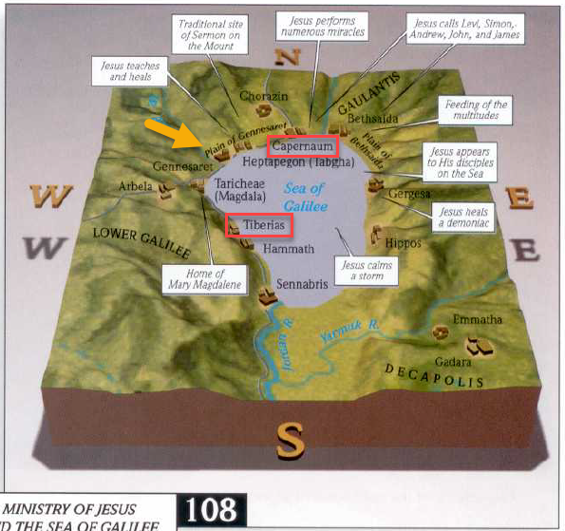

https://en.wikipedia.org/wiki/Herod_Archelaus
https://en.wikipedia.org/wiki/Herod_Antipas
https://en.wikipedia.org/wiki/Pontius_Pilate
https://en.wikipedia.org/wiki/Machaerus#/media/File:Jordan_location_map.svg
https://en.wikipedia.org/wiki/Al-Khazneh
https://en.wikipedia.org/wiki/Herod_Agrippa_II
https://www.eretz.com/wordpress/blog/2013/06/17/trekking-the-sea-of-galilee/
https://en.wikipedia.org/wiki/Sea_of_Galilee
https://www.risenjesus.com/mark-confused-pertaining-location-feeding-5000

