MATTHEW 15
Mat 15:1 - Then Pharisees and scribes came to Jesus from Jerusalem and said,
Mat 15:2 - “Why do your disciples break the tradition of the elders? For they do not wash their hands when they eat.”

- The fact that these Pharisees and scribes came from Jerusalem is not insignificant.
  - It likely shows the growing influence of Jesus and an increase in the concern of the Pharisees and scribes.
  - Capernaum was not a short day trip from Jerusalem. It was 80-85 miles.
  - 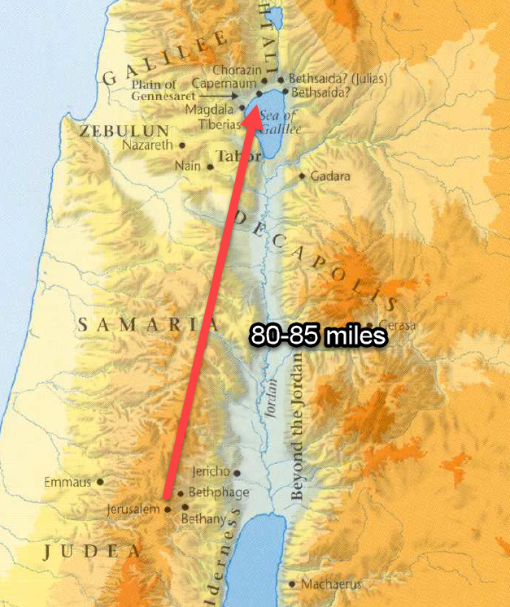
- On their long journey, the Pharisees and scribes must have had a significant amount of time to consider which accusation they wanted to make against Christ and they decided on hand washing.
  - “Why do your disciples no wash their hands when they eat bread?”
  - Notice what they cite as their authority for this practice, the “tradition of the elders.”
  - Their authority is important for the conversation that follows.
- What was hand washing?
  - If you’ve never read the Bible before or haven’t been introduced to Judaism, you may think this “hand washing” refers to the common practice most of us still hold to today.
    - We don’t want to eat with dirty hands because, well, germs and stuff, so we wash them with some soap and water before we eat.
    - But our common modern practice is not what was being asked about in this text.
  - Jewish hand washing is known as netilat yadayim (don’t ask me how to pronounce).
    - The practice is described in great detail in the Talmud
      - The Talmud is a collection of the Jewish oral traditions.
      - These oral traditions were meant to explain and expound on the Torah.
      - The Torah is the written Law of God (Genesis, Exodus, Leviticus, etc)
    - The practice of hand washing began with a command given to the priests when they entered the Temple to perform their duties.
      - They were told in Exodus 30:17-21 to wash their hands and their feet in purification for their holy responsibilities.
      - Exo 30:17-21 - The LORD said to Moses, “You shall also make a basin of bronze, with its stand of bronze, for washing. You shall put it between the tent of meeting and the altar, and you shall put water in it, with which Aaron and his sons shall wash their hands and their feet. When they go into the tent of meeting, or when they come near the altar to minister, to burn a food offering to the LORD, they shall wash with water, so that they may not die. They shall wash their hands and their feet, so that they may not die. It shall be a statute forever to them, even to him and to his offspring throughout their generations.”
    - So the origin of the tradition originated in God’s Law, but the elders expanded on this command and created traditions demanding hand washing and ritual purification for common Jews doing common things.
    - They required the same ritual purification by water to take place at several occasions:
      - Before eating
      - After eating (if they had touched the “salt of Sodom.”)
      - When eating certain fruits and vegetables
      - After sleeping
      - Before prayer
    - They also created rituals about:
      - What type of water was required
      - How much water was required
      - How many times the water had to be poured on the hand
      - Blessings that must be quoted during the ritual
    - Hand washing was not about physical cleanliness, it was about a spiritual purification before the priest (the Jew) approached the altar (the table) to take part in the sacrifice (the bread).
  - APPLICATION:
    - We need to be really careful about taking a “principle” found in one context and creating rules to bind in other contexts.
    - Binding a principle laid down in one context in another context.
- The Pharisees and scribes weren’t asking this question for general information, they were accusing Jesus and His Apostles of sinning by breaking the teachings of the elders.

Mat 15:3 - He answered them, “And why do you break the commandment of God for the sake of your tradition?
Mat 15:4 - For God commanded, ‘Honor your father and your mother,’ and, ‘Whoever reviles father or mother must surely die.’
Mat 15:5 - But you say, ‘If anyone tells his father or his mother, “What you would have gained from me is given to God,”
Mat 15:6 - he need not honor his father.’ So for the sake of your tradition you have made void the word of God.
Mat 15:7 - You hypocrites! Well did Isaiah prophesy of you, when he said:
Mat 15:8 - “‘This people honors me with their lips, but their heart is far from me;
Mat 15:9 - in vain do they worship me, teaching as doctrines the commandments of men.’”

- Jesus does not answer their question with an explanation but with an accusatory question of His own.
  - “Why do you break God’s Law to keep the elder’s traditions?”
  - He is “one-upping” them.
  - Which was more important? The commands of God or the commands of the elders?
  - The answer should be obvious
    - God’s laws have divine authority behind them.
    - The traditions were just that… traditions.
- Jesus then provided an example of how this was done.
  - God commands children to “honor your father and your mother” (one of the 10 commandments).
  - Jesus makes it clear that obedience to that command demands caring for your parents needs, financially or otherwise.
  - The punishment for failing to honor them was death.
  - On the flip-side, there were also commands in the Scriptures that required keeping oaths if those oaths were made to God.
  - The Pharisees and scribes emphasized one of these commands and discarded the other.
  - The tradition of the elders stated if a person dedicated his possessions to the service of God, they were no longer required to use those resources to fulfill their responsibility to their parents.
  - A dedication of this type only exists within the traditional teachings of the Jewish Rabbis, not in the written Law of God (the gospel of Mark calls this dedication “Corban”, Mark 7:11)
  - So their made up tradition voided the word of God
  - Such an oath should never have existed!
  - They were elevating the words of their rabbis above the words of God.
  - Jesus boldly calls them hypocrites!
    - In an outward pretense of piety the dedicated their belongings to God.
    - But it wasn’t because they loved the LORD or His commands.
    - Their show of devotion was, at heart, just a self-serving round-about means to shirk God’s commands.
    - I like the way Albert Barnes defines their hypocrisy.
    - “Hypocrisy is the concealment of some base principle under the pretense or religion. Never was there a clearer instance of it than this an attempt to get rid of the duty of providing for needy parents under and appearance of piety towards God.”
- APPLICATION:
  - We need to be mindful not to stress the importance of one command to the neglect of others.
  - Is it possible to overemphasize a command of God?
    - My immediate thought is, “No, of course not.”
    - But it is wrong to overemphasize one of God’s commands if our devotion to its practice leaves us neglecting other commands.
  - Examples:
    - Many in our Christian culture stress God’s instruction to love so much they allow it to void God’s instruction about admonishing sin.
    - We can stress Jesus’ instruction to be peacemakers so much that we discard His teaching on discipline within the Church.
    - We can stress the need for Bible study and push evangelism to the side.
      - This one hits a bit more close to home for me.
      - It is easy to think we are being godly when we pick up our Bibles to study, but if Bible study consumes so much of our time we fail to fulfill other necessary spiritual acts, we need to do some evaluation.
      - I find Bible study much more in my comfort zone than evangelism.
      - But there are times I need to put down my Bible and work to spread the gospel.
- The prophecy quoted in verse 8 and 9 is located in Isaiah 29:13.
- On the outside, the Pharisees and scribes appeared religious, but on the inside they were very far from what God wanted them to be.
- Their devotion was vain.
  - Vain: producing no result, useless.
- They were more devoted to their own traditions about the Law than the Law itself.
- They had lost sight of whose words were more important.
  - Theirs and their elders?
  - Gods?
- APPLICATION:
  - Whose words are more important to you?
  - Are you quicker to listen to a trusted teacher than to pick up the Bible and read God’s words for yourself?
  - Are you willing to ignore the written Scripture because someone told you it doesn’t apply?
  - The Pharisees and scribes had a very similar problem to many in the religious world today.
  - Are oral traditions more important to us than God’s written commands?
    - How often do you hear a religious teacher cite that some prominent religious figure from the past taught a particular doctrine, and many after him taught the same thing, and this teacher was educated at a seminary with highly educated people who taught the same thing, and that is why you should accept it?
    - What is that? Oral tradition! Tradition of the elders!
    - That isn’t to say that it is wrong… but it might be.
    - Which is why a study like this is so important
      - To examine the written word of God.
      - So that no matter what oral tradition you’ve heard about what you should believe and practice, you can make sure in doing it you aren’t violating the commands of God.
  - Why does Jesus spend so much time dealing with the Pharisees, Sadducees, and scribes in the New Testament?
    - Is it just because He liked beating up on them?
    - No, it is because in dealing with their problems He dealt with our problems.

Mat 15:10 - And he called the people to him and said to them, “Hear and understand:
Mat 15:11 - it is not what goes into the mouth that defiles a person, but what comes out of the mouth; this defiles a person.”

- Picture this with me, Jesus just openly rebuked the most respected religious leaders in Judaism in front of all the people who respected them. He then calls all of the people over to Him and in front of the Pharisees, He teaches the people the direct opposite of everything the Pharisees and scribes held dear. SAVAGE!
  - Welcome to Galilee! They travelled 80 miles to get thrashed.
  - It was occurrences like this that enflamed the Pharisees and scribes hatred of Christ.
  - Religion was their turf and it only took one encounter for them to get taken to school and embarrassed by a 30 years old who never attended Mosaic Law seminary.
- In verse 2, I want you to think about how big of a shift this statement would be for a Jew who grew up under the Mosaic Laws of clean/unclean.
  - The Law of Moses taught that a person was clean or unclean based many times on their outward surroundings.
  - It mattered what they touched, who they were around, where they went, etc…
- Now Jesus is saying what makes a person clean or unclean, undefiled or defiled, isn’t the outside but the inside.
  - A person isn’t defiled if he eats bread without ritualistically washing his hands.
  - A person was defiled if his heart wasn’t right towards God.
- The Pharisees and scribes were case-and-point.
  - They looked great on the outside.
    - They washed their hands.
    - They recited the blessings.
    - They dedicated their possessions to God.
  - But their insides were rotten.
    - They sought loopholes around God’s commands.
    - They were hypocrites.
    - They’re hearts were far from God.

Mat 15:12 - Then the disciples came and said to him, “Do you know that the Pharisees were offended when they heard this saying?”
Mat 15:13 - He answered, “Every plant that my heavenly Father has not planted will be rooted up.
Mat 15:14 - Let them alone; they are blind guides. And if the blind lead the blind, both will fall into a pit.”

- The Apostle’s of Jesus come up to him stating the obvious, “Do you know you offended the Pharisees?”
- An average Jew telling off the Pharisees and scribes was probably something they didn’t see every day and they may have been concerned about the consequences.
- Jesus’ response, “Don’t worry about it!”
  - There are many trees which grow in the religious world and not all bear good fruit.
  - They are not the offspring of God and they were not planted by Him.
  - Those who are not born from the seed of the word of God planted in their hearts are not of God.
- The Pharisees and scribes were those described back in Matthew 13:14-15.
  - Mat 13:14-15 - Indeed, in their case the prophecy of Isaiah is fulfilled that says: “You will indeed hear but never understand, and you will indeed see but never perceive.” For this people's heart has grown dull, and with their ears they can barely hear, and their eyes they have closed, lest they should see with their eyes and hear with their ears and understand with their heart and turn, and I would heal them.”
  - They were blind to God’s message, yet they fancied themselves religious guides to others.
  - How can someone ignorant of God (blind) guide another person who is ignorant of God (blind)?
  - Answer: they can’t! They will both walk off the road and fall into a ditch.
  - Christ was concerned with honest hearts.
  - He would not spend His time casting pearls before the swine, but He would warn the common people about the blind men trying to convince them it was a good idea to follow them.

Mat 15:15 - But Peter said to him, “Explain the parable to us.”
Mat 15:16 - And he said, “Are you also still without understanding?
Mat 15:17 - Do you not see that whatever goes into the mouth passes into the stomach and is expelled?
Mat 15:18 - But what comes out of the mouth proceeds from the heart, and this defiles a person.
Mat 15:19 - For out of the heart come evil thoughts, murder, adultery, sexual immorality, theft, false witness, slander.
Mat 15:20 - These are what defile a person. But to eat with unwashed hands does not defile anyone.”

- Peter approaches Jesus and asks Him to explain this new concept to them.
- Jesus implies he should have been able to reason the words out for himself but goes on to provide an explanation.
  - Food cannot defile a person.
  - Food is eaten and expelled from the body.
  - It is what is allowed to remain in the body, in the heart, that can defile a person.
    - This is very consistent with Jesus’ teaching on the Sermon on the Mount.
    - Lust and adultery and murder begin with what we allow to reside in us.
  - Our hearts are either springs of living water or poison water.
  - External factors cannot influence us unless we allow them entrance through the gate of our hearts to affect it’s output.
  - We can be surrounded by external uncleanliness and not be defiled.
    - This is the state of the Christian everyday.
    - We live in a world full of defiling influences.
    - We are told that we must live in this world but not permit it to live within us!
  - We are only defiled when we allow sin entrance or we are not vigilant and it slips in under our notice.
  - The heart is defiled when it becomes a harbor for wickedness.
  - If we find our heart in this state, we need to purify our hearts and affections (5:8, “Blessed are the pure in heart, for they shall see God.)
  - General principle: what is outside of you cannot defile you in the eyes of God. Only what is inside of you can defile you. Who decides what is allowed inside of you? You do!

Mat 15:21 - And Jesus went away from there and withdrew to the district of Tyre and Sidon.
Mat 15:22 - And behold, a Canaanite woman from that region came out and was crying, “Have mercy on me, O Lord, Son of David; my daughter is severely oppressed by a demon.”

- At the end of chapter 14, Jesus was on the plain of Gennesaret.
- He now departs Galilee to go Northwest to Tyre and Sidon
- 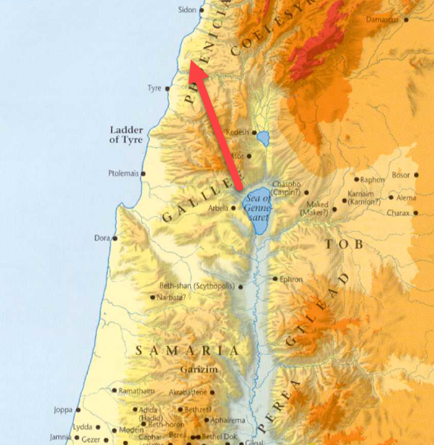
- Jesus’ intention for making this 40+ miles journey isn’t fully explained by Matthew.
  - The encounter we are about to read is the only significant event recorded from the journey.
  - This encounter may have been the primary purpose for visiting Tyre and Sidon.
- Sometime during His visit, Jesus is approached by a Canaanite woman.
  - Mark’s gospel calls her a Syrophoenician.
  - This woman was not a Jew, she was a gentile.
- She cried out to Jesus and addressed Him in a very curious way.
  - She calls Him the “Son of David.”
  - Why is that so curious?
  - Because this gentile woman appears to recognize Jesus as the Messiah.
  - “Son of David” is the term used in reference to Jesus in Matthew 1:2 when Matthew provides the genealogy of Jesus to prove Him to be the Messiah.
  - This could not have been a general greeting among the Jews because not all Jews were David’s descendants.
- The woman was requesting Jesus help for her daughter who was troubled by a demon.

Mat 15:23 - But he did not answer her a word. And his disciples came and begged him, saying, “Send her away, for she is crying out after us.”

- Through all of her crying and pleading, Jesus did not respond.
- The disciples were annoyed with her and asked Jesus to send her away.
- Jesus’ unwillingness to send her away makes it clear He was not simply trying to dispose of the woman.

Mat 15:24 - He answered, “I was sent only to the lost sheep of the house of Israel.”
Mat 15:25 - But she came and knelt before him, saying, “Lord, help me.”
Mat 15:26 - And he answered, “It is not right to take the children's bread and throw it to the dogs.”
Mat 15:27 - And she said, Truth, Lord: yet the dogs eat of the crumbs which fall from their masters' table.
Mat 15:28 - Then Jesus answered and said unto her, O woman, great is thy faith: be it unto thee even as thou wilt. And her daughter was made whole from that very hour.

- Eventually, Jesus responded, making His mission clear to the Canaanite woman.
- He had not come to preach and teach among the gentiles, only the Jews.
  - That isn’t to say Jesus never helped gentiles.
  - We’ve already encountered a few instances where gentiles received miracles from Jesus.
  - He said this to the woman to test her faith. To see how resolved she was to care for her daughter.
- The woman responded with a statement of great humiliation.
  - She acknowledged Jesus mission.
  - She knew that the Son of David was a Messiah to the Jewish nation.
  - But she begged that the abundance of the Messiah’s blessings might spill over to a gentile.
  - She is asking for something that doesn’t belong to her.
  - She is asking for grace.
  - If you know anything about Jesus, you know He isn’t in the business of withholding grace.
- In the King James Version (KJV), verse 25, in place of “knelt before him,” the text says she “worshipped Him, saying, Lord, help me.”
- The way Jesus replies to the woman now kneeling at His feet is a bit shocking.
  - Jesus’ actions in coming to Tyre and Sidon and in what He is about to do for this woman prove that He didn’t say this to be derogatory towards the woman but, again, to test her resolve.
  - Referring to the Jews as “children” and the gentiles as “dogs,” He tells her it would not be right to take what belonged to the Jews and throw it the gentiles.
  - Paraphrase: “It wouldn’t be right for me to take what belongs to someone else and give it to someone who doesn’t deserve it.”
    - That is really interesting because right now, Jesus is on a mission to do that very thing.
    - To take what belongs to someone else and give it to someone who doesn’t deserve it.
    - What a lesson on grace for a Jewish audience of disciples who had been taught by their religious leaders they were the children of Abraham and the inheritors of the Kingdom of Heaven on account of their bloodline.
      - “Our blood keeps us in good standing with God!”
      - “We will enter the Kingdom because we are Jews”
      - They believed themselves entitled to it.
    - The woman acknowledges she doesn’t deserve what she is asking for but asks anyway in hope that Christ would give a gift!
    - Who approached God correctly? The entitled Jews or the grace desperate Syrophoenician woman?
      - The Jews needed to understand that they were in as desperate need for something they didn’t deserve as this woman was.
      - We need to understand that we are in as desperate need as this woman and approach God the same way.
    - The Jews thought their blood was everything.
    - The Syrophoenician woman knew her blood was nothing.
    - Jesus’ blood is the only blood that matters.
    - And that blood was spilled to give the undeserving the grace they didn’t deserve.
- But people in our world don’t like to be told they are undeserving.
- At this point, if I was the Canaanite woman, I probably would have gotten off the ground and turned to Jesus and said, “forget you, if your are going to be a jerk, I don’t want your help!”
- Luckily for her daughter, this woman didn’t respond like me.
  - Upon hearing Jesus’ words, she humbled herself even further.
  - “Truth, Lord: yet the dogs eat of the crumbs which fall from their master’ table.”
- Her humility impressed Jesus!
  - He paid her a high compliment, saying, “O woman, great is thy faith…”
  - And He did as she requested in healing her daughter.
- Now I want to look at 2 reasons why Jesus may have traveled 40+ miles to encounter this woman with the Apostles.
  - (1) First, Jesus may be using this woman to illustrate the future of the Kingdom.
    - Jesus had just spent time in Nazareth and Galilee.
    - What had occurred there?
      - The Jews had rejected Him in Nazareth
      - The Jews had rejected Him in Galilee and even sent Pharisees and scribes all the way from Jerusalem to undermine Him.
    - Jesus then departed Jewry (I had to use this word at least once) and travelled to Tyre and Sidon.
    - What occurred there?
      - A gentile woman came crying after Jesus calling Him the Messiah.
      - She acknowledged Him as the only one who could help her.
    - The people who should have know the Messiah and worshipped Him didn’t…
    - The gentile who shouldn’t have know the Messiah fell down at His feet worshipping…
    - Does this in any way parallel what we will see as we follow Christianity through its 1st Century history?
      - Largely the Jews rejected their Christ, not being able to acknowledge their sinful state.
      - Paul will later write how the gospel was then taken to the gentiles because they gladly accepted the Savior.
    - Notice the Apostle’s attitude towards the two groups just discussed.
      - The Apostles came to Jesus earlier in the chapter concerned about the offended Pharisees and scribes.
      - On the other hand, the Apostles were quick to ask Jesus to turn this woman away.
    - It may be that Jesus took them up to Tyre and Sidon to help them adjust their thinking about those who would accept His message.
    - This may foreshadow the gentile acceptance of the gospel.
    - This is the second time Jesus has highly complimented the faith of a gentile (Mat 8:10).
  - (2) To show His Apostles and unexpected picture of Himself!
    - Here we see a woman who was born into low social status, like Jesus.
    - This woman didn’t come for personal benefit but to seek the good of someone else, like Jesus.
    - This was a woman who was willing to make herself uncomfortable to accomplish her goal, like Jesus.
    - This woman, when she could have taken offense, humbled herself further to accomplish her mission, like Jesus.

Mat 15:29 - Jesus went on from there and walked beside the Sea of Galilee. And he went up on the mountain and sat down there.
Mat 15:30 - And great crowds came to him, bringing with them the lame, the blind, the crippled, the mute, and many others, and they put them at his feet, and he healed them,
Mat 15:31 - so that the crowd wondered, when they saw the mute speaking, the crippled healthy, the lame walking, and the blind seeing. And they glorified the God of Israel.

- Jesus returns to Galilee after what appears to be a pretty short trip up to Tyre and Sidon.
- Jesus walks up a mountain, sits down, and crowds of sick people start to ascend the mountain.
- 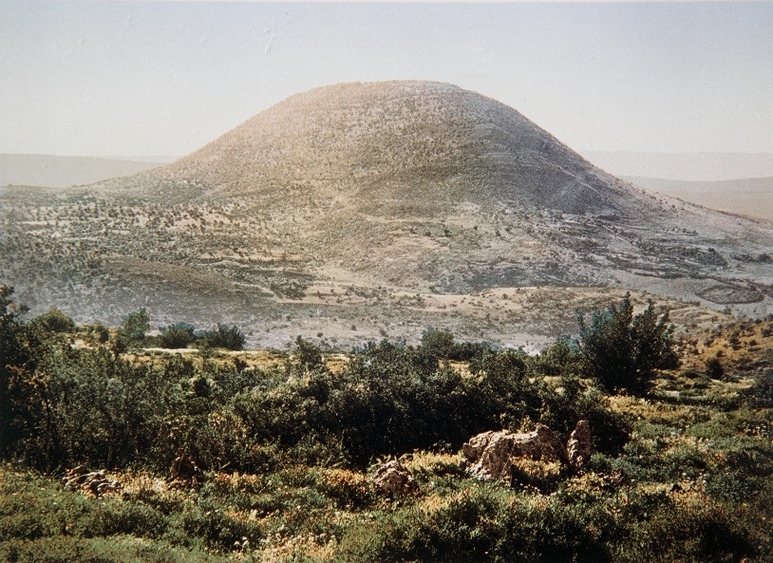
- Maybe a mountain like Mount Tabor (above).
  - You can imagine people streaming up the sides of that hill to get to Jesus at the top.
  - Friends carrying beds with lame people.
  - Others leading blind people around rocks and mud.
  - Parents carrying their sick children in their arms.
  - Lepers trying to make their way up while avoiding others.
  - Some restraining and dragging demon possessed people who they cared about.
    - Have you ever tried to drag a person up a hill?
    - It’s hard!
- Those who assisted the sick put them at Jesus feet.
- APPLICATION:
  - There are several applications we could draw from the short 3 verse section but I want to focus on those we just discussed, those who brought the sick.
  - Why did Jesus decide to do His healing on the top of a mountain?
    - We don’t know.
    - The text doesn’t tell us.
  - But we know it would have required some effort to reach Him.
  - Those who brought the sick to Jesus must have cared about those they were bringing.
  - They loved them enough to exert considerable effort to take them to the only place they could receive relief, Jesus’ feet.
  - If they hadn’t loved them, the inconvenience would have prevented them from helping.
  - One of my personal prayers lately has been, “Lord, help me to love people more!”
    - How is it possible that I encounter any number of people in my life, knowing they are spiritually sick, and don’t even attempt to show them the way to Jesus’ feet?
    - I think it’s probably because I love them too little.
      - If I loved them more I would exert the effort.
      - I wouldn’t be able to look at a sick person, know Jesus is ready to heal them on the mountain, and just ignore the whole reality and go about my day.
      - Does it require effort? Yes!
      - Does it require personal inconvenience? Sometimes!
      - Does leading people to Christ require us to climb a few mountains?
    - Imagine you have a servant who says, “Yes, I want to be your servant as long as I don’t have to exert any effort and I’m never personally inconvenienced!”
      - He wouldn’t be much of a servant.
      - Imagine God has a servant who He has healed and bought with a price.
      - That servant says to God, “I’m happy to serve you as long as I’m not asked to put forth effort or inconvenienced!”
      - Are we that servant?
      - I find I’m really good at coming up with reasons why God’s commands aren’t asking me to be inconvenienced in a ways I don’t like.
      - Am I really going to try to use those excuses when the guy next to me is hauling his sick friend up a mountain to meet Jesus?
    - The more we love others, the more spent our lives will be in effort to help the spiritually sick find healing.

Mat 15:32 - Then Jesus called his disciples to him and said, “I have compassion on the crowd because they have been with me now three days and have nothing to eat. And I am unwilling to send them away hungry, lest they faint on the way.”
Mat 15:33 - And the disciples said to him, “Where are we to get enough bread in such a desolate place to feed so great a crowd?”
Mat 15:34 - And Jesus said to them, “How many loaves do you have?” They said, “Seven, and a few small fish.”
Mat 15:35 - And directing the crowd to sit down on the ground,
Mat 15:36 - he took the seven loaves and the fish, and having given thanks he broke them and gave them to the disciples, and the disciples gave them to the crowds.
Mat 15:37 - And they all ate and were satisfied. And they took up seven baskets full of the broken pieces left over.
Mat 15:38 - Those who ate were four thousand men, besides women and children.
Mat 15:39 - And after sending away the crowds, he got into the boat and went to the region of Magadan.
- The miracle here is so similar to the feeding of the 5,000 in chapter 14 we will not take the time to draw out the same points of application.
- Why does Jesus perform a similar miracles more than once?
- Probably because, just like us, the disciples needed the same truths reaffirmed to them more than one time to allow them to sink in.
- Jesus then travelled into the coasts of Magdala
- “It is a wretched hamlet of a dozen low huts huddled into one, and the whole ready to tumble into a dismal heap of black basaltic rubbish.” - The Land and the Book (Thomson), vol. ii. p. 108. This was the birthplace of Mary Magdalene

https://www.chabad.org/library/article_cdo/aid/607403/jewish/Meal-Hand-Washing.htm
https://www.learnreligions.com/jewish-hand-washing-rituals-2076317
https://www.chabad.org/library/article_cdo/aid/4114662/jewish/Why-Wash-Hands-for-Bread.htm
https://en.wikipedia.org/wiki/Talmud
https://en.wikipedia.org/wiki/Handwashing_in_Judaism

