MATTHEW 17
Mat 17:1 - And after six days Jesus took with Him Peter and James, and John his brother, and led them up a high mountain by themselves.
- The events of chapter 17 take place 6 days after the events of chapter 16
- Jesus takes 3 of His Apostles up into a high mountain.
  - The exact location of the “mountain” is unknown
  - Some suggest it was Mount Tabor in southern Galilee while other point to Mount Hermon.

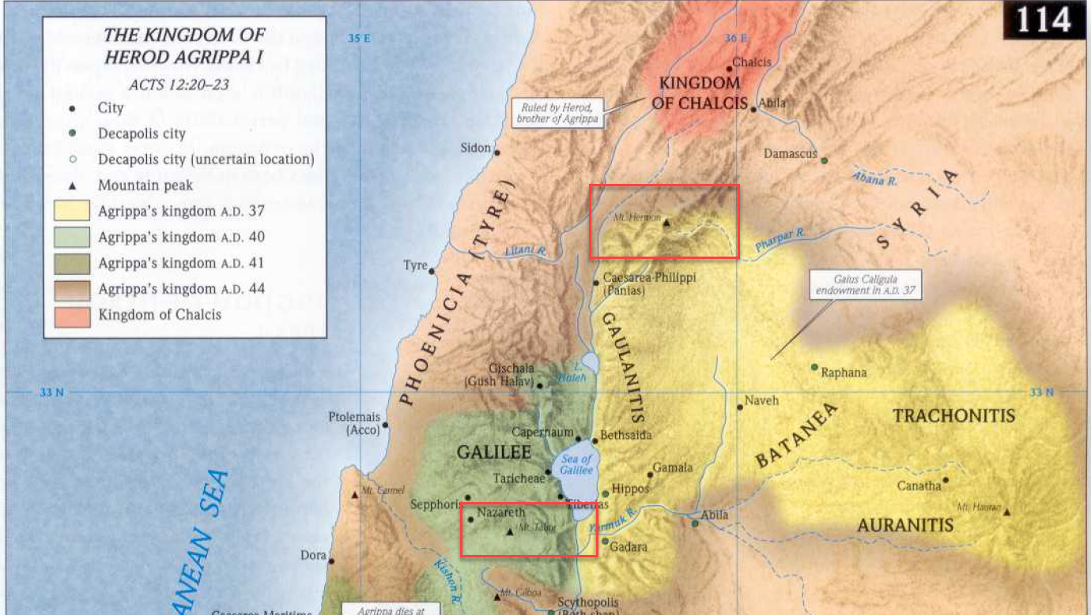
- Mount Tabor in 2011
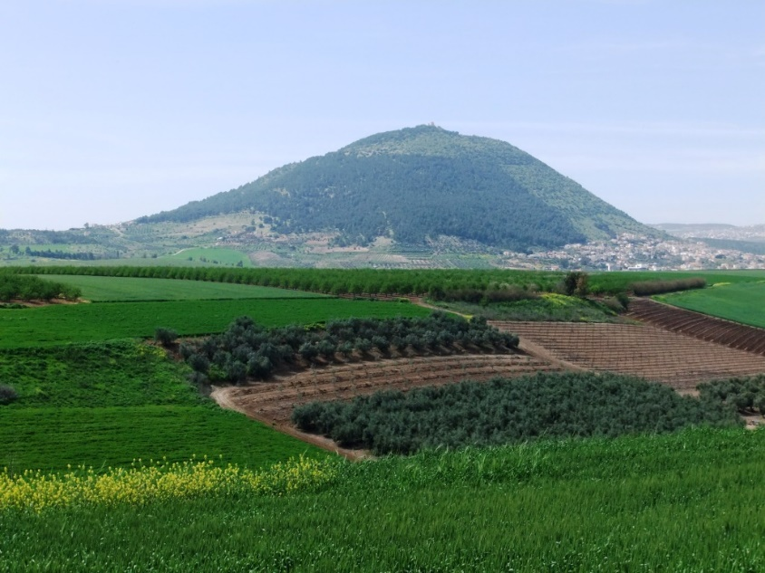
- Mount Hermon
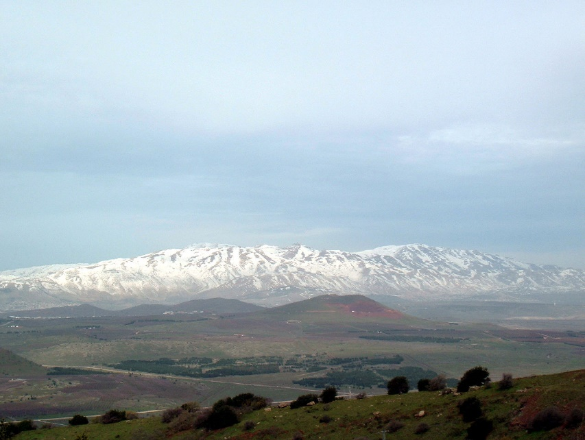
- Why does Jesus only opt to take only 3 of His Apostles with Him to witness this event?
  - We are not told.
  - This was not the only time Jesus permitted these three to witness events hidden from the other 9.
    - Did they need extra faith building?
    - Was this a privilege for their devotion?
    - We just don’t know and I’m not sure speculation is fruitful in this case.
- In order to pick up all the small details of this event, it is important to read all three of the gospel writer’s accounts
  - Matthew 17
  - Mark 9
  - Luke 9
- Jesus took the three Apostle’s up into the mountain to pray (according to Luke’s gospel).
- While Jesus was praying, He was “transfigured.”
  - What does “transfigured” mean.
  - I found this etymology chart interesting for the origin of the English word.
    - 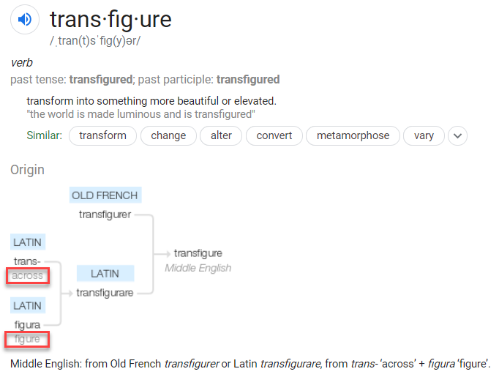
    - To move “across figures”
    - Synonyms include: change, alter, metamorphoses.
  - What about the Greek?
    - According to Strongs, the term carries the same meaning, to transform or change.
    - 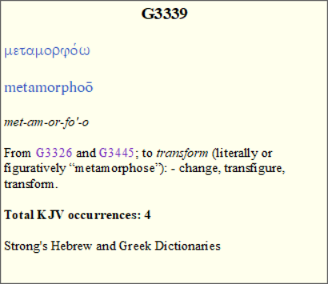
    - The same word is used in 2 other familiar passages
      - Rom 12:2 - Do not be conformed to this world, but be transformed by the renewal of your mind, that by testing you may discern what is the will of God, what is good and acceptable and perfect.
      - 2Co 3:18 - And we all, with unveiled face, beholding the glory of the Lord, are being transformed into the same image from one degree of glory to another. For this comes from the Lord who is the Spirit.
      - SIDE NOTE: Notice, as we behold the glory of Christ we are transfigured.
- Don’t get tripped up on this passage because of the fancy word.
- While praying, Jesus’ appearance changed.
  - “His face shown like the sun”
  - “His clothes became white as light”
  - If you read John’s vision of Christ in Revelation 1, you’ll see the similarities in the appearance of Jesus.
- One commentator I read rightly pointed out that while we think of this transformation as a miracle, the true miracle was God’s consistent appearance as a normal man.
  - The Apostles see a sliver of Christ’s true appearance escaping from its human shell.
  - It may be a greater miracle that Christ’s glory didn’t come bursting out of Him on a daily basis than that it made a momentary appearance in this account.
- Jesus’ appearance wasn’t the only thing that changed. The attendees at the prayer gathering also increased.
  - Along with the Apostles and Jesus, two new men were present.
  - Although we don’t know how, the 3 Apostles were able to recognize them as Moses and Elijah.
  - Why these two men?
    - There are many significant Old Testament characters so why did Jesus choose these two?
    - It is likely because they represented two pillars of the Old Testament system, the Law and the Prophets
    - Moses was God’s chosen law giver and Elijah represented the authority of God’s prophets.
    - Moses provided the people with the Laws of God and the prophets worked among the people throughout their history to encourage them to follow it.
  - Luke’s account tells they were speaking to Jesus about “His departure, which He was about to accomplish at Jerusalem” (Luke 9:31)
  - All three gospel accounts seem to suggest the guests did not stay with Jesus long.
- As Moses and Elijah were departing, Peter felt the need to say something.
  - He blurted out, “If you wish, I will make three tents here, one for you and one for Moses and one for Elijah.”
  - Luke tells us that Peter said this when the men were departing.
  - Mark tells us he said this because, “he did not know what to say…”
- What does Peter mean “make three tents?”
  - The word for “tent” used here is the same word used for “tabernacle” in the New Testament (used a lot in Hebrews).
  - Before the Temple in Jerusalem replaced the tabernacle during the reign of Solomon.
  - The tabernacle was a tent (a very elaborate tent) where the Ark of the Covenant was kept during the period of the wilderness wanderings and the Judges.
  - The Jewish tabernacle was the place of God’s presence and a place of worship.
  - The same word is used to refer to other places of worship (idol worship) such as the “tent of Moloch” (Acts 7:43).
  - So what is Peter’s meaning?
  - He seems to be saying, “Lets construct a monument or a holy site in honor of Moses, Elijah, and Jesus.”
- An alternative view
  - If I understand correctly the Greek word used here for “tent,” although it can be used to talk about a holy site like the Jewish tabernacle, it can also be used to talk about an ordinary tent/hut in which people lived.
  - Notice how Peter offered to build the tents “as the men were parting from Him” Luke 9:33)
  - It is possible Peter wanted the men to stay.
    - If Moses or Elijah showed up in my neighborhood, I would offer to put them up in my house for the night because it isn’t everyday you get to spend an evening with Moses.
    - They probably wanted to talk to them.
    - Might have had some questions.
  - So Peter offered to build them a place to stay for a while.
- This question of Peter’s received an immediate response.
  - A bright cloud enclosed them (Luke says they were “encompassed”)
  - A voice came out of the cloud, saying, “This is my beloved Son, with whom I am well pleased; listen to Him.”
  - Whatever this voice sounded like, it must have been more than the voice of a human, because the Apostles are terrified and fall immediately on their faces (a very common response to hearing the voice of God in the Bible).
- What does God intend to communicate?
  - If you take the first interpretation of Peter’s question above, God is rejecting Peter’s offer to build three tabernacles.
  - Why?
    - For one, Jesus had no need of a physical tent/tabernacle.
    - For two, elevating Moses and Elijah to the level of Christ was a mistake.
      - Christ was greater than the Law giver and the prophets
      - Jesus was going to accomplish what the Old Law couldn’t and He was the fulfillment of all of its prophecies.
    - The voice distinguishes Christ from the other two and clarifies whose instruction they needed to heed.
    - With their presence, Moses and Elijah confirmed the identity of Christ and now the Father seals their confirmation with His unbreakable word.
    - An appearance of Moses and Elijah would be huge in convincing Matthew’s Jewish audience that Jesus really was the Messiah.
    - In a broader sense, this would have communicated a shift in the identity of God’s authorized messenger.
    - For thousands of years, Moses and the prophets were the authorized mouthpieces of God, but now God had given all authority over to His Son and had sent Him to the world as the “Word” of God (John 1).
  - If you take the alternative interpretation of Peter’s question, this can be understood in a similar way.
  - Peter wanted Elijah and Moses to stay and talk further, so He offered his tent construction services.
  - God, with His voice, makes it clear Peter doesn’t need to hear the words of Moses and Elijah.
  - He has all he will ever need in the words of the Son of God.
- As quickly as the two guests, the cloud, and the voice came, they disappeared just as quickly.
- Jesus goes to the Apostles lying on their faces and lifts them up.

Mat 17:9 - And as they were coming down the mountain, Jesus commanded them, “Tell no one the vision, until the Son of Man is raised from the dead.”
Mat 17:10 - And the disciples asked him, “Then why do the scribes say that first Elijah must come?”
Mat 17:11- He answered, “Elijah does come, and he will restore all things.
Mat 17:12 - But I tell you that Elijah has already come, and they did not recognize him, but did to him whatever they pleased. So also the Son of Man will certainly suffer at their hands.”
Mat 17:13 - Then the disciples understood that he was speaking to them of John the Baptist.

- Jesus tells the Apostles they are not to tell anyone about what they had just witnessed until He had risen from the dead.
  - The reason is not specifically given.
  - Peter does make reference to his experience in 2Peter 1:16 and it seems his readers had at least some familiarity with the events on the “holy mountain.”
  - 2Pe 1:16-18 - For we did not follow cleverly devised myths when we made known to you the power and coming of our Lord Jesus Christ, but we were eyewitnesses of his majesty. For when he received honor and glory from God the Father, and the voice was borne to him by the Majestic Glory, “This is my beloved Son, with whom I am well pleased,” we ourselves heard this very voice borne from heaven, for we were with him on the holy mountain.
- I imagine Jesus’ 3 companions had about 6,000,000,000 questions to ask Jesus on their trek down the mountain but only one is recorded for us.
- Having just seen Elijah, they recalled a statement often made by the scribes.
  - “Then why do the scribes say that first Elijah must come?”
  - As we’ve discussed in previous chapters, the scribes took the prophecy of Malachi 4:5 literally and taught that the actual prophet Elijah was going to come back to earth to prepare the way for the Messiah.
  - In Matthew 11:14, Jesus taught that John was the “Elijah” of the prophecy. He represented Elijah in that he came with his spirit and power.
  - *I would refer you back to the notes on chapter 3 and 11 for more detail*
  - Evidently these 3 Apostles needed a little bit more clarification on that point.
  - Jesus explains how John, like Elijah, was mistreated by the powers of his day.
  - The Son of Man would experience similar treatment.

Mat 17:14 And when they came to the crowd, a man came up to him and, kneeling before him,
Mat 17:15 said, “Lord, have mercy on my son, for he has seizures and he suffers terribly. For often he falls into the fire, and often into the water.
Mat 17:16 And I brought him to your disciples, and they could not heal him.”
Mat 17:17 And Jesus answered, “O faithless and twisted generation, how long am I to be with you? How long am I to bear with you? Bring him here to me.”
Mat 17:18 And Jesus rebuked the demon, and it came out of him, and the boy was healed instantly.

- Mark’s account of this interaction contains a few more details and so we will save most of our discussion on this text until we get to Mark
- Jesus and the 3 walk down off the mountain and are greeted by a crowd.
- A man approached Jesus and wanted Jesus to heal his demon possessed son
- He had asked the remaining 9 disciples to cast the demon out but they had failed.
- In verse 17, Jesus gives a very stern rebuke leaving many to wonder who the target of his ire was.
  - Jesus appears to be venting His frustration with the faithlessness of those around Him.
  - How many miracles had He already performed and yet doubts still existed?
- Was this condemnation meant for the Apostles who had failed to cast out the demon?
  - It is possible .
  - This would not be the first time Jesus called them faithless.
  - Twisted can be understood as being bent out of your original direction.
  - They had performed miracles with confidence in chapter 10 and now something was hindering them.
  - They had been thrown off course.
- I think it is also possible the harsher part of this condemnation was meant for the scribes.
  - Although they aren't mentioned in Matthew’s account, the gospel of Mark tells us that the scribes were present and were arguing with the Apostles, perhaps mocking them for failing to cast out the demon.
  - The scribes had witnessed enough of Jesus' miracles to know He had the power to cast out this demon.
  - Their continual harassment of Jesus’ Apostles was due to their hard-hearted faithlessness.
- Jesus then asked for the boy to be brought to Him and He cast out the demon.
- APPLICATION:
  - Jesus followers are not always representative of Jesus Himself.
  - Many have a bad impression of Christ because they had a bad experience with someone who claimed to be His follower.
  - It is important to remember 2 things:
    - Christians are not perfect like their Savior (which is why they need a Savior). You may be wronged by an honest Christian who made a mistake.
    - Many wear the name “Christian” but are not genuine followers of Christ.

Mat 17:19 - Then the disciples came to Jesus privately and said, “Why could we not cast it out?”
Mat 17:20 - He said to them, “Because of your little faith. For truly, I say to you, if you have faith like a grain of mustard seed, you will say to this mountain, ‘Move from here to there,’ and it will move, and nothing will be impossible for you.”

- The disciples are apparently confused about their inability to cast out the demon and they ask Jesus for the reason.
- It was because they had “little faith.”
- Even the smallest genuine faith has extraordinary power.
- This is because faith is not a belief in our own strength but in a God who can accomplish what we cannot.
- God has the power to move pieces (as large as mountains) which would be to us unmovable obstacles.
- APPLICATION:
  - The Apostle’s actions show the result of Christianity when attempted without the power of God.
  - Many try to live the Christian life and accomplish work for the Lord without relying on the power of God.
    - It is very much a personal effort.
    - But if we are going to reach the world, we need more than personal strength… we need our God’s help!
  - Human effort cannot guarantee any lasting results.
  - It can also introduce pride when something “great” has been accomplished.

Mat 17:22 - As they were gathering in Galilee, Jesus said to them, “The Son of Man is about to be delivered into the hands of men,
Mat 17:23 - and they will kill him, and he will be raised on the third day.” And they were greatly distressed.

- Again, Jesus tells his Apostles about God’s ultimate plan for Himself.
- The Apostles were distressed by His statements.
- Jesus has really ramped up His talk about His own suffering, death and resurrection.
  - 16:21
  - 16:24
  - 17:9
  - 17:12
  - 17:22-23
  - This will continue in the upcoming text and the Apostles will struggle to grasp His meaning.
  - I wonder if the Apostles suspected Jesus was speaking figuratively or if He was speaking another kind of parable to them.

Mat 17:24 - When they came to Capernaum, the collectors of the two-drachma tax went up to Peter and said, “Does your teacher not pay the tax?”

- A tax collector approaches Peter and asks Him if his master (Jesus) pays the Temple tax.
- This 2 drachma tax was likely the temple tax talked about in Ex 30:13-16, 2 Kings 12:5-17, and Nehemiah 10:32-33.
  - 2 drachma are equivalent to ½ shekel.
  - The money was paid for the upkeep of the Temple and holy things.
- A half shekel was equivalent to 1-2 day’s wage (depending on who you ask).
- We will discuss this tax in much more detail when we talk about Jesus cleansing the Temple.

Mat 17:25 - He said, “Yes.” And when he came into the house, Jesus spoke to him first, saying, “What do you think, Simon? From whom do kings of the earth take toll or tax? From their sons or from others?”
Mat 17:26 - And when he said, “From others,” Jesus said to him, “Then the sons are free.
Mat 17:27 - However, not to give offense to them, go to the sea and cast a hook and take the first fish that comes up, and when you open its mouth you will find a shekel. Take that and give it to them for me and for yourself.”

- Peter responds that his Master does in fact pay taxes.
- When Peter enters the house, Jesus asks him, “What do you think, Simon? From whom do kings of the earth take toll or tax? From their sons or from others?”
  - From who do kings collect taxes?
  - From their children, the heirs to the throne?
  - Or from common people?
- Peter provides the correct answer, “from others.”
  - Common people pay the taxes, not the king’s fellow royals.
  - The king’s family are free from tax responsibility.
- What is Jesus’ point?
  - I believe the point Jesus is trying to get across is, just because you have the liberty (freedom) to do something, doesn’t mean you should practice your liberty at every occasion.
  - If indulging in your liberty is going to hinder, delay, or render your mission to preach the kingdom impossible, it is better to participate in what you are free not to do.
  - It is better to be inconvenienced by participating in something unnecessary than to refuse at the expense of your influence in a community.
  - Jesus is the King’s Son.
  - He was greater than the Temple.
  - He owed the Temple nothing.
  - He paid an unnecessary tax to ensure the message of the Kingdom did not have unnecessary hinderances.
  - As servants of God, we need to do the same.

https://www.google.com/search?q=define+transfigured&rlz=1C1SQJL_enUS807US807&oq=define+transfigured&aqs=chrome..69i57j69i60l4j69i65l2j69i61.3444j0j4&sourceid=chrome&ie=UTF-8

