READ MATTHEW 2:1
- Matthew’s reference to the birth town of Jesus is not insignificant. It is another evidence of Jesus’ claim to be Messiah.
  - The Jews expected the Christ to come from Bethlehem (see John 7:24)
  - Their expectation, in part, was based on a prophecy found in the book of Micah.
  - Mic 5:2 - But you, O Bethlehem Ephrathah, who are too little to be among the clans of Judah, from you shall come forth for me one who is to be ruler in Israel, whose coming forth is from of old, from ancient days.
READ MATTHEW 2:2-6
- Who is Herod?
  - Reigned for 34 years in Judea
  - He was a half-Jew
  - He convinced the Romans that he could keep the peace in Palestine and therefore should be given authority.
  - He was a ruthless killer who murdered many of his own family members to remain in power.
- Who were the wise men and how did they know about Jesus and the star?
  - We have almost no detail about their identity.
  - To my knowledge, there is no prophecy in the Old Testament that would have suggested the appearance of a star at the birth of the Messiah
    - This may be evidence that God had relationships with and gave revelation to people outside of his chosen people (Israel)
    - This is supported by other passages of the Bible (i.e. Melchizedek and God sending Jonah to gentile Assyria).
    - The Bible’s focus is narrowed to the story of the Jews
- Notice that the wise men arrived after Jesus’ birth and likely did not meet him in the manger
READ MATTHEW 2:7-12
- Herod asks the wise men to find the child and return to him to disclose his whereabouts. He tells the wise men that he wants to worship the baby but secretly intends to murder him.
- After departing from Herod, the star appeared and led them to the house of Jesus where they presented Him with gifts.
  - Gold
  - Frankincense – A resin from the Boswellia tree often used to make incense. Native to west Africa, the Arabian Peninsula, and India
  - 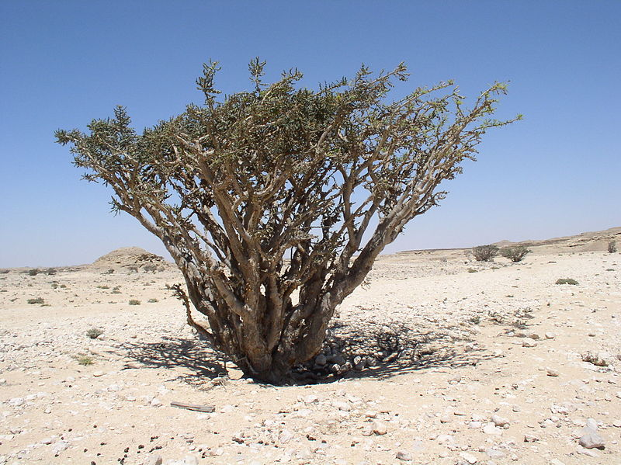
  - 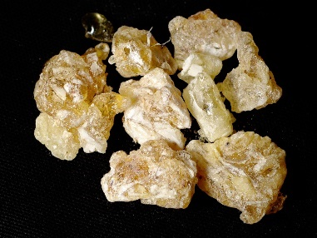
  - Myrrh – Also a resin extracted from a tree. Used in perfume, incense, and can be mixed with wine to make a pain killer. Native to Somalia, Oman, Yemen, and Ethiopia.
  - 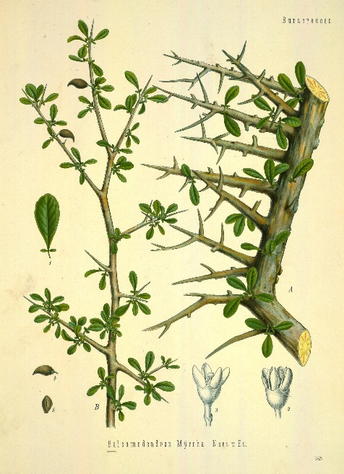
  - 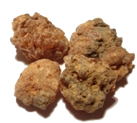
- God warned the wise men not to return to Herod in a dream. They obeyed and went home another way.
READ MATTHEW 2:13-15
- Joseph is told to flee Palestine and go to Egypt
  - They remained in Egypt until Herod died (verse 15)
  - 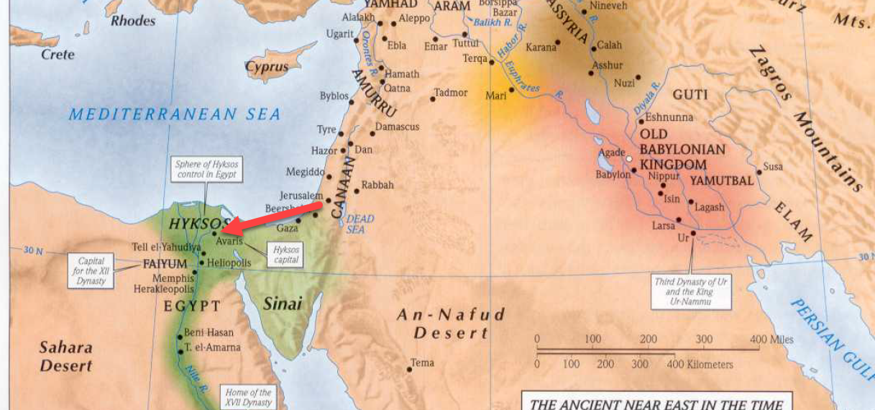
  - Journey of roughly 200-250 miles
  - Their time in Egypt was only a few years at the most because secular history tells us that Herod died shortly after the birth of the Messiah.

READ MATTHEW 2:16-18
- When Herod realized the wise men weren’t coming back, he became very angry and killed all the male children around Bethlehem who were 2 years and under
- Many bible critics deny this genocide actually happened because it is absent in the records of secular history.
- There are several reasons why we should accept the record of Matthew 2:16:
  - 1. This murderous behavior is completely consistent with the character of Herod the Great
  - 2. The Bible has proven itself to be historically accurate while being the most criticized and scrutinized work of history every produced.
- The prophecy of verse 18 is from Jeremiah 31:15.
  - Rachel was one of the mothers of the 12 tribes.
  - Rachel died and was buried in the territory of Benjamin around Ramah (a city north of Jerusalem) while her and Jacob were traveling to Ephrath (Bethlehem)
    - 1 Samuel 10:2
    - Genesis 35:16-21
    - Genesis 48:7
- The initial words of Jeremiah referenced the carrying away of the tribes of Judah and Benjamin into Babylonian captivity.
- This second reference to the prophecy calls Rachel up from her grave again to weep over the slaughter of her descendants children.
- 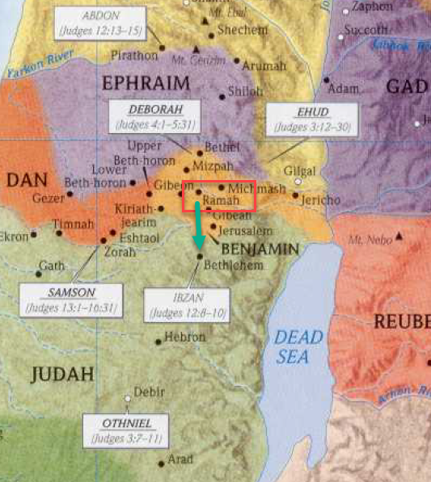
READ MATTHEW 2:19-23
- Following the death of Herod, an angel appeared to Joseph informing him of Herod’s death and instructing him to take Jesus and his mother back to the land of Israel.
- Joseph did as he was told and settled in Nazareth.
  - He was afraid to return to Judea because Archelaus took control after Herod the Great’s death.
  - Archelaus was the son of Herod the Great and the brother of Antipas (Herod Antipater). He was half-brother to Herod II, also called Herod Phillip I.
    - Herod Philip I is mentioned in reference to John the Baptist, who was killed for opposing Philip’s wife’s divorce and marriage to his half-brother Antipas
      - Mat 14:1-4 At that time Herod the tetrarch heard about the fame of Jesus, and he said to his servants, “This is John the Baptist. He has been raised from the dead; that is why these miraculous powers are at work in him.” For Herod had seized John and bound him and put him in prison for the sake of Herodias, his brother Philip's wife, because John had been saying to him, “It is not lawful for you to have her.”
    - Herodias left Philip and married Antipas
    - Josephus writes, “Herodias took upon her to confound the laws of our country, and divorced herself from her husband while he was alive, and was married to Herod Antipas.”
  - Archelaus reigned 9 years before being removed by Augustus Caesar
  - Following his removal, the land of Israel became the formal Roman province of “Judaea.”

https://en.wikipedia.org/wiki/Frankincense
https://en.wikipedia.org/wiki/Myrrh
https://en.wikipedia.org/wiki/Boswellia
https://en.wikipedia.org/wiki/Herod_Archelaus
https://en.wikipedia.org/wiki/Commiphora
https://en.wikipedia.org/wiki/Commiphora_myrrha

