MATTHEW 21
Mat 21:1 - Now when they drew near to Jerusalem and came to Bethphage, to the Mount of Olives, then Jesus sent two disciples,
Mat 21:2 - saying to them, “Go into the village in front of you, and immediately you will find a donkey tied, and a colt with her. Untie them and bring them to me.
Mat 21:3 - If anyone says anything to you, you shall say, ‘The Lord needs them,’ and he will send them at once.”

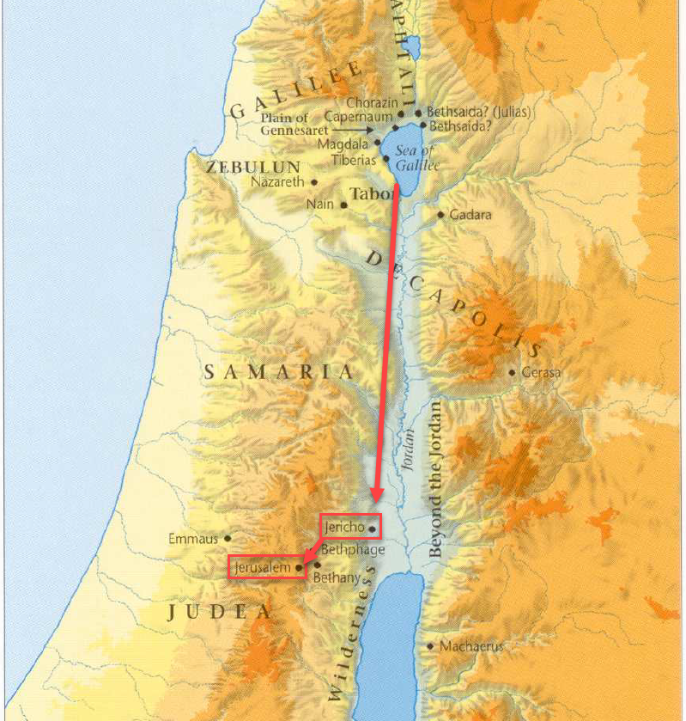
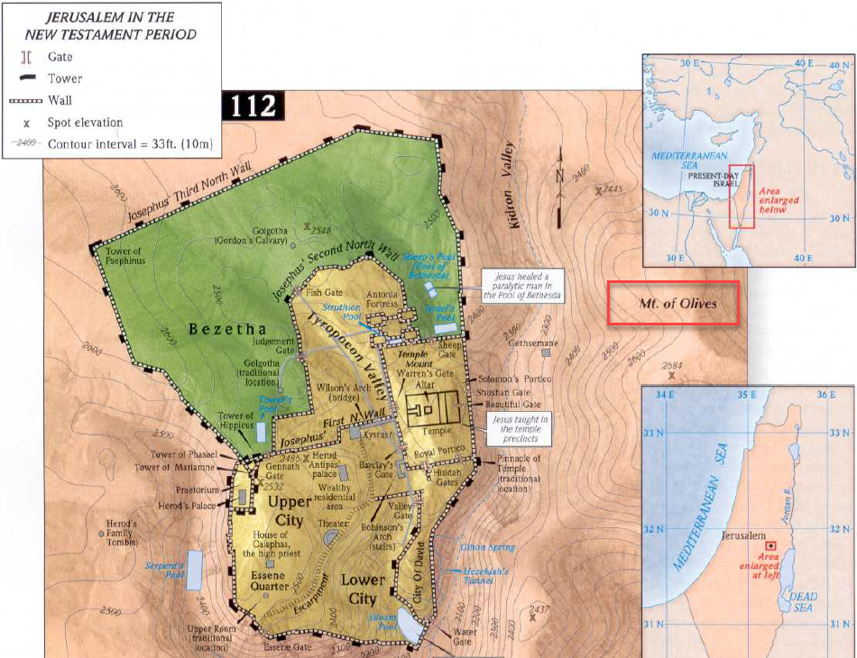
- It is important to recognize that chapter 1 takes place at the beginning of the last week of Jesus’ life.
- And the events of the next few chapters all take place in Christ’s last week.
- After meeting and healing the two blind men outside Jericho, Jesus makes his way to the Mount of Olives on the East side of Jerusalem.
- He tells two of His disciples to go into the village and find Him a donkey. The donkey had already been providentially prepared by God.
- Upon finding the donkey, they were to bring it back to Him.
- The donkey is going to be used for Jesus’ entrance into Jerusalem.
- Jesus is going to use the donkey to enter the city of Jerusalem in an event commonly referred to as the Triumphal Entry.
  - The people will recognize Him as their Savior.
  - He will be welcomed as a King.

Mat 21:4 - This took place to fulfill what was spoken by the prophet, saying,
Mat 21:5 - “Say to the daughter of Zion, ‘Behold, your king is coming to you, humble, and mounted on a donkey, on a colt, the foal of a beast of burden.’”
- I don’t know about you, but when I think about a King, I typically envision him riding a mighty steed, not a donkey.
- Why did Jesus choose a donkey?
- Because Jesus wasn’t a king like most kings!
  - He was humble and His animal communicated something different than the pride of most earthly kings.
  - The prophecy cited here is from Zechariah 9:9
- Donkey facts:
  - Colt: Male donkey under 4 years old.
  - Filly: Female donkey under 4 years old.
  - Foal: Baby male or female donkey under 1 year old.
  - Gelding: Castrated male donkey.
  - Stallion: Uncastrated male donkey.
  - Yearling: Male or female donkey between 1 and 2 years old.

Mat 21:6 - The disciples went and did as Jesus had directed them.
Mat 21:7 - They brought the donkey and the colt and put on them their cloaks, and he sat on them.
Mat 21:8 - Most of the crowd spread their cloaks on the road, and others cut branches from the trees and spread them on the road.
Mat 21:9 - And the crowds that went before him and that followed him were shouting, “Hosanna to the Son of David! Blessed is he who comes in the name of the Lord! Hosanna in the highest!”
Mat 21:10 - And when he entered Jerusalem, the whole city was stirred up, saying, “Who is this?”
Mat 21:11 - And the crowds said, “This is the prophet Jesus, from Nazareth of Galilee.”

- Jesus entered the city knowing He would receive a king’s welcome but without the personal pride of other kings.
  - Christ was entering their city as a King but a King clothed in humility.
  - He was their King but He would also play the lowly role of being their sacrifice.
  - The voices that glorified Him as He entered the city would soon curse Him as He was led out of the city to His death.
- It is interesting to contrast Jesus’ first appearance on a donkey in Jerusalem to His appearance on a white horse in Revelation.
- If we look back to the story of Jehu in 2 Kings 9:13 it reveals the practice of laying clothing on the ground was something done for royalty.
- Others laid palm branches on the ground (where we get the term Palm Sunday).
- The crowds surrounding Jesus were all shouting a term we haven’t encountered yet, “Hosanna.”
  - If my research is correct, the word translated “hosanna” comes from the Hebrew term “Hoshia-na” (yasha’na), meaning “please save.”
  - Although originally a cry for help, the people now used the phrase as a statement of praise for help arriving.
    - Psa 118:25-26 - Save (yasha) us (‘na), we pray, O LORD! O LORD, we pray, give us success! Blessed is he who comes in the name of the LORD! We bless you from the house of the LORD.
    - Mat 21:9 - And the crowds that went before him and that followed him were shouting, “Hosanna to the Son of David! Blessed is he who comes in the name of the Lord! Hosanna in the highest!”
    - We already know the Jews associated the term “Son of David” with the Messiah.
    - The people appear to have connected the dots. Their prayer of “save us” was being answered by the One who came in the name of the LORD, Jesus, who was the Son of David!
- One thing I took notice of when studying this chapter was that, at least in Matthew, this is really the first public proclamation of Jesus’ identity as the Christ.
  - Even in chapter 16, when Peter made his confession about Christ, Jesus told the Apostles not to tell anyone about the truth of His identity.
  - One question I’ve had for years is, “Why is Jesus always telling people not to tell others about Him being the Messiah.”
- I think this text may be part of that answer and a super important point in Matthew’s larger argument of Jesus identity.
- Matthew wants Jewish readers to accept Christ as the Messiah based on the evidence of His life.
  - There is a difference between someone telling you something is true and you reaching that conclusion based on evidence.
  - Perhaps part of the reason Jesus didn’t widely proclaim His identity publicly was because He wanted the Jews to come to their own conclusion based on evidence.
- And what was the conclusion of the Jews?
- Answer: Matthew 21:1-11.
  - “Jesus is the answer to our hosanna.”
  - “The Son of David is here to save us!”
- The Jews concluded Jesus to be the Christ.
- Matthew is writing to his audience and showing them their own fathers concluded Christ to be the Messiah.
- Now, it would be less than a week before the conviction of the Jews faltered and they ended up turning against God
  - Jesus didn’t turn out to be the Messiah they expected.
  - How typical of the Jews, how historically consistent, for them to turn to God and then so quickly lose their way.
  - But this time, God had built their salvation into their mistake.
- Matthew isn’t trying to convince his readers Jesus was the Messiah they expected, he is trying to convince them He was the Messiah they needed.
  - God knew His people (the Jews) so well He prepared a way of salvation for them based on their consistent habit to sin against Him.
  - Was that not the Messiah the Jews needed?
  - Any Jew reading Matthew’s gospel who was honest with Jewish history should have been able to see God’s incredible Messianic design.
- In verses 10-11, we see the whole city abuzz with Jesus’ arrival.

Mat 21:12 - And Jesus entered the temple and drove out all who sold and bought in the temple, and he overturned the tables of the money-changers and the seats of those who sold pigeons.
Mat 21:13 - He said to them, “It is written, ‘My house shall be called a house of prayer,’ but you make it a den of robbers.”

- Upon entering his hometown a typical king would go to his palace but Christ goes to the spiritual seat of God, the Temple.
- And in a scene that probably shocked much of the adoring crowd, Jesus, in righteous anger, upends the tables of the Temple market.
  - Instead of marching to the Roman garrisons and demanding freedom from their injustice, Jesus’ fury is poured out on His own people.
  - He is enraged at their extortion and greed.
- Lets ask a question… Should a Jew have been shocked that God acted this way?
  - What should they have expected?
  - Did the God of the Old Testament just pat the Jews on the back and tell them they were doing a great job?
  - What about the prophets? Some of the Jews may have only thought Jesus was a great prophet, what should they have expected?
  - Did the prophets spend their time telling the Jews how well they were doing?
  - Answer: No!
  - If the Jews knew anything about the God they claimed to serve they would have known He had been verbally flipping tables for generations.
  - Only a person who didn’t know the God of the kings and prophets would believe God would come to the earth and not correct the Jews first-and-foremost.
- This is perhaps why Matthew so often quotes the prophets.
  - His readers also may have needed a reminder that Jesus was consistent with the God of their fathers and even if they didn’t like that about Jesus, it was still an evidence He came from God.
  - A Messiah who went easy on the Jews would be the Messiah whose identity should be questioned.
- Let’s ask another question… Why was Jesus so angry?
  - The text tells us there were money changers and animal salesmen in the Temple complex but why did that insight the anger of the Lord?
  - Didn’t people need those services?
  - What was the big deal?
  - Isn’t Jesus going a bit overboard here?
- In order to understand a little better, I did some research into the ancient Temple and its practices to give the story some context.
- The Three Temples:
  - (1) Without going into too much Temple history… The original temple built by Solomon was no longer standing. It had been destroyed when the Babylonians conquered Judah.
  - (2) Upon returning from Babylonian captivity, the Jews built a new Temple but it didn’t compare to the glory of the first.
  - (3) In order to win the favor of the Jews, Herod the Great greatly “improved” the existing Temple to once again put it on the map as an architectural wonder.
- But Herod, with the help of the Jewish elite, had turned the new and “improved” Temple into a money making machine… which, was not its intended purpose!
- The Temple made money a few different ways:
  - (1) Temple Tax
    - We discussed this at the end of chapter 17.
    - A half-shekel (about a days wage) was collected annually from most Jewish men for the upkeep of the Temple.
    - Estimating the total:
      - Let’s use modern numbers and say every man made $10/hour.
      - They worked 8 hours a day.
      - Approximately 3 million taxpayers around the world.
      - = $240,000,000.
    - This tax was collected throughout the Roman Empire and shipped via armed guards back to Jerusalem.
  - (2) Money Changers
    - The temple tax was not paid in common money, it was only paid with the Tyrian shekel (from the region of Tyre).
    - The Tyrian shekel bore the image of Melkart, their equivalent of Baal.
    - Most people weren’t coming through Tyre so they had to get their money changed.
    - Apparently there was a bit of extortion going on.
    - Apparently the Jews made tons of money doing this.
    - Note the words of Titus the Roman general (and later emperor) in a speech to the Jews just before the fall of Jerusalem:
      - "We [Romans] have given you leave to gather up that tribute which is paid to God [the Temple tax], with such other gifts that are dedicated to him: nor have we called those that carried these donations to account, nor prohibited them; till at length you became richer than we ourselves, even when you were our enemies" (Josephus, Wars, VI.6,2).
  - (3) Animals sales
    - Jews sold animals used for sacrifice to fellow Jews in the Temple complex.
    - Why was this a profitable business?
    - If you remember the Old Testament commands about sacrifices, the animals couldn’t be blemished
    - There would be great risk of this on a long journey.
    - Even Jesus had to travel 75+ miles to get to Jerusalem for the feast.
    - It would be much easier to travel light and buy an animal in Jerusalem.
    - Who wants to haul a sheep around for several hundred miles?
    - In addition, it was the corrupt priests who were responsible for inspecting the animals, which would have been an opportunity to make a little extra profit…
  - So you can kind of see this playing out? People would come to the Temple, they would pay to get their money changed and then they would have to pay a high price to buy an animal with that money, and then they would be required to give their half-shekel tax… triple dipping
  - Ancient historian Josephus calls Annas the high priest “a great hoarder up of money.”
    - The position of High Priest was a position acquired through bribery.
    - The priestly line from the Old Testament no longer existed.
  - Josephus (Antiq. 14.105-109) reported that in 54 B.C. the Roman general Crassus raided the Temple, taking cash reserves weighing about 2000 talents (about 176,000 pounds) (roughly 3.5 billion dollars)
  - Keep this in mind when you read the rest of the New Testament and the Gospels
  - Jesus is going around telling people that they aren’t going to need to go to the Temple anymore (women at the well).
  - Paul would later preach WE are now the Temple of God
  - Why were the Jewish elite so bent on discrediting Paul?
    - Was it because they really cared about the souls of their Jewish friends?
    - No! Paul was directly attacking their money making ability with this new Christian teaching.
- In the Old Testament, we read about how the people had become so corrupt they started moving idols into the Temple.
- Were the Jewish elite of the 1st Century any better? They had brought their idolatries and worship of money into the Temple complex.

Mat 21:14 - And the blind and the lame came to him in the temple, and he healed them.
Mat 21:15 - But when the chief priests and the scribes saw the wonderful things that he did, and the children crying out in the temple, “Hosanna to the Son of David!” they were indignant,
Mat 21:16 - and they said to him, “Do you hear what these are saying?” And Jesus said to them, “Yes; have you never read, “‘Out of the mouth of infants and nursing babies you have prepared praise’?”
Mat 21:17 - And leaving them, he went out of the city to Bethany and lodged there.

- I think it is interesting Jesus didn’t leave the Temple after cleansing it of its corruption.
  - He remained and allowed the sick to come to Him for healing.
  - The Temple was once again the location of God’s presence on earth.
- The Temple was intended to be a place where a needy people could petition God through their priests.
  - It had become a place where needed people were extorted.
  - Jesus transforms it back to its original design.
  - It would be through Christ their High Priest people would petition God in the future.
  - What is the response of the chief priests and scribes?
  - They were indignant/displeased.
  - APPLICATION:
    - Religious reformation is likely to make “religious” people angry.
    - To the individual initiating the reforms, that can be scary, because you’ve been told they are the ones who know the scriptures, they are the experts, and they’ve got years and years of tradition behind them, and who are you?
    - Jesus was being told the same thing about the Pharisees, priests, scribes, and Sadducees.
    - We can’t let the potential anger of “religious” people keep us from preaching truth and taking action to see it propagated.
  - APPLICATION:
    - When we build our “religious” views on years and years of the traditions of our fathers and our father’s fathers but fail to look back far back enough to see THE Father, reformation may be necessary.
    - The Jews struggled with this.
    - We struggle with this.
    - Christ came to reveal the Father to us all.
- The chief priests and scribes imply Jesus ought to silence the children who are in the temple crying, “Hosanna, to the Son of David.”
  - Jesus implies if they were as wise as the children they would be crying “Hosanna!”
  - Jesus cites their own scriptures to silence them (Psalm 8:2).
- Jesus then departs Jerusalem and goes to Bethany (see green square) to spend the night.
- 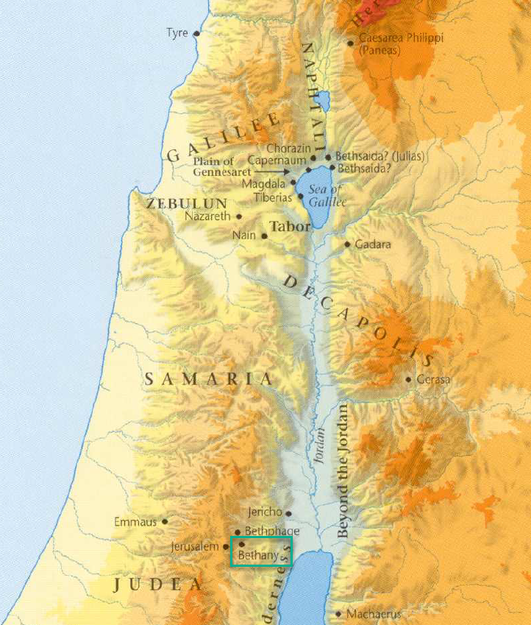

Mat 21:18 - In the morning, as he was returning to the city, he became hungry.
Mat 21:19 - And seeing a fig tree by the wayside, he went to it and found nothing on it but only leaves. And he said to it, “May no fruit ever come from you again!” And the fig tree withered at once.
Mat 21:20 - When the disciples saw it, they marveled, saying, “How did the fig tree wither at once?”
Mat 21:21 - And Jesus answered them, “Truly, I say to you, if you have faith and do not doubt, you will not only do what has been done to the fig tree, but even if you say to this mountain, ‘Be taken up and thrown into the sea,’ it will happen.
Mat 21:22 - And whatever you ask in prayer, you will receive, if you have faith.”

- Did Jesus regularly go around murdering trees?
- No, He used the fig tree as a parable to teach His Apostles important lessons.
- In Matthew’s text we are told Jesus approaches the tree after seeing its leaves but doesn’t find any fruit.
  - Mark chapter 11 includes a confusing additional line.
  - “…for it was not the season for figs.”
  - So Jesus went looking for figs when it wasn’t fig season, got mad, and cursed it?
  - Seems a bit strange, right?
- To understand this passage, we need to put our botany hat on for a few minutes and dig into fig tree science.
- The following information comes from the International Standard Bible Encyclopedia:
  - Fig-trees are cultivated all over the Holy Land, especially in the mountain regions.
  - Fig-trees are usually of medium height, 10 or 15 ft. for full-grown trees, yet individual specimens sometimes attain as much as 25 ft.
  - In Palestine and other warm climates the fig yields two crops annually--an earlier one, ripe about June, growing from the "old wood," and a second, more important one, ripe about August, which grows upon the "new wood," By December, fig-trees in the mountainous regions of Palestine have shed all their leaves, and they remain bare until about the end of March, when they commence putting forth their tender leaf buds (Mt 24:32; Mr 13:28,32; Lu 21:29-33), and at the same time, in the leaf axils, appear the tiny figs.
  - Early Figs: These tiny figs develop along with the leaves up to a certain point--to about the size of a small cherry--and then the great majority of them fall to the ground, carried down with every gust of wind. These immature figs are known to the fellahin (farmer or agricultural worker in Palestine) as taksh, by whom they are eaten as they fall; they may even sometimes be seen exposed for sale in the markets in Jerusalem. In the case of many trees the whole of this first crop may thus abort, so that by May no figs at all are to be found on the tree, but with the best varieties of fig-trees a certain proportion of the early crop of figs remains on the tree, and this fruit reaches ripe perfection about June. Such fruit is known in Arabic as dafur, or "early figs," and in Hebrew as bikkurah, "the first-ripe" (Isa 28:4; Jer 24:2; Ho 9:10). They are now, as of old, esteemed for their delicate flavor (Mic 7:1, etc.).
  - The miracle of our Lord (Mt 21:18-20; Mr 11:12-13,10,21) which occurred in the Passover season, about April, will be understood (as far as the natural phenomena are concerned) by the account given above of the fruiting of the fig-tree, as repeatedly observed by the present writer in the neighborhood of Jerusalem. When the young leaves are newly appearing, in April, every fig-tree which is going to bear fruit at all will have some taksh ("immature figs") upon it, even though "the time of figs" (Mr 11:13 the King James Version), i.e. of ordinary edible figs--either early or late crop--"was not yet." This taksh is not only eaten today, but it is sure evidence, even when it falls, that the tree bearing it is not barren.
- 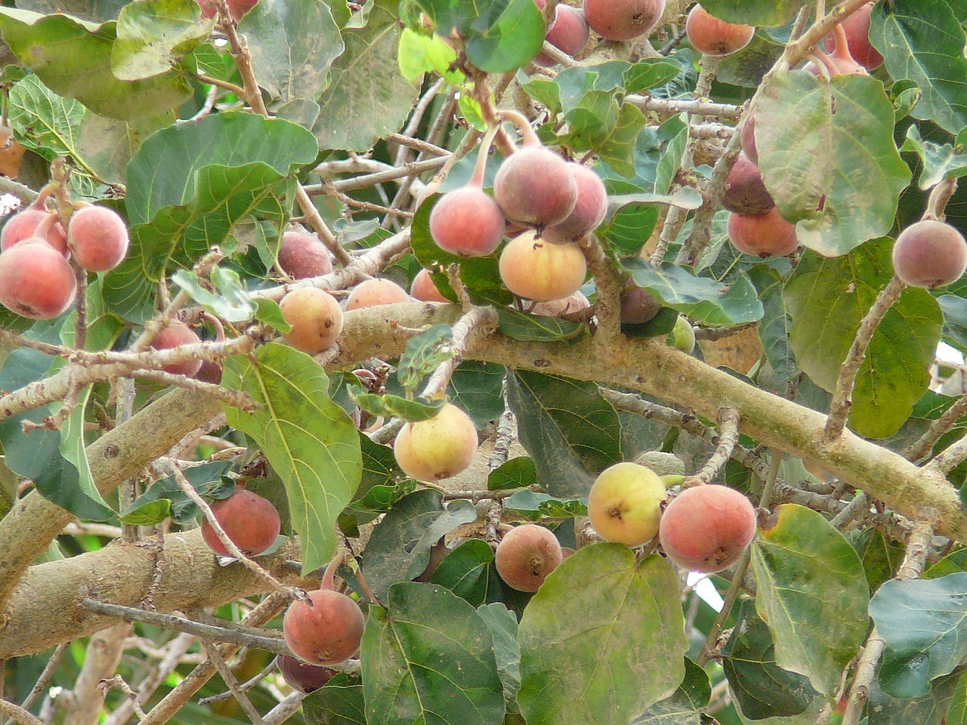
- In light of all this, Jesus approached the fig tree probably expecting some of these delicious “early figs.”
  - The foliage on the tree suggested He would find something.
  - When He found nothing, it was an indication the tree wasn’t going to bear fruit during the June harvest.
  - His condemnation of the tree is based off what His findings tell Him about the tree in the future.
  - The tree looked good from a distance but upon closer inspection it was revealed to be fruitless.
- What might Jesus be teaching His Apostles with this tree? I think there are at least 2 things.
  - First, lets deal with the obvious lesson as explained by Jesus.
    - Jesus curses the tree to show the power of prayer in God’s creation.
    - Prayer prayed in faith is immensely powerful because we are petitioning the God who has the power to move His creation as He desires.
    - Implied here is our prayer’s alignment with the will of God.
  - Second, Jesus is reiterating a point He’s made in the past about judgement on the fruitless.
    - The fruitlessness of the Pharisees, scribes, and Sadducees has already been well established.
    - They, like the full-leafed fig tree, looked good from a distance but were ultimately fruitless (Jesus will condemn them even more strongly in the upcoming chapters).
    - But Jesus may also be alluding to the fruitlessness of the common Jews.
    - They had all gathered in the Jerusalem to practice their religious devotions but what were those worth considering they were going to turn around and kill the Son of God in a few days.

Mat 21:23 - And when he entered the temple, the chief priests and the elders of the people came up to him as he was teaching, and said, “By what authority are you doing these things, and who gave you this authority?”
Mat 21:24 - Jesus answered them, “I also will ask you one question, and if you tell me the answer, then I also will tell you by what authority I do these things.
Mat 21:25 - The baptism of John, from where did it come? From heaven or from man?” And they discussed it among themselves, saying, “If we say, ‘From heaven,’ he will say to us, ‘Why then did you not believe him?’
Mat 21:26 - But if we say, ‘From man,’ we are afraid of the crowd, for they all hold that John was a prophet.”
Mat 21:27 - So they answered Jesus, “We do not know.” And he said to them, “Neither will I tell you by what authority I do these things.

- Jesus enters the Temple and was confronted by a slightly different group of critics from the usual Pharisees and scribes.
- The chief priests and elders wanted to question Him.
  - They asked Him who gave Him authority to overturn the market tables and teach a new law.
  - Was this an honest question?
  - It wasn’t (are you surprised?)
- In order to expose their dishonesty, Jesus commits to answering their question if they can provide an answer to His first.
  - “The baptism of John, from where did it come? From heaven or from man.”
  - Essentially, He was asking if John made up his teaching or if he was a prophet with a message from God.
- The Pharisees discussed it amongst themselves and found out they were in a bind.
  - They couldn’t say John made it up because it would put them out of favor with the common people. The common people believed John was a prophet.
  - They couldn’t say it was from God because they had rejected John. If they admitted it was from God, Jesus would ask them why they didn’t heed John’s words. Not to mention, they would have to accept Jesus as the Christ because John confirmed His identity as such.
- They were stuck. Like any good politician, they dodged the question.
- They responded, “We do not know.”
- Their dishonesty had been exposed and because of their inability to answer Jesus’ question, Jesus does not answer theirs.

Mat 21:28 - “What do you think? A man had two sons. And he went to the first and said, ‘Son, go and work in the vineyard today.’
Mat 21:29 - And he answered, ‘I will not,’ but afterward he changed his mind and went.
Mat 21:30 - And he went to the other son and said the same. And he answered, ‘I go, sir,’ but did not go.
Mat 21:31 - Which of the two did the will of his father?” They said, “The first.” Jesus said to them, “Truly, I say to you, the tax collectors and the prostitutes go into the kingdom of God before you.
Mat 21:32 - For John came to you in the way of righteousness, and you did not believe him, but the tax collectors and the prostitutes believed him. And even when you saw it, you did not afterward change your minds and believe him.

- Jesus asks the elders and chief priests to examine the actions of two sons.
  - One son, in his rebellion, told his father he would not go work in the field. However, he later changed his mind and did as his father asked.
  - The second son, in his hypocrisy, told his father he would go work in his field but never actually showed up.
- The first son was rebellious but repented.
- The second son persisted in hypocrisy.
- Who are the characters of our story? Jesus tells us!
  - The first son represents those like the tax collectors and prostitutes.
    - They were living in unrighteousness and rebellion to God.
    - But upon hearing the preaching of the Christ, they repented and turned to God (Jesus is lumping our author, Matthew, in with the prostitutes).
    - The most despised in the eyes of men enter the Kingdom of Heaven before the most respected in the eyes of men (first shall be last).
  - The second son is like the chief priests and elders.
    - They made it look like they were obedient to the Father’s requests but they were hypocrites.
    - They claimed to align with the will of the Father but after being corrected they would not change their minds.
  - APPLICATION:
    - Are we like the first son? Can we repent when shown we are wrong?
    - Or are we like the second son? Even after being shown our error, do we persist due to an inability to humble ourselves?

Mat 21:33 - “Hear another parable. There was a master of a house who planted a vineyard and put a fence around it and dug a winepress in it and built a tower and leased it to tenants, and went into another country.
Mat 21:34 - When the season for fruit drew near, he sent his servants to the tenants to get his fruit.
Mat 21:35 - And the tenants took his servants and beat one, killed another, and stoned another.
Mat 21:36 - Again he sent other servants, more than the first. And they did the same to them.
Mat 21:37 - Finally he sent his son to them, saying, ‘They will respect my son.’
Mat 21:38 - But when the tenants saw the son, they said to themselves, ‘This is the heir. Come, let us kill him and have his inheritance.’
Mat 21:39 - And they took him and threw him out of the vineyard and killed him.

- The Parable:
  - The master of a house puts a lot of work into a vineyard.
  - He leases it out to some tenants and then moves away.
  - Around harvest time, the master sends servants back to the vineyard to collect what is due him.
  - But the tenants who are leasing the land beat one of the servants, kill one, and stone another.
  - The master sends a second company of servants and the tenants treat them similarly.
  - Finally, the master decides to send his son, assuming the tenants will have greater respect for him.
  - But the tenants drag the son out of the vineyard and kill him.
- The Interpretation:
  - God had put a lot of work into the nation of Israel.
  - He trusted them to keep His commandments and statutes.
  - But they often failed Him.
  - God sent many messengers to the children of Israel to ask them to give Him what He deserved (worship and reverence and faithfulness and single-hearted devotion).
  - They treated God’s messengers very poorly.
  - God continued sending messengers, eventually sending servants like Jeremiah, Ezekiel, Amos, and Malachi.
  - Some were beaten, some were stoned, and some where killed
  - Eventually, God sent His Son.
  - You would think the people would respect His Son but it wasn’t the case.
  - In just a few days, the rebellious tenants of the nation of Israel would take Jesus outside of the city and kill Him.
  - They would attempt to make themselves the true rulers of God’s people.

Mat 21:40 - When therefore the owner of the vineyard comes, what will he do to those tenants?”
Mat 21:41 - They said to him, “He will put those wretches to a miserable death and let out the vineyard to other tenants who will give him the fruits in their seasons.”

- Jesus asks the elders and chief priests what the master should do with the wicked tenants.
- Correctly, they answered, “He will put those wretches to a miserable death and let out the vineyard to other tenants who will give him the fruits in their season.”
- Like king David before Nathan, the elders and chief priests unknowingly pronounced judgement on themselves.

Mat 21:42 - Jesus said to them, “Have you never read in the Scriptures: “‘The stone that the builders rejected has become the cornerstone; this was the Lord's doing, and it is marvelous in our eyes’?

- This is a quotation from Psalm 118:22-23.
- As we discussed in chapter 16, Christ was to be the cornerstone on which the Church was built.
- The Church rightfully belongs to Him.
- Those who had been entrusted with the revelations of God (Jews) would reject Christ.
  - They did not consider Him foundation material.
  - So like the master’s son, they tossed Him out of the vineyard and killed Him.
- But God had accounted for their stubborn hearts and woven His redeeming work through the hardness of their hearts.
- We all ought to spend some time marveling at God’s plan for salvation.

Mat 21:43 - Therefore I tell you, the kingdom of God will be taken away from you and given to a people producing its fruits.
Mat 21:44 - And the one who falls on this stone will be broken to pieces; and when it falls on anyone, it will crush him.”

- The action of the elders and chief priests would bear the same consequences as those of the wicked tenants.
  - The Kingdom would not be theirs to possess.
  - It would be given to others to manage.
- The religious leaders had two options in front of them, as do we all.
  - (1) We can either humble ourselves and enter the Kingdom.
  - (2) Or we can resist and be destroyed.
    - In the end, every enemy of God will be crushed.
    - Every knee will bow.

Mat 21:45 - When the chief priests and the Pharisees heard his parables, they perceived that he was speaking about them.
Mat 21:46 - And although they were seeking to arrest him, they feared the crowds, because they held him to be a prophet.

- It didn’t take the chief priests and elders long to realize they were the target of Jesus’ piercing words.
- They were so angry they wanted to kill Jesus right then and there but were afraid the people would turn against them.

- Notice the shift from the middle of this chapter (beginning in verse 23) until the end.
  - The Jewish religious leaders approached Christ to put Him on trial.
  - By the end, Jesus has flipped the script and has put them on trial and has even reached a verdict based on a conviction out of their own mouths (verse 41).
  - #GETREKT

https://en.wikipedia.org/wiki/Ficus_sycomorus
www.thedonkeysanctuary.org.uk
https://www.biblestudytools.com/bible-study/topical-studies/what-does-hosanna-mean.html
https://www.crosswalk.com/faith/bible-study/what-does-the-word-hosanna-mean.html
http://gospelhall.org/index.php/faqs/110-bible-questions-and-answers-other/3572-why-did-the-newly-anointed-solomon-ride-on-a-mule-not-a-donkey-or-a-mare
https://www.thegospelcoalition.org/article/jesus-curse-fig-tree/
https://www.cgg.org/index.cfm/fuseaction/Library.sr/CT/BQA/k/72/Why-Did-Jesus-Curse-Fig-Tree-Mark-1112-14.htm
https://www.internationalstandardbible.com/F/fig-fig-tree.html

