MATTHEW 25
- Remember, there is no contextual break between the end of chapter 24 and the beginning of chapter 25.
- Chapter 24 ended with Jesus’ discussion of the end of time and this chapter picks up in the middle of His dialogue.

Mat 25:1 - “Then the kingdom of heaven will be like ten virgins who took their lamps and went to meet the bridegroom.
Mat 25:2 - Five of them were foolish, and five were wise.
Mat 25:3 - For when the foolish took their lamps, they took no oil with them,
Mat 25:4 - but the wise took flasks of oil with their lamps.
Mat 25:5 - As the bridegroom was delayed, they all became drowsy and slept.
- At the end of chapter 24, Jesus encouraging the Apostles to remain watchful using a parable about a wise and wicked servant.
- He again drives the point home with another parable, this time about 10 virgins and a wedding feast.
- Lets set the scene.
  - I’ve read from several commentaries and historical sources and they all seem to differ slightly on the details of 1st century Jewish weddings.
  - But one thing seems pretty clear, there were at least 2 parts to the marriage ceremony.
    - (1) Betrothal
      - Betrothal was a period in which the husband and wife were formally united by contract but the wife remained in the house of her father.
      - Betrothal was taken more seriously than modern engagement and required a divorce to sever the relationship.
    - (2) Marriage
      - After the period of betrothal, the groom would go to his father-in-law’s house and lead his bride in a procession back to his own home.
      - The marriage would then be consummated and she would live in his house.
  - The scene Jesus describes appears to be the procession of the bride and groom back from the father-in-law’s house to the house of the groom.
  - The 10 young women were waiting outside of the grooms house to welcome him and his bride back and celebrate the joyous occasion with a feast.
  - The lamps in their hands were probably made of clay and of a simple design.
  - 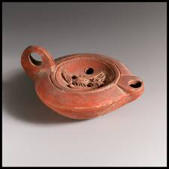
  - 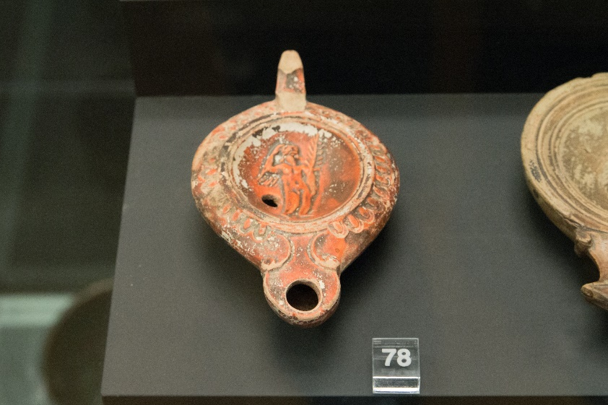 (looks like Aladdin lol)
  - Oil was held in the inside of the device and burned on a small wick extending from the end.
  - Some suggest these lamps were actually more like torches.
  - Either way the point of the parable is the same.
- In modern weddings, things don’t always happen exactly on time.
  - Things get delayed.
  - Photos take longer than expected.
  - The caterer is late.
- Apparently, ancient weddings weren’t any different.
- The 5 wise virgins knew this and packed extra oil.
- The 5 foolish virgins only took the oil in their lamps.
- Sure enough, the groom was delayed (let’s blame the mother-in-law).
- While waiting, the 10 young women fell asleep.

Mat 25:6 - But at midnight there was a cry, ‘Here is the bridegroom! Come out to meet him.’
Mat 25:7 - Then all those virgins rose and trimmed their lamps.
Mat 25:8 - And the foolish said to the wise, ‘Give us some of your oil, for our lamps are going out.’
Mat 25:9 - But the wise answered, saying, ‘Since there will not be enough for us and for you, go rather to the dealers and buy for yourselves.’
Mat 25:10 - And while they were going to buy, the bridegroom came, and those who were ready went in with him to the marriage feast, and the door was shut.
Mat 25:11 - Afterward the other virgins came also, saying, ‘Lord, lord, open to us.’
Mat 25:12 - But he answered, ‘Truly, I say to you, I do not know you.’
Mat 25:13 - Watch therefore, for you know neither the day nor the hour.

- At midnight the groom finally arrived!
- The 10 virgins woke up and prepared their lamps (which may have been burning while they slept).
- What is wick trimming?
  - Keeping the wick trimmed to 1/8 of an inch at all times helps control the amount of “fuel” or wax that is present. By keeping the amount of fuel limited, the flame will create ideal complete combustion where carbon particles are absorbed by the flame (Yankee Candle).
  - This causes the flame to burn cleaner and brighter.
- When preparing their lamps, the 5 unwise virgins realized they didn’t have enough oil.
- They asked the 5 wise virgins if they could spare some but they replied they didn’t have enough.
- The foolish virgins had no choice but to go in search of extra oil and hope they made it back before the groom arrived.
- Unfortunately, they didn’t make it.
  - The 5 wise women greeted the groom and went into the feast with him.
  - The 5 foolish women were locked outside and were not granted entrance once the doors had been shut.
- Meaning of the Parable:
  - The meaning is easily understood if we keep the prior context in mind.
  - Jesus is telling His Apostles they need to be like the 5 wise virgins waiting for His return.
  - The 5 wise virgins didn’t know when the groom would come but prepared themselves to meet him at any time.
  - The Apostles (and Christians in general) always need to be prepared for the “coming of the Lord.”
  - Jesus uses the same words in 25:12 as in 24:36 (day and hour).
  - APPLICATION:
    - Sadly, many wait too long to make their preparations for the end.
    - When they realize the day and hour (death) is upon them, they go looking for the truth but don’t always find it because they waited too long and run out of time.
    - Don’t be an unwise virgin!

Mat 25:14 “For it will be like a man going on a journey, who called his servants and entrusted to them his property.
Mat 25:15 To one he gave five talents, to another two, to another one, to each according to his ability. Then he went away.

- For His next parable Jesus returns to the imagery of a servant.
- A man was going on a journey and gave a part of his possessions to three servants to care for while he was gone.
  - There was no stock market to put your money into.
  - He invested his money with his servants in hopes they would steward it properly and provide a positive return.
    - He gave 5 talents to one.
    - He gave 2 talents to anther.
    - He gave 1 talent to the last of the three.
  - We’ve discussed the “talent” in a few previous chapters.
    - A talent wasn’t a specific piece of money, it was a weight.
    - The Roman talent weighed approximately 72.5 lbs.
    - Depending on the material (gold, silver, bronze, etc) this talent could be worth a significant amount of money.
  - The division was made on the basis of “ability.”
    - Towards the end of the parable we will see that each man was called into account based on what He was given by the master.
    - They are not judged based on what the others received.
  - APPLICATION:
    - God has distributed talents (skills and abilities) and resources to all of us according to His providential wisdom.
    - It does us no good (but certainly does us harm) to spend our days envying the talents and resources of others and comparing ourselves.
    - God will judge our stewardship on what He has given to us, not based on what He has given others.
    - So make the most of what you have, pray for an increase in ability for the glory of God, and praise God for the work being done by others who have gifts you don’t possess.
    - God doesn’t withhold gifts because He is stingy or has low inventory.

Mat 25:16 - He who had received the five talents went at once and traded with them, and he made five talents more.
Mat 25:17 - So also he who had the two talents made two talents more.
Mat 25:18 - But he who had received the one talent went and dug in the ground and hid his master's money.

- The master departed on his journey and the servants immediately set to work.
- The man with 5 talents made 5 more talents through advantageous trading.
- The man with 2 talents made 2 additional talents.
- But the man with 1 talent dug a hole in the ground and buried his talent to protect it.

Mat 25:19 - Now after a long time the master of those servants came and settled accounts with them.
Mat 25:20 - And he who had received the five talents came forward, bringing five talents more, saying, ‘Master, you delivered to me five talents; here, I have made five talents more.’
Mat 25:21 - His master said to him, ‘Well done, good and faithful servant. You have been faithful over a little; I will set you over much. Enter into the joy of your master.’
Mat 25:22 - And he also who had the two talents came forward, saying, ‘Master, you delivered to me two talents; here, I have made two talents more.’
Mat 25:23 - His master said to him, ‘Well done, good and faithful servant. You have been faithful over a little; I will set you over much. Enter into the joy of your master.’

- After “a long time,” the master returned and called his servants to square up his books.
  - The first servant came with 5 talents of profit and was commended by his master and honored.
  - The second servant came with 2 talents of profit and was commended by his master and honored.

Mat 25:24 - He also who had received the one talent came forward, saying, ‘Master, I knew you to be a hard man, reaping where you did not sow, and gathering where you scattered no seed,
Mat 25:25 - so I was afraid, and I went and hid your talent in the ground. Here, you have what is yours.’
Mat 25:26 - But his master answered him, ‘You wicked and slothful servant! You knew that I reap where I have not sown and gather where I scattered no seed?
Mat 25:27 - Then you ought to have invested my money with the bankers, and at my coming I should have received what was my own with interest.
Mat 25:28 - So take the talent from him and give it to him who has the ten talents.
Mat 25:29 - For to everyone who has will more be given, and he will have an abundance. But from the one who has not, even what he has will be taken away.
Mat 25:30 - And cast the worthless servant into the outer darkness. In that place there will be weeping and gnashing of teeth.’

- Finally, the man who had received 1 talent came forward.
  - He had not made any profit because his talent had been buried in the ground.
  - He explained his actions on account of fear of his master’s temperament.
    - The statement in verse 24 shows us how the servant understood his master, “I knew you to be a hard man, reaping where you did not sow, and gathering where you scattered no seed.”
    - He seems to be accusing him of having a reputation of being unfair or expecting too much.
    - He is indirectly laying the blame on his master for his own failure, saying his master’s temperament drove him to respond the way he did.
    - But this accusation doesn’t match up with the master’s treatment of the other 2 servants.
    - There are many who accuse God of being unfair in His expectations and believe it to be some kind of excuse.
    - But their perception is misguided.
      - Serving God in a continued state of fear will paralyze us.
      - Serving God because we know His loving nature will enable us.
- The statement, “Here, you have what is yours” deserves our attention.
  - The man knows he didn’t do what the master really wanted him to do but hopes he will be safe in the fact that, although he didn’t make any increase, he also didn’t lose any of the money.
  - Many people (I mean professing Christians) will meet God on the final day and will use the same defense.
    - I know I didn’t use what was given to me to advance the Kingdom as well as I should have but…
    - I never did it any harm!
    - I didn’t do anything immoral.
    - I attended Church.
    - I didn’t do violence to anyone.
  - Is the Lord going to be pleased with that answer?
- In verse 26, I don’t think the master is confirming he is an oppressive and unfair man.
  - Let me try to capture the idea in a paraphrase:
  - “Supposing I was an unfair, oppressive man with expectations too high to achieve, you would think you would have at least put my money in the bank where it could gain a small profit on interest.”
  - He is telling the man his actions don’t make sense even if his assumptions were correct.
- Because of the servant’s neglect of duty, the master takes the talent form the 1 talent man and gives it to the man having 10 talents.
- What does verse 29 mean?
  - You will remember we encountered the same phrase in Matthew 13:12.
  - Who is the “one who has?”
    - I understand this to be a person who “has” a mind prepared to accept the responsibilities of the Kingdom.
    - Their lives then show fruit through the practice of their duty.
    - One who “has” such a mind and life will be used and honored by God.
  - Who is the “one who has not?”
    - In contrast, this would be a person whose mind and heart are closed off to the acceptance and practice of the responsibilities of a servant of the Lord.
    - This person’s heart is not good ground for growth.
    - The work the Lord could have accomplished through them and the subsequent reward will be given to a more faithful servant.
- Verse 30 is certainly sobering!
  - Jesus seems to overlap the fate of the servant with spiritual reality.
  - The servant would be punished for his failure.
  - Those in the Kingdom of Heaven who neglect their responsibilities risk the same punishment.
- Application and Meaning:
  - As servants of the Kingdom of God, Christ has entrusted us with the resources to advance His Kingdom.
  - Upon His return, we will be called into account as to their management.
  - It is a parable about being mindful of the Master’s return and our responsibility while He is away.
  - We don’t want Him returning to find us huddled in a corner in fear of Him or in fear of “what could go wrong.”
  - If the power of God is behind us and that power is sovereign over all things, there isn’t much left to that could God wrong.

Mat 25:31 “When the Son of Man comes in his glory, and all the angels with him, then he will sit on his glorious throne.
Mat 25:32 Before him will be gathered all the nations, and he will separate people one from another as a shepherd separates the sheep from the goats.
Mat 25:33 And he will place the sheep on his right, but the goats on the left.

- The remainder of the chapter transports us to the throne room of God on the coming Day of Judgement.
- The Son of man “comes in His glory.”
  - This is the event described in 24:36-51.
  - Remember, sometimes the coming of the Lord refers to the coming at the end of time and sometimes it refers to the Lord coming in judgement on individual nations (see chapter 24 study for more details).
- The righteous and unrighteous are separated by God.
  - The righteous (sheep) will be on His right.
  - The unrighteous (goats) will be on His left.

Mat 25:34 - Then the King will say to those on his right, ‘Come, you who are blessed by my Father, inherit the kingdom prepared for you from the foundation of the world.
Mat 25:35 - For I was hungry and you gave me food, I was thirsty and you gave me drink, I was a stranger and you welcomed me,
Mat 25:36 - I was naked and you clothed me, I was sick and you visited me, I was in prison and you came to me.’
Mat 25:37 - Then the righteous will answer him, saying, ‘Lord, when did we see you hungry and feed you, or thirsty and give you drink?
Mat 25:38 - And when did we see you a stranger and welcome you, or naked and clothe you?
Mat 25:39 - And when did we see you sick or in prison and visit you?’
Mat 25:40 - And the King will answer them, ‘Truly, I say to you, as you did it to one of the least of these my brothers, you did it to me.’
Mat 25:41 - “Then he will say to those on his left, ‘Depart from me, you cursed, into the eternal fire prepared for the devil and his angels.
Mat 25:42 - For I was hungry and you gave me no food, I was thirsty and you gave me no drink,
Mat 25:43 - I was a stranger and you did not welcome me, naked and you did not clothe me, sick and in prison and you did not visit me.’
Mat 25:44 - Then they also will answer, saying, ‘Lord, when did we see you hungry or thirsty or a stranger or naked or sick or in prison, and did not minister to you?’
Mat 25:45 - Then he will answer them, saying, ‘Truly, I say to you, as you did not do it to one of the least of these, you did not do it to me.’
Mat 25:46 - And these will go away into eternal punishment, but the righteous into eternal life.”

- We will take this last section as one large chunk.
- 2 fates await those from “all nations” standing before the throne of God.
  - (1) A kingdom prepared before the foundation of the world (eternal life).
  - (2) Eternal punishment
- Their judgement is based on only one thing, the way they treated those less fortunate than themselves.
  - Hungry… Food.
  - Thirsty… Water.
  - Stranger… Hospitality.
  - Naked… Clothing.
  - Sick… Visit.
  - Prison… Care.
- The righteous stand before Jesus and He tells them they had done all these things for Him.
  - They asked Him, “when?”
  - He responded, “When you did it to the least of my brothers, you did it to Me!”
  - In caring for their needy brothers they had cared for Christ.
- The unrighteous stand before Jesus and He tells them they turned a blind eye and done none of these things for Him.
  - They asked Him, “when?”
  - He responded, “When you didn’t do it to the least of my brothers, you didn’t do it to Me!”
  - In neglecting to care for the needy brothers and sisters they had neglected Christ.
- One of the things that stands out to me about this judgement scene is the simplicity of the judgement.
  - Unlike the other writings in the New Testament, Jesus doesn’t dig into the details of the atonement, propitiation, grace/works, etc…
  - Jesus sums up the judgement with a question about caring for the needy.
  - Why?
    - I don’t know exactly but it may be because, in many ways, it is one of the most simple tenants of Jesus’ teaching.
    - Jesus has been caring for the sick and needy His whole ministry.
    - His care for the needy was a picture of His greater spiritual mission.
    - He came to give help to all human beings who needed someone to help them escape a situation they were powerless to overcome.
    - When we learn to appreciate Jesus’ care for us in salvation, our appreciation ought to be visible as we extend a picture of Christ’s love to the needy around us.
    - You learn how to love from God and then you love your neighbor (2 greatest commands).

https://learning-scenter.yankeecandle.com/wick-trimming
https://www.insider.com/why-you-should-always-trim-candle-wicks-2016-11

