MATTHEW 3
READ MATTHEW 3:1-6
- A man named John the Baptist appears on the scene at the opening of chapter 3 with little to no introduction
- Luke’s gospel gives a bit more background on John (see Luke chapter 1)
  - John was the son of Zechariah and Elizabeth from the tribe of Levi
  - An angel appeared to Zechariah in the Temple and foretold of John’s birth
  - Elizabeth was a relative of Mary (Jesus’ mother)
- John was preaching in the “wilderness” of Judea, which was likely in the area shown on the map below
- 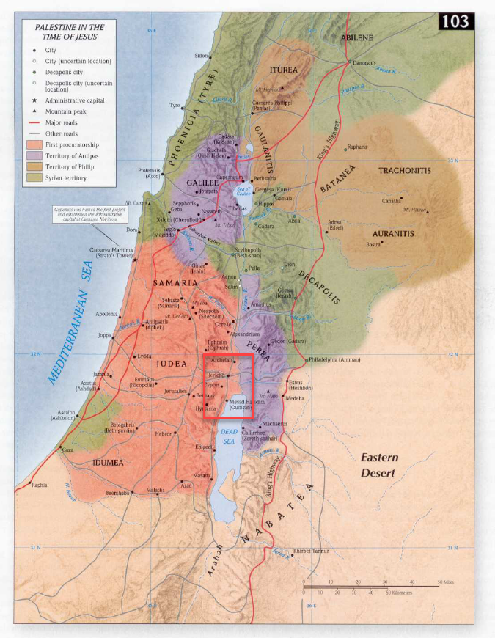
- Note, John didn’t just come out of nowhere. He wasn’t a man who just woke up one day and decided he would start preaching about the Messiah. He was specifically designated by God to fill a role that had been prophesied about. He was to “prepare the way” for Jesus.
  - Isaiah, who lived approximately 750 years before this time, spoke of a man who would precede the Messiah.
  - Verse 3, is a prophecy taken from Isaiah 40:3
  - During the middle ages, whenever a king would journey to a town, he would have horsemen ride ahead and announce his intention to visit the town. This would give the people a “heads-up” to prepare for the arrival of someone very important.
  - In the same way, John was sent before Jesus to prepare the way for the “King” of the Kingdom of Heaven.
- John’s message: “Repent, for the kingdom of Heaven is at hand.”
  - Jesus was going to reveal Himself to the world soon and He would bring the “Kingdom of Heaven” (the Church) with Him.
  - The term “at hand” means “close” or “soon to come.”
    - An art teacher might say, “Make sure all of your supplies are at hand”
    - A revolutionary might say, “The time for action is at hand.”
- John bore a striking resemblance to the prophets of Jewish history, especially the prophet Elijah (see Luke 1:17, Matthew 17:10-13, and Malachi 4:5).
  - He wore garments of animal hair like Elijah (2 Kings 1:8)
  - John was sent to sinful Israel to call them to God, just as Elijah was sent to call Israel out of their wickedness and idolatry during the days of Ahab and Jezebel.
  - One of the idols of the Jews may have been freedom.
    - They had just come out of the silent years and the Maccabean revolt had one them their freedom for a time.
    - They had now lost that freedom, but it may have been the case that they had valued it so highly as to make it an idol and rejected any Messiah who didn’t serve that idol.
  - John preached boldly in the midst of his enemies (we will see this in the upcoming verses), just as Elijah preached boldly to those who wanted to kill him.
  - On the Mount of Transfiguration (Matthew 17), Elijah appears to represent all of the prophets of God, of which John was one.
- John became so popular that “Jerusalem and all Judea” were going out into the wilderness to hear him preach.
  - Those who accepted his call for repentance, confessed their sins, and were baptized for the remission of sins (Mark 1:4)
  - Remission: the cancellation of a debt, charge, or penalty.
READ MATTHEW 3:7-10
- Enter the Pharisees and the Sadducees
  - Who are the Pharisees?
    - Generally made up of wealthy men who turned their attention to religion. They had significant influence among the common Jewish citizens.
    - Promoted strict adherence to the Old Testament Laws and oral traditions
    - Promoted Jewish culture rather than Hellenization
    - Believed in the supernatural.
    - Believed in an afterlife
  - Who are the Sadducees?
    - Upper economic class among the Jews (contrast with Jesus followers). They had significant influence with the governing Roman authorities.
    - Rejected the Pharisees’ binding of tradition. Viewed the written Torah (first 5 books of the Old Testament) as the only binding law.
    - More friendly to Hellenization
    - Limited belief in the supernatural
    - Rejected the resurrection of the body, the afterlife, and angels.
    - Responsible for the Temple in Jerusalem.
- As we continue through Matthew’s book, we will see the Pharisees and Sadducees at continual odds with Jesus. Having read the descriptions above, it is not hard to see why…
  - The Pharisees didn’t like Jesus because He repeatedly condemned them for creating unauthorized laws and rules that they bound on their fellow Jews. In addition, Jesus condemned them for their hypocrisy, because they didn’t even keep the laws they bound on others.
  - The Sadducees didn’t like Jesus because He was always talking about the afterlife, and resurrection, and angels, and was just generally WAY to supernatural for their liking. They also disliked Him because He threatened their lucrative money-making operation at the Temple.
- John wastes no time pointing out the moral failures of these two sects (boldness of Elijah).
  - He calls them to repentance
  - Advises them of future judgement and punishment
  - Warns them of the danger of assuming their right standing with God because of their descendance from Abraham (a mistake made by many Jews throughout the Old Testament).
  - APPLICATION: Do we assume we are in a right relationship with God because we claim the name Christian? Here we have an example of those who claimed the name “Jew” (God’s chosen people), but were very far removed from God.
- APPLICATION: The Christian world, full of its denominations, is just like the Pharisees and Sadducees.
  - Like the Sadducees, many denominations reject the parts of Jesus’ teachings they don’t like or find unbelievable. They try to make Christianity as secular and friendly to the culture as possible, but do it at the expense of forfeiting God given moral principles.
  - On the flip-side, like the Pharisees, many denominations bind rules on people that God has not bound. This is often a reactionary response to the liberalism in the world
  - The truth is only found in the teaching of Jesus. The same was true then as it is now.
READ MATTHEW 3:11-12
- John compares his baptism, what he is doing there in the Jordan river, to a baptism of one greater than himself.
  - We know that he is referencing Jesus who will appear in a few verses.
  - John’s baptism was one of water for the forgiveness of sins, but it was still only a precursor to the full image of Jesus’ baptism.
  - Those baptized into Jesus are baptized into an image of His death, burial, and resurrection (Romans 6:1-11)
  - Obviously, that had not happened yet in Matthew 3
  - According to John, Jesus’ baptism would come with 2 marks:
    - 1. The Holy Spirit - likely referencing the outpouring of the Holy Spirit in Acts chapter 2 when the Church was established.
    - 2. With Fire – In light of verse 12, this likely refers to the fires of judgement on the wicked.
      - Malachi 3:2 talks abut Jesus as a refiner’s fire
      - Similar to the coming judgement of the tares in Matthew 13:30
        - And notice, that this judgement was going to include judgement for Jews
        - John just told the Pharisees and Sadducees that being a descendant of Abraham would not save them.
        - It is likely that many Jews expected the Messiah to come and to come with judgement but only for the enemies of Israel.
        - They thought the Messiah was their earthly king to free them from political oppression.
  - In verse 12, Jesus references a winnowing fork
    - 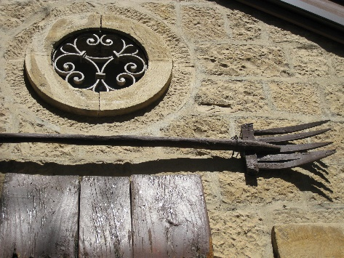
    - This fork was used to throw grain into the air so that the chaff (bad part of the crop) would blow away in the breeze, while the wheat (the good part) would fall to the ground. The chaff would then be burned and the wheat gathered into the barn.
    - Those who genuinely repent will be gathered into God’s house (the barn) but the unrepentant (Scribes and Pharisees) will face judgement (be burned)
    - Notice, the axe is “laid to the root of the trees” in verse 10 and the “winnowing fork is in his hand” in verse 12, signifying these events are not far off.
READ MATTHEW 3:13-17
- John acknowledges Jesus superiority to himself
  - John is a beautiful example of a man who preached a God centered message, even as people were flocking to hear him.
  - Jesus pays John a tremendous compliment in Matthew 11:9-11 for his faithfulness.
  - APPLICATION:
    - Isn’t that our responsibility too? To point people to someone greater than us?
    - But its really hard not to trip over your own message by pointing people to yourself, especially if the multitudes come to hear you.
    - Its when we muddy the message, when it becomes unclear who we are pointing people towards, that things start to go wrong.
- Not long after John’s address to the Pharisees and Sadducees, Jesus came from Galilee to be baptized.
  - Initially, John refused, stating that things should have been the other way around (Jesus baptizing John)
  - But Jesus insists and John consents
- Why did Jesus need to be baptized
  - Obviously, Jesus wasn’t baptized for the forgiveness of sins.
  - Jesus said it was necessary to “fulfill all righteousness.”
    - The term fulfilling usually indicates that an action has been taken which requires a follow-up.
      - Example: You place an order on Amazon.com, Amazon then “fulfills” your order.
      - Example: A prophecy is made, that prophecy is later “fulfilled.”
    - Jesus’ baptism confirms the fulfillment of long-standing prophecies in the Old Testament.
      - Jesus is confirming that John is, in fact, the prophesied forerunner of the Messiah. Allowing Himself to be baptized by John communicates His approval of John’s message to the onlookers.
      - He is then announcing the fulfillment of the prophecies about a coming Messiah by claiming that identity for Himself.
- The icing on the cake immediately follows in verses 16 and 17.
  - God (a voice from Heaven) gives the final confirmation.
    - Jesus confirms that John’s message is from God
    - Jesus confirms that He is the Messiah from God
    - God confirms both claims
- This would have been a powerful sign to all of the Jews present that the Christ had finally arrived.

https://en.wikipedia.org/wiki/Sadducees
https://www.blueletterbible.org/Comm/stewart_don/faq/right-books-in-old-testament/question13-sadducees-different-old-testament.cfm
https://en.wikipedia.org/wiki/Matthew_3:12

