MATTHEW 4
READ MATTHEW 4:1
- Following His baptism, God (the Spirit) leads Jesus out into the wilderness to be tempted.
- It is important to keep the context of chapter 3 in mind when you begin reading chapter 4
  - Keep in mind that Jesus has just been confirmed, by the word of God, to be God’s Son… The Messiah
  - The temptations Jesus is about to face are going to call God’s word into question.
  - Very similar tactic to what we see Satan doing in Garden of Eden.
READ MATTHEW 4:2
- Before the temptation, Jesus fasts for 40 days, seemingly in preparation for the temptation.
  - The New Testament doesn’t give us any specific commands to fast but it does tell us of the benefits of fasting.
  - Fasting and prayer are often coupled together.
  - We will do a separate study on fasting
  - Notice how verse 2 specifically says that Jesus was hungry (as if we couldn’t have guessed)
  - APPLICATION: Physical strength is not equivalent to spiritual strength
    - You see how Jesus sacrificed physical health to prepare Himself spiritually for what was coming.
    - While I don’t think the Bible is calling us to fast 40 days, I wonder how many of us have even once made that trade?
    - We are all busy, and that busyness often leaves us with little time in our days for spiritual study, application, prayer.
      - We would be wise to skip a meal to feed ourselves spiritually, we would be wise to skip the gym to make time for prayer.
      - How often do our lives acknowledge what Jesus’ life acknowledged here? That provision for the spiritual battle takes priority over provision for the physical.
READ MATTHEW 4:2-4
- The very first things Satan does is question God’s authority.
  - God said Jesus was His Son
  - Satan questions
    - It is interesting that Satan doesn’t directly contradict God by saying, “You aren’t the Son of God.”
    - He used this approach with Adam and Eve.
    - APPLICATION:
      - Satan is subtle and we would be wise to make note of that.
      - Satan doesn’t attempt to destroy people’s faith by busting in the front door and announcing, “Everything you’ve ever believed is wrong!”
      - He introduces one doubt at a time… nice and slow.
    - APPLICATION:
      - It is also important to identify this as a question attacking Jesus’ identity.
      - Temptation is always a question of identity
        - Who do we serve?
        - Ourselves? Like Satan convinced Adam and Eve
        - Or God? We are His children and serve Him.
      - Satan attacks identity effectively in our culture
        - If he can get a university professor to convince a student of the truth of evolutionary biology, he doesn’t even need to bother with the authority of the words of God.
        - That student has lost their true identity.
- Jesus does not feel the need to prove God’s word, instead He reaffirms His belief in its validity by quoting it in rebuttal to Satan.
  - The verse referenced by Jesus is Deuteronomy 8:3
  - Deu 8:3 - And he humbled you and let you hunger and fed you with manna, which you did not know, nor did your fathers know, that he might make you know that man does not live by bread alone, but man lives by every word that comes from the mouth of the LORD.
  - APPLICATION:
    - Satan would not have confessed Jesus, even if He had turned the stones to bread
    - There are some people who aren’t worth answering. Proof is of no interest to them.
READ MATTHEW 4:5-7
- Again, Satan questions the word of God by asking for proof of Jesus’ identity.
  - He asks Him to throw Himself off the pinnacle of the temple.
  - He even quotes a scripture
  - Psalm 91:11-12 - For he will command his angels concerning you to guard you in all your ways. On their hands they will bear you up, lest you strike your foot against a stone.
  - APPLICATION:
    - Just because someone can quote some Scripture, doesn’t mean they know what they are talking about!
- Jesus responds to Satan by quoting God’s word back to him.
  - Jesus quotes Deuteronomy 6:16
  - Deu 6:16 - “You shall not put the LORD your God to the test, as you tested him at Massah.”
    - Jesus’ quotation show the complete hypocrisy and ridiculousness of Satan’s request.
    - Satan is asking Jesus to put God to the test, while he is putting God (Jesus) to the test.
- Twice now, Satan has called God’s word into question. In his third temptation, he resorts to his fallback strategy.
- Satan’s last temptation is not a challenge but an offer
  - Christ would be glorified in heaven with His Father again in eternal glory, but only after a three year ministry and significant suffering.
  - Satan offers Jesus something immediate.
  - All of the kingdoms of the world could be His if He bowed to Satan
  - APPLICATION:
    - For many years, I looked at this temptation almost as if it wasn’t even a temptation
    - Jesus is literally the king of the universe. Why would He ever be tempted with such a lousy offer from Satan.
      - All the kingdoms of the earth were only a small portion of what He already possessed as universal King.
      - How is that even tempting? It isn’t even a real temptation!
    - But that is wrong!
      - I know it is wrong because this is the temptation I fall prey to on a daily basis.
      - I know who God says I am (my identity)
        - A child of His
        - Justified through Christ to spend eternity with Him.
        - To be an heir with the universal King
        - 2Tim 2:12 - if we endure, we will also reign with Him
      - It is an astounding reality.
        - But Satan comes to me with a small pleasure.
        - He whispers in my ear, “You aren’t glorified in Heaven yet!”
        - “There is still a lifetime of difficulty ahead!”
        - “I’ve got a pleasure you can have RIGHT NOW!”
      - What is astounding is that Satan can win us over with a much weaker offer than what He offered to the Lord.
        - Have you ever been offered the throne of the world?
        - Me neither! It is usually something a lot smaller.
      - If Satan can’t convince us the word of God is false, he may attempt to win us over with immediate pleasure.
- Like the first 2, Satan’s offer failed to shake Jesus’ conviction.
  - He once again denied Satan and affirmed His contentment in the promise of God by quoting the Scriptures
- After the third temptation, Satan departed
- In parallel, we are told, “resist the devil and he will flee from you” (James 4:7).
READ MATTHEW 4:12-17
- John was arrested for opposing the immoral divorce and remarriage of Herodias, Herod’s wife (see the note on Matthew 2:19-23).
- When Jesus heard of the arrest, He left Nazareth (His hometown) and went to live in Capernaum by the sea (sea of Galilee)
  - 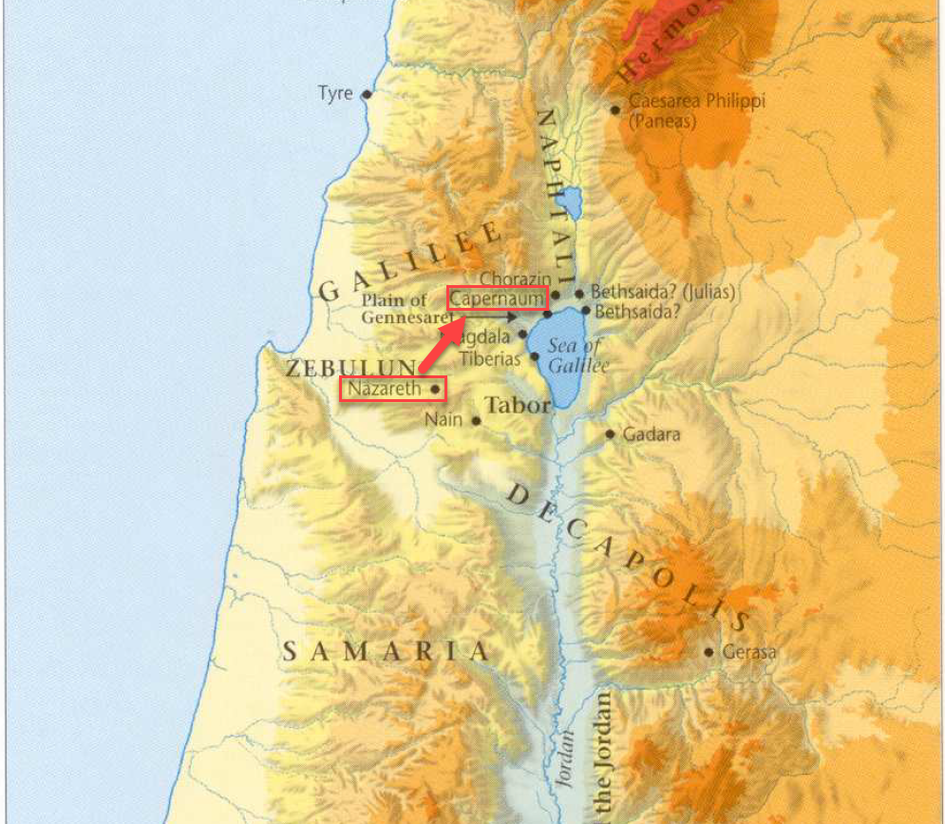
  - Capernaum was roughly 20 miles north east.
  - Jesus’ move brought about the fulfilment of a prophecy (verses 15 and 16)
    - The prophecy is taken from Isaiah 9:1-2
    - Isaiah 9 contains several details about the Messiah. The prophecy in verses 6-7 are often quoted.
    - Isaiah 9:6-7 – For to us a child is born, to us a son is given; and the government shall be upon His shoulders and His name shall be called Wonderful Counselor, Mighty God, Everlasting Father, Prince of Peace. Of the increase of His kingdom there will be no end, on the throne of David and over His kingdom, to establish it and to uphold it with justice and with righteousness from this time forth and forevermore. The zeal of the LORD of hosts will do this.
- 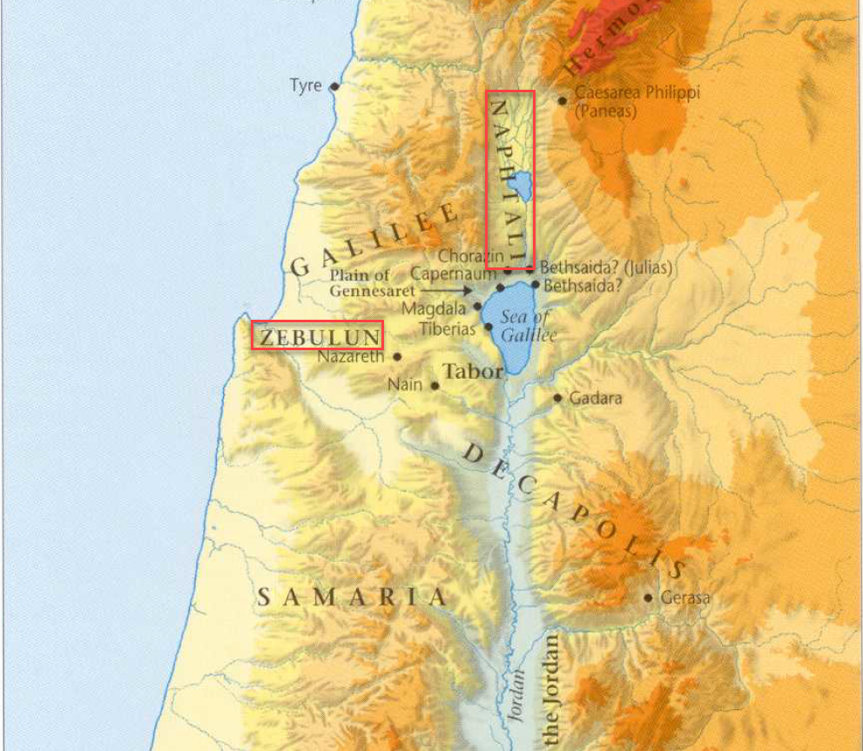
  - Following John’s arrest, Jesus steps up to preach the message of repentance and the coming of the Kingdom of Heaven (verse17)
READ MATTHEW 4:18-22
- In verse 18, Jesus begins to call people to follow Him and learn from Him.
  - 12 men were specifically chosen to be in Jesus’ inner circle
  - They are known as the 12 Apostles
- From the map above, you can see that Capernaum sits right on the coast of the Sea of Galilee.
  - While Jesus was walking by the sea, He saw two sets of brothers.
    - Simon (Peter) + Andrew
    - John + James
  - They were fisherman by profession.
- Jesus called the brothers to follow Him and they did without hesitation
  - We don’t know for sure what attracted the brothers to Jesus
    - Maybe it was His boldness in telling them to follow
    - Maybe Jesus spoke other words to them that aren’t recorded
    - Maybe they were just curious
  - We don’t know all the details but the example of the 4 brothers in immediately dropping their occupations to following Jesus is admirable and a pattern to follow.
  - Nothing could possibly be more important than following Jesus.
READ MATTHEW 4:23-25
- If you look at the map above, you will see the region of Galilee in which Jesus preached.
- Jesus’ message consisted teaching in the synagogues and preaching the gospel of the Kingdom.
- Lets define 2 helpful terms
  - Gospel
    - Gospel comes from the Greek work “euangelion,” meaning “good news.”
    - Jesus was preaching good news to the Jews. The Kingdom, which had been prophesied about for generations, was finally coming.
  - Synagogues
    - It is thought that synagogues originated during or shortly after the Jewish captivity in Babylon beginning around 606 B.C.
    - The center of Jewish worship and sacrifice was the Temple in Jerusalem where the priests ministered
    - The synagogues arose as locations of secondary worship. Prayer and reading the Old Testament Scriptures were the focus of synagogue devotion.
    - They were also important places of gathering for the Jewish community outside of Jerusalem.
- Jesus’ public proclamation of the coming Kingdom was confirmed by miracles.
  - Multitudes of sick people were brought for healing
  - Jesus healed them
  - APPLICATION:
    - Compare this with modern day faith healers
- As Jesus continued to heal and preach, His popularity grew and larger and larger crowds started following him
- The cities and areas mentioned in verse 25 can be located on the included maps.
- APPLICATION:
  - Although some people may find maps really boring, they are an important tool to understanding the Bible.
  - Geography and topography help bring the Bible to life when you read it. Neglecting to appreciate the nuances of the land on which the story of the Bible plays out will leave the Scriptures feeling flat and abstract.

