MATTHEW 8
Mat 8:1-4 - When he came down from the mountain, great crowds followed him. And behold, a leper came to him and knelt before him, saying, “Lord, if you will, you can make me clean.” And Jesus stretched out his hand and touched him, saying, “I will; be clean.” And immediately his leprosy was cleansed. And Jesus said to him, “See that you say nothing to anyone, but go, show yourself to the priest and offer the gift that Moses commanded, for a proof to them.”

- Jesus concludes the Sermon on the Mount and “great crowds” followed Him.
  - One man is mentioned specifically, a leper.
  - Leprosy (known as Hansen’s Disease)
    - Caused by a bacterial attack on the nerves
    - The bacteria is slow acting and some people can be infected for years without the telltale symptoms
    - The bacteria causes skin deformity and nerve damage
    - If untreated, leprosy will cause hand and/or foot paralysis.
    - Other injuries often occur due to lack of feeling in the extremities
    - Fingers and toes are commonly lost
    - Loss of vision, loss of vision, and nasal deformity are also common in with advanced Hansen’s
    - Treatment for leprosy was developed in the 1940s (antibiotics)
  - According to the Law of Moses, a person diagnosed with leprosy was considered unclean and was not allowed to associate with their “clean” countrymen.
    - Lev 13:3 - and the priest shall examine the diseased area on the skin of his body. And if the hair in the diseased area has turned white and the disease appears to be deeper than the skin of his body, it is a case of leprous disease. When the priest has examined him, he shall pronounce him unclean.
- Perhaps this man came to Jesus in response to Matthew 7:7-10
  - Matt 7:7-8 – “Ask, and it will be given to you; seek, and you will find; knock, and it will be opened to you. For everyone who asks receives, and the one who seeks finds, and to the one who knocks it will be opened.”
  - He heard the word of God and acted in conviction rather than allowing that conviction to grow cold.
- It would not have been culturally appropriate (not to mention hygienically appropriate) for a man with contagious leprosy to barge into a “great crowd” to speak with Jesus.
  - People likely withdrew when they saw him.
  - Some may have yelled at him to go away.
  - He wasn’t just facing the judging eye of one or two people, he was facing the disdain of a whole crowd of people.
- But he was a man who had a desperate need and only one hope on earth.
  - Nothing was going to get in his way of getting to the Great Physician.
  - Peer pressure and cultural boundaries no longer mattered
- APPLICATION:
  - The Bible often uses physical ailment to teach spiritual lessons and that is exactly what is happening here.
  - We are all sick with a fatal spiritual illness, namely sin.
    - There is only one hope for a cure, namely Jesus
    - But things stand in our way of going to Him, namely peer pressure and cultural boundaries.
    - Be more like the leper!
- APPLICATION
  - In verse 2, the man’s statement isn’t a question, it is a statement.
  - Like the instruction in James 1, this isn’t a double-minded man. He comes to Jesus in full confidence of His ability.
  - And that is glorifying to God. When we approach God with doubt, does that glorify God?
    - Verbally, we would never acknowledge God’s inability but our hearts betray us
    - “I just don’t see a pathway to get there.”
    - Only God needs to see the way.
  - God is glorified when His children come to Him knowing He can manipulate His world however He wishes to care for them and refine them.
- APPLICATION:
  - Notice how this man makes is request out in the open in front of everyone.
    - Aren’t we sometimes afraid to request so boldly in public in prayer.
    - Sometimes we make our really big requests to God in the closet because we just aren’t sure we want others to see how big we pray.
    - And I think sometimes, we do that because we are afraid to look foolish if God doesn’t answer that prayer with what we asked.
  - Perhaps God wants us to pray our boldest prayers in public because it’s how He receives the most praise.
    - When God is invoked only in private, when great work is accomplished, people may have a tendency to look at the individual who accomplished it.
    - When God is invoked in public, people’s eyes are more likely to be turned towards God.
  - We would only not pray boldly in public if (1) doubted God’s ability or (2) Were more concerned about our image than God’s.
- APPLICATION:
  - Pain can be a blessing
    - This man was probably in pain every day of his life.
    - That pain clarified his prioritizes
  - Pain can do the same for us in terms of spiritual priorities
    - When a person is mostly comfortable they will allow small roadblocks to stand in their way of doing something they know needs accomplished (some nagging problem that needs fixed but isn’t yet annoying enough to disturb them in any great way).
    - But when pain is real and unbearable, we seek a cure immediately.
      - How many people don’t seek God until a tragedy?
      - How many people’s spiritual priorities change when they face a serious illness?
      - God is pushed up the priority ladder when He is the only one who can help
  - In some ways, pain can be grace.
  - On Judgement Day, we will thank God for the correcting power of pain if it was the only medicine potent enough to redirect a sinful life.
- APPLICATION:
  - Jesus’ healing is immediate
    - We don’t know how long this man had suffered, but leprosy was a disease that would have caused the inflicted pain every day.
    - Not to mention the newly infected would have to face the horrors of their future every time they returned to the leper colony and saw those with more advanced affliction.
    - Imagine this man, perhaps enduring years of pain
    - He comes to Jesus and is healed in an instant.
  - I am not yet old, but I have begun to notice the slight signals of aging
    - I have pain after going to gym
    - I have a bit less hair
    - Certain things just don’t work as well as they once did.
    - I can’t imagine what it will be like in 60 years.
    - I wish my body would grow younger instead of older.
    - Physically speaking, i’m not looking forward to what is ahead.
  - But it is a sweet thought and hope to me that when i’ve gotten old and tired of my confinement in a broken down body. After I’ve endured years of pain and frustration and handicap… In an instant, Jesus will make me new again.
- The Old Testament Law had rules regarding what was to take place when a leper was cleansed. It is to these that Jesus is referencing in verse 4. You can read about them in Leviticus 14.

Mat 8:5-9 - When he had entered Capernaum, a centurion came forward to him, appealing to him, “Lord, my servant is lying paralyzed at home, suffering terribly.” And he said to him, “I will come and heal him.” But the centurion replied, “Lord, I am not worthy to have you come under my roof, but only say the word, and my servant will be healed. For I too am a man under authority, with soldiers under me. And I say to one, ‘Go,’ and he goes, and to another, ‘Come,’ and he comes, and to my servant, ‘Do this,’ and he does it.”

- Following His encounter with the leper, Jesus went to Capernaum (see red box above)
- When He entered the city, He was approached by a centurion
- The Roman Centurion:
  - There were approximately 5,000 men in a Roman legion
  - The legion was made up of 10 cohorts
  - A cohort was made up of 6 centuries
  - A century consisted of 80-100 men
    - Centuries fought, marched, and camped together
    - They carried their own provisions and weapons
  - The century was then divided into 10 contubernia (8-10 men in each)
  - The centuries were led by a centurion
  - The contubernia were led by a decanus
    - These leadership tears were created by the Marian Reforms of 107 BC
- This probably would have shocked the Jews for at least 2 reasons:
  - (1) The Jews did not like the Romans and here the Jewish Messiah was discussing the needs of a Roman Gentile
  - (2) A Roman was not only humbling himself before a Jew but was acknowledging his authority and superior power
- Jesus tells him He will “come and heal” his paralyzed servant, to which the centurion responds, “Lord, I am not worthy to have you come under my roof.”
  - This too likely would have shocked the Jews.
  - Jews did not enter Gentile houses (Acts 10:28).
  - This had more to do with the Jews believing the Gentiles unworthy than the other-way-around.
  - But here we see a Gentile confessing his unworthiness before a Jew.
- From the eyes of a Jew, this whole seen would have probably been bittersweet
  - They loved seeing a roman humble himself before a Jew
  - They may not have liked “their Messiah” helping a Gentile
- Notice also, this was a man who was willing to humble himself to seek the blessing of another (his inferior). This quality is admirable and we will see it again in the Syrophoenician women whose story we will get to later in the gospels.
- Displaying incredible faith and trust in the power Jesus possessed, the centurion asked Jesus to heal his servant with only a word.
  - Being a man of authority himself, the centurion asked Jesus to use the authority of only His words to command healing.
  - Because of his rank, the centurion’s word was enough to bring his 80-100 men to attention and direct them anyway he wanted.
  - He believed Jesus’ words were enough to bring nature to attention and directed it anyway he wanted.

Mat 8:10-13 - When Jesus heard this, he marveled and said to those who followed him, “Truly, I tell you, with no one in Israel have I found such faith. I tell you, many will come from east and west and recline at table with Abraham, Isaac, and Jacob in the kingdom of heaven, while the sons of the kingdom will be thrown into the outer darkness. In that place there will be weeping and gnashing of teeth.” And to the centurion Jesus said, “Go; let it be done for you as you have believed.” And the servant was healed at that very moment.

- It isn’t uncommon for the gospels to mention people who marveled at the works of Jesus, but it rarely mentions Jesus marveling
  - Jesus was marveling at the faith of the centurion
  - He then compliments the centurion in a way that would have infuriated some of the Jews and perplexed the rest.
    - “ Truly, I tell you, with no one in Israel have I found such faith.”
    - For those with a closed mind, this was all they needed to reject Jesus
      - The Messiah was coming to lead Israel to glorious victory against there oppressors (or so they thought)
      - Yet, this man is slapping Israel in the face by complimenting a leader of the Roman army.
    - For those with an open mind, it must have really got them thinking
      - Jesus just preached a sermon condemning many of the Jewish traditions and interpretations of the Law.
      - Then He spent His time with an outcast leper and an enemy solder.
      - What could this mean?
  - Jesus’ next statement may have been one of His most divisive, at least in the presence of a Jewish audience.
    - “I tell you, many will come from east and west and recline at table with Abraham, Isaac, and Jacob in the kingdom of heaven, while the sons of the kingdom will be thrown into the outer darkness. In that place there will be weeping and gnashing of teeth.”
    - If you were a Jew reading this gospel account, this might be the place you rolled up the scroll and threw it away.
      - No long-awaited, prophesied, Savior of the Jews would say what Jesus just said.
      - If someone hated Jesus before, they hated Him more now
      - If someone was curious about Jesus, they were more curious now
    - Let’s define some terms as concisely as possible
      - “East and west” = every nation
      - “Abraham, Isaac, and Jacob” = fathers of the Jewish nation
      - “Sons of the kingdom” = the Jews
      - “Outer darkness” = eternal punishment
    - Jesus is saying,
      - There will be people who come from every nation (Gentiles) who have communion with the fathers of the Jews, even sitting and dining with them. By “reclining at table” Jesus seems to be referring to our eternal life with the faithful of all generations.
      - The children of the kingdom (Jews) who rejected Christ would not be allowed at the table with their forefathers but instead would be put outside in the darkness. This darkness represents separation from God and the faithful and is used to symbolize eternal death and punishment.
    - The audacity of Jesus to say some Gentiles would enjoy God’s blessing and many Jews would be excluded must have sent shockwaves through the crowd.
      - What did the Messiah have to do with Gentiles?
      - How could a Gentile have fellowship with Abraham?
    - Jesus’ words here reinforce the warning John gave to the Pharisees and Sadducees in 3:9.
      - It wasn’t enough just to be a child of Abraham.
      - The true children of Abraham had faith like Abraham
- Jesus ends His interaction with the centurion by rewarding His faith and healing his servant.

Mat 8:14-17 And when Jesus entered Peter's house, he saw his mother-in-law lying sick with a fever. He touched her hand, and the fever left her, and she rose and began to serve him. That evening they brought to him many who were oppressed by demons, and he cast out the spirits with a word and healed all who were sick. This was to fulfill what was spoken by the prophet Isaiah: “He took our illnesses and bore our diseases.”

- Peter must have lived in Capernaum
  - This makes sense because his profession was fishing and as you see from the map, it is right next to the water.
  - This is also consistent with chapter 4, verse 12-22 where Jesus first encountered Peter and Andrew and called them to follow Him.
- Peter was married and his mother-in-law was sick. Jesus healed her with a touch and she got up and started serving Him.
- Throughout the day, the word must have spread about Jesus’ healings because in the evening many people started bringing their sick to Jesus at the house.
- Jesus not only healed sick people, He also “cast out” demons. I will discuss the “demons” in more detail at the end of the chapter.
- Matthew tells his readers that Jesus’ miraculous healings were the fulfillment of a prophecy with which every Jew would have been familiar, Isaiah 53.
  - Isaiah 53:4 - Surely he has borne our griefs and carried our sorrows; yet we esteemed him stricken, smitten by God, and afflicted.
- Remember, Matthew also quoted Isaiah in chapter 2, verse 23
  - Most of the Jews viewed the prophets of the Old Testament as inspired by God
  - Using the prophets’ own words would have been a convincing evidence of Jesus’ identity

Mat 8:18-22 - Now when Jesus saw a crowd around him, he gave orders to go over to the other side. And a scribe came up and said to him, “Teacher, I will follow you wherever you go.” And Jesus said to him, “Foxes have holes, and birds of the air have nests, but the Son of Man has nowhere to lay his head.” Another of the disciples said to him, “Lord, let me first go and bury my father.” And Jesus said to him, “Follow me, and leave the dead to bury their own dead.”

- A crowd was surrounding Jesus and He determined to go “over to the other side.” By this He meant the other side of the Sea of Galilee.
- Before departing, a scribe came up to Jesus wishing to express his devotion to Him.
  - Jesus’ response to the scribe is important to consider
  - He doesn’t just pat the man on the back and congratulate him on his commitment
  - Instead, Jesus ask the man if he really knows what he is getting himself into.
    - Jesus wasn’t a normal man living a normal life in a normal house in a normal town.
    - Jesus had a mission to accomplish and He would later give His followers a mission to accomplish.
    - Sacrifices were going to have to be made to follow Jesus.
      - One of those sacrifices might be the safety and security of a home.
      - Almost all human beings have homes where we feel comfortable, safe, and where we are surrounded by the familiar.
      - Even animals have homes (foxes and birds)
      - But Jesus didn’t
      - He lets the scribe know that a similar sacrifice might be asked of him.
  - APPLICATION:
    - Is this how we respond to people who say they want to be followers of Jesus?
    - Probably not, right?
      - Usually we congratulate them on their commitment
      - We pat them on the back and tell them they’ve made the best commitment of their lives.
    - But do we warn them ahead of time about the commitment?
    - About what it really costs to die to yourself daily?
    - If we did, we might have less “converts,” but we might have more that endure to the end.
- Another man approached Jesus with an explanation of why he couldn’t follow Jesus just-this-minute, “Lord, let me first go and bury my father.”
- Jesus responded “Follow me, and leave the dead to bury their own dead.”
  - Jesus has received a lot of criticism for this response over the years.
  - What did the man mean by “bury my father” and what did Jesus mean by “let the dead bury their own dead?”
    - (1) “Lord, let me first go and bury my father.”
      - It could be that the man meant exactly what he said, his father had died and he needed to go arrange the funeral
        - Burying a loved one wasn’t wrong
        - Like today, it probably would be considered shameful for a child not to care for the remains of their deceased loved ones, especially a parent
        - It would be considered his responsibility
      - He could have meant that his father had not yet died but he wanted to wait to follow Jesus until his aging dad passed on.
        - Again, caring for an aging parent is not wrong
        - It is the responsibility of a child
    - (2) “Let the dead bury their own dead.”
      - Jesus’ statement may have been a statement about the priorities of those in different spiritual conditions.
        - A paraphrase might be, “Let those who are spiritually dead attend to the physical affairs of a dying world, but those who are spiritually alive must follow me because I will lead you to spiritual life.
      - Jesus’ statement may have been a general statement about priorities.
        - A paraphrase might be, “Even the things you believe are most important, like burying a parent, ought to fall lower on the priority scale than following me!”
        - Nothing is more important than being a disciple of Jesus.

Mat 8:23 - And when he got into the boat, his disciples followed him. And behold, there arose a great storm on the sea, so that the boat was being swamped by the waves; but he was asleep. And they went and woke him, saying, “Save us, Lord; we are perishing.” And he said to them, “Why are you afraid, O you of little faith?” Then he rose and rebuked the winds and the sea, and there was a great calm. And the men marveled, saying, “What sort of man is this, that even winds and sea obey him?”

- After His interaction with the would-be disciples, Jesus got into a boat to sail on the Sea of Galilee
- Jesus’ vehicle
  - In 1986 a 1st Century Galilee fishing vessel was discovered during a drought
  - The boat is 27 ft long and 7.5 ft wide
  - It is now housed in the Yigal Allon Museum in Kibbutz Ginosar
  - 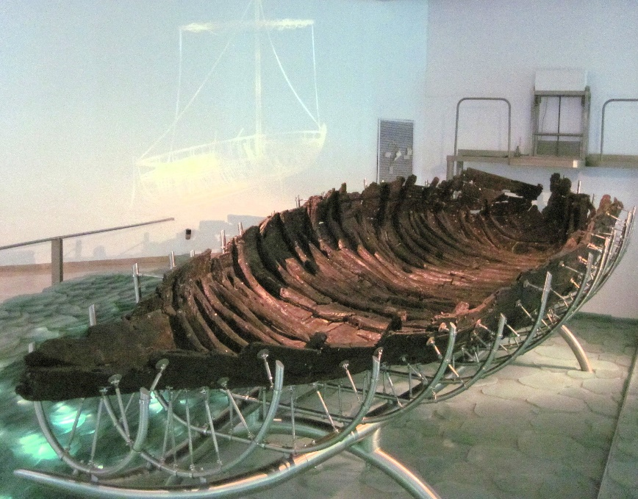
- While on the sea, a tremendous storm arose and the Apostles believed they might go down with their ship (you know the storm must have been bad if experienced fishmen feared for their lives).
  - This was likely a windstorm
  - Wind storms kick-up very quickly in the sea of Galilee. The wind comes off the east side of the Sea from an area known as the Golan Heights (Lexham Geographic Commentary on the Gospels)
  - 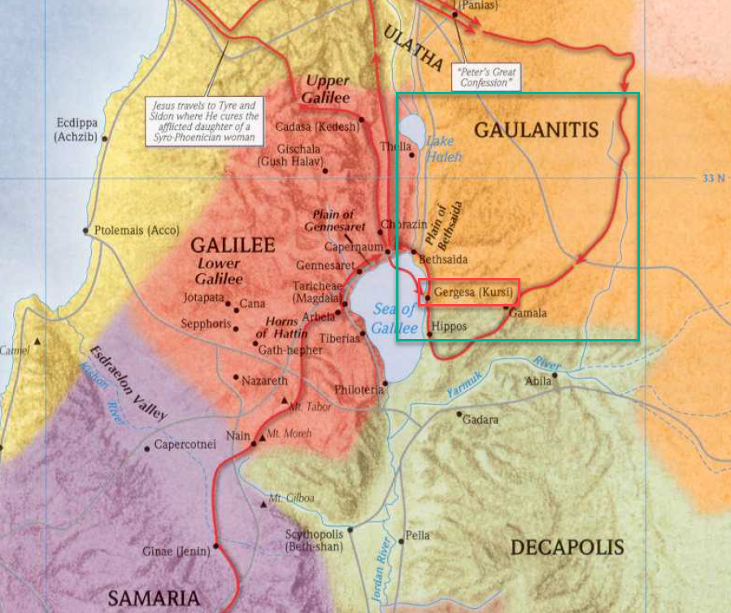
- Curiously, Jesus was sleeping onboard, apparently not concerned with the waves that must have been hitting him.
- The Apostle’s woke Him up pleading with Him to save them.
- But before saving them, He rebuked them for their lack of faith.
- Jesus calms the storm and the Apostles marvel, they are shocked at Jesus’ power.
- APPLICATION:
  - Do you remember the man in verse 20 who was told if he followed Jesus he might not have a place to lay his head?
  - Many people think the safest place to lay their head is in a secure home, with locks on the doors, in a comfortable bed, in a nice suburban neighborhood but this is incorrect.
  - Here we see that the safest place to lay your head is in a 27 foot fishing vessel being tossed around by the waves on the Sea of Galilee.
  - You may follow Jesus and not have a house where you can lay down to sleep, but your location does not determine your safety.
  - Location is irrelevant to safety when eternity is in perspective.
  - You will never be safer than when you lay your head down in your effort to follow Jesus as one of His disciples.
- APPLICATION:
  - Did you notice how the Apostles cried out to Jesus to save them (“Save us, Lord, we are perishing”) but were then shocked when He did?
  - How often do we pray and ask God for something but are then shocked when He comes through and helps us?
  - It would be better to pray with confidence and then be shocked if God didn’t come through (btw, we would never be shocked again).
- APPLICATION
  - I think the story of the storm and the sea are beautiful parallels of a trial all faithful Christians likely face at some point in their lives, the temptation to believe that Jesus has forgotten about them.
  - Have you ever heard someone ask, “Where is God?”
    - “Where is God in my suffering?”
    - “Where is God in my financial struggle?”
    - “Where is God in a natural disaster?”
  - Like the Apostles, they can’t understand why Jesus is sleeping on them. It’s like He doesn’t care about their suffering and the “storms” of their lives.
  - But the conclusion of this story lays down a principle that is also confirmed to modern Christians in verses like Romans 8:28.
    - Jesus is never unaware of our suffering
    - He will deliver the faithful from their storms
    - And as with the Apostles, God’s deliverance will help our weak faith by giving us a chance to marvel at Him.

Mat 8:28-34 - And when he came to the other side, to the country of the Gadarenes, two demon-possessed men met him, coming out of the tombs, so fierce that no one could pass that way. And behold, they cried out, “What have you to do with us, O Son of God? Have you come here to torment us before the time?” Now a herd of many pigs was feeding at some distance from them. And the demons begged him, saying, “If you cast us out, send us away into the herd of pigs.” And he said to them, “Go.” So they came out and went into the pigs, and behold, the whole herd rushed down the steep bank into the sea and drowned in the waters. The herdsmen fled, and going into the city they told everything, especially what had happened to the demon-possessed men. And behold, all the city came out to meet Jesus, and when they saw him, they begged him to leave their region.

- Matthew’s account of this miracle is much shorter than the other Gospel records
- Where were the Gadarenes?
  - If you look in Mark’s record of this story, he uses the name “Gerasenes.”
  - Most people believe this area was located on the east side of the Sea of Galilee around the city of Gergesa (see the red square on the map above). This makes sense for several reasons:
    - (1) The area is on the “other side” of Galilee (verse 18)
    - (2) It is in the region of the Golan heights which explains the presence of a windstorm
    - (3) There are several steep banks in the area that lead down into the sea (verse 32) (Check out Google Earth)
- This was an area largely inhabited by Gentiles
  - In the text above, you will notice they were pig herdsman
  - Pigs were unclean to the Jews
- When Jesus arrived two “demon-possessed men” met Him.
- Mark’s account narrows in on only one of these men but that does not mean there weren’t two.
  - There are many references to “demons” or “evil spirits” in the New Testament, especially during the life of Jesus.
  - At this point, let me say only a few things about my view on the demons of the New Testament.
    - These demon’s appeared to have minds of their own. They spoke to Jesus and had knowledge of Jesus that their hosts did not have (see verse 29).
    - Mark’s account mentions this particular demon giving super-human strength to its host (Mark 5:4)
    - The demons could inhabit animals.
    - The Jews in the Bible appear somewhat familiar with demon possession.
    - Outside of the early years of the Church, I am not aware of any biblical references to casting out demons.
    - It is possible that Zechariah 13:2 refers to the disappearance of evil spirits at the time of the Messiah and the establishing of the Church.
    - Some people equate evil spirits with mental illness. Personally, I do not equate the two (mostly because of the first three points).
    - We know demons and spiritual enemies of God exist even today (Eph 6:12), but I do not see evidence that demon possession is still occurring.
    - That being said, I am open to evidence and discussion.
- These demon knew Jesus and the authority He had over them.
  - They asked Him if He intended to torment them “before the time?”
  - “The time” is probably a reference to the final Judgement Day when Satan and his angels will be cast into hell.
  - Curiously, the demons requested to be sent into a herd of pigs nearby and even more curiously, Jesus obliged.
  - He sent the demons into the pigs (Mark says there were about 2,000) and they all ran down a steep cliff and drowned in the Sea of Galilee
- As soon as the pig herdsman saw what Jesus had done, they ran into the city and told all the people
- Rather than coming out to thank Jesus for healing the man, they ask Him to leave (probably on account of the pigs).

https://www.cdc.gov/leprosy/about/about.html
https://answersingenesis.org/biology/disease/biblical-leprosy-shedding-light-on-the-disease-that-shuns/
https://en.wikipedia.org/wiki/Leprosy
https://en.m.wikipedia.org/wiki/Marian_reforms
https://en.m.wikipedia.org/wiki/Centurion
https://en.wikipedia.org/wiki/Sea_of_Galilee_Boat
Lexham Geographic Commentary on the Gospels
https://earth.google.com/web/search/golan+heights
https://en.wikipedia.org/wiki/Golan_Heights

